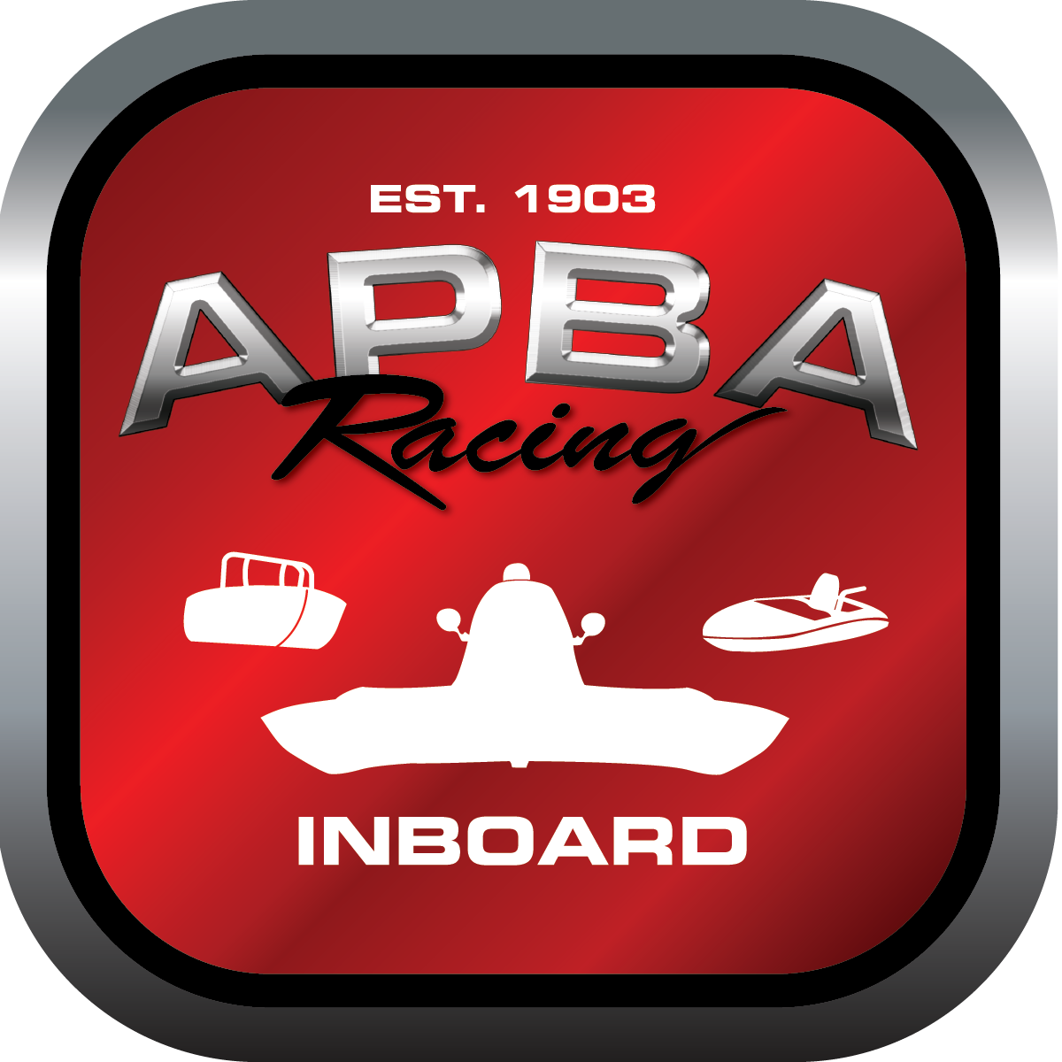
Office use only:
Control Number: NT10
Assigned Group:
Initial Screening:
Ballot: Pass: ______/ Fail: _____
Effective for Race Year: 2019

2019 Inboard Rule Change Proposal
Name: Katelyn Shaw
APBA #: 70857
E-mail: t2racing@yahoo.com
Telephone: 2018418198
Date: Nov. 19, 2018

Note: Proposals must be submitted to the Inboard Office by December 1, 2018 to be considered.
Save and E-mail completed form to: inboardracing@apba.org or melildon@yahoo.com
US mail to APBA Inboard Office 8039 Stone Barn Dr, West Chester, Ohio 45069

Check all that apply:
General Safety Rule
General Racing Rule x
Stock Class Technical Rule *
Modified Class Technical Rule *

Affected Class(es): All inboard classes

Specific Rule Information: [Note: All fields must be completed for consideration.]
Add rule: 6.5.3.1- All results should be completed using a computerized scoring system unless circumstances require otherwise

Author’s VERY BRIEF Summary of Proposed Action:

Computerized system for scoring

Affected Rule: Addition of rule

Proposed rule:
Add rule: 6.5.3.1- All results should be completed using a computerized scoring system unless circumstances require otherwise

Reason
Racers should be able to have results in a timely manner. This would allow results to be completed immediately after an event. With all of APBA going to a unified system, this would be common practice for following years and should be implemented immediately.

