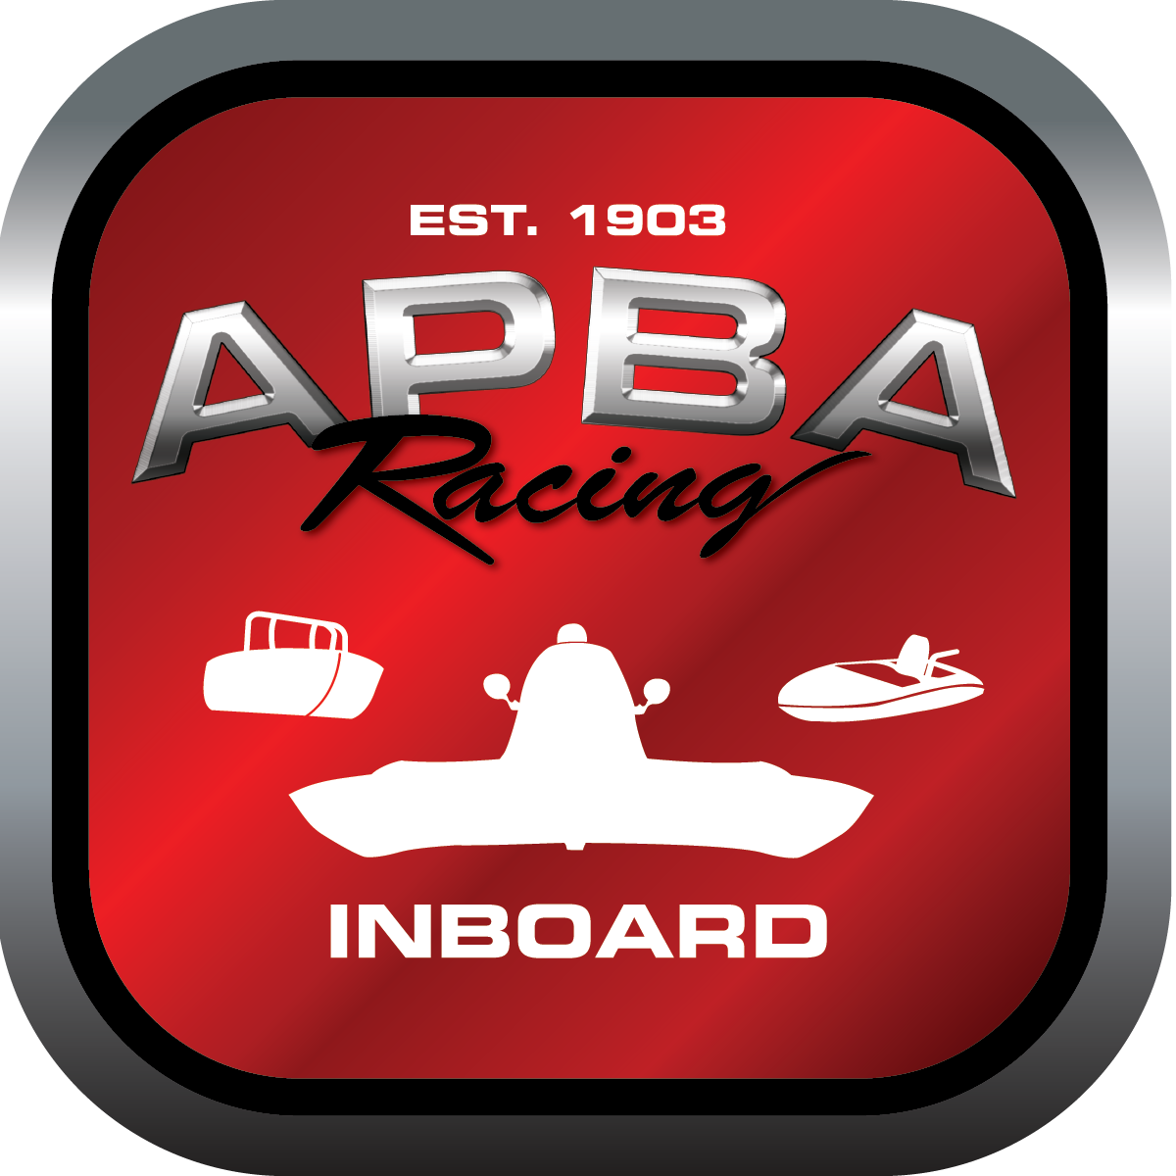
Office use only:
Control Number: NT8
Assigned Group:
Initial Screening:
Ballot: Pass: ______/ Fail: _____
Effective for Race Year: 2019

2019 Inboard Rule Change Proposal

Name: Wally Johnston
APBA #: 6079
E-mail: agitator@q.com
Telephone: 406-443-2384
Date: 11/5/2018

Note: Proposals must be submitted to the Inboard Office by December 1, 2018 to be considered.
Save and E-mail completed form to: inboardracing@apba.org or melildon@yahoo.com
US mail to APBA Inboard Office 8039 Stone Barn Dr, West Chester, Ohio 45069

Check all that apply:
General Safety Rule
General Racing Rule
Stock Class Technical Rule x
Modified Class Technical Rule

Affected Class(es): 5 litre

Specific Rule Information: [Note: All fields must be completed for consideration.]

39.1
Author’s VERY BRIEF Summary of Proposed Action: Change name of 5 litre class

Affected Rule: 39.1

Proposed rule: Change the name of the 5 litre class to “Pro Lite 350” and keep the E designation

Reason for change: The 5 litre name implies that the class is running a 5 litre engine. Need to evolve the name as the rules have evolved.

