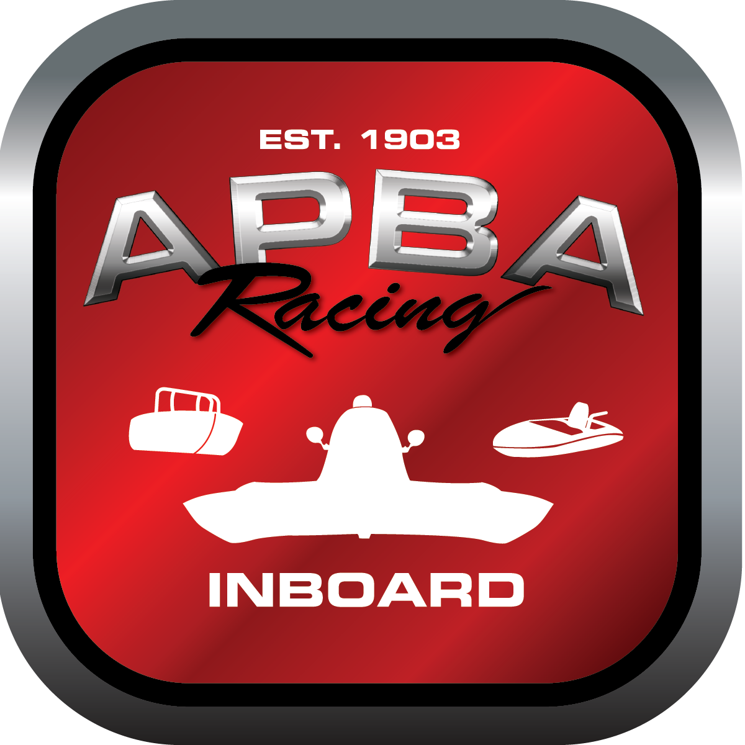
Office use only:
Control Number: T9

Assigned Group:
Initial Screening:
Ballot: Pass: ______/ Fail: _____
Effective for Race Year: 2019

2019 Inboard Rule Change Proposal

Name: Wally Johnston
APBA #: 6079
E-mail: agitator@q.com
Telephone: 406-443-2384
Date: 11/5/2018

Note: Proposals must be submitted to the Inboard Office by December 1, 2018 to be considered.
Save and E-mail completed form to: inboardracing@apba.org or melildon@yahoo.com
US mail to APBA Inboard Office 8039 Stone Barn Dr, West Chester, Ohio 45069

Check all that apply:
General Safety Rule
General Racing Rule
Stock Class Technical Rule * x
Modified Class Technical Rule *

Affected Class(es): 5 litre

Specific Rule Information: [Note: All fields must be completed for consideration.]
45

Author’s VERY BRIEF Summary of Proposed Action: Eliminate rules for obsolete engines.

Affected Rule: 45

Proposed rule: Eliminate 45.1 and 45.2

Reason for change: These engine packages are obsolete. Neither have been in use since 2014, as the new rules for the 350 and 305 mod were introduced in 2015.

