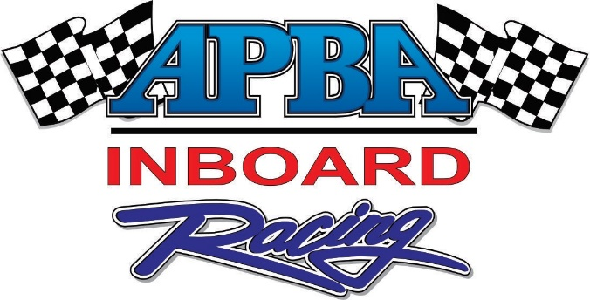

February 1, 2018

Mike Smith
XYZ Company
1367 South Lewis
Anaheim, California 92805

Dear Mike:

Here is the 2017 Sponsorship agreement for the 2018 APBA Inboard Hydrofest that outlines the benefits and cost as well as the agreed upon payment schedule.

Thank you for your support of the APBA Inboard Hydrofest and our sport. I am positive that this will be an excellent vehicle to advertise and promote your products. We look forward to working with you.

Sincerely,

Your Name Here
Your Title Here
The sample basic sponsorship agreement below outlines what you have offered, negotiated, and agreed to. Never include any benefit that YOU are not 100% certain that you can deliver. For large corporate sponsors offering a large amount of money, a more comprehensive legal document will need to be drawn up.

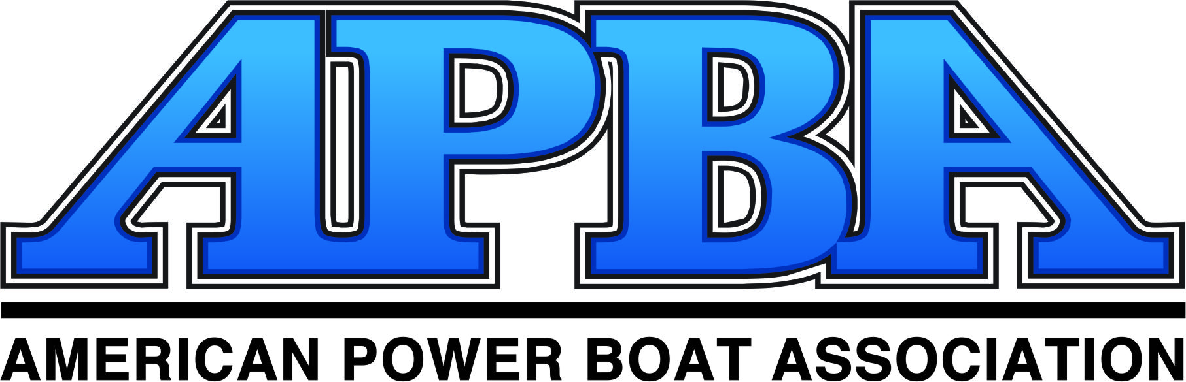

2018 APBA HYDROFEST

SPONSORSHIP AGREEMENT

TITLE SPONSOR OBLIGATIONS
- $15,000 cash ($5,000 due with signed contract and balance due on or before May 21, 2018);
- $2,500 in product support;
- Provide XYZ Company banners for display at the event;
- Provide logo for use on all printed material.

TITLE SPONSOR BENEFITS
- Mention in the event title (The XYZ Company APBA Inboard Hydrofest) and title rights;
- XYZ Company logo to be incorporated into event logo;
- XYZ Company to receive one open and one closing bumper on each of the television shows;
- Complimentary booth space up to 20 feet X 40 feet at the event;
- Right to be the “official ?????? product” and category exclusivity;
- Primary on-site signage at the event (level 1);
- Large logo on all promotional items related to the Inboard Hydrofest (T-Shirts, posters, magazine advertisements, inspection decals, tour logo, etc);
- Primary mention in all printed material pertaining to the events (Magazine advertisements, posters, flyers, advertising, press releases, etc.);
- Primary mention in all advertising pertaining to the events;
- Substantial company mention by announcers at every event (level 1);
- XYZ Company name to be primary focus on APBA Web sites developed to promote the events;
- XYZ Company logo on all awards;
- XYZ Company logo on officials’ apparel and premiums such as T-shirts, sweatshirts, etc.;
- Sponsorship includes company logo added to custom stage backdrops to be used at the event;
- 100 complimentary tickets to the event;
- First right of refusal the following year.

For XYZ Club:

Signed: ___________________________________________ Date:

Title:

For YYZ Company:

Signed: ___________________________________________ Date:

Title:

