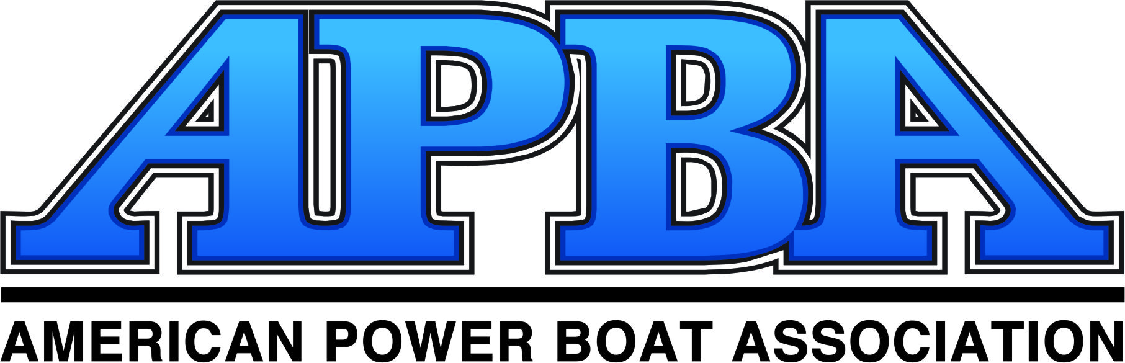

(CLUB OR EVENT LOGO HERE)

Confirmation/Host Site Agreement

2018 APBA Inboard Hydrofest

City, State July 00-00, 2018

I. Services Provided for Event
- Provide a two-day, Inboard Hydroplane racing event professionally run and specifically designed to entertain an audience for five to six hours each day;
- Provide all necessary equipment for race: clock, computer, printer, buoys, public address system, buoys, flags, stop watches, tents; tables, chairs; air compressor, pit passes, rope, supplies, etc.;
- Provide $10,000 minimum in tow money/cash awards and oversee the distribution of the funds to event participants;
- Provide a minimum of 15 qualified officials to run each event from the pit area to the race course from Thursday afternoon's on-site set-up through the end of Sunday's racing;
- Provide safety rescue boats and the safety rescue crew and divers to serve as event rescue;
- Supply gasoline and oil for officials' safety boats;
- Provide the scaffolding and stage equipment;
- Prepare all the necessary insurance and official paperwork;
- Provide all rules and regulations for event and the administering of those rules and enforce adherence to safety and insurance requirements;
- Provide press releases and photos for local and national media;
- Provide posters for distribution to local media;
- Develop unique logo for the host sites event;
- Follow a pre-approved racing schedule, which has been tentatively set as follows:

THURSDAY FRIDAY
12:00 noon-8:00 pm Site Setup 8:00 AM-7:00 pm Site Setup

SATURDAY SUNDAY
6:30-8:00 am Registration 7:00-8:00 am Registration
8:00 am Riders' Meeting 8:00 am Riders' Meeting
8:30-10:30 am Practice 8:30-10:00 am Practice
10:30 am - 1:00 pm Qualifying heats 10:00 am – 12:30 pm Heats
1:00 pm-2:00 pm Break 12:30 pm – 1:30 pm Break
2:00-5:00 pm Heats Continued 1:30 pm – 4:30 pm Final Heats
8:00 pm Racers' Party 5:00 pm Awards & Tear Down

Cost To Host Site For Event
Fee to be paid to the XYZ Club - $20,000
Additional Items to be furnished by Host Site:
- Two cranes from approved vendor to launch boats into the water;
- Ambulance Saturday and Sunday 8:00 AM-7:00 PM;
- Security- Friday and Saturday nights from 7:00 PM-6:00 AM;
- Lunches and Beverages for officials for Friday, Saturday, and Sunday;
- 60 cinder blocks (to anchor buoys);
- Pay for use of park or facility;
- Clean-up Fee (if applicable);
- Portable Bathrooms (if needed);
- Insurance for events not related to boat racing.

Payment Schedule
The host would be required to submit funds according to the following payment schedule:
- $5,000 due with signed letter of intent;
- $7,500 due 60 days prior to the event;
- $7,500 due 14 days prior to the event.

Cancellation\Refunds
The host site deposit is non-refundable in the event that the host site cancels the event for any reason beyond the control of the XYZ Club. If the XYZ Club is forced to cancel the event due to circumstances other than weather, a full refund will be awarded to the host site. If before the event, the host site cancels the event for any reason, 50% of the fee collected to date will be refunded to the host site.
In the event that the entire event is canceled due to weather or other circumstances beyond the control of the XYZ Club, 50% of the site fee will be refunded within 30 days following the event. If the XYZ Club runs part of its program before the event is canceled, the contract will be considered complete.

Sponsorship/Promotions
To fund the APBA Inboard Hydrofest, the XYZ Club and the host site work as partners on the event. The XYZ Club solicits national sponsors and boating companies to help support and fund the event. The host site normally solicits local sponsors to help support the event and help pay for the host site fee. The XYZ Club will provide photos and video footage and other promotional items to help the host site raise funds. The XYZ Club will produce posters for the event and include all local sponsors on the poster for each event.
The event host will be entitled to all promotional, sponsorship, and merchandising dollars it rises pertaining to the personal watercraft event, as well as all spectator and ancillary event gate fees, if applicable. The APBA is entitled to all series promotional, sponsorship, and merchandising dollars it raises, as well as the rider entry fees. The Host Site is entitled to name a Title and Presenting sponsor for the event.
The XYZ Club agrees to honor all event sponsorship commitments regarding signage, booth space, etc., that the host site makes pertaining to the Inboard Hydrofest, while the host site agrees to honor all commitments regarding booth space, signage, etc., made by the XYZ Club. Local sponsors’ names will also be mentioned in all press releases and other print media promotions related to the event.
The rights to the sale of soft goods merchandise pertaining specifically to the event is retained by the XYZ Club and the XYZ Club reserves the right to have the series' soft goods area at the event. It is understood that a copy of the insurance policy is available, upon request, and that also, upon request, the host site can name up to five additional insured on said policy.
For the XYZ Club:
Signed: _______________________________________________ Date:
Title:
For the Host City [Name Here]:
Signed: _______________________________________________ Date:
Title:

