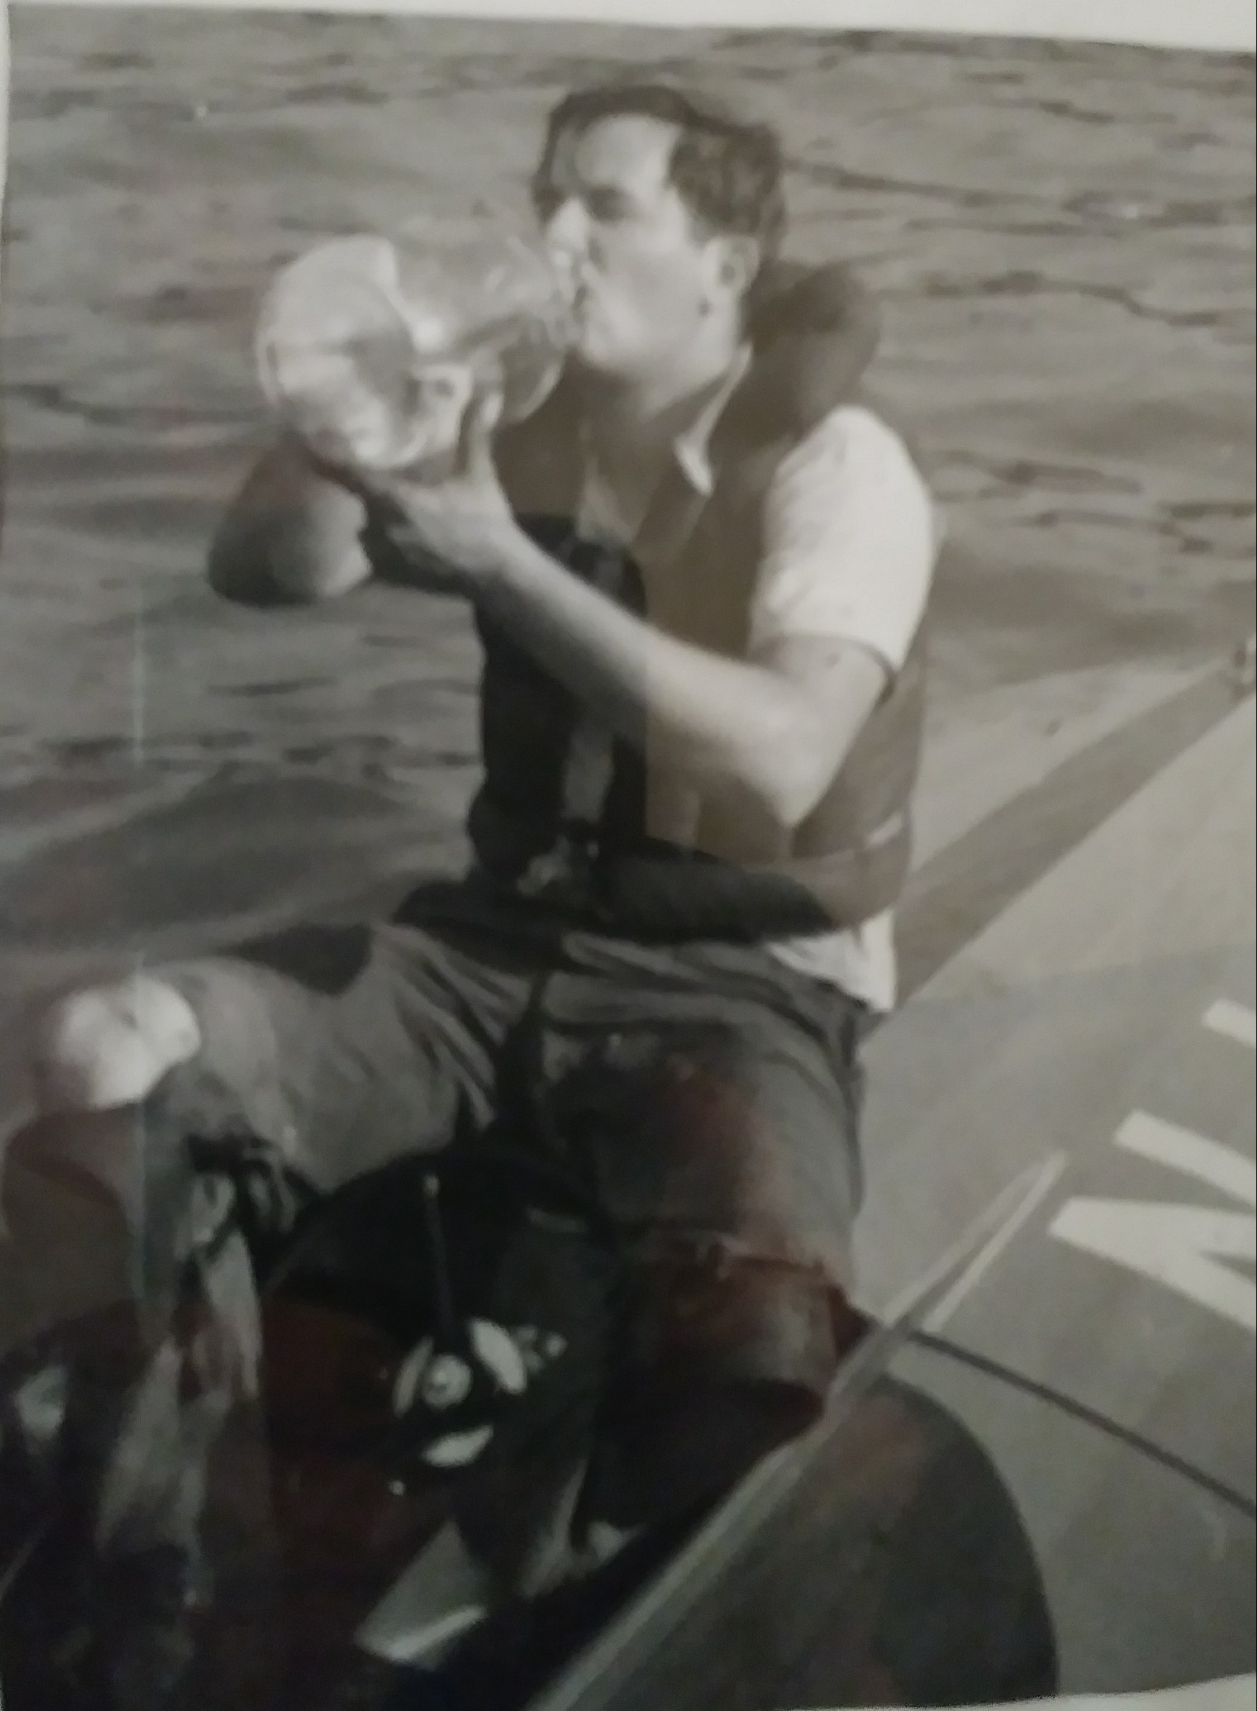  Charlie Strang refreshes between heats |  | 2018 Race Schedule  (Copy and paste your race dates)  (Text boxes are linked)  NEWBERG MEMORIAL  MAY 26-27  NEWBERG, OR  Point Lookout Regatta  JUNE 1-3  RIDGE, MD  QUAKE AT THE QUARRY I  JUNE 16-17  Lathrop, CA  Milton Three PONDS  JUNE 9-10  MILTON, NH  2018 PRO NATIONALS  JUNE 22-24  CONSTANTINE, MI  SO/MOD NATIONALS  JULY 17-21  MOSES LAKE, WA  TOP’O MICHIGAN MARATHON NATS  AUGUST 11-12  INDIAN RIVER, MI  DAYTON RECORDS RUN  AUGUST 24-25  DAYTON, OH  OPC NATIONALS  SEPTEMBER 1-2  SHREVEPORT, LA  INDIAN SUMMER REGATTA  SEPTEMBER 22-23  NICOLAUS, CA
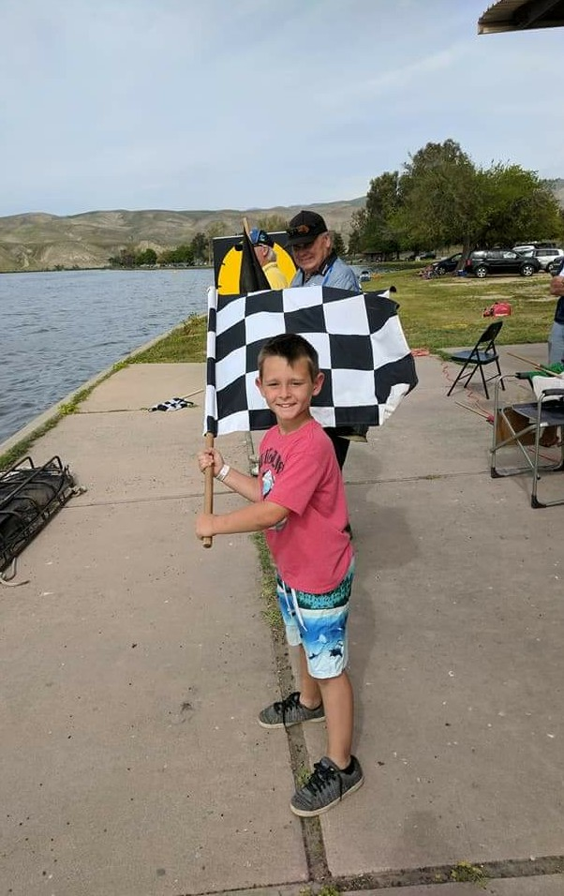  Racing is a family sport with classes for youngsters |  | Race Information  (Select and paste your copy)  (Text boxes are linked)  From the time your parents give you permission, until the day the doctor wouldn’t recommend it, the thrill and the excitement of power boating can be enjoyed. Whether you’ve been a life-long fan trying to get a feel for the adrenaline running through your body, or you’re trying to introduce your son or daughter to the sport, there’s everything far and in between in this octane-fueled pastime.  Experience, budget, or age are all mythical barriers of entry, for the sport offers everything for even the young and inexperienced. Whether you have all of the power boating experience in the world or none, there is a race category for you.  There’s no lack of options when racing with the American Power Boat Association (APBA). With nearly 100 different classes of racing across 13 categories, APBA offers the most diverse mix of power boat racing options in the United States.  The APBA sanction’s race events throughout the United States called regattas. Regattas are typically a weekend long series of different races with multiple categories and classes.  So, which category or class is right for you? Visit the APBA website: www.apba.org and select the New To Racing tab for additional information and contacts.

