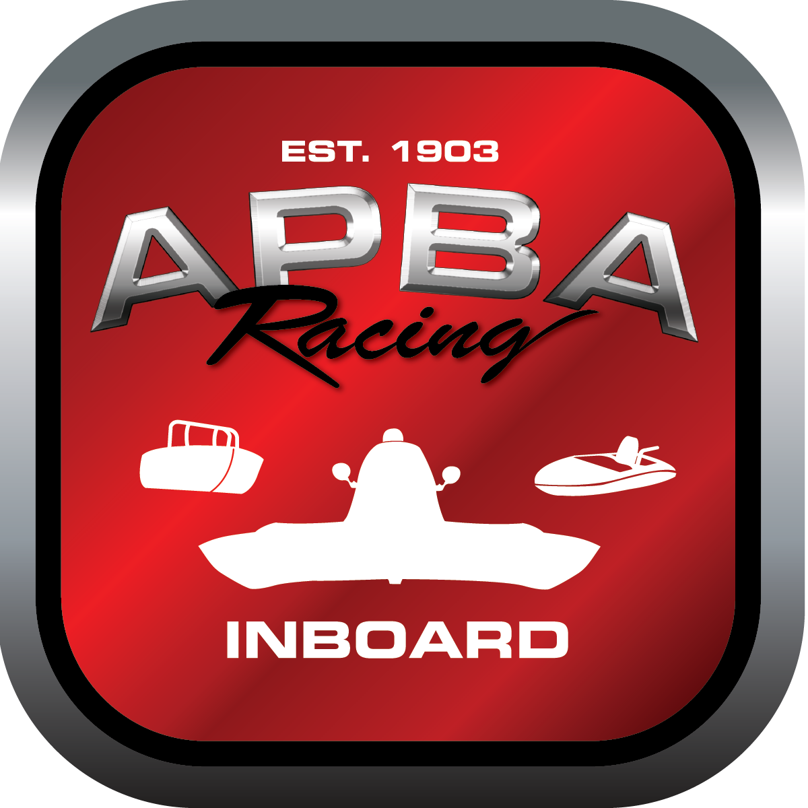
Office use only:
Control Number: T11
Assigned Group:
Initial Screening:
Ballot: Pass: ______/ Fail: _____
Effective for Race Year: 2019

2019 Inboard Rule Change Proposal

Name: Katelyn Shaw
APBA #: 70857
E-mail: t2racing@yahoo.com
Telephone: 2018418198
Date: Nov. 19, 2018

Note: Proposals must be submitted to the Inboard Office by December 1, 2018 to be considered.
Save and E-mail completed form to: inboardracing@apba.org or melildon@yahoo.com
US mail to APBA Inboard Office 8039 Stone Barn Dr, West Chester, Ohio 45069

Check all that apply:
General Safety Rule
General Racing Rule
Stock Class Technical Rule * x
Modified Class Technical Rule *

Affected Class(es): SE/SA

Specific Rule Information: [Note: All fields must be completed for consideration.]

Author’s VERY BRIEF Summary of Proposed Action:

Make stricter rules in regards to GPS units in flatbottom classes.

Affected Rule:
55.1.3 A GPS unit must be installed (out of the driver’s reach) before each run on the water (testing or racing). It will be the owner’s
responsibility to see that it happens. The GPS will be checked by the inspector of the event or his appointed representative. GPS
readings will be included on the summary sheets.
55.1.3.1- It is the responsibility of the owner to have a working GPS onboard their vessel. This GPS should be a Garmin etrex.
Submit other model numbers to the IRC for approval.
55.1.3.2- It will be the responsibility of the driver to show the inspector the GPS speeds after each heat. Failure to show a speed
will result in a disqualification

Proposed rule:
Change rule to:

55.1.3 A GPS unit must be installed (in a location approved by the inspector) by the inspector before each run on the water (testing or racing). It will be the owner’s responsibility to see that it happens. The GPS will be checked by the inspector of the event or his appointed representative. GPS readings will be included on the summary sheets. The inspector will be the last person to see the GPS before each heat and the first one to touch the unit when the boat returns to the dock. Failure to show speed, or to follow the rules will result in a disqualification.
55.1.3.1- It is the responsibility of the owner to have a working GPS onboard their vessel. This GPS must be a Garmin etrex.
55.1.3.2- All drivers must provide a working unit at the drivers meeting. Units will be placed into a bag and will be drawn at random for each driver.

Reason
This is a modification to the current GPS rule after a year of trial and error. It was noted by many that several people came in with the same speed several times and this would prevent the driver from being able to adjust the readings.

**Rule would be the same for SA class**

