SCOREM (Version 10) INSTRUCTION MANUAL
(for Outboard Racing)

By: Donna K. Roskowski, 2011

This instruction manual is intended to give the scorer an overview of the new versions of the scoring programs and a general “how to” manual to get going. SCOREMv10.1, 10.2, 10.3 and 10.4 are Microsoft Excel based outboard scoring programs for use on the race site. You will need a basic understanding of Microsoft Excel to operate these programs. Once you have a general understanding of how to use one version of the program, you will be able to easily work with the others. These programs generate roll call lists, lap sheets, results summaries and functions as a timer for the race. It’s really easy and will save you a lot of time. I recommend trying this out first in your living room, and not on the race course. The final chapter of this manual consists of a few scenarios for you to use to familiarize yourself with the program before race day.

The SCOREM program was written several years ago by Mia Camacho Fitzgerald. Since then, several additions and upgrades have been made. All four versions of SCOREMv10 are variants of the original program. In fact, SCOREMv10.2 is virtually identical, just with a few added features. I have spent a lot of time digging into this program. After figuring out what made it tick, I modified the program to work for me and the Indiana Outboard Association. (Yeah, we’re a MOD club, we modify things, go figure…) It has been used successfully by me at our races for over 5 years now, including two MOD Nationals and one MOD Divisionals. I learned a lot by making mistakes, and getting really mad at the computer. My intent is to provide enough information to give you some understanding of where the information comes from and why it works. Once you know that, if something gets entered wrong or deleted, and it will, you will know exactly where to go and how to fix it quickly. In this manual you will see a few things that are in bold type. They may be red or black and maybe underlined. These are important things that I cannot emphasize enough. I’ve learned these things the hard way and paying attention will save you a lot of heartburn later. So, with all of that being said, let’s get started………..

GETTING STARTED:
FIRST - PRINT THIS MANUAL. I know it kills a tree, but you’re going to need and want it. Trust me.
Download the SCOREMv10 programs from the APBA website www.apba-racing.com.
SCOREMv10.1 is a one day, two heat race workbook, no eliminations
SCOREMv10.2 is a two day, two heat race workbook, no eliminations
SCOREMv10.3 is a one day, three heat race workbook, no eliminations
SCOREMv10.4 is the elimination race workbook, one heat eliminations, one heat final.

You will probably want to also download the driver’s lists and the computer number list from the APBA website. They are found in the same place as the programs.

Open the program that you want to use in Microsoft Excel.
You will see a dialog box with the following or similar warning:

“Macros may contain viruses. It is always safe to disable macros, but if the macros are legitimate, you might lose some functionality.”

These programs contain macros to run the timer and will not function without them. You will need to click on “Enable Macros”. You may need to close and re-open the file to enable the macros.

Create a “Master” file folder and save clean copies of the programs on your computer. If you have a problem, you can always revert to a “clean” copy of the program.

Click “SAVE AS” and save a copy of the program with your race name and year. If you race in the same location more than once a year, make sure you have different names for each.
Example: “Huntington2010.xls”.

REALLY IMPORTANT!!!! Have your computer on and open to SCOREMv10.1 as you read this. You will understand it a lot more and have a better feel for it if you follow along and do it yourself. The more you use this program, the more comfortable you will be with it. READ THE ENTIRE MANUAL! You can stop at the SCARY STUFF at the end, if you want to. That part isn’t for the faint of heart or those what REALLY don’t want or have to know how it all works.
BEFORE STARTING:
You are going to want to have a printer available on the race site for printing roll call lists, lap sheets, etc. Which obviously means you will need a power source at registration and on the judge’s stand. You might be able to do registration using the battery on your computer, but I would not recommend it. I use the same generator power that is used for the clock during my races and I have never had a problem. CAUTION: Generator power is “dirty” power and you may risk your computer by using it. You may want a line filter or battery backup between your computer and the generator.

Have extra printer cartridges or toner on hand. I recommend at least one, maybe be two. I go through a black HP printer ink cartridge every race weekend and a color one about every three to five races or so. This includes printing post-race summaries, etc. I always print roll call sheets and lap sheets 95% of the time.

Protect your paper stash and keep it dry. Paper likes to suck up moisture. It does not take very much time at all for paper to get damp enough to cause a lot of problems. Wet paper will make printing difficult, if not impossible. Believe me I’ve tried it, and it’s not much fun. You may jam your printer and have wet little pieces of paper stuck in your printer in bad places. Depending on the printer that you have, your printer may generate enough heat to “dry” it during the printing process and you may see steam coming out of your printer. (Yes, that’s right – steam. Not smoke.) In any case, have some of the lap sheet pads from APBA on hand in case you can’t print lap sheets from the computer. I keep 8-10 of these pads on hand at all times, just in case.

IMPORTANT!!!! SAVE YOUR WORKBOOKS OFTEN!!! Saving after every heat is best. If you’ve done much work on the judge’s stand, you know that the generator WILL run out of gas at some point and all power stops. If you do not save your race data, you could lose it. It happens to the best of us, so don’t beat yourself up over it. All is not lost if you have your completed lap sheets and back up timers!!! Save yourself the aggravation and save often.

The next few pages contain screen shots of each of the four programs. These are the various working summary sheets that will be open while your race is going on. Each has its advantages. Most of the examples in this manual use the SCOREMv10.1 for demonstration. It’s a simple one day race, and is pretty simple. The others will be discussed later in the manual.
SCOREMv10.1 - one day, two heat racing
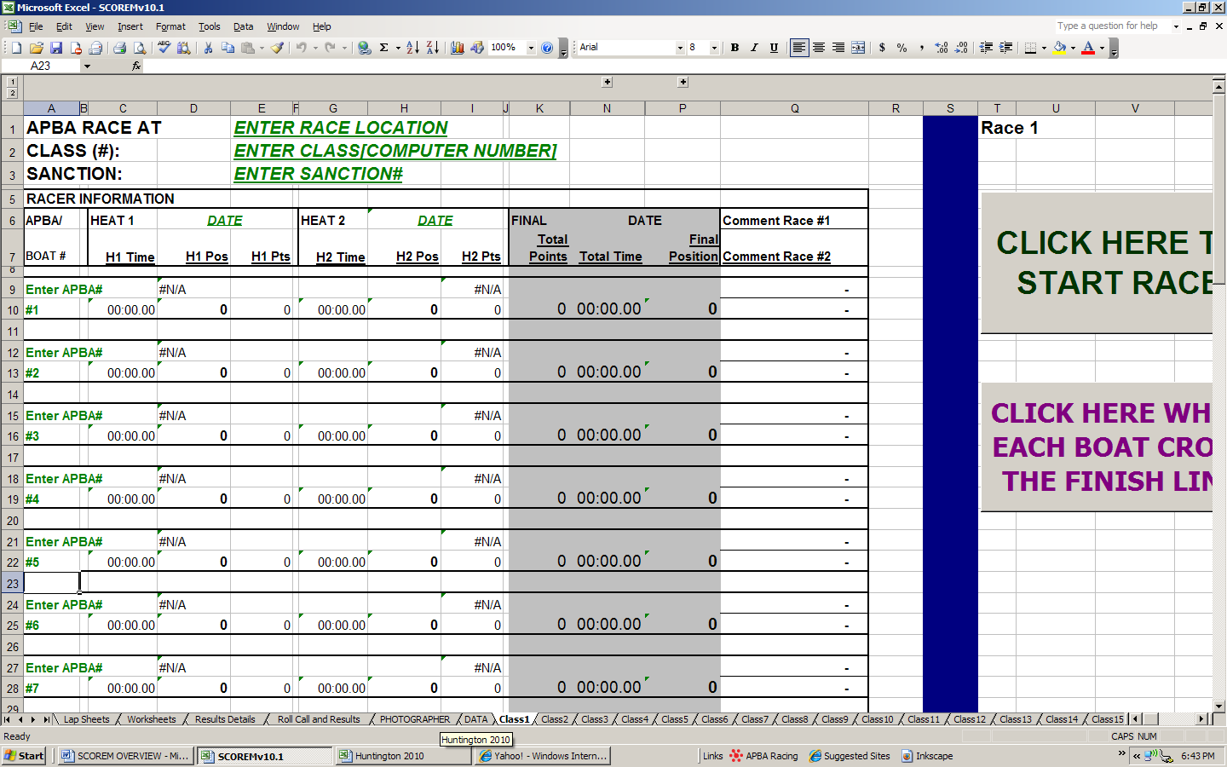SCOREMv10.2 – two day, two heat racing
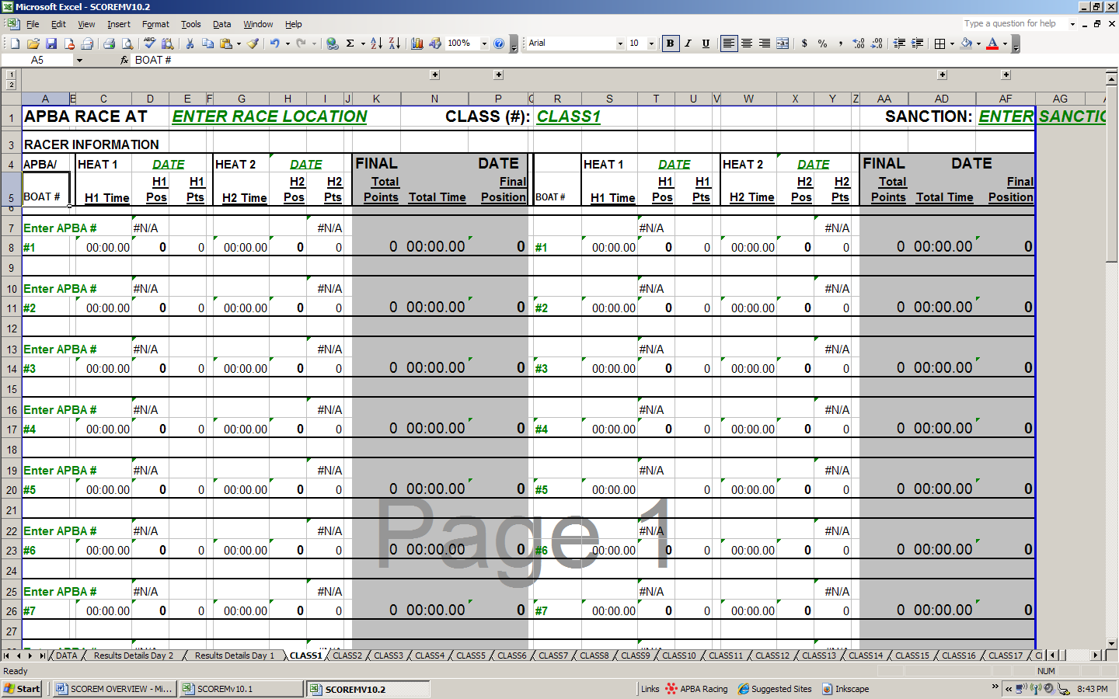

SCOREMV10.3 - one day, three heat racing
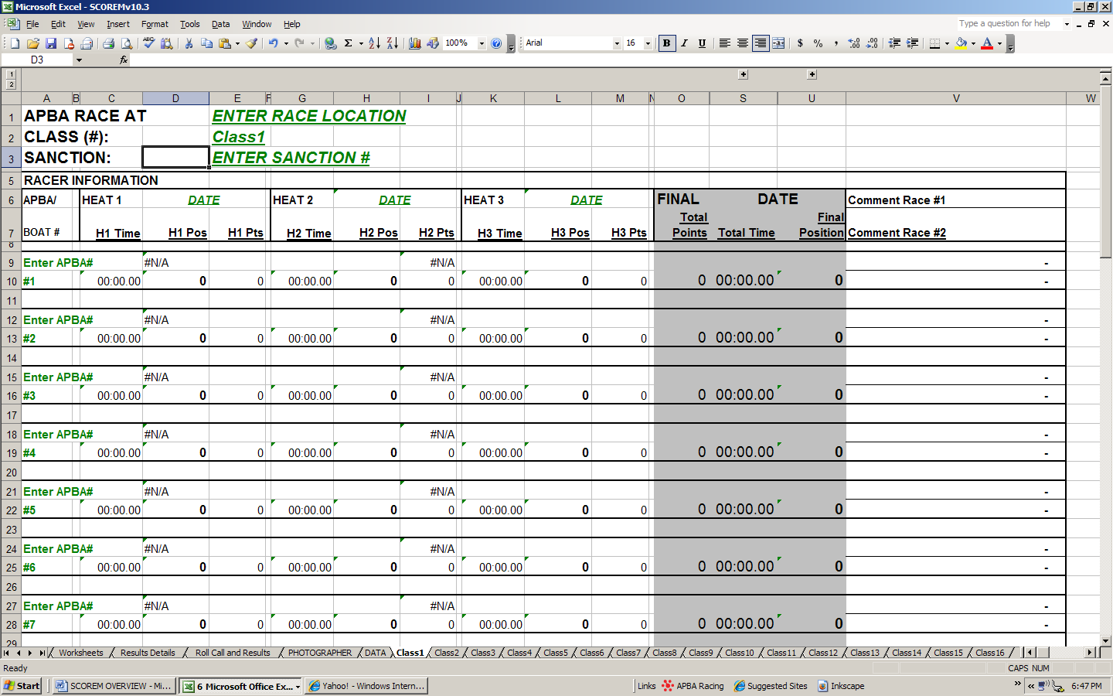
SCOREMV10.4 - one heat elims, one heat final elims races
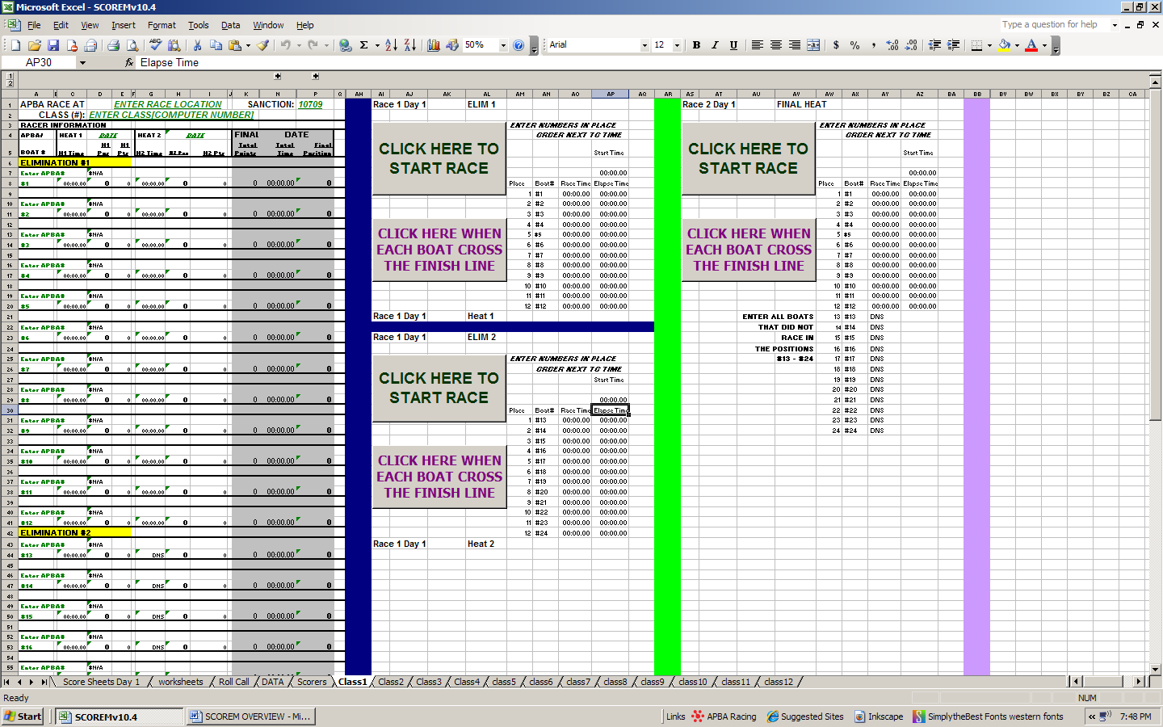
SET UP INSTRUCTIONS:
You will need to set up or customize your workbook for each of your races. It’s a bad idea to “clear” or “over-write” previously run race data. It can be done, but it is better to start with a “clean” file.

CLASS TABS/SUMMARY TAB:
Each class has its own tab, or summary. The first class tab, “Class1” contains set up information for the entire workbook. The race location, sanction number and dates entered on this tab will be automatically entered in all of the other class tabs, the roll call list, the results details tab, the lap sheets, etc. Shown here is SCOREMv10.1, the one day race.
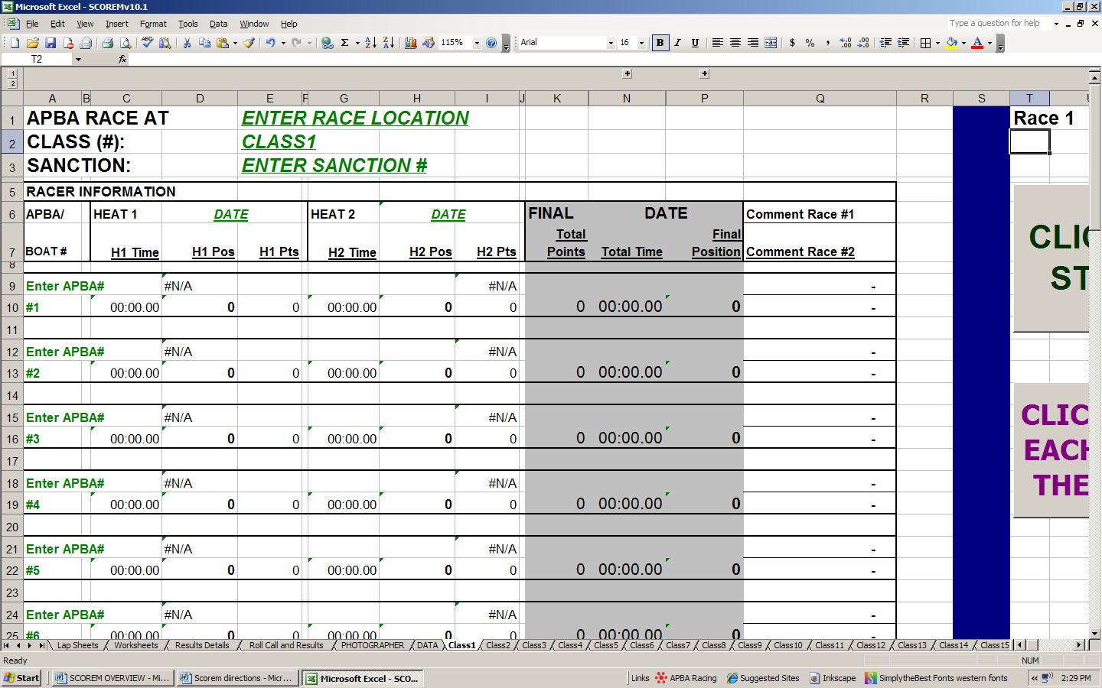
#2, #3, #4
#5
#1

- Double click on the “Class1” tab and rename it with the class name.
Example: 250MH.
2) Enter the Race Location in cell “E1”
3) Enter the Class in cell “E2”.
Example: 250ccMH (AMH) [05420]
If the race is a National, Divisional, NAC race, etc. there is enough room to type this after the class name.
4) Enter the sanction number in cell “E3”.
5) Enter the date in cell “D6”. The dates in “H6” and “N6” will automatically change. If something happens and the second heat is run on a different day, these can be manually changed. (See MANUAL ENTRIES)
CLASS/SUMMARY TAB (Cont’d):
6) Re-name the rest of the “Class” tabs with the appropriate class names. It helps to have the race schedule ahead of time and set this up before you set foot on the race site. Drivers really appreciate roll call in race order. The classes will appear on the roll call list in the order in which they are entered in the workbook. Depending on how you set up your workbook, this may not be in race order.

For example: Which ever class is entered in the “Class1” tab will be the first class on the roll call list as well. “Class2” is the second class on the roll call list, and so on. (SEE ROLL CALL TAB)

Inevitably, your race director is going to change the schedule a little. If you desire, you can re-arrange the order of the class tabs. You just need to click and hold on the CLASS tab name at the bottom, and drag it over so it is in whatever order you want. This will NOT change the order of roll call, etc. It will just make it easier for you to progress through your flights and not have to skip around looking for the correct class.

After the race, this is the tab that you will print out and mail into APBA along with the entry blanks and lap sheets. The tab is already set up to print, so all you have to do is hit the “print” button. You will need to open each class tab and print each class individually.
DATA TAB:
Click on the DATA tab. This is where the drivers’ names and APBA numbers are stored in the computer program. 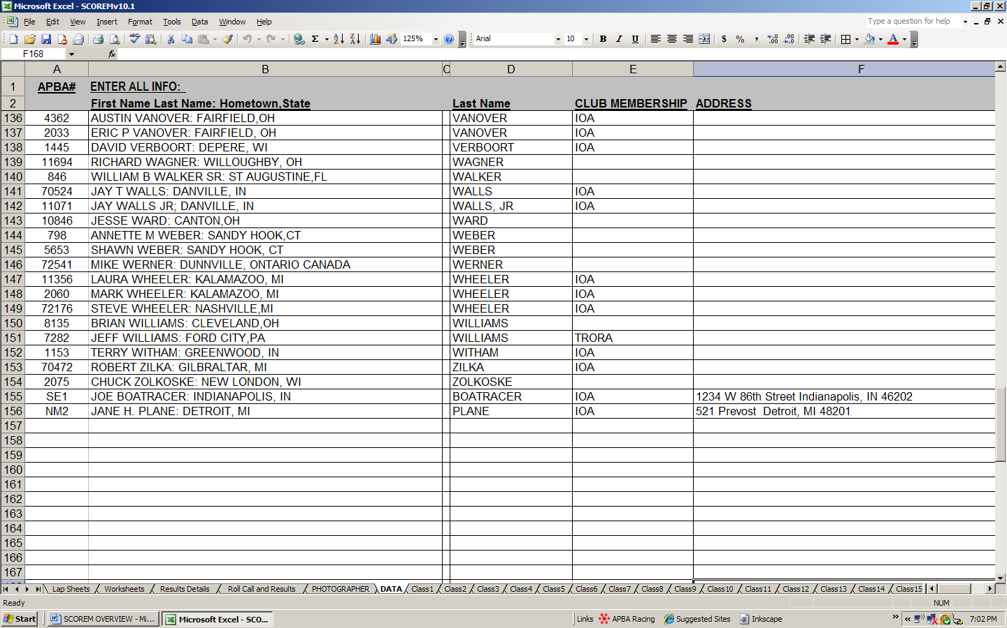

All of the driver information used in this program is pulled from this tab. APBA #’s, driver’s name and hometown and State are required. Driver’s club information and mailing addresses are optional.

Data lists are available from the APBA website. It is recommended that you download the list at the beginning of the race season. You will have to add some driver’s info because not all drivers make it on the list by the time the list is generated. You will spend a lot of time at your first race or two entering drivers onto the list. Your updated DATA list can be copied and pasted into the program file for your next race. It is advisable to start with the APBA list, and then maintain your own list after that. (I use my list from the previous year, since it has most, if not all, of my club members in it already.)

ADDING TO THE LIST: If a driver’s information is not on the DATA tab list, it is easy to add them. Scroll down to the bottom of the list, and add the APBA# in column A, the “driver’s name: hometown, state” in column B, Last name in column D, at a minimum. Club information and mailing addresses are entered in columns E and F, respectively.

DATA TAB (Cont’d):
ADDING SINGLE EVENT AND NEW MEMBERS: Enter “SE1” in place of the APBA# for the first single event member, “SE2” for the second, and so on. Enter “NM1” in place of the APBA# for the first new member, “NM2” for the second, and so on. Add the remainder of the driver’s info in the appropriate columns. (See red circle on the previous page on the left). Mark these on the Registration form so you’ll be able to keep track later.

***HELPFUL HINT: If you have multiple workbooks in use during a race, it save a LOT of time if you “copy” and “paste” your newly added drivers into all of the workbooks that you are using for the race. That way you do not have to type the same driver’s info in more than once.

CAUTION: APBA does recycle APBA#’s from time to time. If a number hasn’t been used for awhile, they may re-issue it to another driver. Using really old driver lists could become a problem. The formulas in the CLASS tabs tell the computer to look for the driver number on the DATA tab and place the driver info that is next to that number in a certain place on the CLASS tab. The computer stops looking after it finds the APBA# the first time, even though that APBA# may be on the list more than once. It assumes there are not duplicates, and there should not be. You will know if/when this happens because another drivers name will show up on CLASS tab when you type in the APBA#. You will then need to locate the APBA # or number(s) on the DATA list, delete the old driver info, and add the new info onto the list.
REGISTRATION:
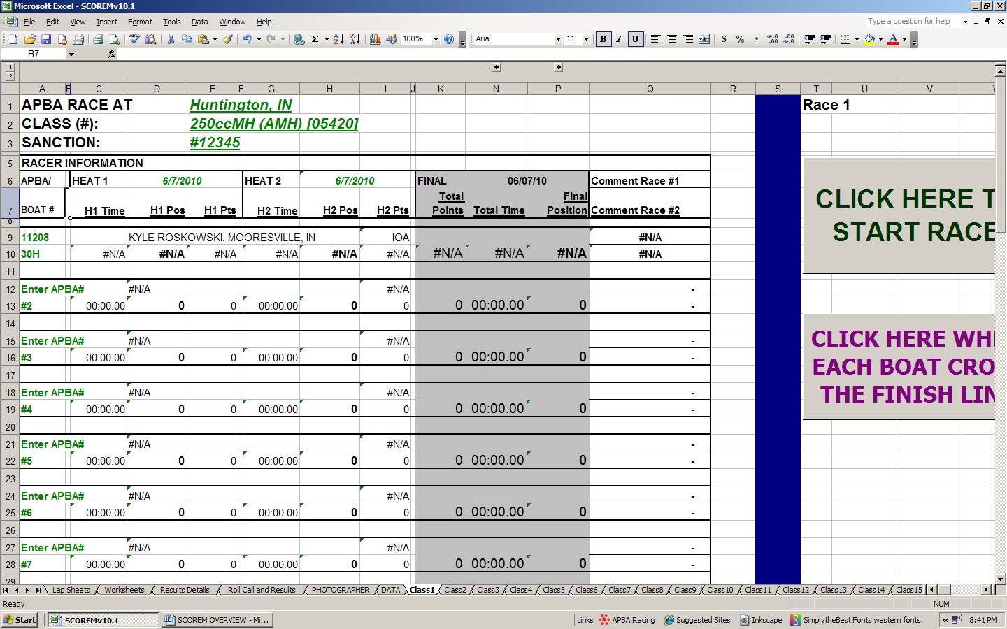

Click on the cell that says “ENTER APBA#” and enter the Driver’s APBA#. The drivers name and hometown should automatically pop up on the sheet. If the club info is used, it will show up in cell “I9”. If the driver’s info does not show up, go to the DATA TAB and add it in (SEE DATA TAB). This workbook can handle up to 12 boats, numbered #1 - #12. (SCOREMv10.4 can handle 24 boats, 12 in each elimination heat) Enter the boat number in the cell below the drivers APBA#. Repeat this for each driver registered in the class.

This can be done as each driver registers, or by class after registration closes. I have done it both ways. For larger class that may have eliminations, you might want to wait and do it by class and use the elimination workbook (SCOREMv10.4) if you need it. I find that it goes faster if done by class. It cuts down on errors (like putting a driver in the wrong class).

You will notice that some of the other cells have changed and now have “#N/A” in them. This is the program getting ready for the race, but also can be an indicator of a problem later. (See SUMMARY SHEET TROUBLESHOOTING). At this point, the program is looking for the race timing info and results which don’t exist yet since you’re just at registration.

REGISTRATION (CONT’D):
MAKE SURE YOU SAVE YOUR WORK AFTER REGISTRATION!!!! You will want to print the ROLL CALL list for the drivers meeting about this time. Also after drivers meeting, save any changes made to the race info on the CLASS/SUMARY TABS. I would recommend waiting to print lap sheets until after drivers have made their boat number changes and you’re sure you have everyone in the correct class. I also recommend printing one full set of lap sheets at a time.

ROLL CALL AND RACE RESULTS:
Once registration is complete, this sheet will be automatically generated for each class. The information on this sheet is pulled directly from the CLASS tab. If anything is missing or incorrect, return to the CLASS tab and correct it. Print this for the driver’s meeting. Note any changes made during roll call. Inevitably, someone will make a boat number or other change even though they just registered. After the meeting, make the changes on the CLASS tabs, and then print the lap sheets.

*****Before the race, print an extra copy of the roll call sheet for the announcer. It’s a nice list for them to know who’s who on the race course.
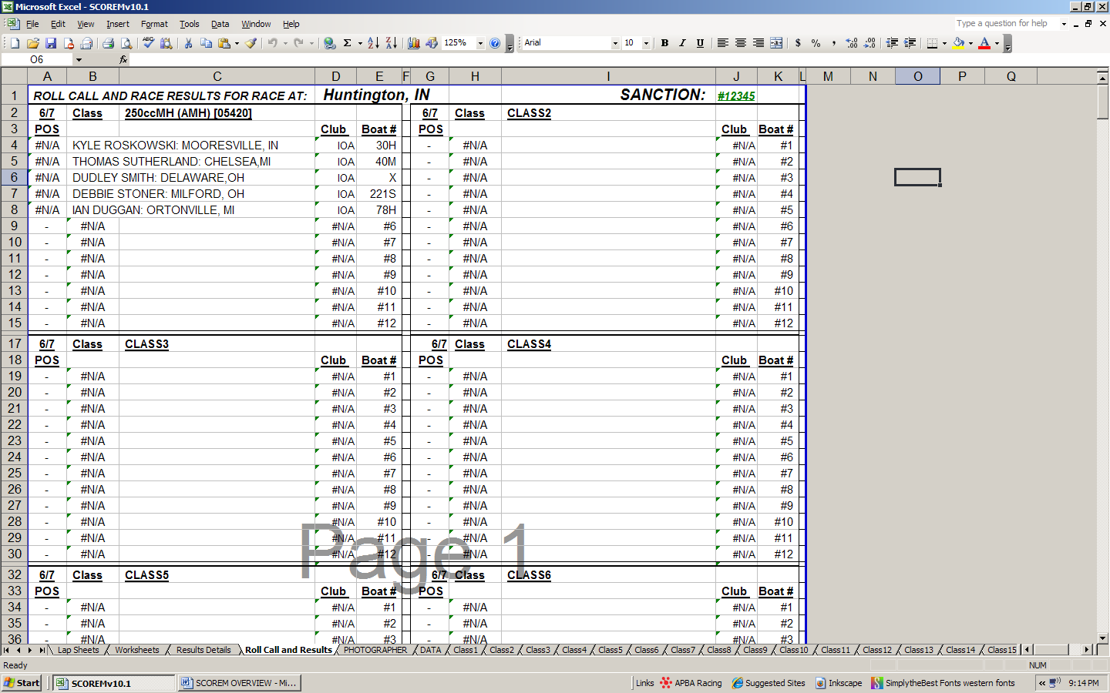

After the race, this sheet will have the final positions listed. This can be given to the media or posted, if desired.
LAP SHEETS:
The lap sheets are populated from the registration information contained in the CLASS tab. The driver's information and boat numbers are automatically printed on the bottom of the sheet. Like the ROLL CALL list, any missing or incorrect information, can be corrected on the CLASS tab.

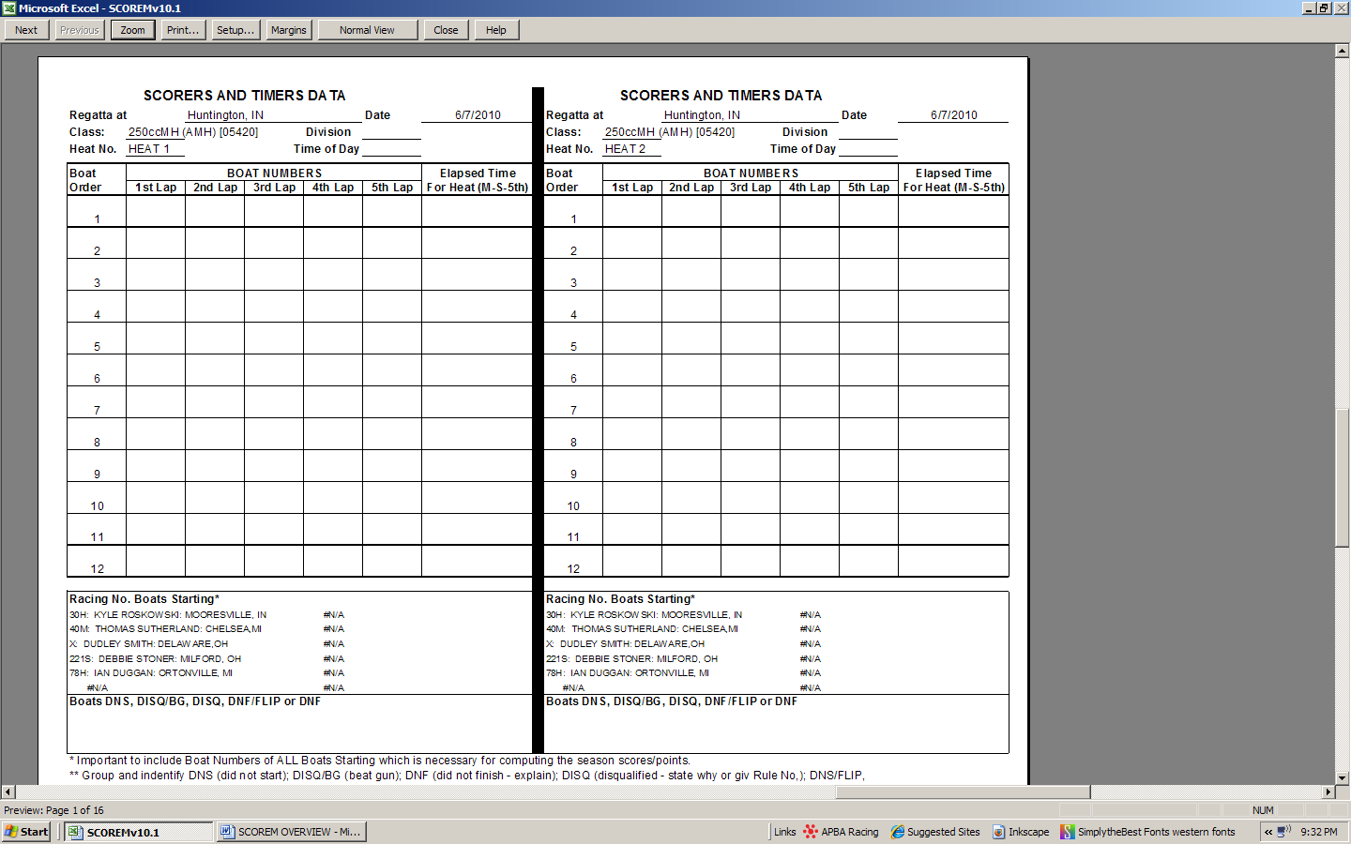
WORKSHEETS:
Worksheets are pre-filled out by the computer with the race location, class, driver’s name and boat number, if you want to use them. These really are not necessary when using the SCOREM programs. They are intended to help train new scorers manually or as a paper back up. If you are using the computer to do all the paperwork and don’t want to use the timer function, this will save you a bunch of time. Like the lap sheets and the roll call list, the information on this sheet is pulled from the CLASS tab.

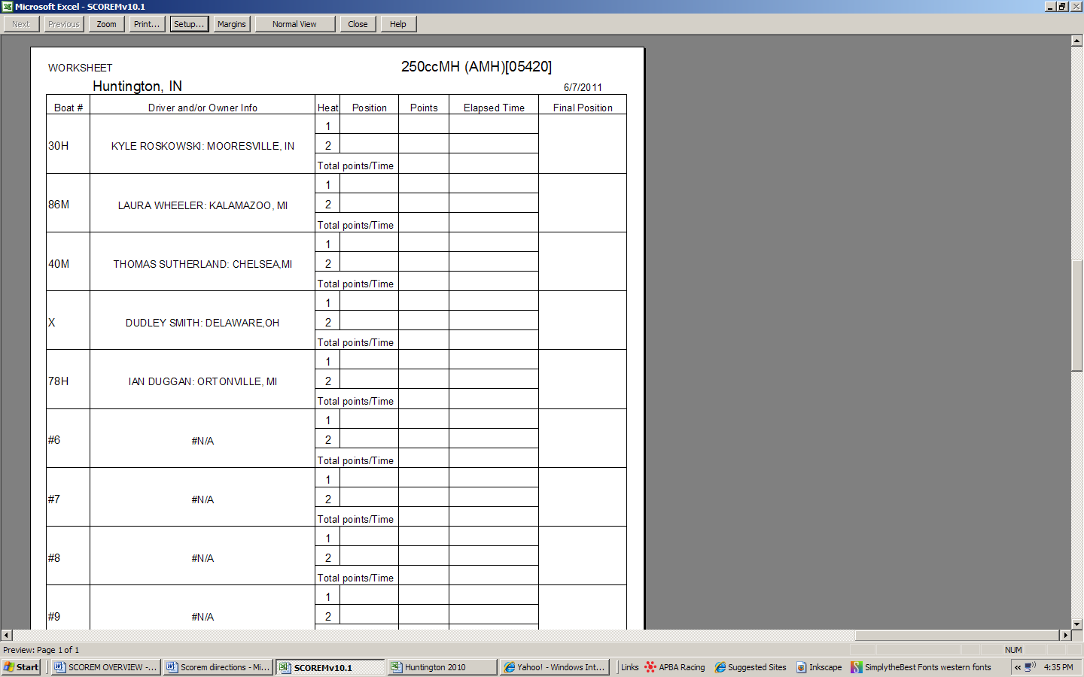

TO TIME THE RACE:
On the CLASS tab, scroll over to the right using the scroll bar. You will see the timers (pictured below). To start the heat, click on the gray box when the clock hits zero.
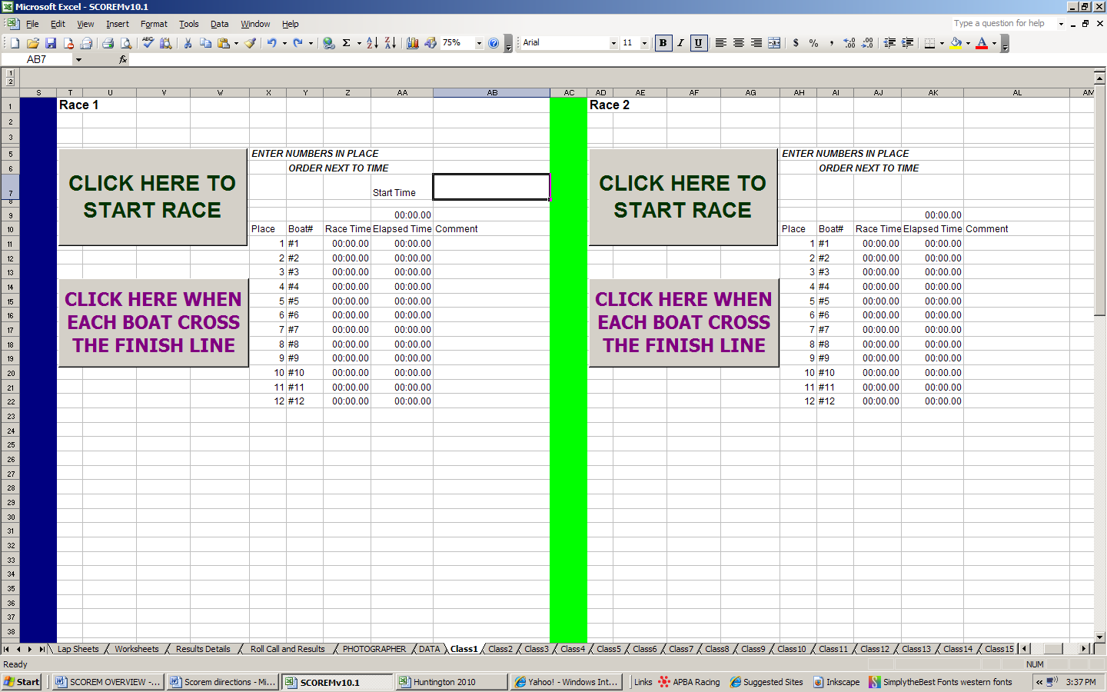
Scroll bar

Move the cursor down to the next box “CLICK HERE WHEN EACH BOAT CROSSES THE FINISH LINE”. As each boat finishes, click this button. It is fairly sensitive and can go as fast as you can. It’s similar to your handheld timer - it may take a second for the times to appear. Repeat on the second timer for the next heat.
**Always use at least one backup timer.

If/when you make a mistake, or miss timing a boat, the times can be manually entered in using the times from the backup timer.

The format for the timer is “00:00.00”. This is critical. It must be typed as: Minutes, colon, seconds, period, milliseconds.
AFTER THE HEAT IS OVER (Timer Continued):
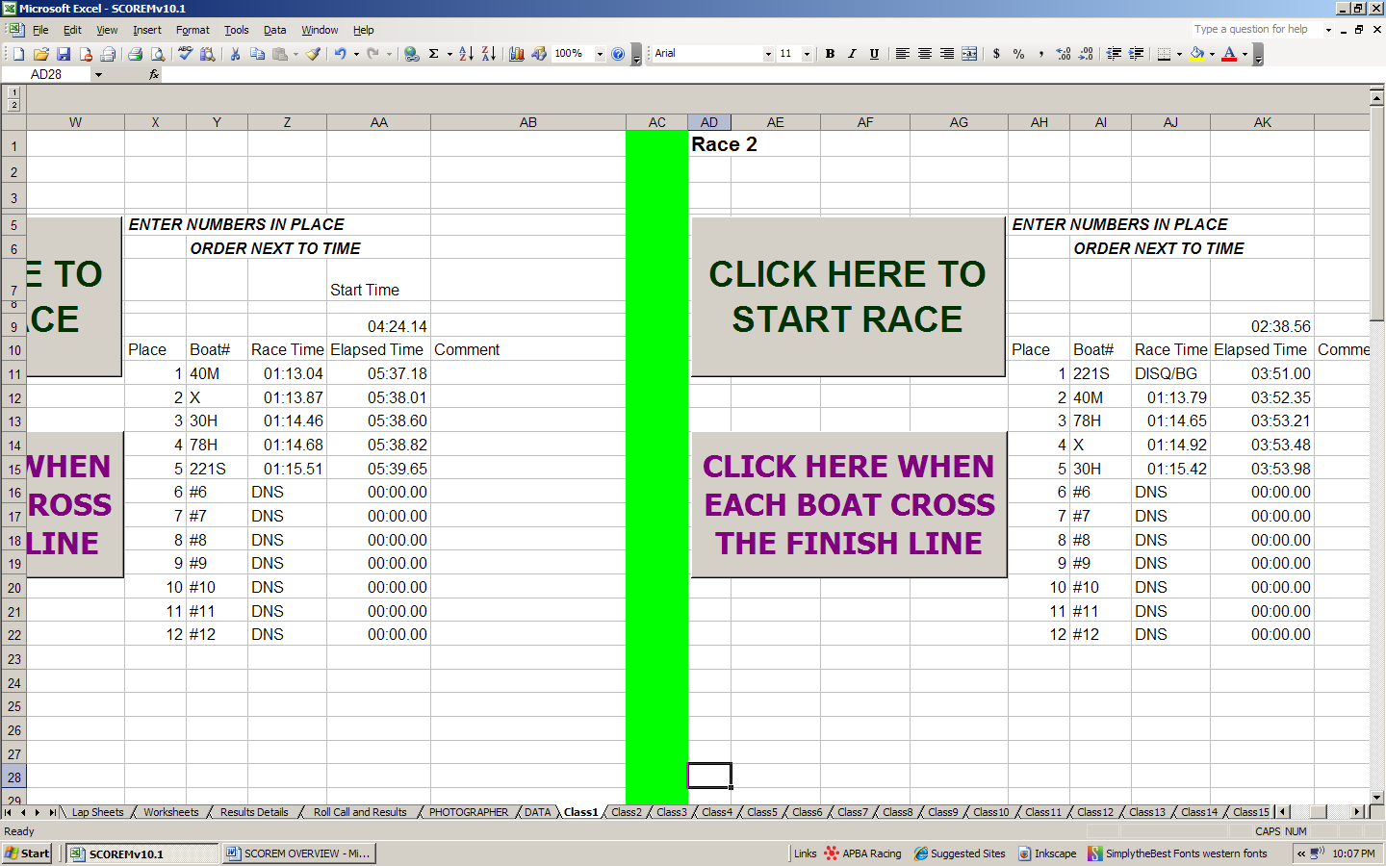

- Enter ALL boats in the order of finish, regardless of their legality.
- Then, enter any disqualifications (DISQ), gun jumpers (DISQ/BG), flipped boats (DNF/FLIP), and any boats that did not start (DNS) or finish (DNF) in the Race Time cell next to the appropriate boat number.
- The comment field on the right of the timer is for brief comments related to the DISQ – examples weight, inspection, hit buoy, etc. This also may be helpful to note the time a driver went in the water in this space.
This will appear on the race summary in the comment column. Empty cells below the timer can be used for additional race comments, but those will NOT appear on the race summary.

All boats and positions must be accounted for in the timer results for positions 1-12, even if there are less than 12 boats racing. In this example, Empty positions #6-#12 are still considered “boats” for the program to work. In the above example, all boats were legal in heat 1. In the second heat, boat 221S has jumped the gun. Since only 5 boats were racing, positions #6-12 are recorded as “DNS”. This can be particularly tricky in the eliminations workbook, SCOREMv10.4, where the empty positions are not necessarily sequentially numbered.

RACE SUMMARY:
The completed one day race summary appears as follows:
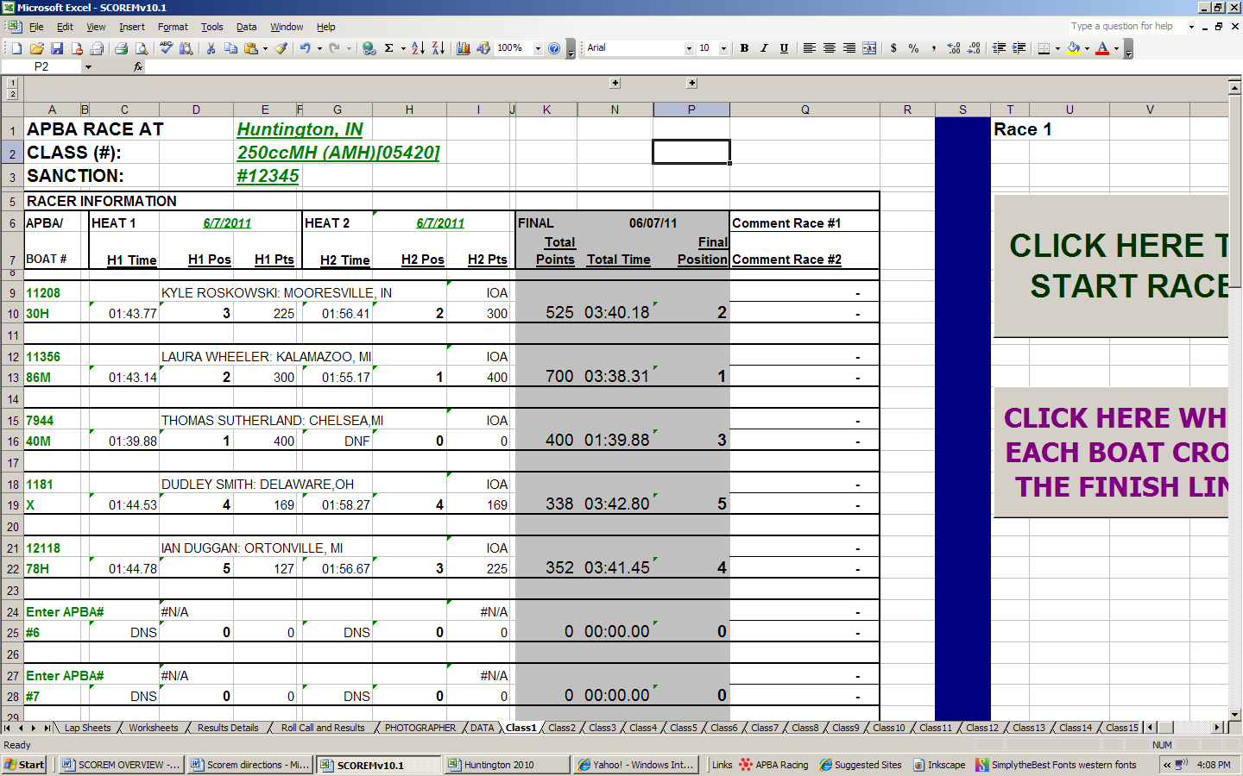

As you can see, the times, etc., are pulled from the timer cells and automatically entered into the cells of the appropriate driver. Places and points are automatically figured and added. The total times are added and a final position is awarded for each boat/driver. (SEE TROUBLESHOOTING: BREAKING A TIE)

IMPORTANT: The sheet populates because the computer looks for the BOAT NUMBER in the timer cells and places the times associated with that number in the appropriate cells. If the boat numbers in the summary and the timer cells do not match, you will get an error (“#N/A”) (SEE ERROR MESSAGES). Simply check the boat numbers in column A with the boat numbers in the timer cells in columns “A” and “AY” and correct the error, where ever it occurs. This includes boats for all 12 positions in the race summary. This is the MOST COMMON PROBLEM. It’s easy to fix!!!

The next common problem is not accounting for ALL of the boats and positions. Remember “boats” #6-12? This is more common in the elims tab workbook (SCOREMv10.4) where the “boats” and positions are not all sequentially numbered positions and will include the boat numbers of those that were eliminated in the first heats.

RACE SUMMARY (CONT’D):
Check to make sure that your race data makes sense after every heat.
- Do you have positions 1, 2, 3, etc? Any ties?
- Do all of the points make sense? 400 for first place, etc.
- Do all of the boats have times?

SCORER SIGNATURE:
The new SCOREM programs have an automatic signature, if you want to use it. There is a SCORERS tab where you will need to enter your APBA # and name. The bottom of each summary has a signature line and a place for the scorer’s APBA#. Then when you type your APBA number in the specified cell on the first CLASS tab, your name should appear on the Chief Scorer signature line. The remaining CLASS summaries will automatically print your name on the bottom. If there are multiple scorers, this will still work. Each scorer will have to type their APBA# in on the class tabs that they scored and their name should print on the signature line.

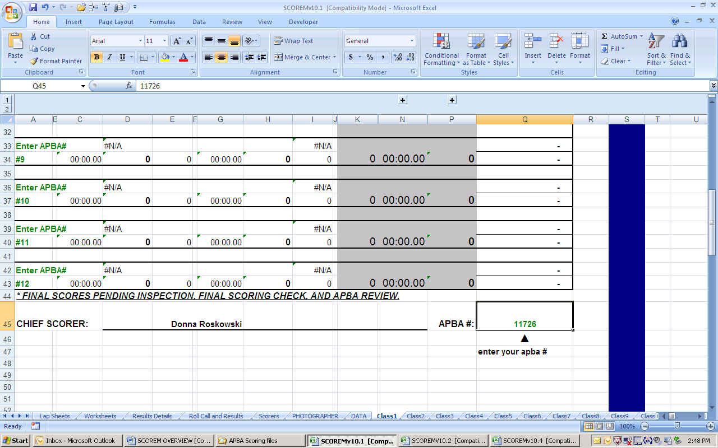
RESULTS DETAILS:
This is intended for posting at the race site between flights or after the race. It’s nice to have at Nationals.
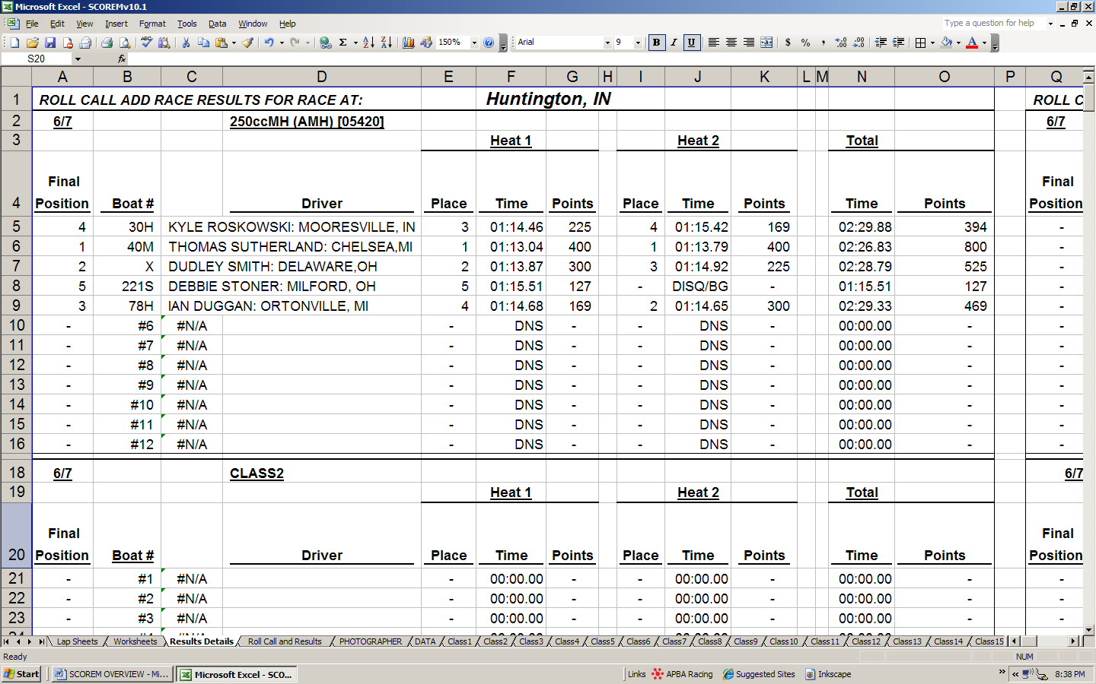

PHOTOGRAPHER TAB:
This is intended to provide mailing addresses for the club photographer, if desired, and not for public dissemination. You will need to add the addresses into the DATA tab for this to work.
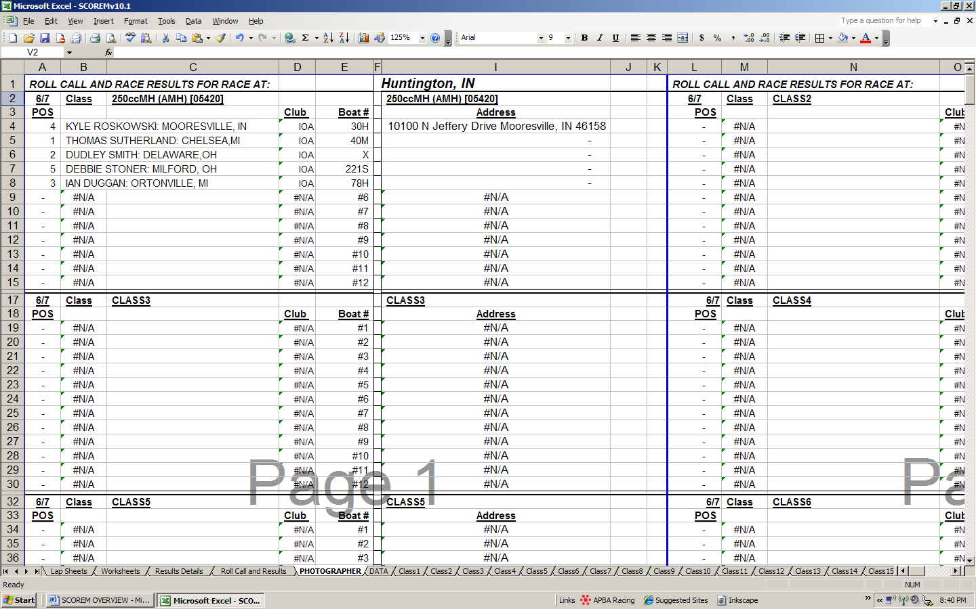
AFTER THE RACE:
- Just like any race, you need to check your summaries.
  - Check the Race Location, Sanction numbers and dates for correctness.
  - Make sure the class name and class computer numbers are on the summaries. The computer number list is on the APBA website with the scoring programs, etc.
  - Verify times and places for correctness. (See ERROR MESSAGES)
  - Print each summary. You will need to click on each CLASS tab and print each summary individually. Each CLASS tab should already be set up so that you only have to hit the print button. If you re-size cells, you will alter the print format. You might want to do a “Print preview” first and make sure everything is on the same page.
  - Sign each summary at the bottom. This can be done electronically or manually. (See SCORER SIGNATURE SETUP)
  - Organize the entry blanks in the same order that is on the summary sheet.
  - Assemble the paperwork in a stack with the summary sheet on top, next the entry blanks, and the lap sheets on the bottom, for each class.

TROUBLESHOOTING:

BREAKING TIES:
The computer program will not break a tie. It will give both boats the same position, and skip the next position before continuing. YOU will need to break the tie manually by changing the position of the slowest boat. In the event that you need to recalculate positions, or re-do the summary, after breaking a tie, you will need to restore the formula in the cells where the final positions are calculated (SEE MANUAL ENTRIES). Examples are after inspection, the final positions may change due to disqualifications.

ERROR MESSAGES:
You will see “#N/A” and/or “#VALUE!” in cells that do not populate correctly on the summary sheets, lap sheets, roll call lists, results details sheets and photographer sheets. This is an indication that something isn’t right in the locations where the information is pulled from. Once you check the places where the information comes from and fix the problem, the sheets will populate correctly. There are no error messages that will appear in the timer clocks on the CLASS tabs (SEE AFTER THE RACE). If information is missing, you may see these same error messages, or the information is just not available. (See MISSING INFORMATION)
“#N/A” usually means that the computer did not find what it was looking for.
“#Value!” means that a wrong format was used. This is most commonly found when manual times are entered into the timer blocks or a disqualification code is misspelled. You may have used a comma in the time format, instead of the colon.

Keep in mind that the spaces are characters to a computer. You may not see a mismatch because of an extra space somewhere. It’s usually right before or after a boat number either in the timer cells or in the boat number that you entered at registration. Just remove the extra space.

FORMULAS:
Many of the cells in this program contain formulas that make the time, place and point calculations. These formulas are just simple mathematics or references to other information and/or combinations of information. Some formulas require certain entries have certain information or information in a particular format. Formulas can be restored by copying a cell that does the same function and pasting into the cell where it needs to work. For an example, see TIMER TROUBLESHOOTING. Manual entries always delete formulas. The good news is that the computer will let you know that something is wrong by giving an error message – “#N/A” or “#VALUE”. (See also ERROR MESSAGES and MISSING INFORMATION)

MANUAL ENTRIES:
You will need to enter disqualification info on the timer tab, and break ties manually (SEE BREAKING TIES). Any time a manual entry is made, it will delete the formulas in a particular cell in the program. If you make a mistake or have to change the final positions, do not panic. This information is easily recoverable!!! The formula just needs to be restored by copying a formula from a cell that contains the same type of information and pasting it into the cell that does not work.

MISSING INFORMATION:
If the drivers APBA# and info is not on the DATA tab, the role call sheets, summaries, lap sheets, etc. will not populate. You will see “#N/A” where this information is supposed to be. This is an indicator that information is missing. Simply add the information on the tab, and everything will be fine! Even if the race has already been run, this info can be fixed or changed if it’s wrong. APBA does re-use numbers every so often, so make sure you aren’t using a really old DATA list. You’ll know if this happens, because the wrong driver’s name will show up. Simply locate the APBA# on the list, and delete the old info, if this were to happen.

SUMMARY TROUBLESHOOTING:
The boat numbers are important to the population of the summary sheet. Duplicate boat numbers or errors in the boat number will cause the sheet to function incorrectly.
For example, you can’t have two boats with “X” on them. One of the drivers is going to have to be “X1” or “1X”.

All boats and positions, #’s 1-12, have to be accounted for in the final summary. (See AFTER THE HEAT IS OVER (Timer Continued)). Once this information is entered, the computer will assign positions and points. The registration information is used to generate the race paperwork including the ROLL CALL AND RESULTS list, the scorer’s WORKSHEETS, and the LAP SHEETS.

Example: The below listed summary has some issues. Notice there are lots of areas that did not populate (not all are circled).
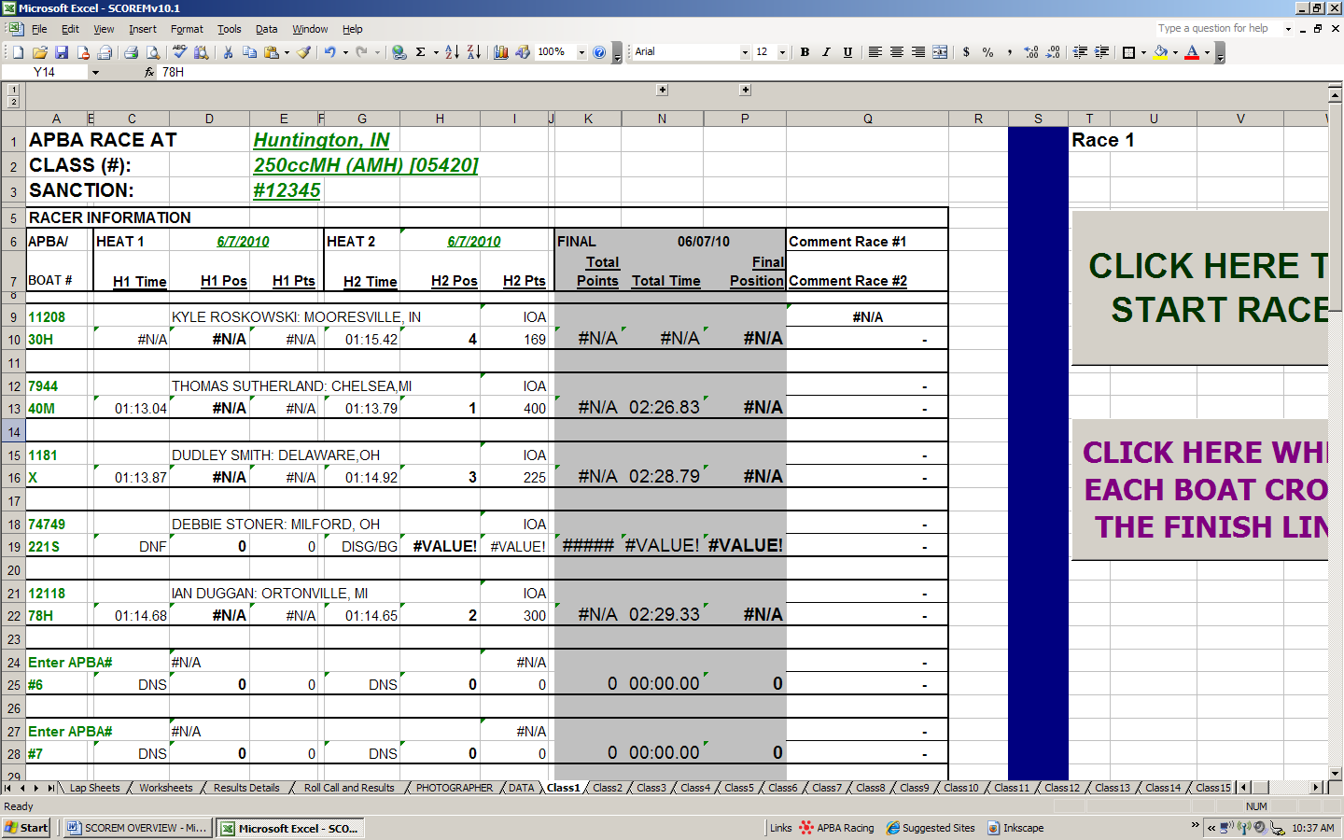

First - Scroll over to the TIMER cells and check the boat numbers in heat 1. Make sure that ALL boats are accounted for and the boat numbers and letters are correct.

This is the most common error. Remember, the boat number is the key to the summary. If the boat number is wrong, or transposed, or has extra spaces, it won’t work. It also looks for ALL of the boat numbers and positions that are listed on the summary. If all boats and positions are not accounted for in the timer section, the sheet will not work right. Each summary has 12 boats and/or positions that the computer is looking for. (Scoremv10.4 has 24 boats)

SUMMARY TROUBLESHOOTING (CONT’D):
Next, check and make sure the disqualifications, etc. are correct. The program looks for specific things in order to work. “DNF”, “DNS”, DISQ”, “DISQ/BG”, “TNT” and “DNF/FLIP” are the only combinations that work. In this example, the computer does not recognize “DISG/BG” because it is looking for “DISQ/BG”. One wrong letter makes a big difference.

These are the timers for the example on the previous page. Note there is an incorrect boat number in the first heat, AND a typo in the second heat.
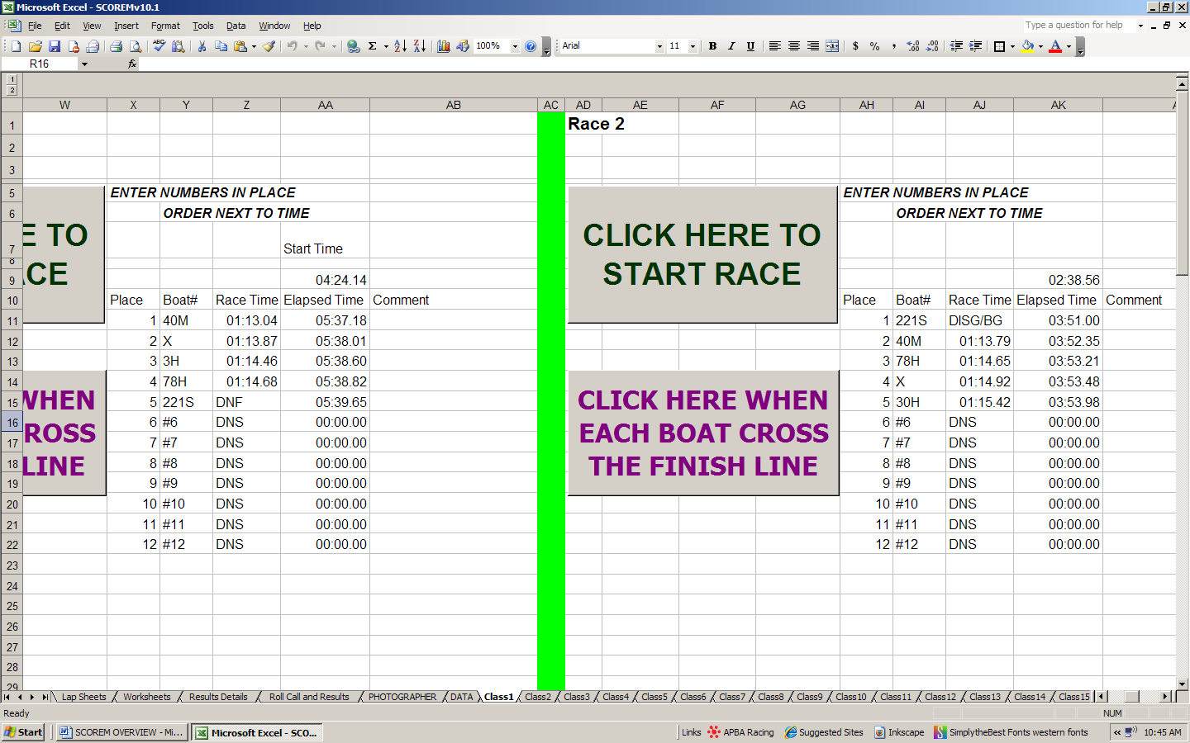
Wrong boat # - should be “30H” not “3H”.
There is a typo – should be “DISQ/BG”, not DISG/BG.

Once you correct an error, the summary should correct itself. If the summary still doesn’t look right, you have other errors to look for.

Keep in mind that any time you enter a DISQ in the timer blocks, you delete the formula that was in that cell. (See Trouble shooting: MANUAL ENTRIES, FORMULAS) You may need to restore the formula to make a correction.

SUMMARY TROUBLESHOOTING (CONT’D):
Just correct those two simple things, and the summary is as it should be.
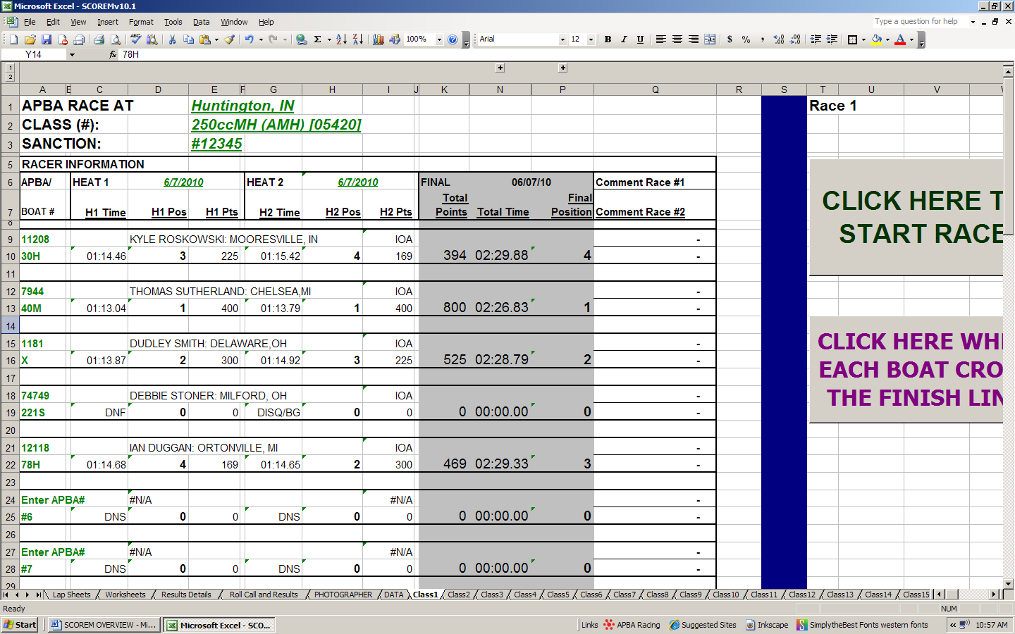

TIMER TROUBLESHOOTING:
The times listed under the cells “Start Time” and “Elapsed Time” are recorded times. (It’s a stopwatch) All of the times recorded in the cells listed below “Race Time” are formulas. Basically what it’s doing is calculating the difference between the start time in cell AA9 and the time the button was pushed at the finish for each boat. As long as you do not mess with these recorded times, you will be fine. But if you do, all is not lost. Just enter the times from the backup timer in the “Race Time” column for each boat.

***If you use the back up timer for one boat, you should use the back up timer for ALL of the boats in that heat. Don’t forget the time format “00:00.00”!!

If you decide to navigate to other workbooks or do anything else on the computer while the race timer is running, you will need to “remind” the computer what it is doing when you go back to the timer. The computer “forgets” what it is doing and where it needs to resume timing. You could wipe out some of your race data doing this, and I REALLY don’t recommend it. (I don’t even do it. It makes me too nervous.)

TIMER FORMULAS:
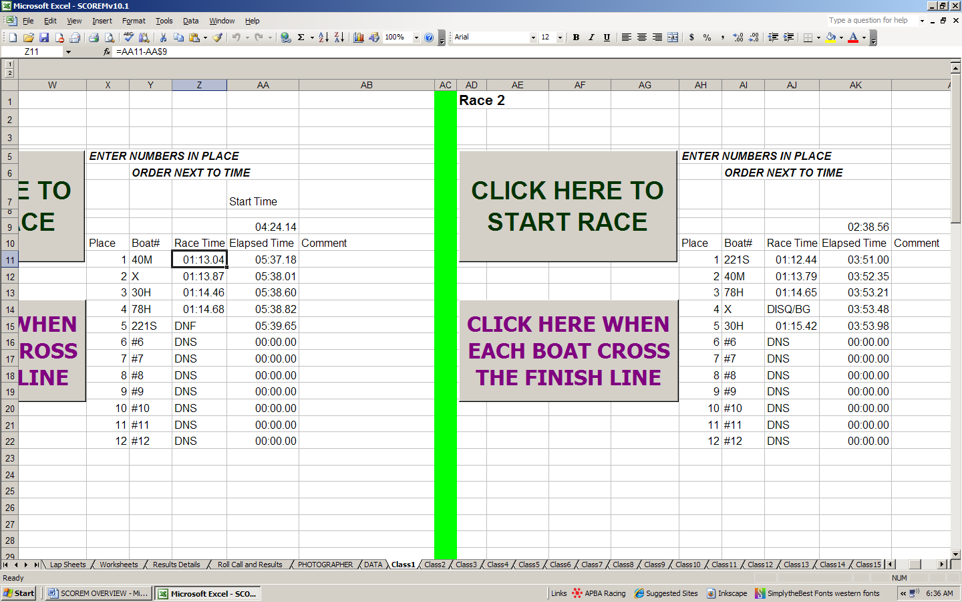
Formula

RESTORING TIMER FORMULAS:
In this example, the scorer (me) disqualified the wrong boat. Boat 221S was the gun jumper, and not boat X. Oops.
1) Replace time for 221S with “DISQ/BG”

1) Click on cell,
Enter “DISQ/BG”

2) Click on a working cell, “CTRL+C” to copy
3) Click on cell, “CTRL+V” to paste

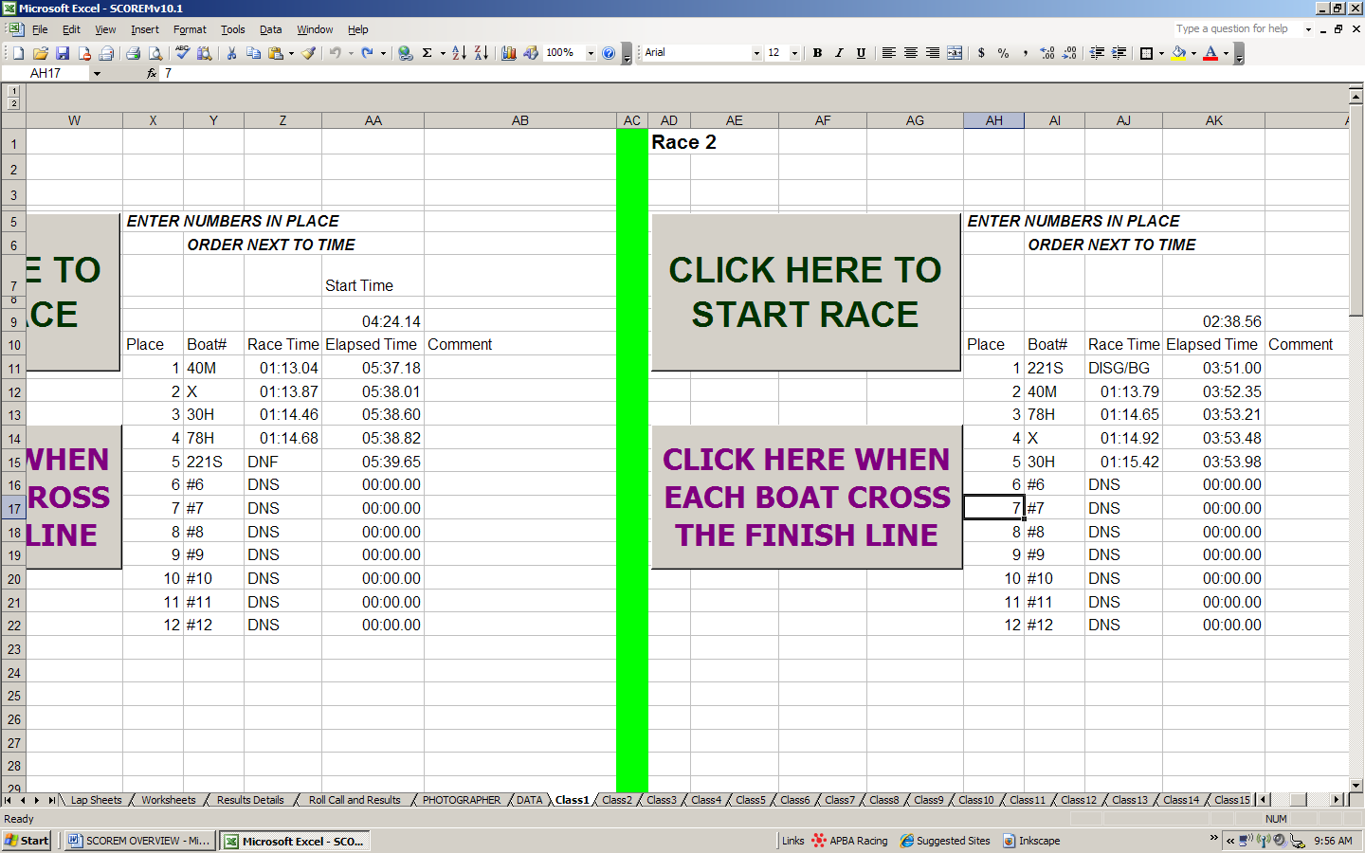
Boat X’s time has been restored and boat 221S is now DISQ/BG. Or is it?????

****NOTE: This also works for restoring other formulas in the program.
OTHER SCOREM PROGRAMS:
SCOREMv10.2
This workbook is virtually identical to the original SCOREM programs. I’ve just added a few things. The two-day workbook works exactly the same as the one day workbook. The driver’s names and boat numbers will automatically be entered in for the second days racing. It has separate WORKSHEETS, LAPSHEETS and RESULTS DETAILS for each day. The ROLL CALL list has both days on it with a column for boat numbers for each day.
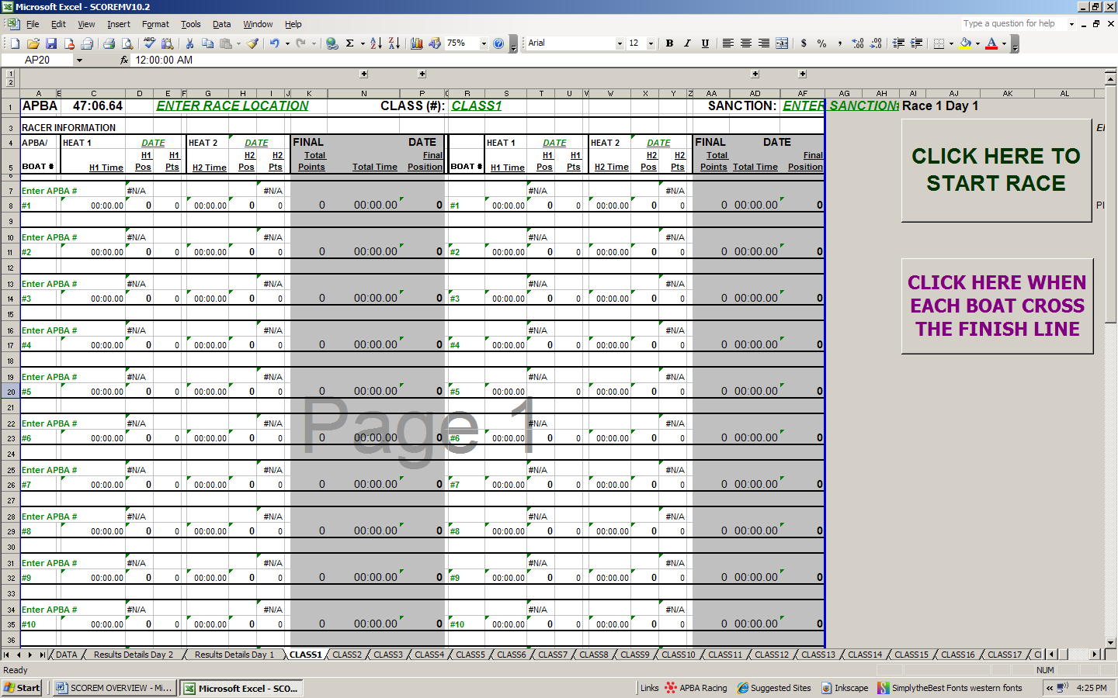
If the driver changes boat numbers for the second day, just change it in the boat number column for the second heat. It will not affect the first day’s racing. However, if you have errors in the first days racing data, it can affect the second day.

NOTE: This workbook has FOUR sets of timer cells in it. Make sure you’re on the right one!!!!!
SCOREMv10.3
The three heat workbook operates just like a two heat workbook. It’s a one day race workbook just like SCOREMv10.1, except it has three heat races. The times and positions are calculated the same way as the other workbooks. Theoretically, this could be used for elims as well, but only if you have 12 boats or less.
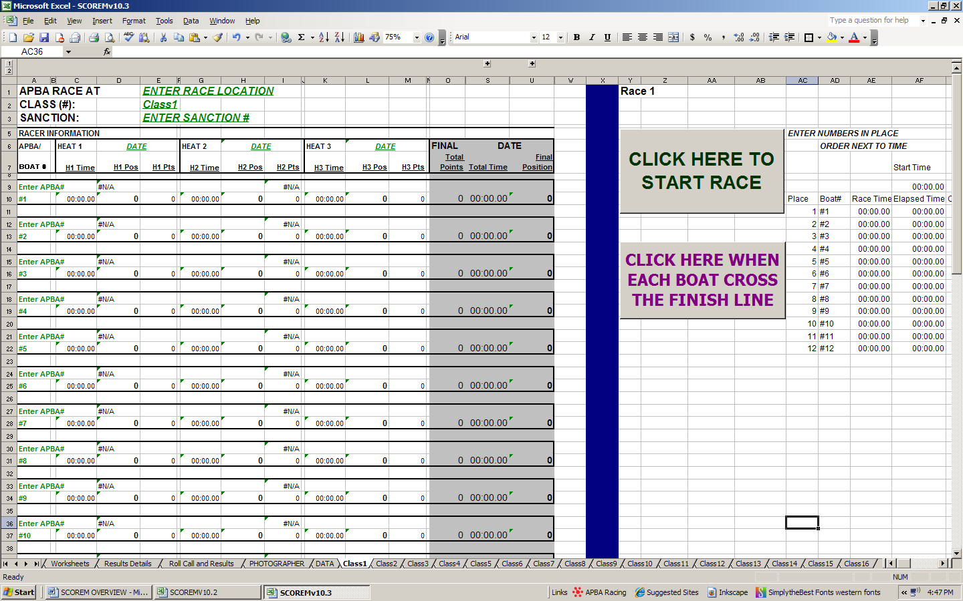
SCOREMv10.4
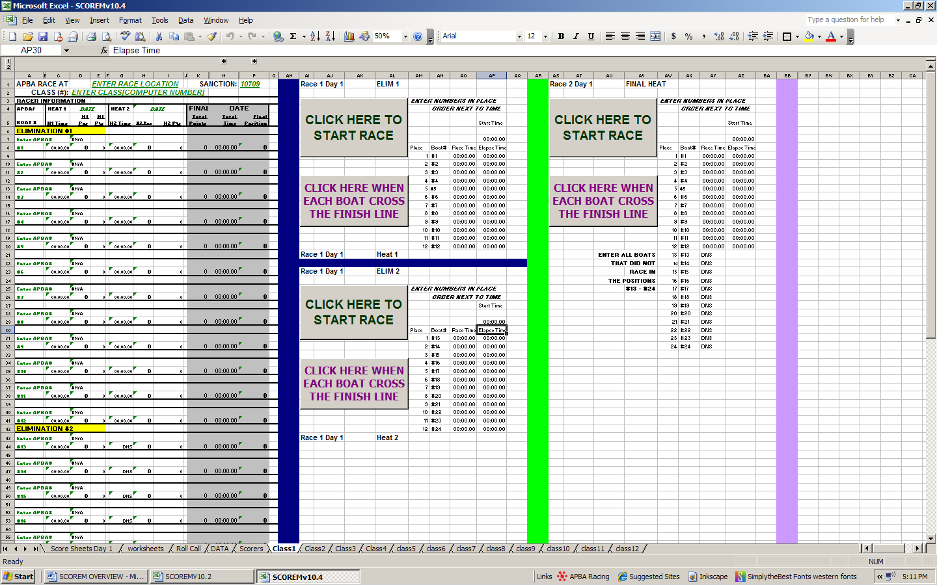
ELIM #1
ELIM #2
FINAL HEAT
SCOREMv10.4 (CONT’D):
This is an all elimination race workbook with 12 CLASS tabs. You will have this workbook and one of the others open at the same time. Most likely you will only use a couple of tabs on this workbook at a race. This one can get a little tricky. The program is really no different that any of the other programs, except that it is set up differently.

You will need to place enter driver’s information in the appropriate elimination heat. Drivers in Elimination 1 are positions 1-12 and drivers in elimination 2 are positions 13-24. You may need to scroll down the page to view the elimination 2 information.
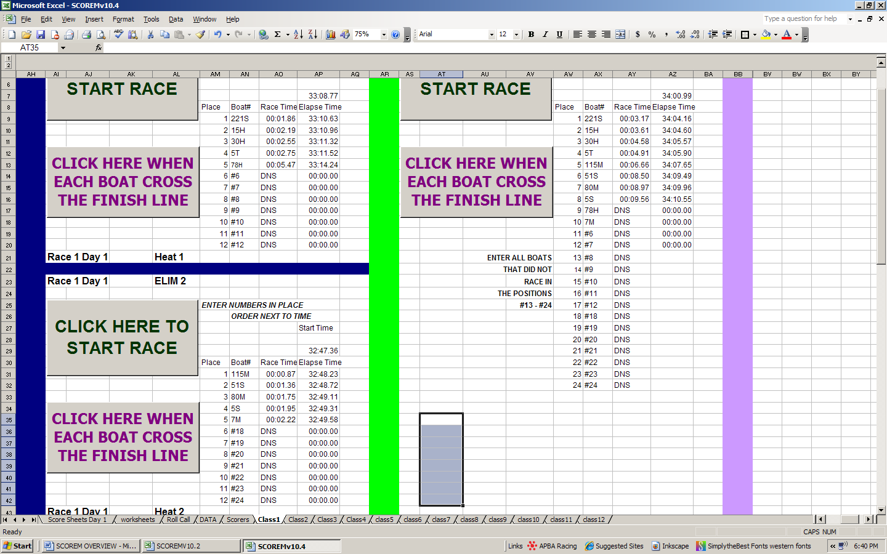
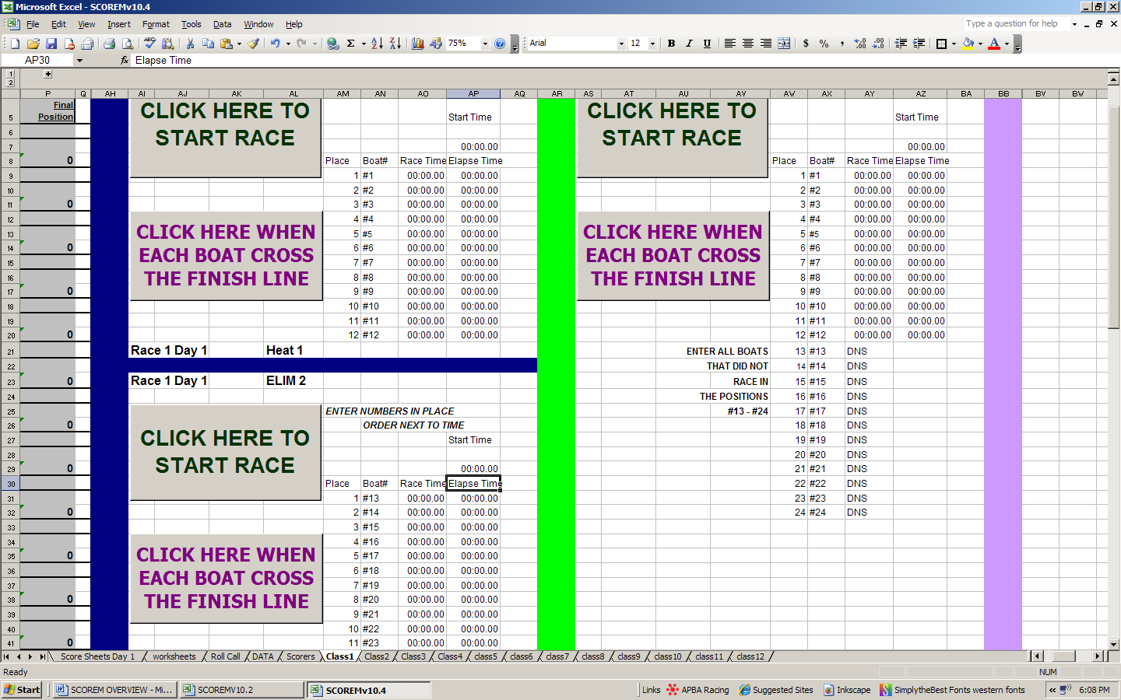
Note that we now have positions #1-24.

As before, all of the boats need to be accounted for in each heat. The individual elimination heats are easy. You have positions #1-12 in the first heat and #13-24 in the second heat. The final heat has to account for all 24 positions. The problem lies in the combinations of boats racing and the open positions in the final heat.

The screen shot on the next page shows a completed race. Note how the positions are accounted for in the final heat. Ten boats raced in two elimination heats. Two boats were eliminated, but must still be accounted for in the final heat. The boats that ran in the final heat are in lines 1-8. The eliminated boats are in lines 9 and 10, each with a “DNS”. Open positions #6-12 and #18-24 are each listed after the boats in positions 1-10.

SCOREMv10.4 (CONT’D):
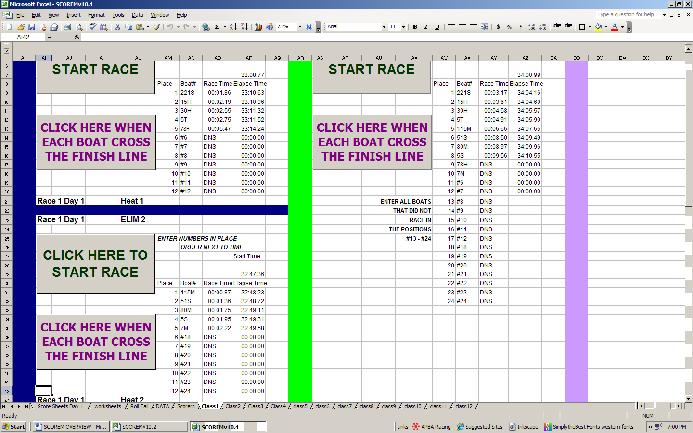

PRINTING ELIMS SUMMARIES FOR APBA: SCOREM is set up to print the summary information on the CLASS tab. For elimination races, this results in two pages and it can be confusing. The RESULTS DETAILS summary is a better summary for the elims for APBA. (Saves paper, too.) Just print the sheets that you will need by checking the print set up and selecting the appropriate pages.
The SCOREMv10.4 also has a sort function on the Results Details and Summary. It will sort by final position, when the “CLICK HERE TO SORT RACE” button is clicked.

FAQ’s and FREQUENTLY ENCOUNTERED PROBLEMS:

Q: I entered a drivers’ APBA# into the computer and someone else’s name came up. Why did this happen and how do I fix it?

A: Occasionally APBA recycles membership numbers. If you use an OLD driver data list, this may happen. You will need to go to the DATA tab, locate the APBA# and replace the old driver information with the new/updated information. (SEE DATA TAB. ALSO TROUBLESHOOTING: MISSING INFORMATION)

Q: I have two drivers that have registered with boat “X”, what do I do? The program won’t work!

A: One of the drivers will have to change his/her number. Have one of them put a “1” on front of or behind their “X”, making it “1X” or “X1”. The important thing is that you know how to tell them apart on your lap sheets. You can call it “FRED”, “JOE”, or “BOB”, if you want. The computer does not care what the boat number is, as long as each boat has its own individual number. (APBA might not like it if you call boats FRED, JOE or BOB). No duplicates are allowed.

Q: The timer didn’t work. I hit the start button at the start and after each boat finished. What happened?

A: Most likely you hit the start timer button at the start and forgot to move your cursor to the finish button. Essentially what happened is you kept re-starting the race by mistake. It happens. You will need to manually enter the times for each boat in that heat using the times from the backup timer.

Q: I have an extra finish time. I think I hit the timer button too many times. What do I do?

A: Determine which time is the extra time by comparing with the back up timer. You have two options. 1) Use the back up timer times for that heat or 2) replace the extra time with “DNS” and use boat number of one of the “open” positions in the summary. (Boat’s #6-12 again). Make sure that each boat has its correct time.

FAQ’s and FREQUENTLY ENCOUNTERED PROBLEMS (CONT’D):

Q: I missed a boat somewhere on the timer. What do I do?

A: Check your back up timers. Evaluate the times and figure out which boat was missed. Enter the times in manually for ALL boats in this heat. OR you can enter “TNT” (Time Not Taken). This can affect the outcome of the race, so let the referee know. You may need to re-run the heat.

Q: Great. So now the Referee insists we re-run the heat. How do I re-set the timer?

A: (Relax. It’s his call.) Here’s the great part. You don’t have to reset the timer! Once you hit the “Click Here to Start Race” button, it will over-write what you’ve already done. Just continue like you would any other heat. If you want to, you can type “00:00.00” in for the start time, but it’s not necessary.

Q: What did I do? I went back to my summary and I see something like this:
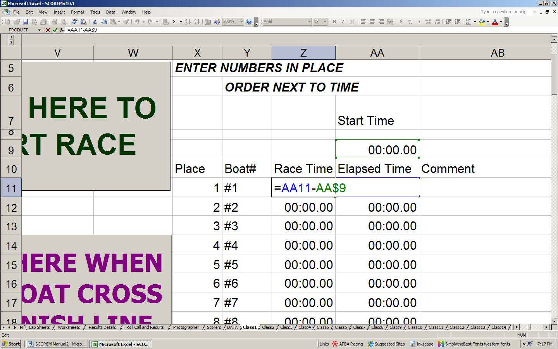

A: You just double clicked on the Race Time cell. All it is doing is telling you what the formula in that cell is.
Hit the escape button “ESC” to get out of it.

FAQ’s and FREQUENTLY ENCOUNTERED PROBLEMS (CONT’D):

Q: ACK! I started the timer and went back to fix something in the summary. When I clicked the finish button, the computer screwed up!! Help!

A: Yes, it probably did. Multi-tasking during a race is not something I would recommend. It’s OK, because the timer is still running. The computer just “forgot” where to start putting the times again. The illustration below show what the timer looks like after it has been started. Note that the “Race Time” column now has “#######” in the cells for the active boats (I added the DNS’ already for the empty positions). IF you HAVE to do something else, like go to another sheet to make a fix, you MUST click on the “ELAPSED TIME” timer cells for the heat to “remind” the computer where it needs to start again and what it’s doing before continuing. (See next screen shot) IMPORTANT!!! If you forget to do this, the computer will very likely record those times in WHICH EVER CELLS WERE CLICKED ON LAST. This could very well be someplace where you don’t want times to be recorded and could delete results that you do want!
*Again, I DO NOT recommend multi-tasking during a race. I don’t do it because it’s more headache than it’s worth.*
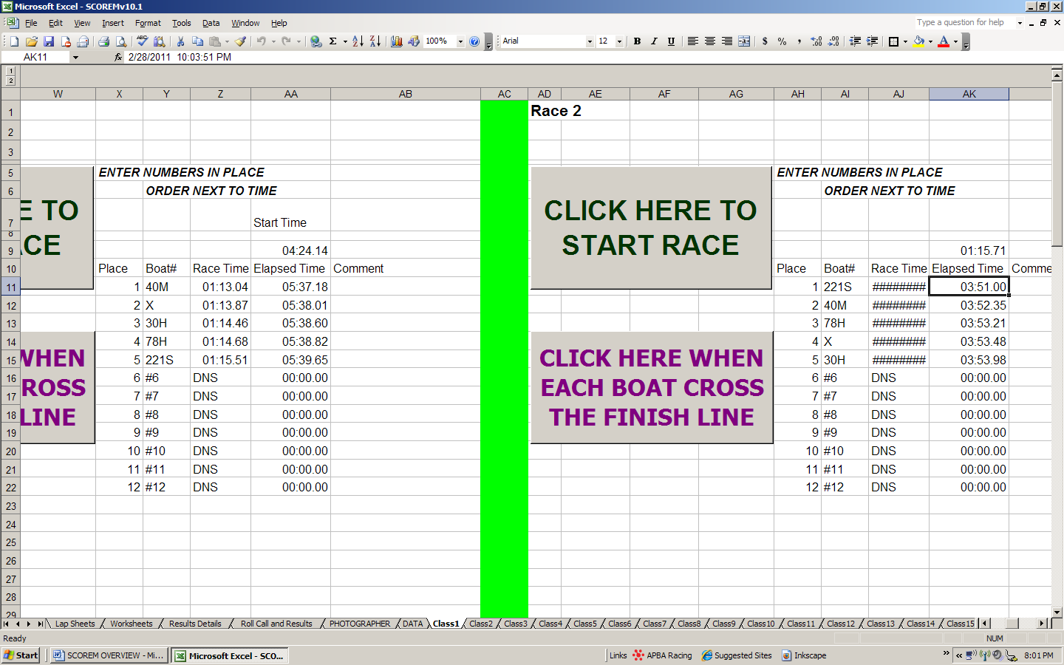
Click on cell, to “remind” computer where to start timing again.

FAQ’s and FREQUENTLY ENCOUNTERED PROBLEMS (CONT’D):

Q: HELP! I’ve still got a problem!

A: Call me on my cell phone (Donna @ 317-435-4547) and I will help you the best that I can.

Q: I’m going to try it, but I’m nervous! I’d really feel better if I saw it work first!!!

A: If you are about to go to your first race, call me ahead of time and I will walk you all the way through it. (SEE the DON’T PANIC section in the HELPFUL TO KNOW at the end) Let me know when your race is, and I will try to be available for phone support!

You are welcome to sit with me and the Indiana Outboard Association (www.indianaoutboard.org) at one of our races and learn!

HELPFUL TO KNOW

DON’T PANIC: This is one of those things that I cannot emphasize enough. Whatever happens, it will all be OK. You can figure out anything that is wrong, if you’re calm about it. As long as you have your lap sheets and back up timer, there isn’t anything that can get “lost”. If it’s bad enough and I cannot get you through it over the phone, you can email the race data file to me (APBASCOREM@yahoo.com) and I will walk through it with you after the race is over.

YOUR FIRST FEW RACES OF THE SEASON:
I don’t know about you, but my first race of the year always takes the longest at registration. There are more drivers to enter onto the DATA list, more people joining clubs and APBA. Allow your self a little breathing room.

REGISTRATION SUGGESTIONS:
- Organize your race entry blanks by class, rather than by driver.

- Entries can be done as each driver registers individually, or by class at the end. If short-handed or if registration is bottlenecked, entering the driver into the computer works better if done at the end of registration or when it’s slow.

If you’re going to do this all after registration, you’ll probably need some extra time before the drivers meeting. I usually have about 30 minutes to an hour. It all depends on how many entries you have, how fast you type and how proficient you are at using this program. You might want to do it as you go.

- Once registration is done, and all entries and in the computer, print the ROLL CALL list.

- WAIT to print lap sheets, etc. until the drivers meeting and roll call is done. Inevitably, someone is going to change their boat number even though they have just registered.

  - If a change is made, just click on to the appropriate class tab and make the correction. Don’t forget to also make the correction on the entry blank!
  - I usually need a good 30 minutes after the drivers meeting to make corrections, print two sets of lap sheets and pack up to go to the judges stand.

PRACTICE BOAT RACING:
- Sit down somewhere, open SCOREM and play boat racing.
- Make up a race location, dates and sanction number (any will work for your “mock” race)
- Use some of the APBA numbers from the DATA tab (any will do) and enter them in the appropriate places (ENTER APBA#) on the CLASS tab. Make up some boat numbers and enter those in. (Mock registration) Check the roll call sheets, lap sheets, etc. to see how the information appears on those sheets.
- Scroll over to the timer and start it. Wait a minute and then hit the finish timer button a few times, like you would be timing boats in a race. Proceed using the instructions in this manual to complete the race summary.

PRACTICE TROUBLESHOOTING:
- Transpose a boat number and see what happens. Then fix it.
- To make things realistic, create a tie situation. Break the tie.
3) Now, make it really interesting. Disqualify the one of the two boats involved in the tie. Look and see what happened. Are all the positions correct? They shouldn’t be. Follow the troubleshooting to restore the formula for calculating positions.
4) Trickier: Re-Instate the disqualified boat. Correct the errors.
WARNING!!!!
SCARY STUFF:
For those crazy people who have to know how it works, this is for you. For everyone else, stop now. This could get painful. If you don’t stop reading now, I can’t and won’t be held accountable for any pain that you might experience.
You were warned…….

The key to the program is the formula bar. This tells you the formula contained in a particular cell. If you are not familiar with it, it’s the bar with “fx” on it. In fact this is the whole key to Excel.
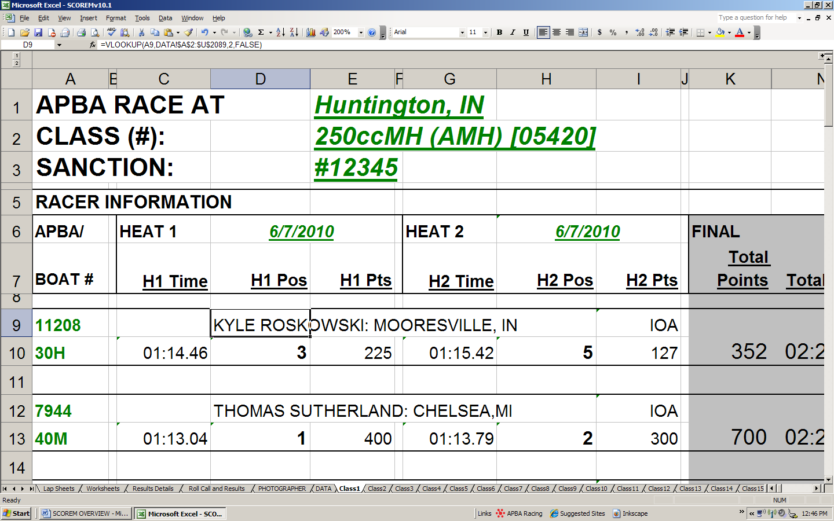

The formula bar will contain a formula or a reference to another cell within the worksheet (tab) or to a cell in another worksheet (tab). A formula is just a set of instructions or conditions for the computer to follow. Just about every formula or cell in this program is a reference to another cell or is a simple math problem!!

In this example, if you look at the formula bar, it says: “=VLOOKUP(A9,DATA!$A$2:$U$2089,2,FALSE)”.

This formula tells the computer what to look for, where to look for it, and what to do if it finds it, and if it doesn’t. Translated this formula means “computer, look up whatever is in cell A9, in the range of cells A2 through U2089 on the DATA tab and if there’s something in the second column, put that information in this cell (and if you don’t find anything, don’t do anything)”. This type of “formula” is used frequently in the SCOREM programs.

As discussed previously, these formulas are deleted when manual entries are made in the program. Copying and pasting a working formula will “repair” the cell and make it work again. The next screen shot depicts cells with the same formulas. This will help you in the event that you need to make these fixes.
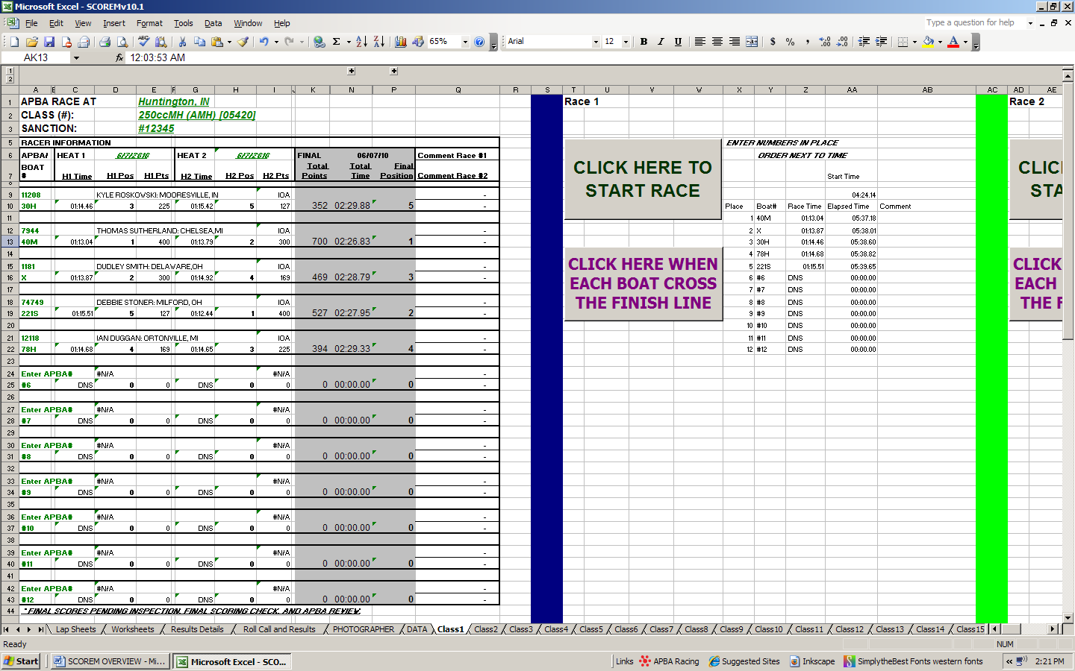
The heat times are pulled from the timer cells using a formula. Each heat has its own formula.
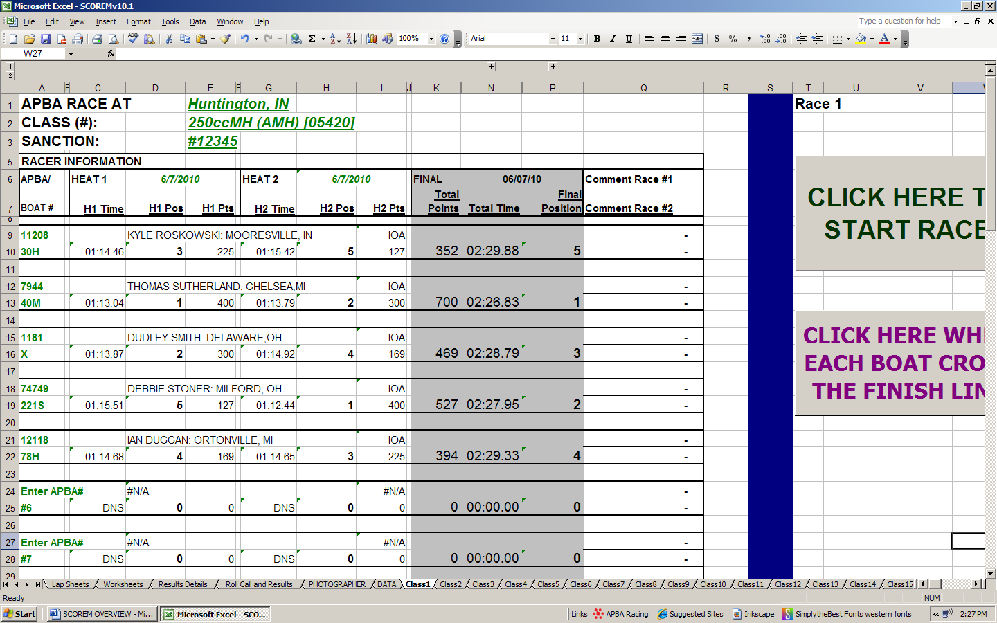
Same formula puts the driver’s name in column D for all 12 positions. The formula differs only in the location of the APBA# that it’s looking for. (Column is the same, row will change.)
Ex: The first driver’s APBA# is in cell A9. The second driver’s APBA# is in A12, and so on.

HEAT TIME FORMULAS: The basic formula: “= VLOOKUP($A10, Y$11:Z$22,2,FALSE)”
Translated: Lookup whatever is in cell A10 (which happens to be the BOAT#) in the range of cells Y11 through Z22 (the Heat 1 timer block where the BOAT#’s are entered) and put whatever is in the column next to it in this space.
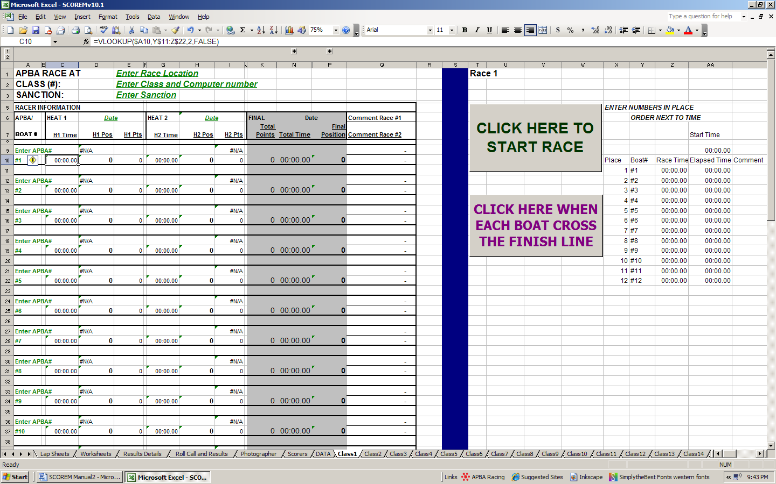
The second heat formula is different only because the computer is looking for the boat number in the second timer block of cells. Otherwise, it is the same.

TIMER CALCULATIONS:
These are simple math!!! The formula: “=AA11-AA$9”. Subtract whatever is in cell AA9 from cell AA11. AA9 is the recorded time that the race started. AA11 is the recorded time of the first boat that crossed the finish line.
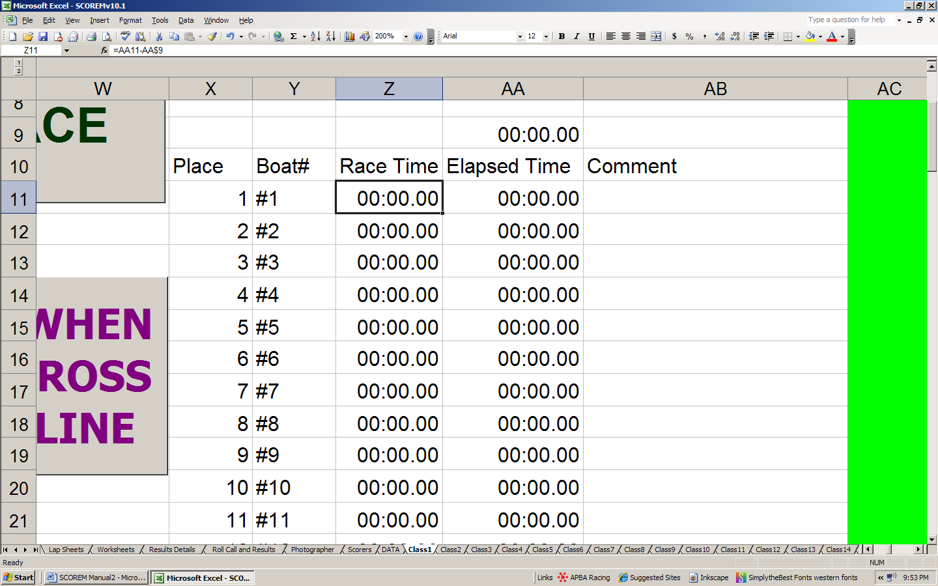
Recorded times.
Like a stopwatch.
Similar formulas

POSITION CALCULATIONS:
The formula: =IF(C10="TNT",0,IF(C10="DNF",0,IF(C10="DNS",0,IF(C10="DISQ/BG",0,IF(C10="DISQ",0,IF(C10="DNF/FLIP",0,IF(C10=0,0,RANK(C10,C$10:C$143,1))))))))

Translated: Look in the cell where the heat time is (in this example C10), and if it sees DNF or any of the other combinations in quotes, enter “0”, if none of those are present, it ranks the times in that column (Column C) from smallest to largest, starting with a “1”.

The formula is looking for specific things. Note the quotation marks in the above formula. These are the specific things that the computer is looking for. If it does not find any of those or a whole number, it does not know what to do. Close matches do not count. It has to be exact. This is why extra spaces are a problem.
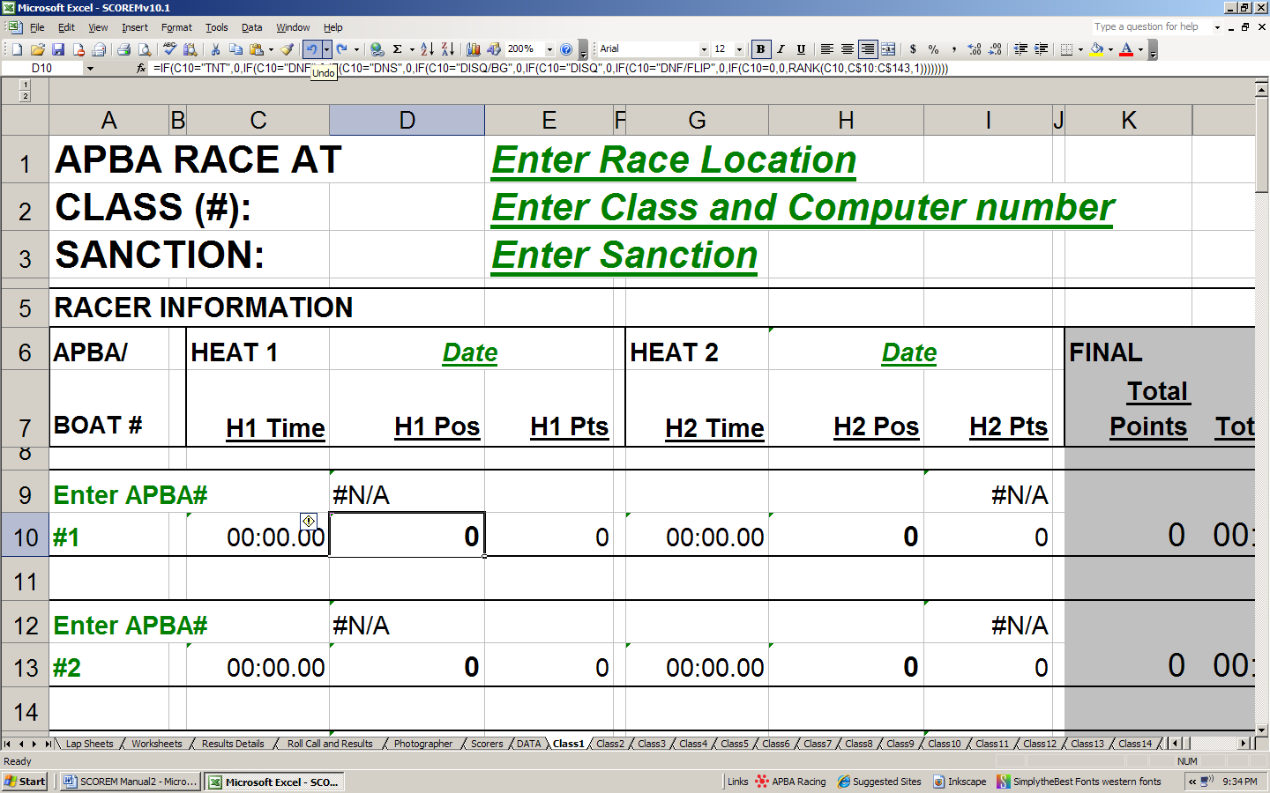
POINT CALCULATIONS:
The formula:
=LOOKUP(D10,{"*",0;0,0;1,400;2,300;3,225;4,169;5,127;6,95;7,71;8,53;9,40;10,30;11,22;12,17;13,13;14,9;15,7;16,5;17,4;18,3;19,2;20,1;21,0})
Translated: Look up whatever is in cell that has the position (in this example D10), if it has a zero, put zero; if it has a 1, put 400; If it has a 2, put 300, and so on.
THE TIMER:
The timer is a set of two “MACROS”. These are brief programs that allow the computer to function as a stopwatch. The first waits for an action to start recording a time. The action is you hitting the “start” button. When that happens, the computer is instructed to start recording the time a particular cell, and then jump down two rows to wait for the second macro action. The second macro also waits for an action, which is you hitting the “finish” button. The computer then records the time at that moment in a certain spot (provided you have not clicked anywhere else on the tab or workbook). If you were to add rows or columns that would move the timer start point over, up or down, the macros would not work together correctly. It will start where it was told to start and nowhere else.

I am not going to tell you how to edit macros. Suffice it to say that it can be done, and new macros can be recorded. I’ve figured it out by trial and error. This is one of those “if it’s not broken, don’t try to fix it” things. If you mess with the macros and you don’t know what you are doing, you’ll have problems.

OTHER TABS:
With the exception of the DATA and SCORER tabs, all of the other tabs contain references to the CLASS tabs. There really are no true “formulas” in them. All they do is pull information from a specific location within CLASS tabs and arrange it in a certain way. If you click on any cell in any of these tabs, you will find a reference to another tab.

For example, I’ve clicked on cell B4 on the ROLL CALL TAB. The formula bar says “=Class1!$D$9”.
This means put the information from the cell D9 on the class 1 tab here. 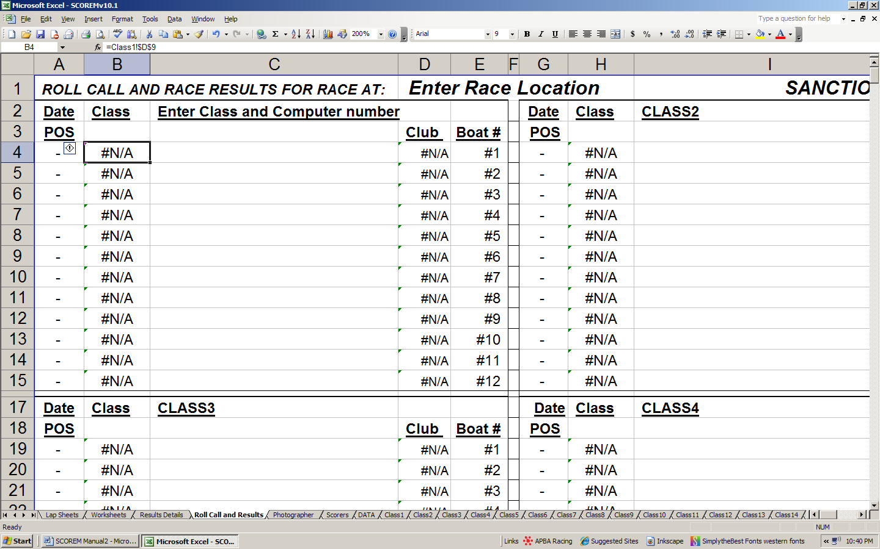

OTHER TABS (CONT’D): If the information is missing, you can click on the cell and find out where it is looking for info. It’s always possible that it’s looking in the wrong place. It’s possible, but not likely. I have thoroughly tested these and have not found any of these errors. Programs can get corrupted or altered. If you try to move things around, you will change the reference and will be in trouble if you don’t know what you are doing.

DISCLAIMER: I have tested these programs out and as far as I am aware they work fine! I have tried my best to correct any errors, but I may have missed some. If you find an error or have a problem, please let me know ASAP so I can make the corrections. Again, the email is APBAscorem@yahoo.com; and my cell is 317-435-4547.

