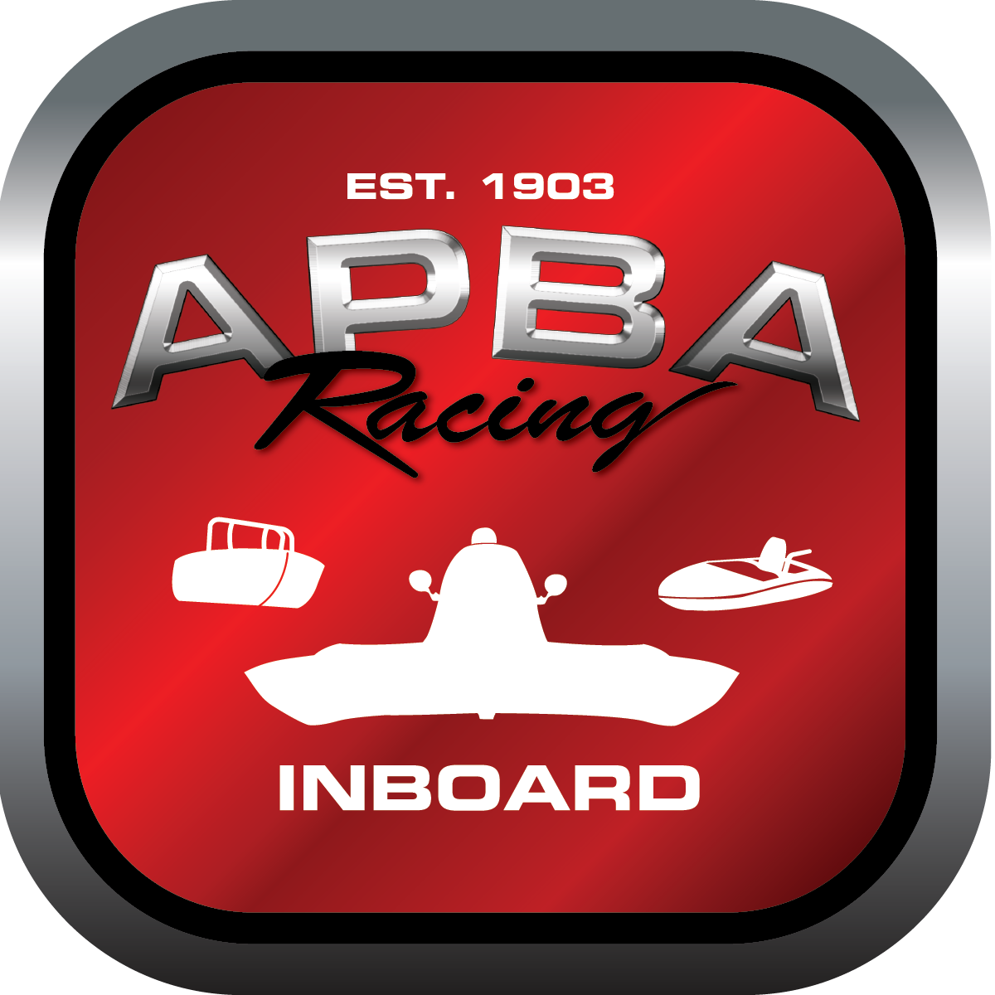
Office use only:
Control Number: NT 2
Assigned Group:
Initial Screening:
Ballot: Pass: ______/ Fail: _____
Effective for Race Year: 2019

2019 Inboard Rule Change Proposal

Name: David Shaw
APBA #: 3091
E-mail: instpov@yahoo.com
Telephone: 973-714-9785
Date: 10/23/18

Note: Proposals must be submitted to the Inboard Office by December 1, 2018 to be considered.
Save and E-mail completed form to: inboardracing@apba.org or melildon@yahoo.com
US mail to APBA Inboard Office 8039 Stone Barn Dr, West Chester, Ohio 45069

Check all that apply:
General Safety Rule
General Racing Rule
Stock Class Technical Rule X
Modified Class Technical Rule X

Affected Class(es): All

Specific Rule Information: [Note: All fields must be completed for consideration.]

Author’s VERY BRIEF Summary of Proposed Action: Add to rule 40.6 “All boats must have a bow eye or other devise which allows the boat to be towed in a forward direction. This must be located in an area that is easily accessible to the driver or tow boat personnel.”

Affected Rule:

Proposed rule: 40.6.1 (or where ever you think it is appropriate.)

Reason for change: We have had several boats that have had to be towed in by the skid fin bracket, or the attachment device is under the boat where it is very difficult to reach.

