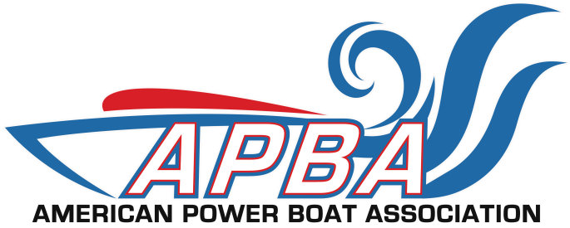
17640 E. Nine Mile Rd., Eastpointe, MI 48021
Phone: 586-773-9700, Fax: 586-773-6490 apba.org

ASSISTANT RISK MANAGER CHECK LIST

Sanction #_______________________________ RETURN THIS FORM TO:
Date of Event__________________________________ AMERICAN POWER BOAT ASSOCIATION

Location (city & state) _________________________ P O Box 377
Assistant Risk Manager________________________ Eastpointe, MI 48021-0377
Daytime Ph:/Cell______________________________ Phone: 586.773.9700
Fax: _________________________________________ Fax: 586.773.6490
Where was registration located prior to race day? ______________________________________________________________________________________________
- Where was registration located on race day? ______________________________________________________________________________________________
- If registration is within the restricted area, explain how it was handled. ____________________________________________________________________________________________________________________________________________________________________________________________
- Was the minor release and adult waiver and release forms available and were they being used at registration for all participants without exceptions. YES______________ NO______________
- In your opinion do registrars understand the importance of the waiver & release?
YES______________ NO_____________ If no, what would you suggest? ___________________________ ______________________________________________________________________________________________
6. At all APBA events it is mandatory that wristbands be used to verify a participant has signed the waiver & release. Were wristbands used at this event? _______________________________________________
______________________________________________________________________________________________
- Were spectators set back from the waters edge per guidelines?
YES______________ NO______________
- Were all course markers in place per the course layout & insurance application?
YES______________ NO______________
- Were restricted areas designated, signed and enforced. YES______________ NO______________
- Were there provisions for keeping swimmers out of the water during on water activity.
YES______________ NO______________
11. Was the launch ramp access restricted? YES______________ NO______________
12. Was there a clear path for launch vehicles so it did not interfere with spectators?
YES______________ NO______________
13. Was the crane area restricted so no cranes were used over the crowd?
YES______________ NO______________ N/A__________________
14. Was tech inspection in accordance with rules? YES______________ NO______________
15. Were ambulance and fire control on site prior to start of event? YES___________ NO___________
- Was there a back-up ambulance available if the #1 ambulance was dispatched?
NOTE: No racing is allowed until there is at least one ambulance on race site.
YES______________ NO______________
- Were incident reports available to assistant risk manager, referee/ risk manager, scorer & race director? YES______________ NO______________
18. Was the nearest trauma center (hospital) notified that an event is taking place with time & location given? YES______________ NO______________
19. Is the contact person at the hospital known? YES______________ NO______________
Name ________________________________________ Phone______________________________
- Are the first aid stations for the spectators separate from participants?
YES______________ NO______________
21. Was there signage and barriers separating the spectator area from all “restricted areas” such as “fuel area”, launch area” and “judges stand”. YES______________ NO______________
22. If bleachers exist, were they in good condition-no loose boards, nails protruding, or gaps on top
row so as to allow a person to fall, and were their handrails to assist persons going up & down?
YES______________ NO______________
23. Are vendor stands in compliance with local codes as to open flames, propane tanks, electrical hook ups, licensing, etc? YES______________ NO______________
24. Was alcohol sold? YES_______ NO_______ Was their signage stating that alcohol will not be sold to anyone under the age of 21 and was it being enforced? YES___________ NO_____________
25. Was the parking area controlled to prevent injuries or property damage?
YES______________ NO______________
26. Were toilet facilities adequate for all. YES______________ NO______________
27. Were all areas free of trip and fall objects or at least well marked? YES_________ NO_________
- Was their adequate lighting for early starts or late finishers? YES____________ NO____________
29. What method of communication is being used with spectators and participants? _________________________________________________________________________________________
30. What method of communication was used between race director/producer and race officials? _________________________________________________________________________________________
- Was there a communication link between the assistant risk manager & local law enforcement?
YES______________ NO______________

