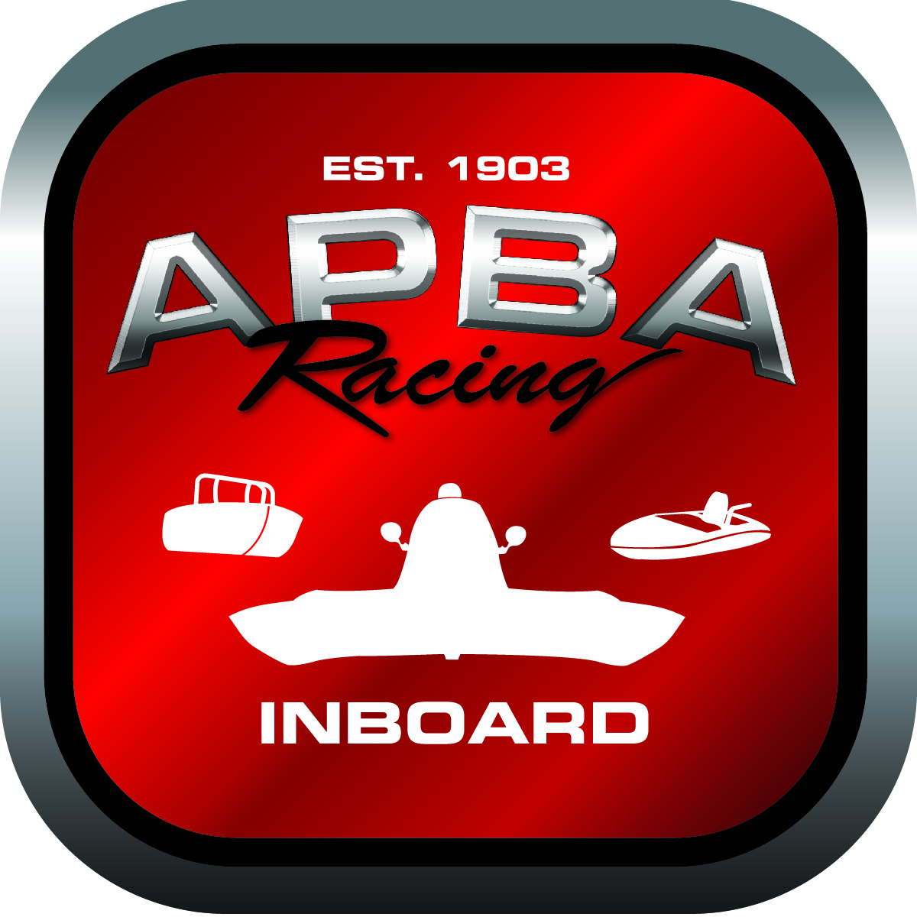
APBA Inboard Capsule/Cockpit Information
Last Updated 10/30/2013

- This information has been put together to aid cockpit manufacturers and racers.

- Attached are various documents whether you are building a cockpit, installing a cockpit, fitting a driver for belts, seats and head clearance, etc.

- Capsule Requirements for capsules being reinstalled in a different hull or if a hull changes classes

If a capsule that was intended for a specific class (the class noted on registration tag), that capsule can only stay in the class it was originally intended for or a smaller class. Smaller class would be defined as being smaller in weight, size and speed. If a hull and capsule were to be used in a different class that was it originally was intended, it will be the owner’s responsibility to contact the Inboard office and the original cockpit manufacturer to have the cockpit registration changed to the proper class. It is the responsibility of the original cockpit manufacturer to ensure that the capsule meets all cockpit requirements for the class it will compete in. If the capsule was built prior to November 1, 2013, the capsule must meet the minimum cockpit requirements for that class per the cockpits rules prior to November 1, 2013. If the capsule was built November 1, 2013 or later, the capsule would need to meet the minimum cockpit requirements for that class per the cockpit rules on or after November 1, 2013. If the original cockpit manufacturer is unable to provide the necessary documents then the cockpit must remain in the class it was originally intended for or a smaller class.

- Manufacturers: Please allow up to 30 days for your core sample to be tested. We recommend that you wait for test results prior to building cockpit..

- Manufacturers and Race Teams: When requesting a new cockpit registration tag or a replacement tag, please allow up to two weeks, plus mail time.
If at any time during your review of any one part of the enclosed information you have questions, please contact the APBA Inboard office so we may assist you through the process.

APBA Inboard Racing
Inboardracing@apba.org

