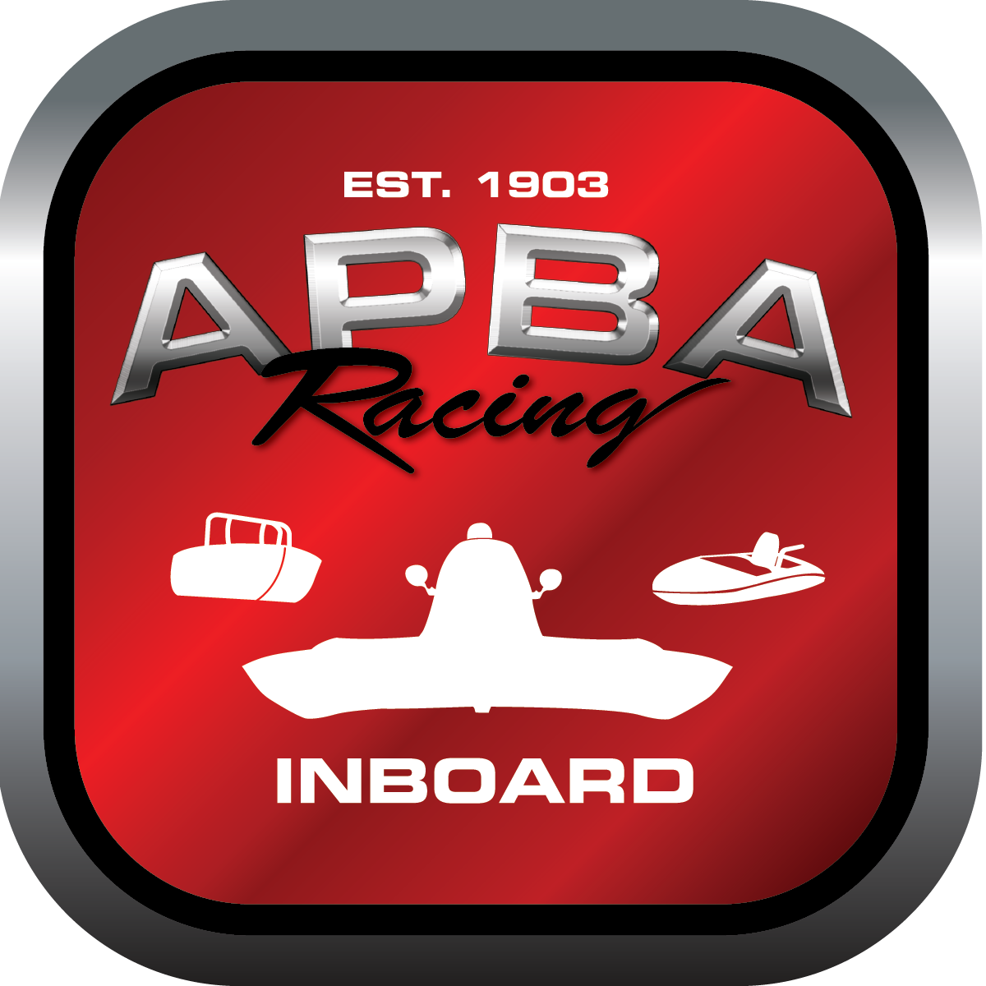
Office use only:
Control Number: NT 1
Assigned Group:
Initial Screening:
Ballot: Pass: ______/ Fail: _____
Effective for Race Year: 2019

2019 Inboard Rule Change Proposal

Name: David Shaw
APBA #: 3091
E-mail: instpov@yahoo.com
Telephone: 973-714-9785
Date: 10/23/2018

Note: Proposals must be submitted to the Inboard Office by December 1, 2018 to be considered.
Save and E-mail completed form to: inboardracing@apba.org or melildon@yahoo.com
US mail to APBA Inboard Office 8039 Stone Barn Dr, West Chester, Ohio 45069

Check all that apply:
General Safety Rule
General Racing Rule X
Stock Class Technical Rule *
Modified Class Technical Rule *

Affected Class(es): All

Specific Rule Information: [Note: All fields must be completed for consideration.]

Author’s VERY BRIEF Summary of Proposed Action: Proposal to allow the use of video from drones to assist in officiating events.

Affected Rule: 13.3

Proposed rule: Add to rule new section, 13.3.1 “Video from designated drones may be used by the Referee and/or his/her designee to help determine course infractions.”

Reason for change: Drones can provide a view that is not available from most starting line, or turn judge positions. By using the video, the race officials can follow the path that a boat has taken to help determine overlap, lane infractions, etc.

