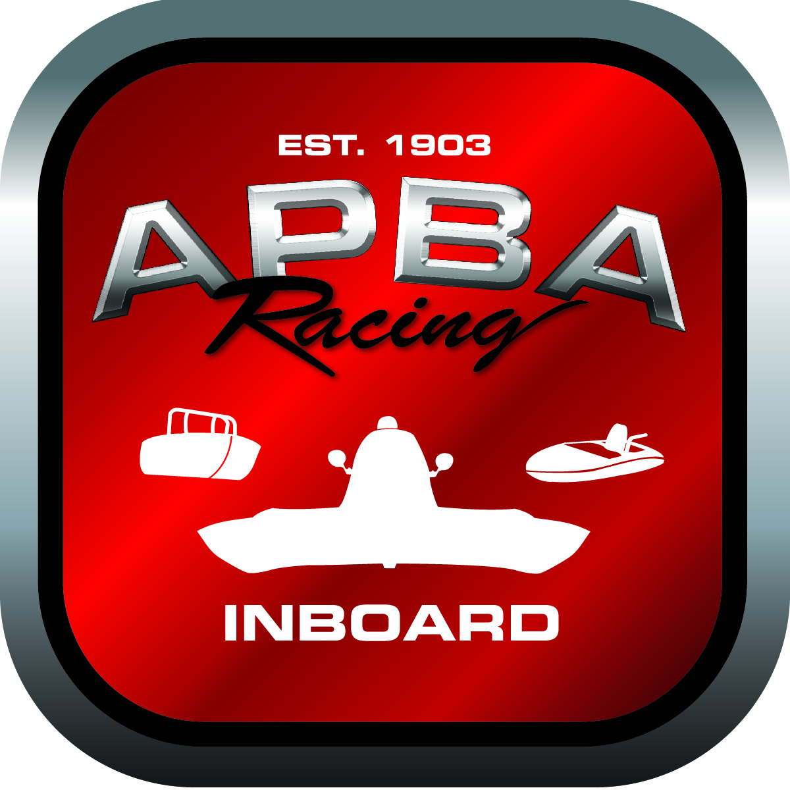
Office use only:
Control Number: T12
Assigned Group:
Initial Screening:
Ballot: Pass: ______/ Fail: _____
Effective for Race Year: 2019

2019 Rule Change Proposal

APBA #: 11990
E-mail: BlitzA64@aol.com
Telephone: 443-867-5504
Date: 11/30/18

Note: Proposals must be submitted to the Inboard Office by December 1, 2018 to be considered.
Save and E-mail completed form to: inboardracing@apba.org or melildon@yahoo.com
US mail to APBA Inboard Office 8039 Stone Barn Dr, West Chester, Ohio 45069

Check all that apply:
General Safety Rule
General Racing Rule
Stock Class Technical Rule X
Modified Class Technical Rule

Affected Class(es): All

Specific Rule Information: [Note: All fields must be completed for consideration.]

Author”s VERY BRIEF Summary of Proposed Action: Add modifications to the 350 engine specs for heavier hulls and to allow HRL boats to compete in APBA if they choose to do so

Affected Rules:

45.3.10 Head: Purchase and/or alteration must be done through the APBA Inboard office (586) 773-9700 or Regates de Valleyfield committee. Michel Pourier (450) 371-6144 ext. 223 The only allowable head for use is Dart Part #:10021070 Dart Iron Eagle S/S 165 and must have the official APBA or ACHA stamp on at all times. Heads must remain unaltered in any way except for flat milling of deck. (No angle milling allowed). Machining outer edge of valve guide for smaller valve seals and bronze liner allowed. Combustion chamber, intake and exhaust ports must be in the original ‘as cast’ configuration. Minimum volume of the combustion chamber: 64 cc. Head intake runner volume: 175cc (± 2cc). Head exhaust runner volume: 70cc. (± 2cc). Valves must be in stock location and at stock angle. Screw in studs (maximum size 0.4375”) and guide plates allowed. No gasket matching. Any evidence of sanding, polishing, relieving, grinding, porting, chemical treating, ceramic work, abrasive blasting, and alteration of the original form or the addition of material to the ports or combustion chambers are prohibited. Dart Iron Eagle S/S 165 tech sheet will be used for thorough inspection.

45.3.11 Valves: Any manufacturer may be used, no titanium or exotic material. Seat angle must be 45 degrees. Swirl polish allowed. Maximum exhaust diameter: 1.500” with a minimum stem diameter of 0.340”. Maximum intake diameter: 1.940” with a minimum stem diameter of 0.340”. Valve stem must remain the same size all the way. No back-cut allowed.

Proposed rules: •

45.3.10.1 Gasket/Port Matching It shall be permissible to perform a minor port match on the intake ports of the heads and intake manifold at the flange mating surface of each if a minimum hull weight of 1,700lbs with driver is met. The heads shall meet rule 45.3.10 in its entirety other than this modification. The intake shall meet rule 45.3.12 in its entirety other than this modification. Dimensions shall be as follows:

Maximum width to the outside wall of both ports shall be 2.70”
Maximum width of each port wall to wall shall be 1.25” each
Minimum width of port dividing wall shall be .200”
Maximum height of each port shall be 1.975”
Maximum port intrusion measured from the flange face of heads/intake shall be .625”
Maximum Intake port volume will be 178cc
There will be no tolerance to the above max/min measurements

45.3.11.1 Valve Modification It shall be permissible to back cut valves that meet rule 45.3.11 above in its entirety if a minimum hull weight of 1,700lbs with driver is met. The maximum distance of the required 45* seat angle and the back cut may not exceed more than .250” as measured from the edge of the valve.

Reason for change: To allow HRL hulls to compete at APBA events. An economical solution to allow heavier APBA hulls a power advantage over lighter hulls with no weight penalty being imposed to lighter hulls that may not want to add weight. An APBA owner can decide to stay at the lighter 1525 weight with the original rule or run more weight, 1,700 and do the modification.

