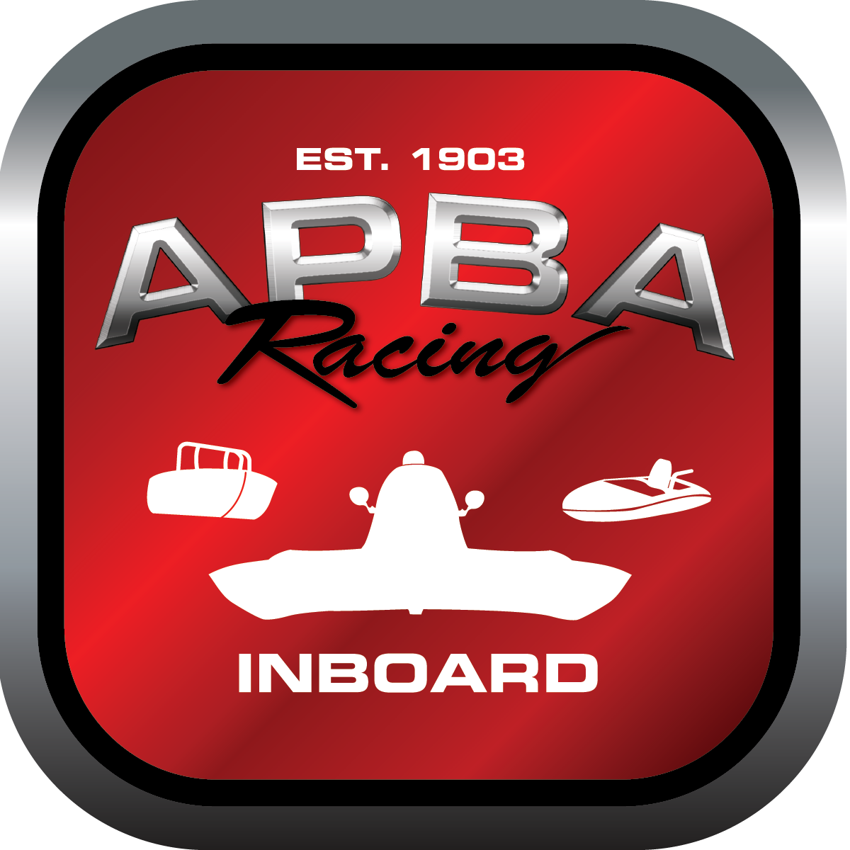
Office use only:
Control Number: T8
Assigned Group:
Initial Screening:
Ballot: Pass: ______/ Fail: _____
Effective for Race Year: 2019

2019 Inboard Rule Change Proposal

Name: Wally Johnston
APBA #: 6079
E-mail: agitator@q.com
Telephone: 406-443-2384
Date:
Note: Proposals must be submitted to the Inboard Office by December 1, 2018 to be considered.
Save and E-mail completed form to: inboardracing@apba.org or melildon@yahoo.com
US mail to APBA Inboard Office 8039 Stone Barn Dr, West Chester, Ohio 45069

Check all that apply:
General Safety Rule
General Racing Rule
Stock Class Technical Rule X
Modified Class Technical Rule

Affected Class(es): 5Litre

Specific Rule Information: [Note: All fields must be completed for consideration.]

Author’s VERY BRIEF Summary of Proposed Action: Remove 5 litre from rule 40.18

Affected Rule: 40.18

Proposed rule: Remove the 5 litre class from the stock class listing

Reason for change: The class is no longer a 5 litre or a stock engine wince the 350 rules were approved. The 250 is the predominate engine in use with only a select few 305 mods being run in the class. The rules for the 350 permit aftermarket parts from pan to carb. It is no longer a “stock” class.

