Appendix 4
3/22/17

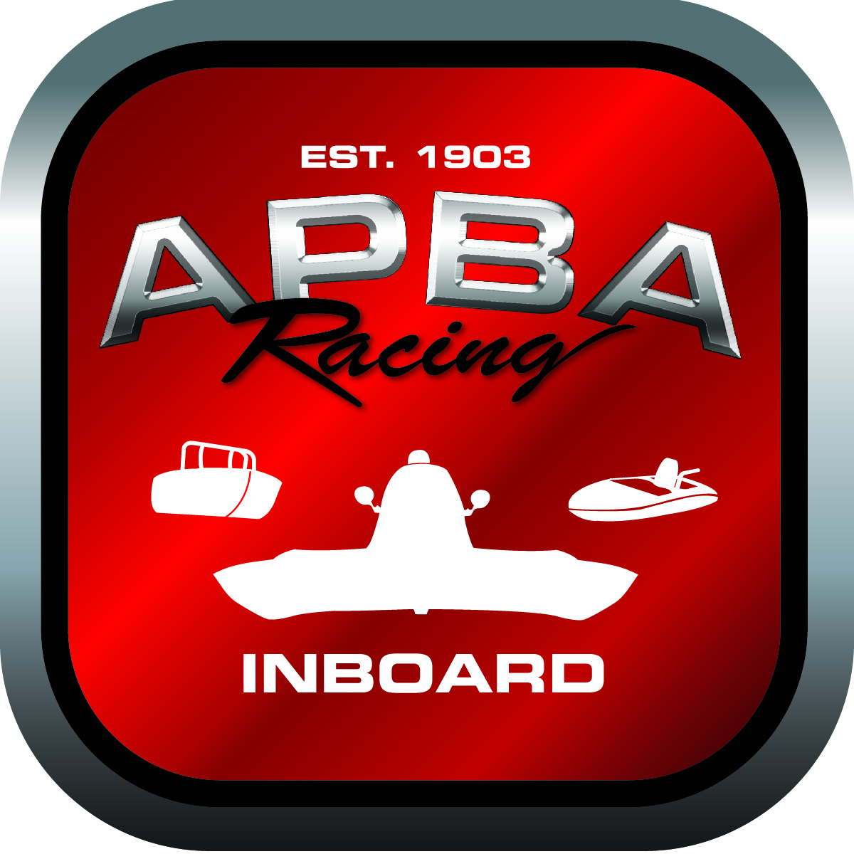

Reinforced Cockpit Registration Application

From:

Please complete all information below and return to:
APBA Inboard Racing Commission
1767 Snowden Circle
Rochester Hills, MI 48306

Manufactured by: _______________________________________

Manufacture Model #: ___________________________________

Date of Manufacture: ____________________________________

Installed by: ____________________________________________

Installation Date: ________________________________________

Class: __________________________________________________

Owner: ________________________________________________

Mail Registration tag to (Preferable Manufacturer):

For Office Use Only

Date Received ___________
Date Sent _______________
Serial Number ___________

