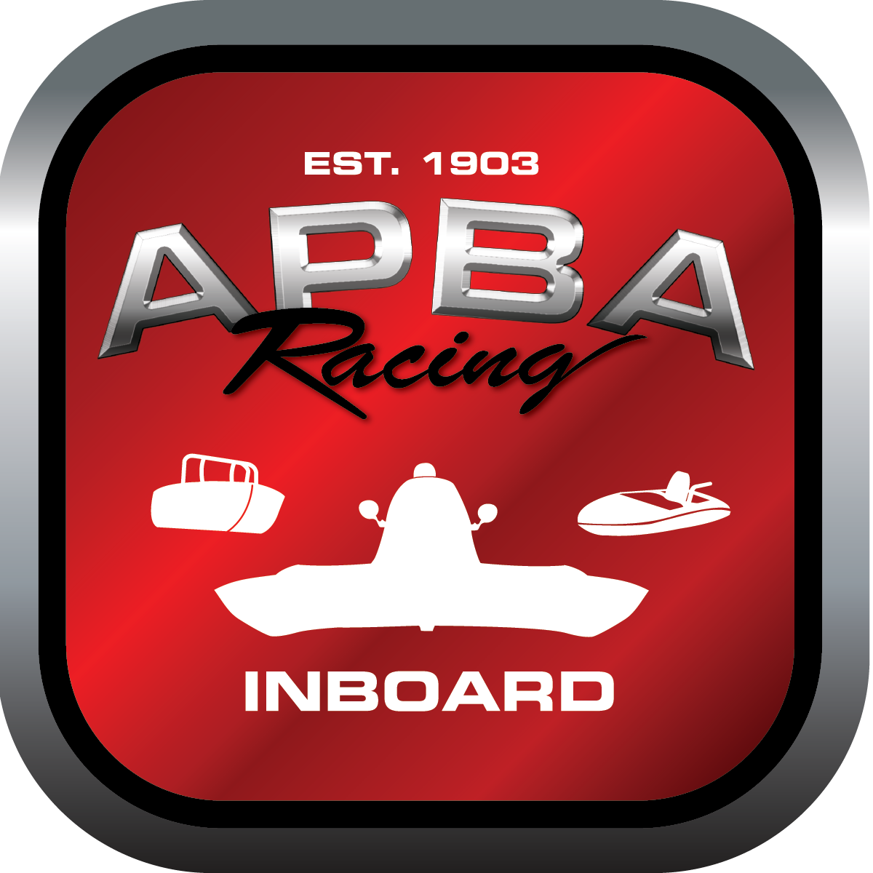
Office use only:
Control Number: S2
Assigned Group:
Initial Screening:
Ballot: Pass: ______/ Fail: _____
Effective for Race Year: 2019

2019 Inboard Rule Change Proposal

Name: Chris Oliver Jr.
APBA #: 1886
E-mail: portsidemar@verizon.net
Telephone: 410-382-2412
Date: 11/30/2018

Note: Proposals must be submitted to the Inboard Office by December 1, 2018 to be considered.
Save and E-mail completed form to: inboardracing@apba.org or melildon@yahoo.com
US mail to APBA Inboard Office 8039 Stone Barn Dr, West Chester, Ohio 45069

Check all that apply:
General Safety Rule
General Racing Rule
Stock Class Technical Rule *
Modified Class Technical Rule *

Affected Class(es): All

Specific Rule Information: [Note: All fields must be completed for consideration.]

Author’s VERY BRIEF Summary of Proposed Action:
Request ability to allow videos from drones to assist officials in course infractions.

Affected Rule:
13.3

Proposed rule:
As an addendum to 13.3, allow for the use of video from official race committee drone to be used by officials to enforce race infractions.

Reason for change:
It is difficult for turn judges and officials to monitor all aspects of the race course and boats. Having the ability to review footage from an aerial view will offer an unbiased and unobstructed perspective from which to make an official ruling on any potential infractions.

