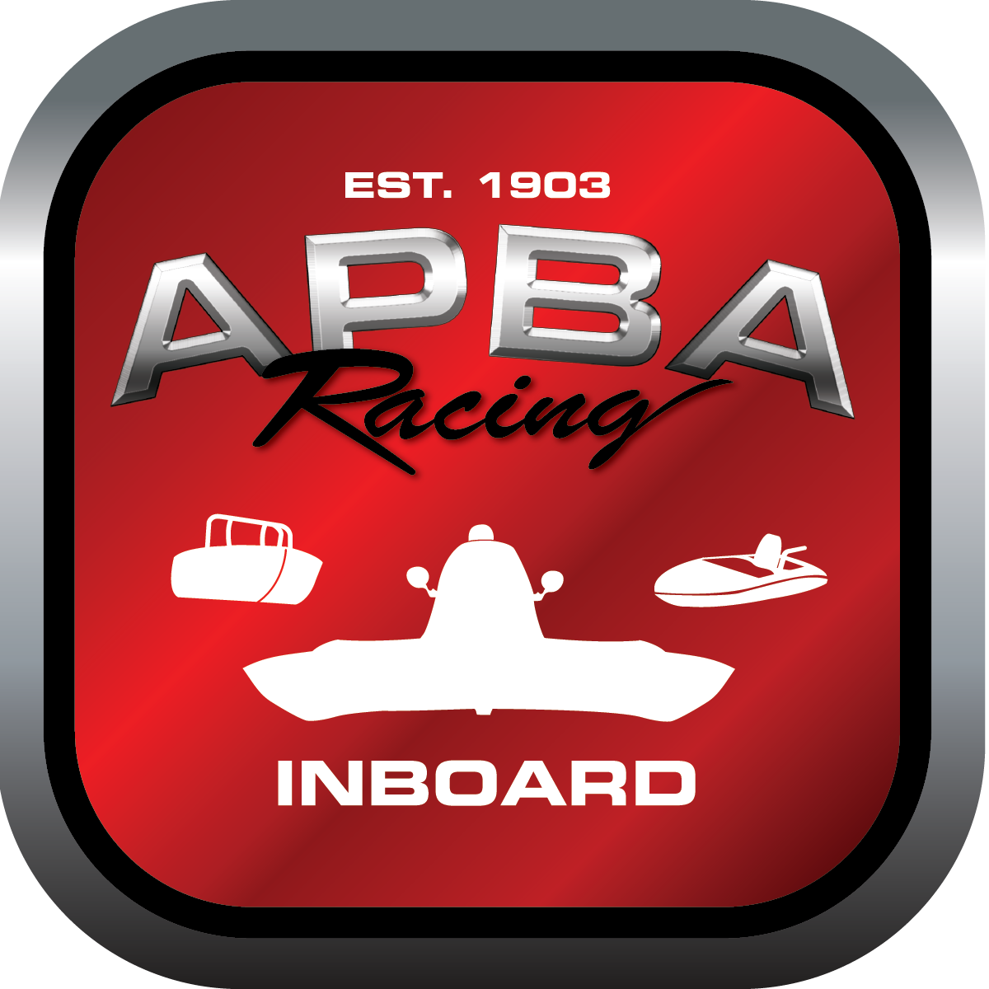
Office use only:
Control Number: T13
Assigned Group:
Initial Screening:
Ballot: Pass: ______/ Fail: _____
Effective for Race Year: 2019

2019 Inboard Rule Change Proposal

Name: Chris Oliver Jr.
APBA #: 1886
E-mail: portsidemar@verizon.net
Telephone: 410-382-2412
Date: 11/30/2018

Note: Proposals must be submitted to the Inboard Office by December 1, 2018 to be considered.
Save and E-mail completed form to: inboardracing@apba.org or melildon@yahoo.com
US mail to APBA Inboard Office 8039 Stone Barn Dr, West Chester, Ohio 45069

Check all that apply:
General Safety Rule
General Racing Rule
Stock Class Technical Rule *
Modified Class Technical Rule *

Affected Class(es): 1.5 Litre Stock

Specific Rule Information: [Note: All fields must be completed for consideration.]

Author’s VERY BRIEF Summary of Proposed Action:
Allow for a newer, more cost effective/economical engine option for the 1.5 Litre Stock class.

Affected Rule:
42

Proposed rule:
Add a new section to rule 42 that allows for the use of a 1.9 SEFI Ford engine in the 1.5 Liter Stock class. The only version allowed is the one from the Sports Car Club of America (SCCA) spec class racer. The engine comes sealed by SCCA. The only seal(s) that may be removed by the owner are from the oil pan, and solely for the purpose of allowing the oil pan and pickup to be modified to fit the engine into the boat. The ECU for the engine is also sealed and may not be modified/re-written. Maximum ignition timing is 20 degrees. The only propellers to be used with this engine are short-hub, 7/8 spline.

Reason for change:
The engine currently used in the 1.5 Litre Stock class has not been manufactured since the late 1980’s. Core engines and parts (including re-built parts) are very difficult to find and expensive as a result. For example, an owner paid ~$300 for a bearing set in 2017. The proposed engine allows a semi-current, inexpensive option - cost ranging between approximately $300-500, and with minimum work, are race-ready.

I have spoken to all the current 1.5L Stock class members and they concur with the recommendation.

