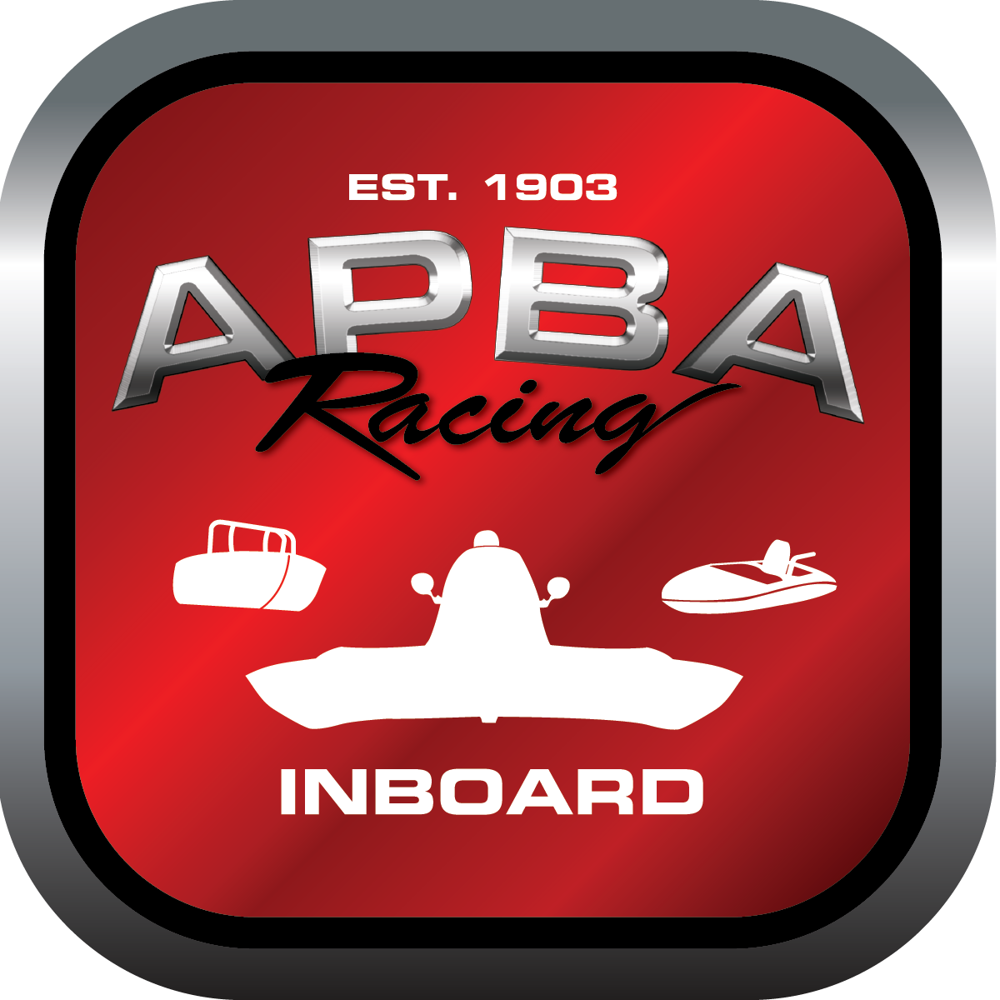
Office use only:
Control Number: T24
Assigned Group:
Initial Screening:
Ballot: Pass: ______/ Fail: _____
Effective for Race Year: 2019

2019 Inboard Rule Change Proposal
Name: Lenny Baker APBA #: 918
E-mail: aquaholicss78@gmail.com
Telephone:425 879 8166
Date:11/30/18
Note: Proposals must be submitted to the Inboard Office by December 1, 2018 to be considered.
Save and E-mail completed form to: inboardracing@apba.org or melildon@yahoo.com
US mail to APBA Inboard Office 8039 Stone Barn Dr, West Chester, Ohio 45069

Check all that apply:
General Safety Rule
General Racing Rule
Stock Class Technical Rule * X
Modified Class Technical Rule *
Affected Class(es):

Specific Rule Information: [Note: All fields must be completed for consideration.]

Author’s VERY BRIEF Summary of Proposed Action: To allow open flat bottom (non-capsuled) boats using the Super Stock rules to run with the Capsuled Super Stock boats.

Affected Rule: 53:15 Carburetor: (Those holes shall be no larger than 1 11/16”, 1.693” inside diameter.)

Proposed rule: Those holes shall be no larger than 1.563” inside diameter.
ADD: The open (non-capsuled) boats can not in any way modify the carburetor. Re-jetting, accelerator pump change 30cc to 50cc and cams for the primary accelerator pump and the secondary throttle shaft are permissible.
Capsuled boats can modify the carburetor in any way and still maintain the 1.563” maximum throttle bore size.

Reason for change: First to slow the boats down.
2nd to allow open boats to run in the Super Stock class to compete with the capsuled boats and entice the open boats to install capsules.
3rd to increase the boat count in the class before it becomes extinct!
This size carburetor is basically the same as the SE class—a Holley 4776 600 cfm.

Capsuled and open boats have been running together for years now under the GPS95 and SA classes!

