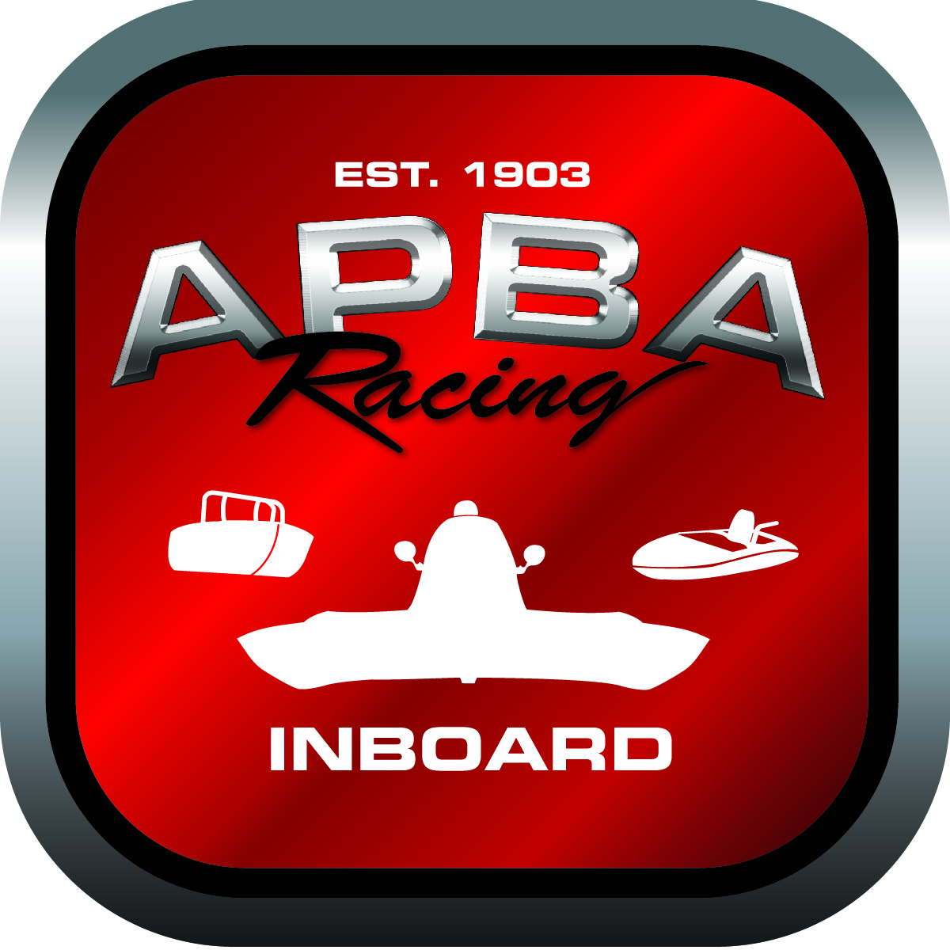
Office use only:
Control Number: T1
Assigned Group:
Initial Screening:
Ballot: Pass: ______/ Fail: _____
Effective for Race Year: 2019

2019 Rule Change Proposal

Author: Bob Schellhase
APBA #: 2987
E-mail: r.schellhase@earthlink.net
Telephone: (206) 818-2650
Date: 10/31/2018

Note: Proposals must be submitted to the Inboard Office by December 1, 2018 to be considered.
Save and E-mail completed form to: inboardracing@apba.org or melildon@yahoo.com
US mail to APBA Inboard Office 8039 Stone Barn Dr, West Chester, Ohio 45069

Check all that apply:
General Safety Rule
General Racing Rule
Stock Class Technical Rule *
Modified Class Technical Rule *

Affected Class(es):
GP

Specific Rule Information:

Author’s VERY BRIEF Summary of Proposed Action:
Allows and facilitates parity between the GP engine rules for Option One (US) and Option Two (HRL).

Affected Rule:
48.6.3.9 Fuel System: Fuel may be metered by carburetors or a mechanical fuel injection system. Fuel injection systems must be injected by hat nozzles using a cast aluminum injector throttle body available from a major manufacturer. No electronic fuel injection systems are permitted.

Proposed rule:
48.6.3.9 Fuel System: Fuel may be metered by carburetors or a mechanical fuel injection system. Fuel injection systems must be injected by hat nozzles using a cast aluminum injector throttle body available from a major manufacturer. Port injection is permitted but not mandatory. No electronic fuel injection systems are permitted.

Reason for change:
This change is to allow what is already allowed in the HRL-GP rules. It allows the Option One rules (US version) to “catch up” and maintain parity with the Option Two rules (HRL or Canadian). It also allows more accurate tuning of the engine which helps promote engine health and longevity.

