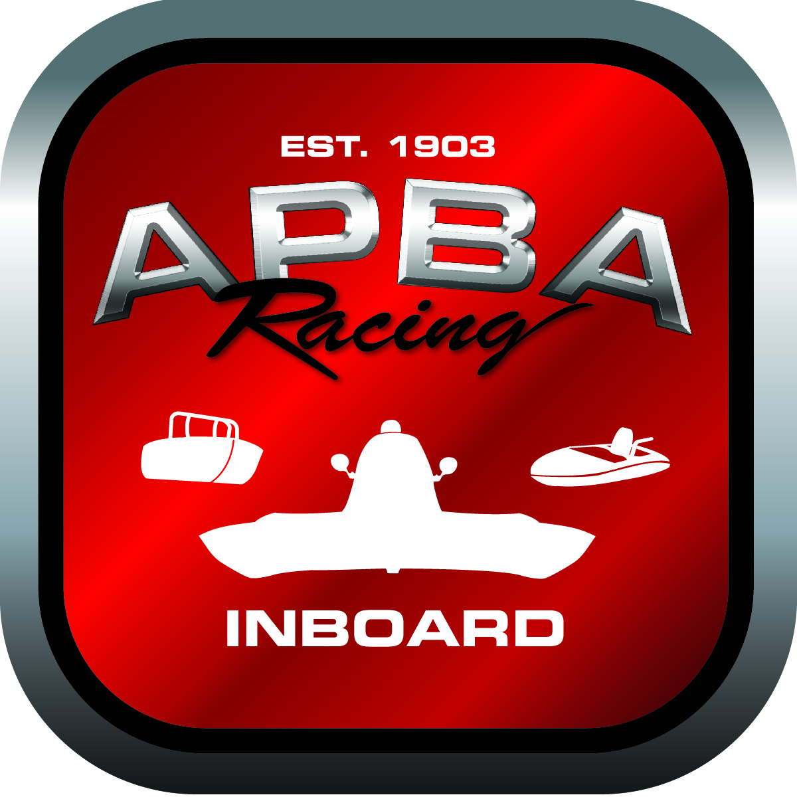
Office use only:
Control Number: T2
Assigned Group:
Initial Screening:
Ballot: Pass: ______/ Fail: _____
Effective for Race Year: 2019

2019 Rule Change Proposal

Author: Bob Schellhase
APBA #: 2987
E-mail: r.schellhase@earthlink.net
Telephone: (206) 818-2650
Date: 10/31/2018

Note: Proposals must be submitted to the Inboard Office by December 1, 2018 to be considered.
Save and E-mail completed form to: inboardracing@apba.org or melildon@yahoo.com
US mail to APBA Inboard Office 8039 Stone Barn Dr, West Chester, Ohio 45069

Check all that apply:
General Safety Rule
General Racing Rule
Stock Class Technical Rule *
Modified Class Technical Rule *

Affected Class(es):
GP

Specific Rule Information:

Author’s VERY BRIEF Summary of Proposed Action:
Allows intercoolers to be used on gasoline fueled motors only.

Affected Rule:
48.6.2 Fuel: Methanol or gasoline. No nitro methane, nitrous oxide or other power producing additives are allowed.
48.6.3 ENGINE OPTION ONE:
……….

48.6.3.2 No intercoolers allowed.

Proposed rule:
48.6.2 Fuel: Methanol or gasoline. No nitro methane, nitrous oxide or other power producing additives are allowed.
48.6.3 ENGINE OPTION ONE:
……….

48.6.3.2 No intercoolers allowed except for gasoline fueled motors only.

Reason for change:
This change is to allow the use on intercoolers on gasoline fueled motors only. It may encourage potential boats with gasoline motors (such as 468 CI GNH boats) to add a supercharger and be allowed to race as a Grand Prix as long as all other GP rules are being met. Intercoolers would still not be allowed on methanol fueled motors.

