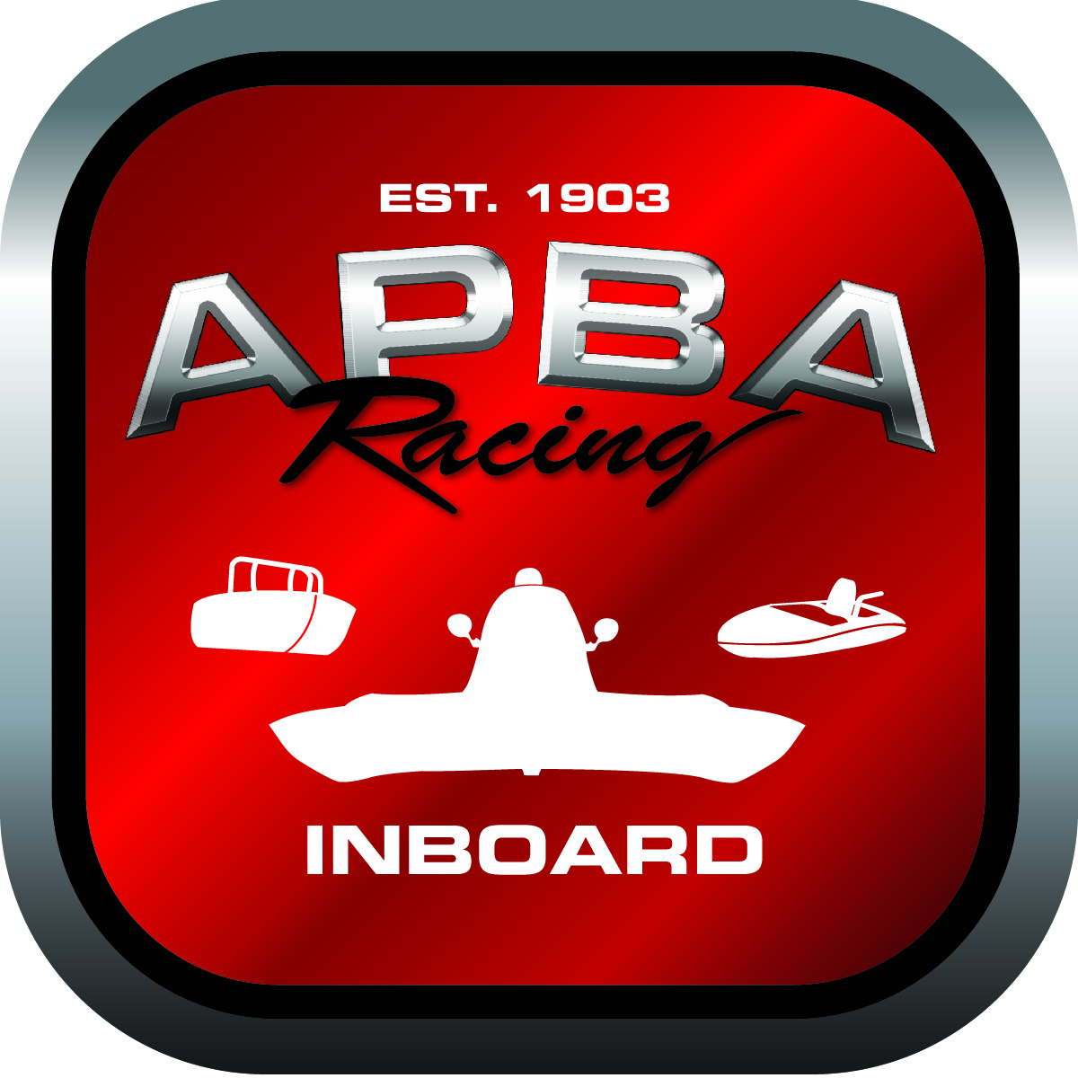
Office use only:
Control Number: NT5
Assigned Group:
Initial Screening:
Ballot: Pass: ______/ Fail: _____
Effective for Race Year: 2019

2019 Rule Change Proposal

Author: Bob Schellhase
APBA #: 2987
E-mail: r.schellhase@earthlink.net
Telephone: (206) 818-2650
Date: 10/31/2018

Note: Proposals must be submitted to the Inboard Office by December 1, 2018 to be considered.
Save and E-mail completed form to: inboardracing@apba.org or melildon@yahoo.com
US mail to APBA Inboard Office 8039 Stone Barn Dr, West Chester, Ohio 45069

Check all that apply:
General Safety Rule
General Racing Rule
Stock Class Technical Rule *
Modified Class Technical Rule *

Affected Class(es):
All

Specific Rule Information:

Author”s VERY BRIEF Summary of Proposed Action:
Opens up the criteria for National Championships for classes that have legal fields at championship events.

Affected Rule:
23.12: National championships will be awarded to all classes that have a minimum of 8 active boats or scored 5,000 points cumulatively as a class during the current season. Additionally, National Championship class must have had a legal field in a minimum of 5 APBA sanctioned race days during the current racing season. Classes meeting these criteria will be awarded a national championship that includes all US-1 honors: US-1 decal, number 1 painted on hull, US-1 ring/trophy, Hall of Champions points, and other not specified. Classes not meeting these criteria will be awarded an Inboard Class Championship that does not include US-1 honors.

Proposed rule:
23.12: National championships will be awarded to all classes that have a minimum of 8 active boats or scored 5,000 points cumulatively as a class during the current season. Additionally, National Championship class must have had a legal field in a minimum of 5 APBA sanctioned race days during the current racing season or must have had a legal field in a minimum of 3 APBA sanctioned race days during the current racing season if one of those racing days was at a championship event such as the Summer Nationals, Divisionals or World Championships. Classes meeting these criteria will be awarded a national championship that includes all US-1 honors: US-1 decal, number 1 painted on hull, US-1 ring/trophy, Hall of Champions points, and other not specified. Classes not meeting these criteria will be awarded an Inboard Class Championship that does not include US-1 honors.

Reason for change:
With the decreased number of races available today, our Nationals and/or Divisionals attendees should not be excluded from the opportunity to win a National Championship. Last year’s rule was a compromise to insure participation in at least a minimum number of events and we may have gone too far. Those classes with legal fields at championship events should be given a little extra credit for having legal fields at their championship events.

