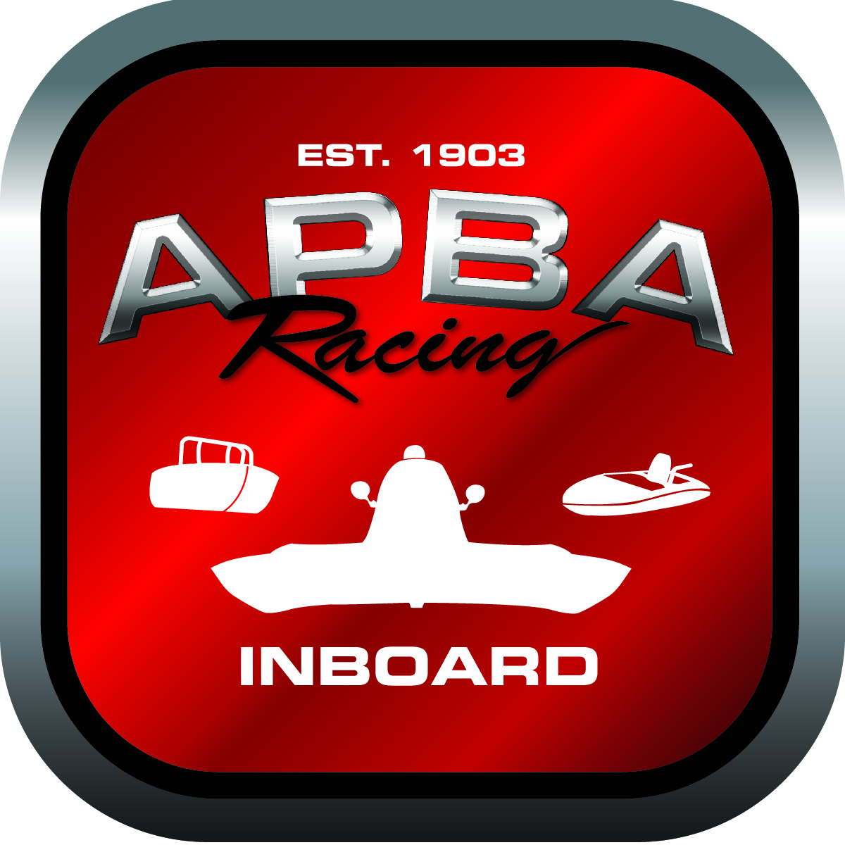
Office use only:
Control Number: NT3
Assigned Group:
Initial Screening:
Ballot: Pass: ______/ Fail: _____
Effective for Race Year: 2019

2019 Rule Change Proposal
APBA #: 11990
E-mail: BlitzA64@aol.com
Telephone: 443-867-5504
Date: 9/22/18
Note: Proposals must be submitted to the Inboard Office by December 1, 2018 to be considered.
Save and E-mail completed form to: inboardracing@apba.org or melildon@yahoo.com
US mail to APBA Inboard Office 8039 Stone Barn Dr, West Chester, Ohio 45069

Check all that apply:
General Safety Rule X
General Racing Rule
Stock Class Technical Rule *
Modified Class Technical Rule *

Affected Class(es): All

Specific Rule Information: [Note: All fields must be completed for consideration.]

Author”s VERY BRIEF Summary of Proposed Action: Add a tow point forward of amidships

Affected Rule:
3.12.5
• All hydroplanes must have a rollover lift bracket or eyelet permanently attached to the rear area of the left sponson. The bracket or eyelet must have at least a 3/4” hole and be strong enough to support the weight of the boat should it need to be righted for rescue purposes. The skid fin bracket would be considered a rollover bracket and does not need to have the 3/4” hole.

Proposed rule: • All hydroplanes must have a rollover lift bracket or eyelet permanently attached to the rear area of the left sponson. The bracket or eyelet must have at least a 3/4” hole and be strong enough to support the weight of the boat should it need to be righted for rescue purposes. The skid fin bracket would be considered a rollover bracket and does not need to have the 3/4” hole. IN ADDITION TO THIS, A TOW ATTACHMENT POINT SHALL BE PROVIDED WELL FORWARD OF AMIDSHIPS FOR RESCUE PURPOSES SHOULD THE BOAT NEED TO BE TOWED AND NOT MANNED.

Reason for change: Our Regatta had an issue with moving an upside down hull because of no tow attachment area forward of amidships. Adding this is a simple inexpensive fix that would help expedite course clearing in the future

