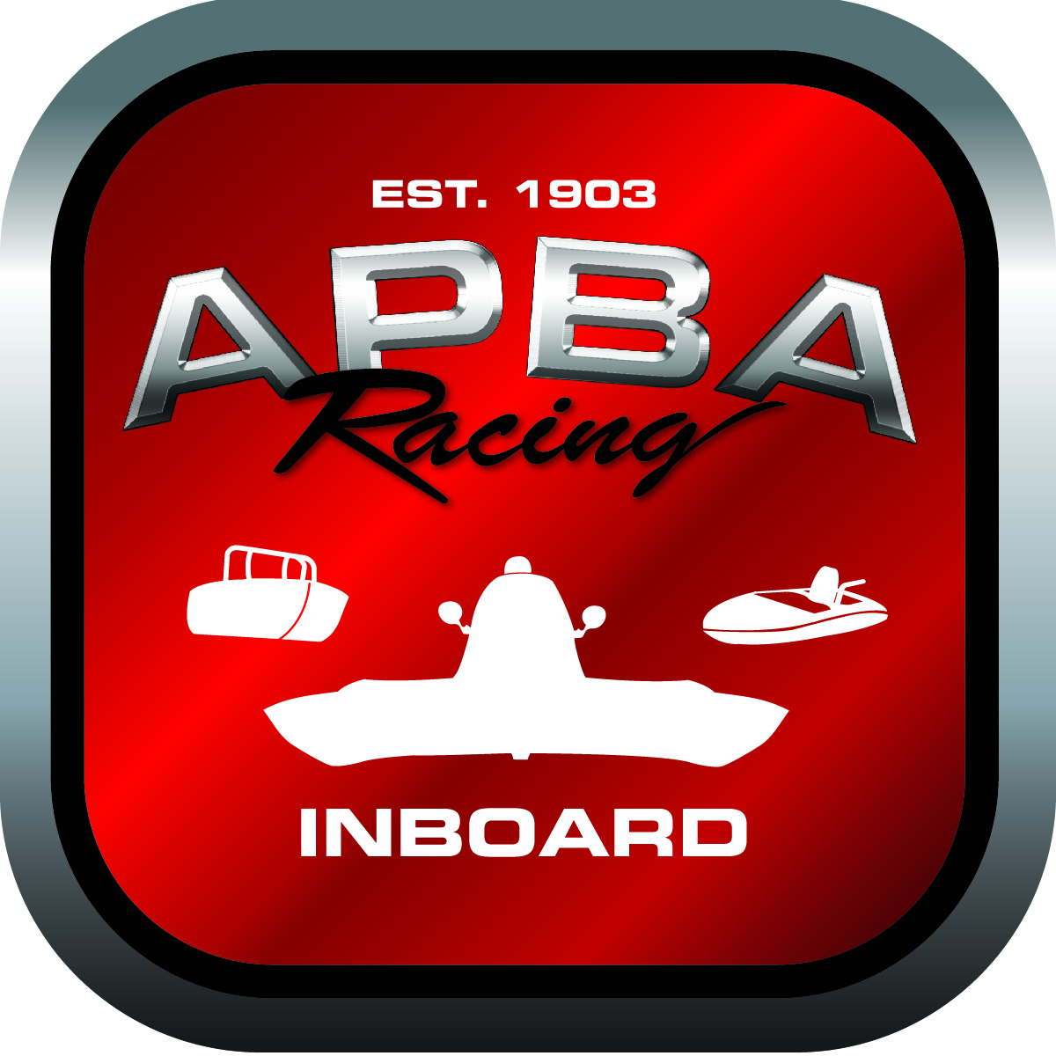
Office use only:
Control Number: NT9
Assigned Group:
Initial Screening:
Ballot: Pass: ______/ Fail: _____
Effective for Race Year: 2019

2019 Rule Change Proposal

Name: Don Melillo
APBA #: 50367
E-mail: melildon@yahoo.com
Telephone: 513-325-5041
Date: Nov. 23, 2018

Note: Proposals must be submitted to the Inboard Office by December 1, 2018 to be considered.
Save and E-mail completed form to: inboardracing@apba.org or melildon@yahoo.com
US mail to APBA Inboard Office 8039 Stone Barn Dr, West Chester, Ohio 45069

Check all that apply:
General Safety Rule
General Racing Rule
Stock Class Technical Rule
Modified Class Technical Rule

Affected Class(es): ALL

Specific Rule Information: [Note: All fields must be completed for consideration.]

Author’s VERY BRIEF Summary of Proposed Action: To set aside 20% of the $20.00 Inboard Promotional Fee charged at Inboard events to be used to pay lodging for officials at all National Events. These events are Eastern and Western Divisionals and the summer Nationals. The Officials are 2 turn judges and a corral official.

Affected Rule: Not a rule but a current fee.

Proposed rule: To set aside 20% of the $20.00 Inboard Promotional Fee charged at Inboard events to be used to pay lodging for officials at all National Events. These events are Eastern and Western Divisionals and the summer Nationals.

Reason for change: To get quality Officials at these events.

