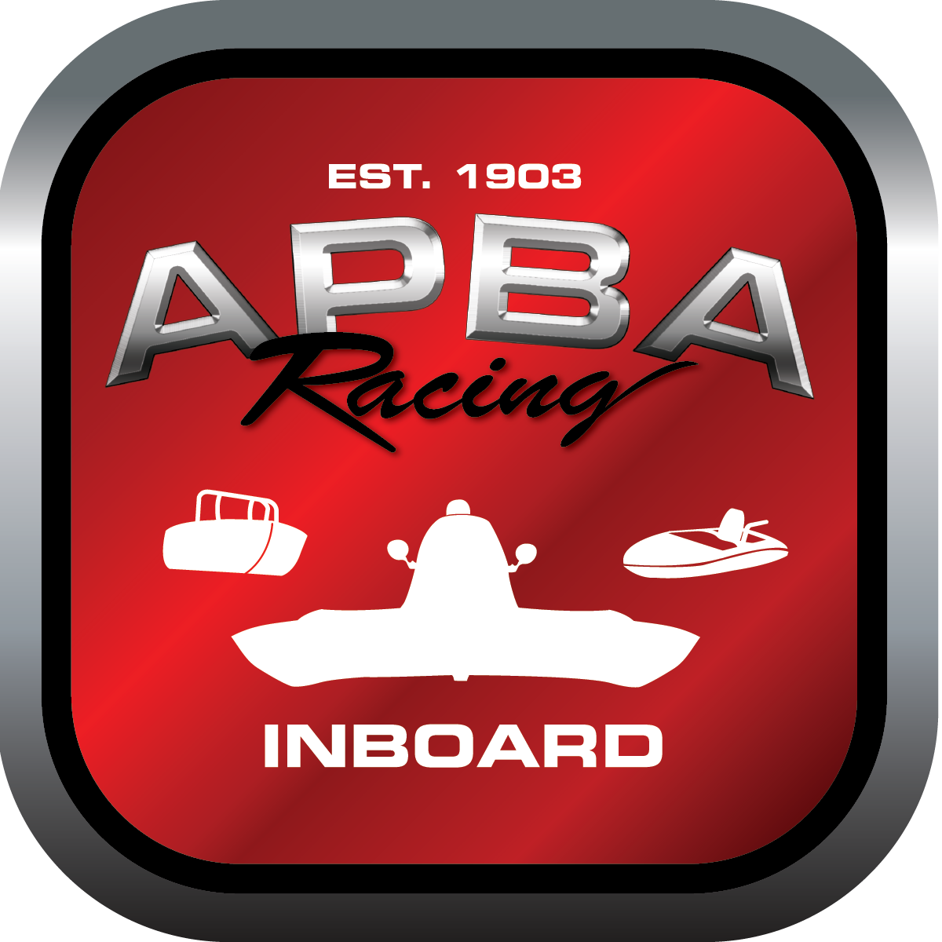
Office use only: T10
Control Number:
Assigned Group:
Initial Screening:
Ballot: Pass: ______/ Fail: _____
Effective for Race Year: 2019

2019 Inboard Rule Change Proposal

Name: John K Bosserman
APBA #: 75830
E-mail: john@norflowinc.com
Telephone:503-784-4604
Date: 10-27-2018

Note: Proposals must be submitted to the Inboard Office by December 1, 2018 to be considered.
Save and E-mail completed form to: inboardracing@apba.org or melildon@yahoo.com
US mail to APBA Inboard Office 8039 Stone Barn Dr, West Chester, Ohio 45069

Check all that apply:
General Safety Rule
General Racing Rule
Stock Class Technical Rule
Modified Class Technical Rule

Affected Class(es): 5litre

Specific Rule Information:
Minimum class weight for 350 engine change
Author’s VERY BRIEF Summary of Proposed Action:
Change minimum weight for 350 engine rule to 1700lbs or weight to match HRL350 engine rule, 305 and 305 mod engine for 5 liter weight remains the same as prior weight rule of 1525lbs.

Affected Rule:
Rule 39.1
Proposed rule:
Add line for minimum weight for 350 engine option of 1700lbs, “ for 350 engine option boat/driver minimum weight shall be 1700lbs.”

Reason for change: help keep heavier older and non foam core boats more competitive in class and for structural safety due to many light core boats having structural failure during events. Also bringing weight in line with Canadian h350class.

