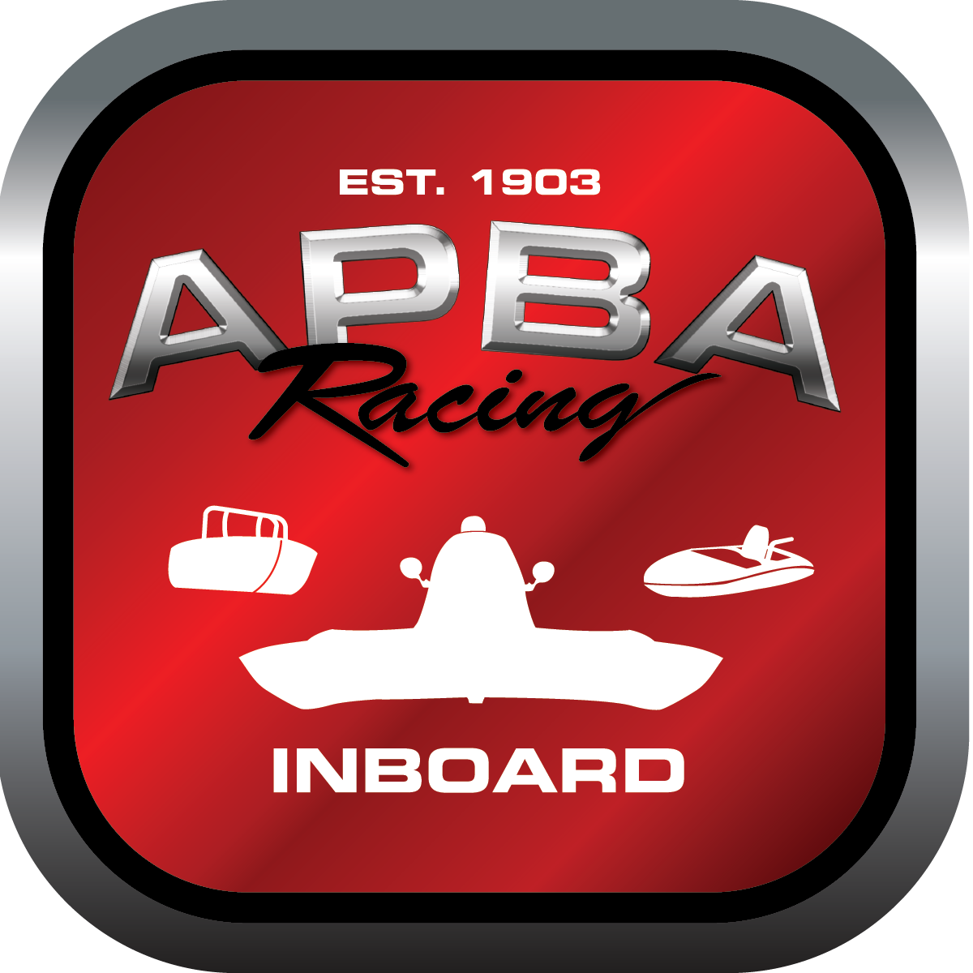
Office use only:
Control Number: T20
Assigned Group:
Initial Screening:
Ballot: Pass: ______/ Fail: _____
Effective for Race Year: 2019

2019 Inboard Rule Change Proposal

Name: Dutch Squires
APBA #: 162
E-mail: megabucks83@comcast.net
Telephone: 303 987 0968
Date: 11/27/18

Note: Proposals must be submitted to the Inboard Office by December 1, 2018 to be considered.
Save and E-mail completed form to: inboardracing@apba.org or melildon@yahoo.com
US mail to APBA Inboard Office 8039 Stone Barn Dr, West Chester, Ohio 45069

Check all that apply:
General Safety Rule
General Racing Rule
Stock Class Technical Rule *
Modified Class Technical Rule *

Affected Class(es): ss/ps

Specific Rule Information: [Note: All fields must be completed for consideration.]

Author’s VERY BRIEF Summary of Proposed Action: combine pro stock and supper stock into 1 capsuled class. Capsuled Flats

Affected Rule:
RULE 52 Pro Stock and rule 53 Super Stock

Proposed rule: Rule 52 Capsuled Flats

Rule 52.1 Pro Stock rules
Rule 52.9 thru 52.xxx Superstock Rules

Reason for change: By combining the classes we have a chance to get a legal field on the race course. It does not require any legal hull to modify anything to be a legal entry. Capsules are required and as/if class grows it will promote more participation in capsuled hulls.

If approver this will require some re-numbering of rules.

