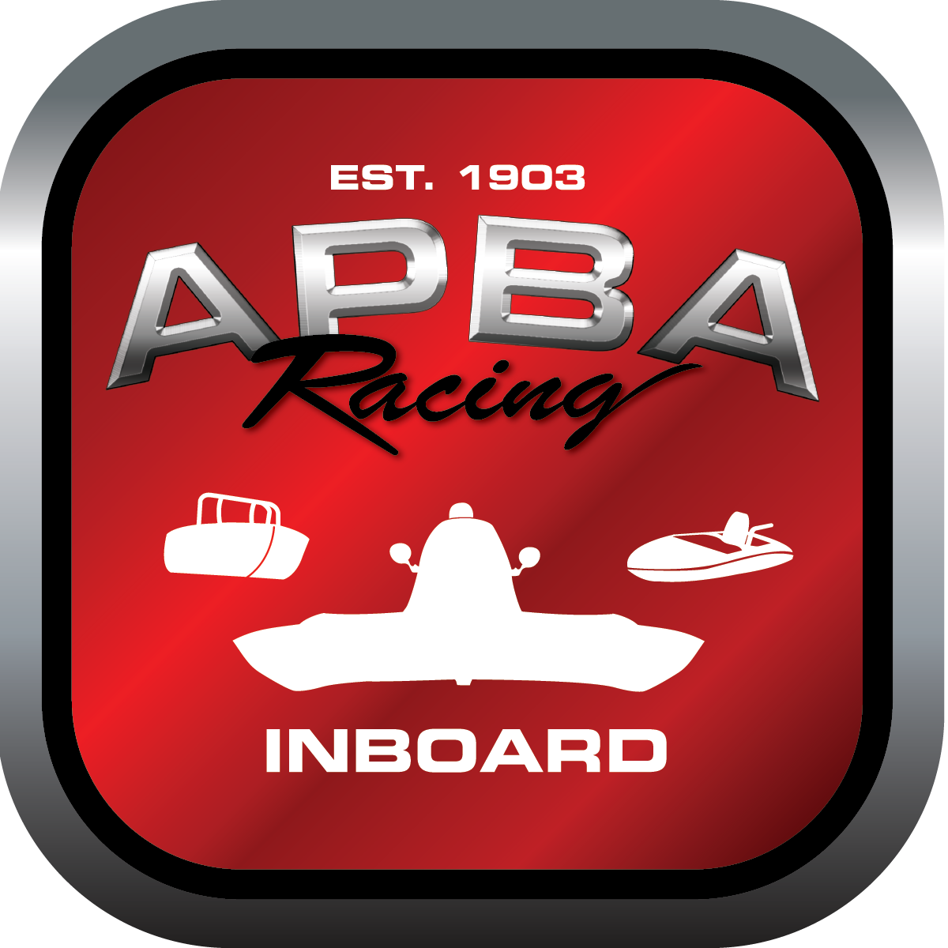
Office use only:
Control Number: S5
Assigned Group:
Initial Screening:
Ballot: Pass: ______/ Fail: _____
Effective for Race Year: 2019

2019 Inboard Rule Change Proposal

Name: Dutch Squires
APBA #: 1621
E-mail: megabucks
Telephone: 303 987 0968
Date: 11/26/18

Note: Proposals must be submitted to the Inboard Office by December 1, 2018 to be considered.
Save and E-mail completed form to: inboardracing@apba.org or melildon@yahoo.com
US mail to APBA Inboard Office 8039 Stone Barn Dr, West Chester, Ohio 45069

Check all that apply:
General Safety Rule
General Racing Rule
Stock Class Technical Rule *
Modified Class Technical Rule * x

Affected Class(es):

Specific Rule Information: [Note: All fields must be completed for consideration.]

Author’s VERY BRIEF Summary of Proposed Action: delete rule 47.3

Affected Rule: 47.3 It is mandatory that all Grand National Hydroplanes competing have two-way radio communications Re number as needed.

Proposed rule:

Reason for change: Not needed all capsuled hulls must have radio communications

