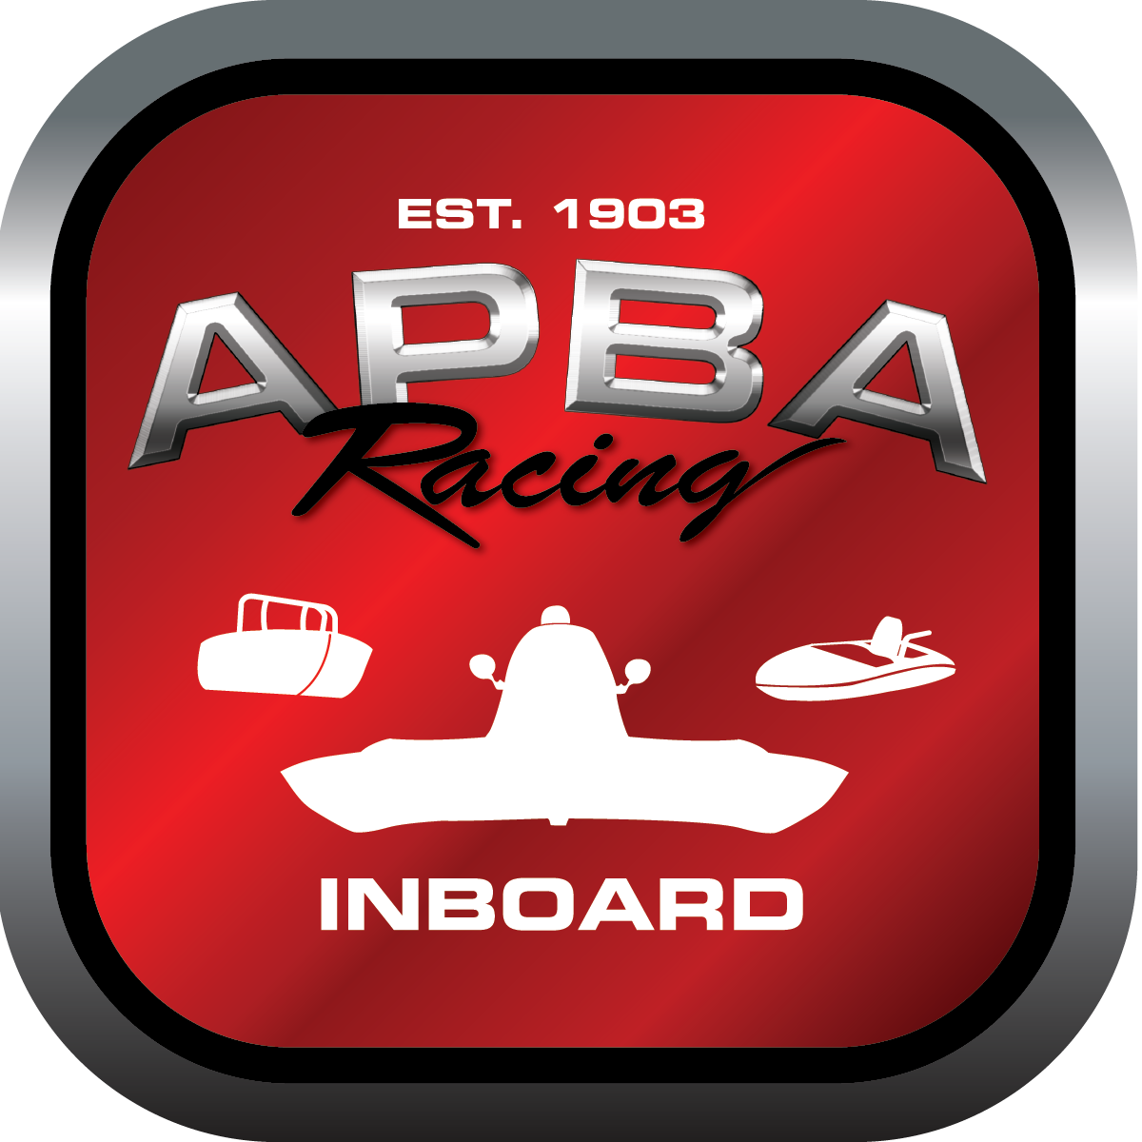
Office use only:
Control Number:
Assigned Group:
Initial Screening:
Ballot: Pass: ______/ Fail: _____
Effective for Race Year: 2019

2019 Inboard Rule Change Proposal

Name:
APBA #:
E-mail:
Telephone:
Date:

Note: Proposals must be submitted to the Inboard Office by December 1, 2018 to be considered.
Save and E-mail completed form to: inboardracing@apba.org or melildon@yahoo.com
US mail to APBA Inboard Office 8039 Stone Barn Dr, West Chester, Ohio 45069

Check all that apply:
General Safety Rule
General Racing Rule
Stock Class Technical Rule *
Modified Class Technical Rule *

Affected Class(es):

Specific Rule Information: [Note: All fields must be completed for consideration.]

Author’s VERY BRIEF Summary of Proposed Action:

Affected Rule:

Proposed rule:

Reason for change:

