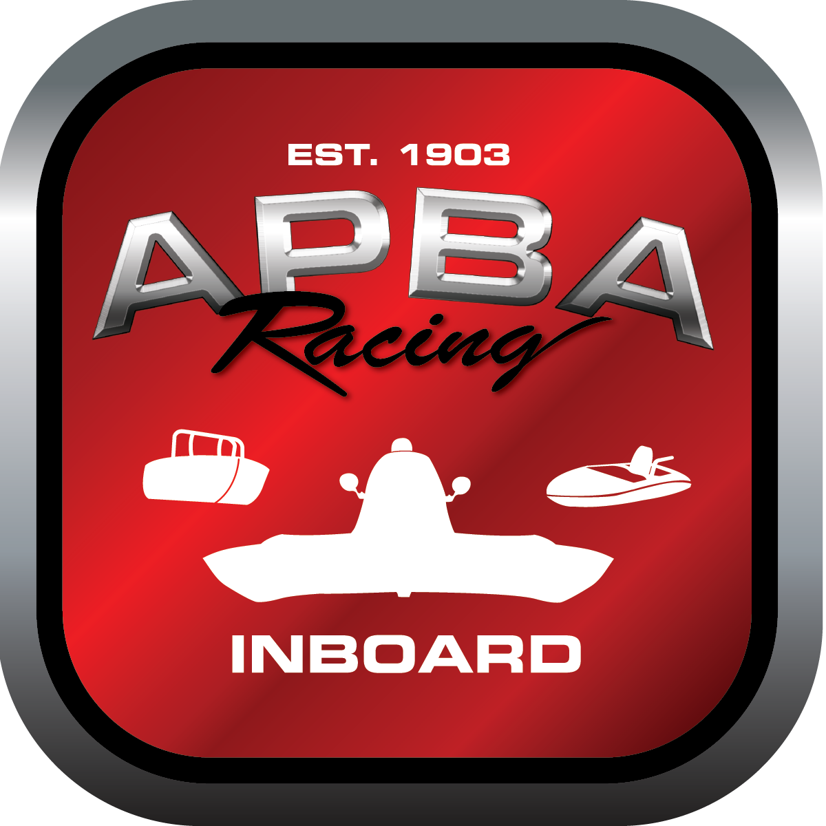
Office use only:
Control Number: NT11
Assigned Group:
Initial Screening:
Ballot: Pass: ______/ Fail: _____
Effective for Race Year: 2019

2019 Inboard Rule Change Proposal

Name: Joe Sovie
APBA #: 50272
E-mail: Sovie43@aol.com
Telephone: 315*323*1589
Date: 11/17/18
Note: Proposals must be submitted to the Inboard Office by December 1, 2018 to be considered.
Save and E-mail completed form to: inboardracing@apba.org or melildon@yahoo.com
US mail to APBA Inboard Office 8039 Stone Barn Dr, West Chester, Ohio 45069

Check all that apply:
General Safety Rule
General Racing Rule
Stock Class Technical Rule * X
Modified Class Technical Rule *

Affected Class(es): 1.5 LItre Stock

Specific Rule Information: [Note: All fields must be completed for consideration.]

Author’s VERY BRIEF Summary of Proposed Action:
To allow younger racers with experience start racing in entry level inboard hydroplane

Affected Rule: 42.1 The purpose of these rules is to promote an entry level class of Inboard hydroplane racing for drivers 14 years of age or older, who will be attracted by relatively low initial cost and economy of operation. It shall be the responsibility of the 1.5 Litre Stock Technical Committee to make technical rule recommendations pertaining to the class to the Inboard Racing Commission.

42.1.2 For testing purposes only- Drivers who are 13 years of age and wish to test at a sanctioned event may do so as long as they are the only boat on the course and all course personnel and Rescue is in place.

Proposed rule: 42.1 The purpose of these rules is to promote an entry level class of Inboard hydroplane racing for drivers 14 years of age or older, who will be attracted by relatively low initial cost and economy of operation. Drivers 13 years of age and have had 2 consecutive years of competition in the J stock classes will also be eligible. It shall be the responsibility of the 1.5 Litre Stock Technical Committee to make technical rule recommendations pertaining to the class to the Inboard Racing Commission.

Reason for change: This rule change would be allowing a younger drive the ability to step up to inboard racing. At this point, the younger driver knows the basics of our rules and has had many heats under their belt.This would also get them interested before they make the next step in outboard classes.

