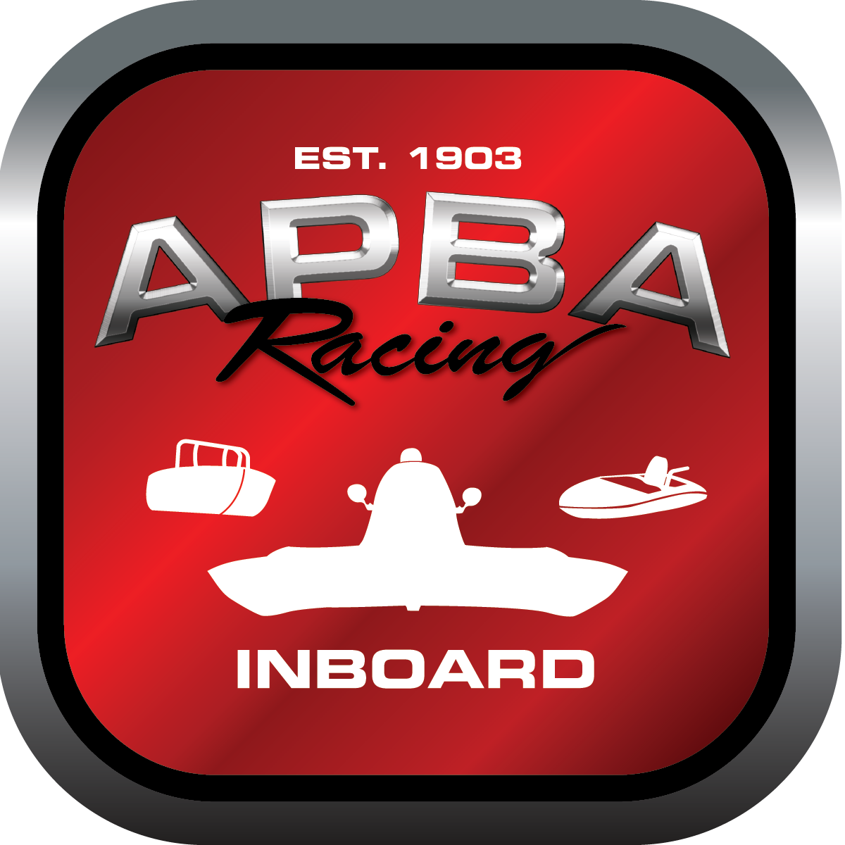
Office use only:
Control Number: T7
Assigned Group:
Initial Screening:
Ballot: Pass: ______/ Fail: _____
Effective for Race Year: 2019

2019 Inboard Rule Change Proposal

Name: ROBERT WILSON
APBA #: 800
E-mail: LEOSRV@EROLS.COM
Telephone: 443-871-6481
Date: 10-29-2018

Note: Proposals must be submitted to the Inboard Office by December 1, 2018 to be considered.
Save and E-mail completed form to: inboardracing@apba.org or melildon@yahoo.com
US mail to APBA Inboard Office 8039 Stone Barn Dr, West Chester, Ohio 45069

Check all that apply:
General Safety Rule
General Racing Rule
Stock Class Technical Rule *
Modified Class Technical Rule *

Affected Class(es): 1 LITER

Specific Rule Information: [Note: All fields must be completed for consideration.]

Author’s VERY BRIEF Summary of Proposed Action: TO INCREASE MAX CC’S AND INTRODUCE ELECTRONIC FUEL INJECTON

Affected Rule: 41.1.3 Maximum displacement, including clearances: 4 cycle - 1260cc.
Fuel: gasoline, carburetors only. Unlimited modifications.

Proposed rule: 41.1.3 MAXIMUM DISPLACEMENT, INCLUDING CLEARANCES : 4 CYCLE – 1650CC SINGLE CAM 2 VALVES PER CYLINDER FUEL: GASOLINE, ELECTRONIC FUEL INJECTION. UNLIMITED MODIFICATIONS

Reason for change: TO ALLOW MORE COMPETIVE 4 CYCLE MOTORS

