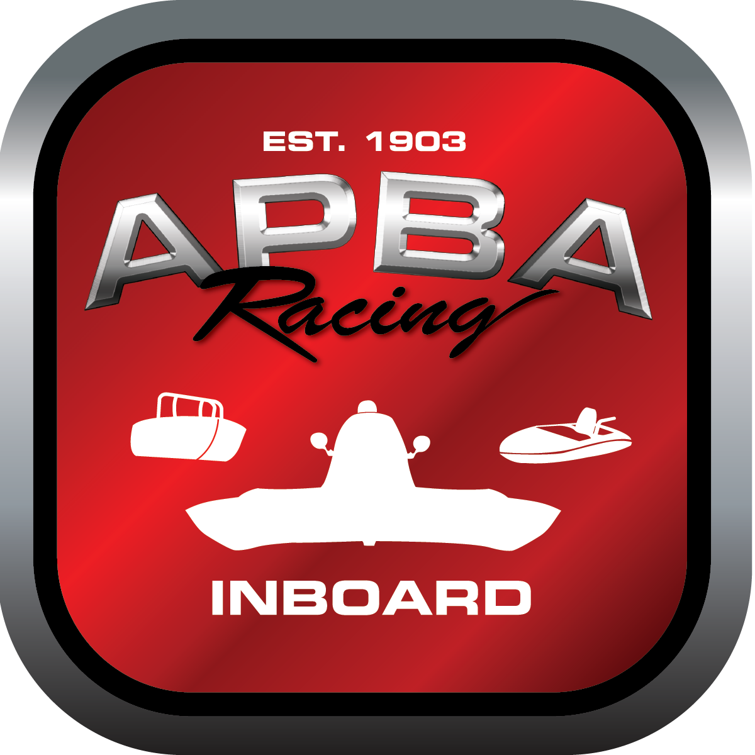
Office use only:
Control Number: T3
Assigned Group:
Initial Screening:
Ballot: Pass: ______/ Fail: _____
Effective for Race Year: 2019

2019 Inboard Rule Change Proposal

Name: Joe Sovie
APBA #: 50272
E-mail: Sovie43@aol.com
Telephone: 315-323-1589
Date: 10-30-18
Note: Proposals must be submitted to the Inboard Office by December 1, 2018 to be considered.
Save and E-mail completed form to: inboardracing@apba.org or melildon@yahoo.com
US mail to APBA Inboard Office 8039 Stone Barn Dr, West Chester, Ohio 45069

Check all that apply:
General Safety Rule
General Racing Rule
Stock Class Technical Rule
Modified Class Technical Rule X

Affected Class(es): 1 Litre Mod

Specific Rule Information: [Note: All fields must be completed for consideration.]

Author’s VERY BRIEF Summary of Proposed Action: This option would allow a already proven engine to be a 4 stroke option for this class. The current 4 stroke option is so outdated and is not competitive as a equivalent engine option. This option would tighten up the competition and make the show better for our fans.

Affected Rule: 41.1.5 Maximum displacement, including clearances: 124.7ci. Ford Pinto. Boats using this motor must conform to all the rules of the 2.5 Litre
Stock Class.

Proposed rule: RULE 43 - 2.5 LITRE STOCK CLASS (2.3 Litre) with Head option 2. Boats using this motor must conform to all the rules of 2.5 Litre Stock Class.

Reason for change: The 1 Litre Mod class has been dominated for the past number of years by the 2 stroke engine. The current 2000cc pinto engine is far from being a equivalent power plant. The older 2.3 Litre cast iron heads are being replaced by the new Esslinger design. This engine configuration is still available and would allow a racer to competitive is the the 1 Litre mod and 2.5 stock classes.

