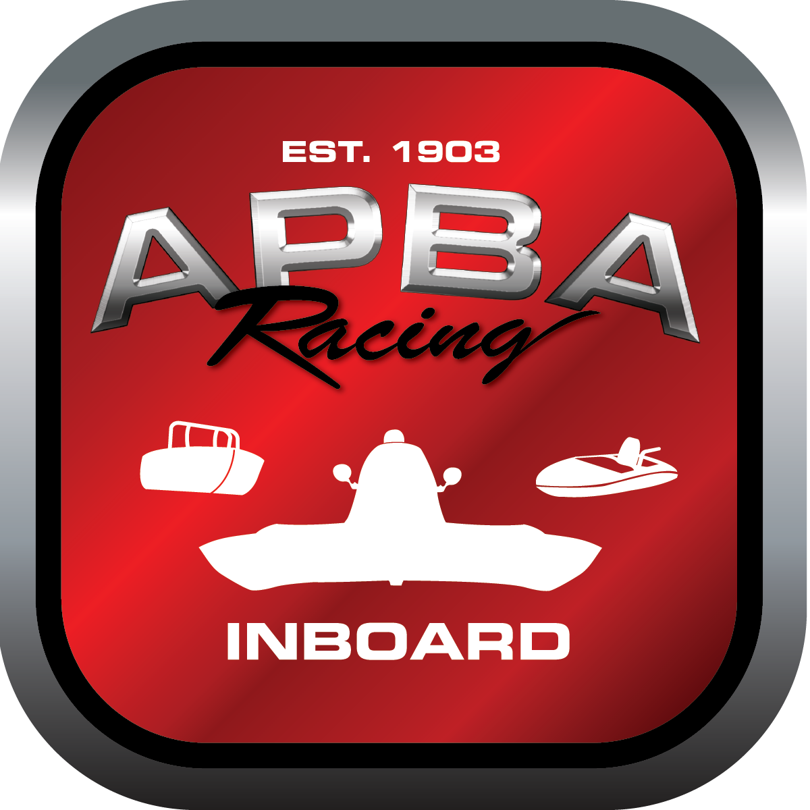
Office use only:
Control Number: T21
Assigned Group:
Initial Screening:
Ballot: Pass: ______/ Fail: _____
Effective for Race Year: 2019

2019 Inboard Rule Change Proposal

Name: Dutch Squires
APBA #: 1621
E-mail: megabucks83@comcast.net
Telephone: 303 987 0968
Date: 11/26/18

Note: Proposals must be submitted to the Inboard Office by December 1, 2018 to be considered.
Save and E-mail completed form to: inboardracing@apba.org or melildon@yahoo.com
US mail to APBA Inboard Office 8039 Stone Barn Dr, West Chester, Ohio 45069

Check all that apply:
General Safety Rule
General Racing Rule
Stock Class Technical Rule *
Modified Class Technical Rule * x

Affected Class(es): NM,2.5 mod,5ltr

Specific Rule Information: [Note: All fields must be completed for consideration.]

Author’s VERY BRIEF Summary of Proposed Action: allow 2.5 mod and 5 ltr to be legal entries in the NM class

Affected Rule:

Proposed rule: 46.6 A 2.5 mod and a 5 ltr are legal entries in the NM class.

(Excludes hulls registered as 2.5 stock S boats)

Reason for change: Allow 2.5 mod and 5 ltr as a legal entry in the NM class. Support for the NM class. More boats on the water. More entry fees for clubs.

