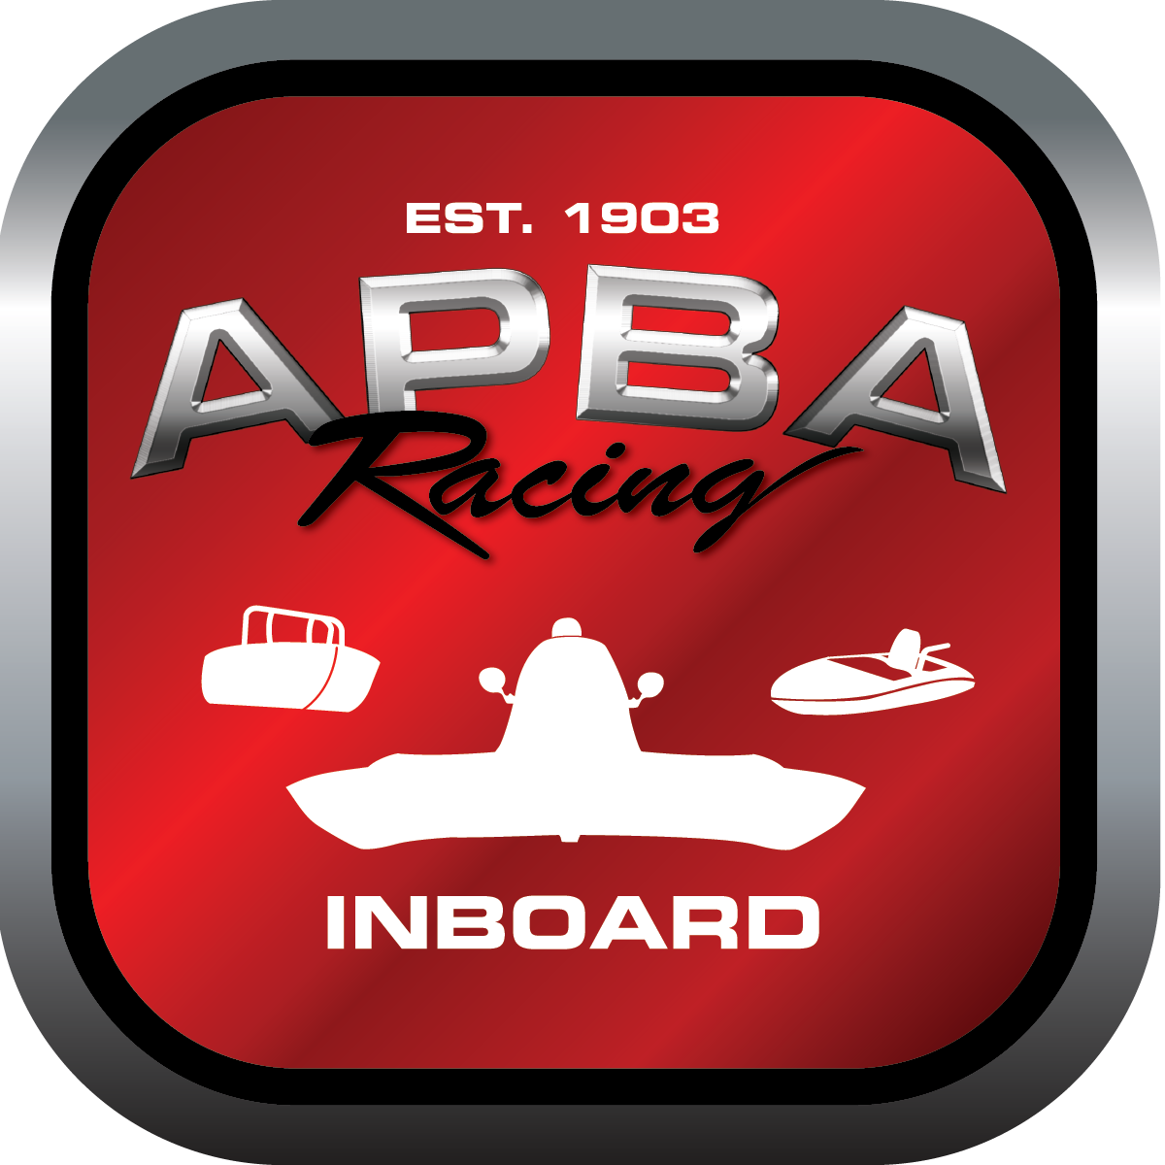
Office use only:
Control Number: NT4
Assigned Group:
Initial Screening:
Ballot: Pass: ______/ Fail: _____
Effective for Race Year: 2019

2019 Inboard Rule Change Proposal

Name: Rob Garratano
APBA #: 72068
E-mail: No1SpeedSkiff@Verizon.net
Telephone: 732-222-3224
Date: November 6, 2018

Note: Proposals must be submitted to the Inboard Office by December 1, 2018 to be considered.
Save and E-mail completed form to: inboardracing@apba.org or melildon@yahoo.com
US mail to APBA Inboard Office 8039 Stone Barn Dr, West Chester, Ohio 45069

Check all that apply:
General Safety Rule
General Racing Rule
Stock Class Technical Rule *
Modified Class Technical Rule *

Affected Class(es): All Inboard classes

Specific Rule Information: [Note: All fields must be completed for consideration.]

Author’s VERY BRIEF Summary of Proposed Action:

Affected Rule: Inboard Racing Rule #9.9, #9.9.1 and 9.9.2

Proposed rule: Remove all three rules in their entirety.

Reason for change: The retiring of an Inboard racing number has never been awarded and the criteria to do so is not likely to be attained. Everyone agrees that the rule book needs to be streamlined and condensed.

