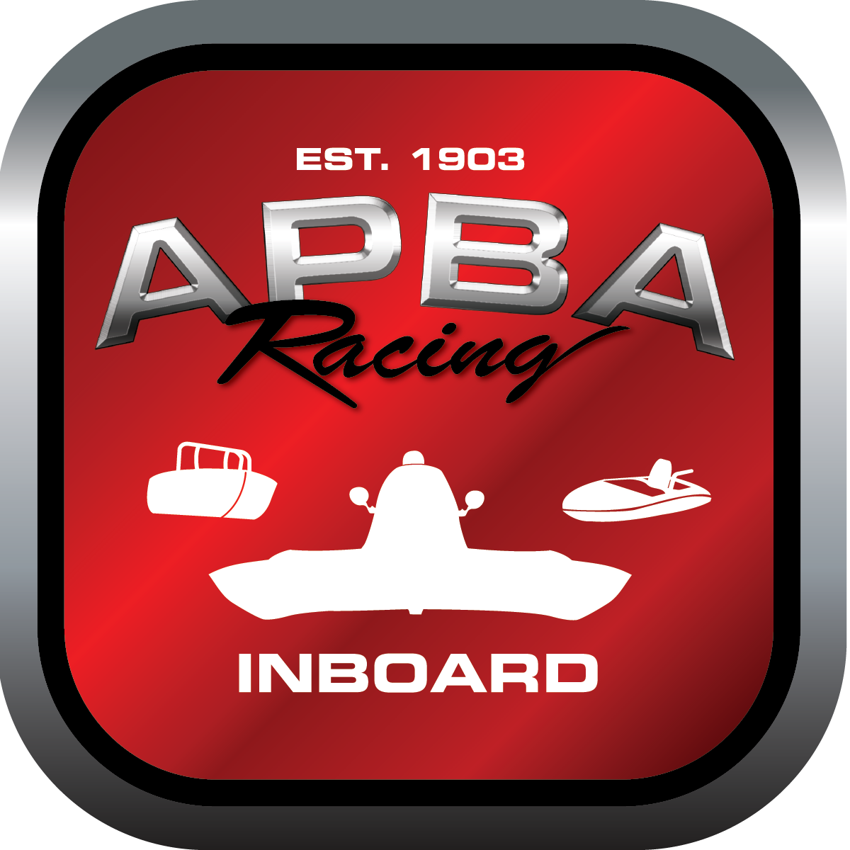
Office use only:
Control Number: S3
Assigned Group:
Initial Screening:
Ballot: Pass: ______/ Fail: _____
Effective for Race Year: 2019

2019 Inboard Rule Change Proposal

Name: Ann Fitzgerlad
APBA #: 2348
E-mail: annfitzgerald@comcast.net
Telephone: 609-889-9181
Date: 12/1/18

Note: Proposals must be submitted to the Inboard Office by December 1, 2018 to be considered.
Save and E-mail completed form to: inboardracing@apba.org or melildon@yahoo.com
US mail to APBA Inboard Office 8039 Stone Barn Dr, West Chester, Ohio 45069

Check all that apply:
General Safety Rule
General Racing Rule X
Stock Class Technical Rule *
Modified Class Technical Rule *

Affected Class(es): All classes

Specific Rule Information: [Note: All fields must be completed for consideration.]

Author’s VERY BRIEF Summary of Proposed Action:

Affected Rule: 16.2.9.1 All boats will score up at the middle backstretch buoy at the predetermined score up time from the drivers meeting. All boats will establish their lane at the exit pin of turn two. After lanes are established, they must hold their lane until the start/
finish line.

Proposed rule: 16.2.9.1 All boats will score up at the middle backstretch buoy at the predetermined score up time from the drivers meeting. All boats will establish their lane at the score up pin. After lanes are established, they must hold their lane to the start/finish line and through the first turn; thereafter, the overlap rule is in effect.

Reason for change: The current rule results in dangerous situations as it allows boats to change lanes in the turn oftentimes causing all the other drivers to shift lanes and fowl one another. Between the score up pin and the starting line, drivers need to focus on their timing and holding their lane and getting a full-throttle start.

