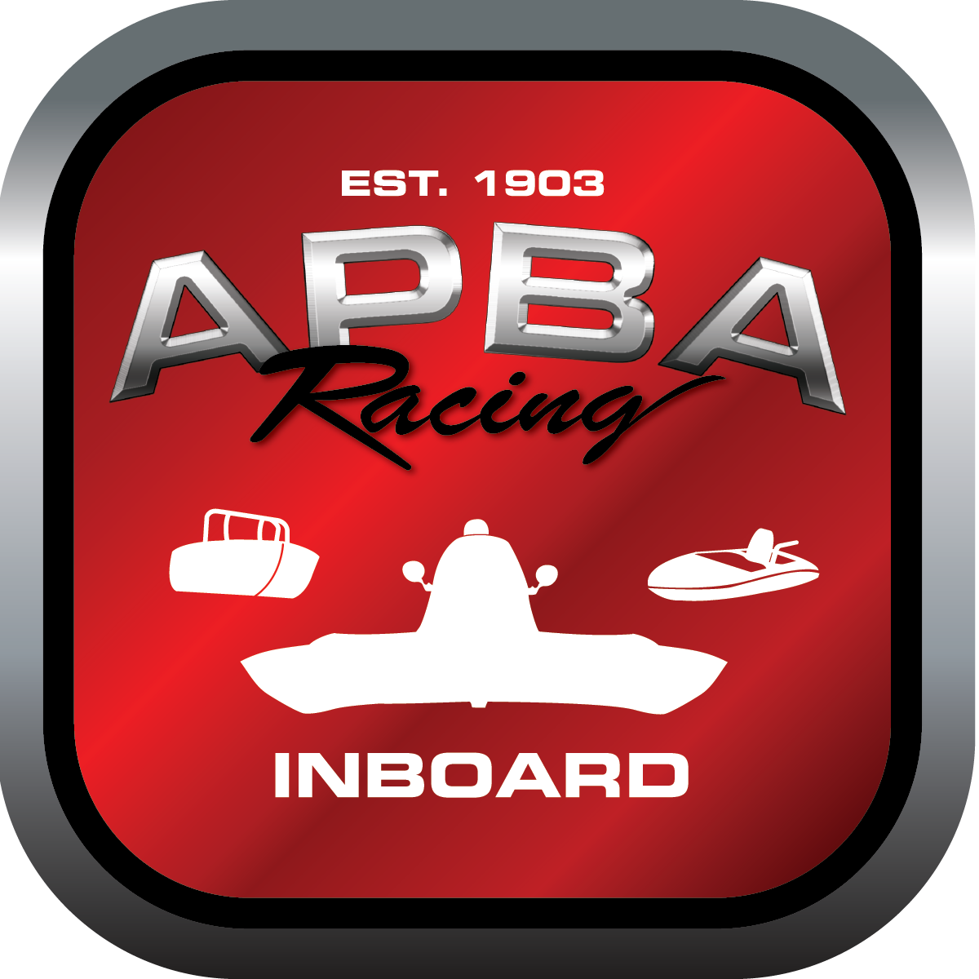
Office use only:
Control Number: T16
Assigned Group:
Initial Screening:
Ballot: Pass: ______/ Fail: _____
Effective for Race Year: 2019

2019 Inboard Rule Change Proposal

Name: DON WHITNEY GNH D
APBA #: 701
E-mail: donaldeli.whitney@sbcglobal.net
Telephone: 586-940-9869
Date: 01DE2018

Note: Proposals must be submitted to the Inboard Office by December 1, 2018 to be considered.
Save and E-mail completed form to: inboardracing@apba.org or melildon@yahoo.com
US mail to APBA Inboard Office 8039 Stone Barn Dr, West Chester, Ohio 45069

Check all that apply:
General Safety Rule
General Racing Rule
Stock Class Technical Rule *
Modified Class Technical Rule * X

Affected Class(es): GNH

Specific Rule Information: [Note: All fields must be completed for consideration.]

Author’s VERY BRIEF Summary of Proposed Action: ADD ENGINE COMBINATIONS TO THE ALLOWABLE USE LIST WITHIN RULE 47.

Affected Rule: 47. GNH class technical rule; 39.1 hull technical data chart

Proposed rule: modify 47.6.3.9: delete phrasing 2500 pounds excluding driver, replace with 2600 pounds including driver.

Reason for change The weight change for the 511 cid engine option benefit: weighing procedure the same as all the other classes (hull is weighed with driver and driver’s equipment) – less confusion for inspectors.

