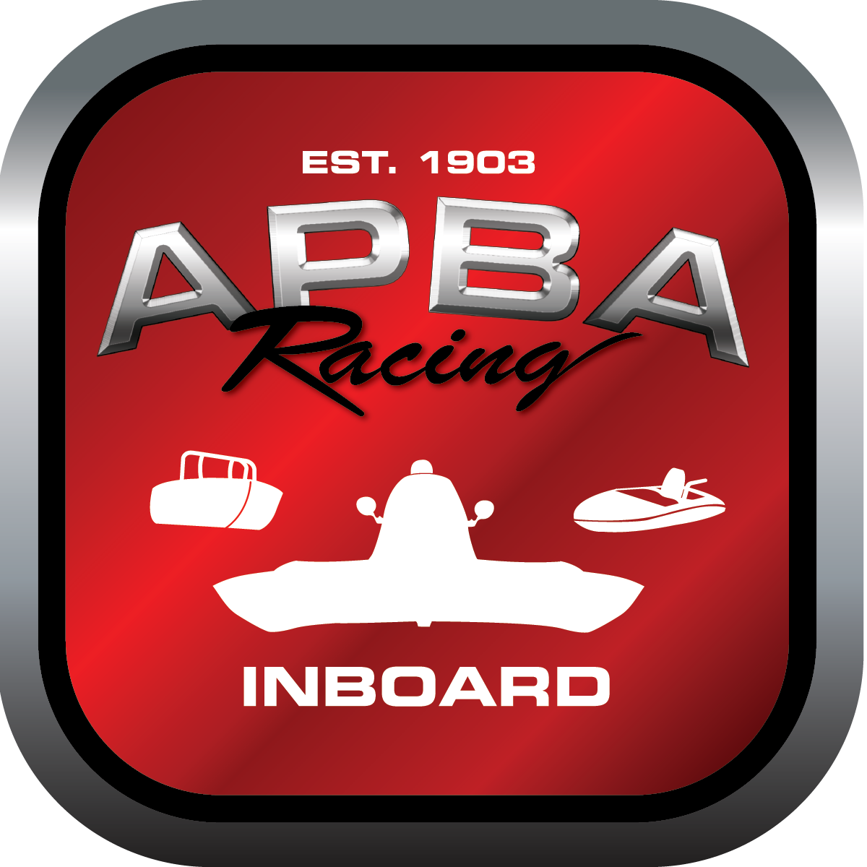
Office use only:
Control Number: T14
Assigned Group:
Initial Screening:
Ballot: Pass: ______/ Fail: _____
Effective for Race Year: 2019

2019 Inboard Rule Change Proposal

Name: DON WHITNEY GNH C
APBA #: 701
E-mail: donaldeli.whitney@sbcglobal.net
Telephone: 586-940-9869
Date: 01DE2018

Note: Proposals must be submitted to the Inboard Office by December 1, 2018 to be considered.
Save and E-mail completed form to: inboardracing@apba.org or melildon@yahoo.com
US mail to APBA Inboard Office 8039 Stone Barn Dr, West Chester, Ohio 45069

Check all that apply:
General Safety Rule
General Racing Rule
Stock Class Technical Rule *
Modified Class Technical Rule * X

Affected Class(es): GNH

Specific Rule Information: [Note: All fields must be completed for consideration.]

Author’s VERY BRIEF Summary of Proposed Action: ADD ENGINE COMBINATIONS TO THE ALLOWABLE USE LIST WITHIN RULE 47.

Affected Rule: 47. GNH class technical rule; 39.1 hull technical data chart

Proposed rule: ADD: 47.6.4 NM boats meeting specs for paragraphs 46.4 and 46.5, weighing 1900 pounds minimum, and 19 feet hull length minimum are legal GNH.

Reason for change: Restore ability for the larger NM class boats to race with GNH Class boats.

