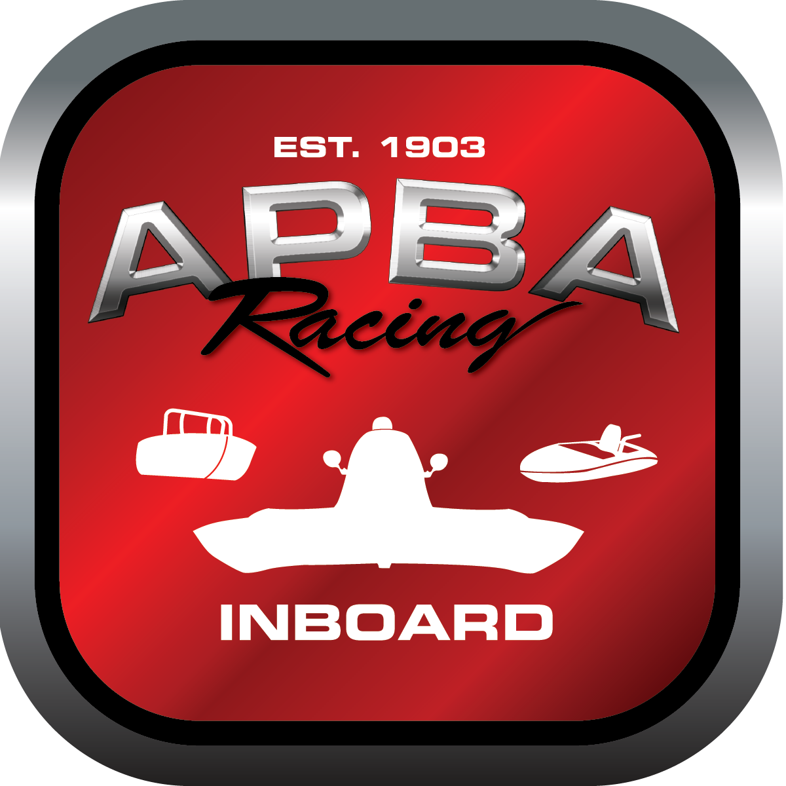
Office use only:
Control Number: S4
Assigned Group:
Initial Screening:
Ballot: Pass: ______/ Fail: _____
Effective for Race Year: 2019

2019 Inboard Rule Change Proposal

Name:DON WHITNEY GNH B
APBA #: 701
E-mail: donaldeli.whitney@sbcglobal.net
Telephone:586-940-9869
Date: 01DE2018
Note: Proposals must be submitted to the Inboard Office by December 1, 2018 to be considered.
Save and E-mail completed form to: inboardracing@apba.org or melildon@yahoo.com
US mail to APBA Inboard Office 8039 Stone Barn Dr, West Chester, Ohio 45069

Check all that apply:
General Safety Rule X
General Racing Rule
Stock Class Technical Rule *
Modified Class Technical Rule * X

Affected Class(es): GNH

Specific Rule Information: [Note: All fields must be completed for consideration.]

Author’s VERY BRIEF Summary of Proposed Action: DELETE REFERENCE TO SPECIAL RADIO TYPE REQUIREMENT; DEFER TO APBA GSR 13 A

Affected Rule: 47.3 It is mandatory that all Grand National Hydroplanes competing have two-way radio communications.

Proposed rule: Delete 47.3 ( 47.3 It is mandatory that all Grand National Hydroplanes competing have two-way radio communications. ) renumber succeeding paragraphs as needed.
OR 47.3 It is mandatory that all Grand National Hydroplanes competing have two-way radio communications. ADD: GNH hydroplanes shall comply with APBA GSR 13 A re: shore to driver audio communication required.

Reason for change: 1. Apba GSR 13 A requires shore to driver audio communication, which is sufficient to maintain safe racing operations. This GNH rule is redundant. 2. Cost – 2 way communication requires extra equipment that adds cost, complexity, and reliability problems.

