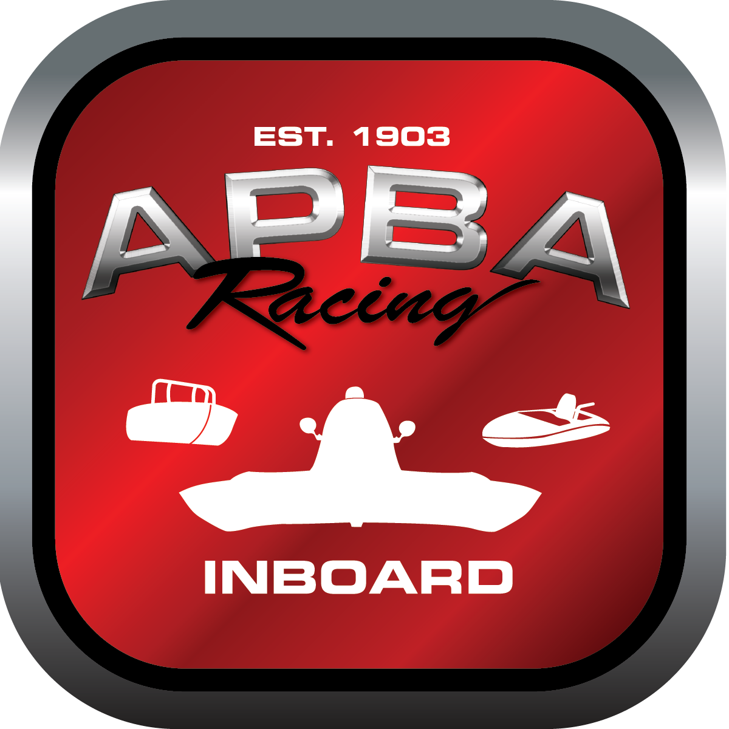
Office use only:
Control Number: T15
Assigned Group:
Initial Screening:
Ballot: Pass: ______/ Fail: _____
Effective for Race Year: 2019

2019 Inboard Rule Change Proposal

Name: DON WHITNEY GNH A
APBA #: 701
E-mail: donaldeli.whitney@sbcglobal.net
Telephone: 586-940-9869
Date: 01DE2018
Note: Proposals must be submitted to the Inboard Office by December 1, 2018 to be considered. Save and E-mail completed form to: inboardracing@apba.org or melildon@yahoo.comUS mail to APBA Inboard Office 8039 Stone Barn Dr, West Chester, Ohio 45069
Check all that apply:
General Safety Rule
General Racing Rule
Stock Class Technical Rule *
Modified Class Technical Rule * X

Affected Class(es): GNH

Specific Rule Information: [Note: All fields must be completed for consideration.]

Author’s VERY BRIEF Summary of Proposed Action: ADD ENGINE COMBINATIONS TO THE ALLOWABLE USE LIST WITHIN RULE 47.

Affected Rule: 47. GNH class technical rule; 39.1 hull technical data chart

Proposed rule: : a. Rule 47.1 Delete the phrasing “ , big block (defined as…..4.600”) “
b. 47.3 Delete all current wording (two way radio), replace with “ Each GNH driver competing shall comply with APBA General Safety Rule re: audio communication between shore and driver.”
c.Add 47.6.4 Engine Option 4; under this new rule copy the rules 46.4 and 46.5 in their entirety (these are the 308 cid and 368 cid engine options in NM). Also add the stipulations that 1.weight and hull minimums are the same as current for NM with those engines; and 2. Driver minimum age is the same as current for GNH, which is 18 (NM is 16). Rule 39.1 will require some adjustment to the chart.
d. modify 47.6.3.9: delete phrasing 2500 pounds excluding driver, replace with 2600 pounds including driver.
e. add wording to 47.6.1, 47.6.2, and 47.6.3: cylinder block bore spacing minimum 4.600 in.

Reason for change: 1, Radio requirement (two way) is redundant with APBA GSR requiring shore to driver audio communication for restrained drivers.
2. Enable the larger NM hulls to race with GNH as in prior years.
3. weighing procedures shall be the same as all the other classes (hull is weighed with driver and driver’s equipment) – less confusion for inspectors.

