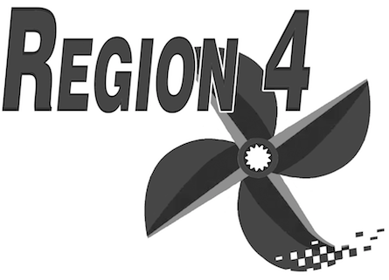
Spring Meeting / Banquet / Safety Cell Training
February 4th, 2017
Meeting Location:
Fisherman's Inn
3116 Main St.
Grasonville, MD 21638
Meeting check-in will start at 9:30 am; meetings will begin at 10:00 am
Cell Test:
1:00 pm
Best Western Hotel
3101 Main St
Grasonville, MD 21638
A block of rooms has been set-aside at the Best Western under Region 4 for $89 per night. You can phone 410-827-6768, or toll-free at 800-828-3361. Otherwise you may email: sales.bw.kentnarrows@gmail.com.
Banquet:
Fisherman's Inn.
Schedule is as follows:
6:30 - Meet and Greet
7:00 - Dinner with awards to follow
$60 per person (seating is limited)
Menu: Choose one (1) of the following:
- Maryland Crab Cakes (2)
- Prime Rib
- Chicken Parmesan
All selections include: Tea, Soda, Coffee, Hot Rolls & Butter, Garden Salad, Baked Potato, Vegetable Medley, and for dessert - house-made vanilla ice cream.
Cash bar and door prizes
Reservations are required and can be made by sending menu choice and check no later than Friday, January 27th to:
KNRA
PO Box 350
Chester, MD 21619

