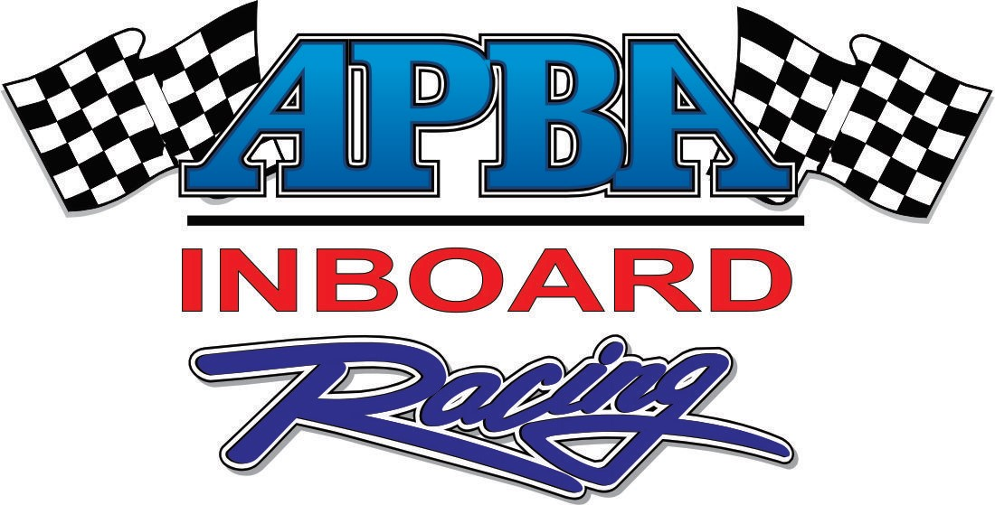

SPONSOR PROPOSAL

The following is a sample sponsor proposal to solicit a local sponsor for an APBA racing event. Actual numbers and content depend on the type of event and the value of the benefits that you are providing. Try to keep it short and simple. You might add a few action race photos to this proposal to spice it up.

I. INTRODUCTION
Americans love hot summer days, extreme sports, music, racing and competition! How do you reach these consumers? Start with the secret ingredient: Water. How do you get their attention? With one of the world's most exciting motorsports: Inboard Hydroplane Racing! How do you make this work for you? Become a sponsor of the Inboard Hydrofest in City, State.
When you hear the huge roar of automotive engines and catch a glimpse of giant roostertails, you know that Inboard Hydroplanes are on the water. As the American Powerboat Association’s largest racing category, Inboard Racing includes both runabouts and hydroplanes that are fast, fun and LOUD. Classes range from wild Jersey Speed Skiffs (70 MPH)) to supercharged 1,500 horsepower Grand Prix Hydroplanes (170 MPH). Inboard Racing combines the casual summertime appeal of beach events with the high-speed thrills of competitive motorsports. On shore, the atmosphere is electric. Powerful, sleek raceboats, dramatic staging, a professional sound system, banners, flags, and pit tents set the stage for a truly spectacular event.
The Inboard Hydrofest will take place in Dayton, Ohio on July 00-00, 20XX. The Inboard Hydrofest features the United States and Canada’s top racers and teams in the highly explosive and exciting sport of Inboard Racing. These racers utilize the most advanced equipment and technology to push their boats to top speeds. Inboard Racing is a fierce battle of skill, technology and innovation on and off the water.
II. PROMOTION
Advertising and Publicity
From both a participant and a spectator standpoint, the local, regional and national levels of promotion will be covered extensively. The XYZ Club will utilize Propeller magazine and boat racing related websites to create awareness and publicity for the event and attract participants. Locally, we will work with local media outlets, dealers and local site and local coordinators, who have strongholds in the surrounding areas of each race site, to promote the events via radio, newspaper, posters, flyers and special events.
The local race committee will employ a comprehensive local advertising program utilizing a variety of media, including radio, print advertising, street banners, flyers and event posters, to promote the event. The advertising will be targeted to active consumers and designed to generate awareness, enhance sponsorships and drive attendance. Press releases announcing the event will also be sent to all local newspapers within 45 miles of each race site. Select event partners will provide additional advertising for the events that will generate a significant amount of pre-race publicity for each event.
Internet Publicity
The Inboard Hydrofest will be promoted extensively on the Internet on www.apba.org, yourwebsitename.com and popular boat racing internet sites and forums. These websites will be used to promote the event, the event sponsors, and attract participants to the event.
“On-Site” Presentation
The Inboard Hydrofest incorporates several unique and exciting staging features into its aquatic arena. The events stage, scoring stands, shoreline banners, and pit fencing provide excellent signage locations to enhance sponsors image and create brand awareness. The combination of advanced promotion and advertising, professional on-site appearance, great racing and spectator crowds create an event racing experience.
During competition, the public address announcers guide spectators through the waves and around the buoys, giving insight into the personalities and technology of professional watercraft racing. The stage manager will ensure delivery of public address announcements and keep the crowd entertained with the hottest music and on-site giveaways.
Posters
The XYZ Club will produce and distribute 300 custom-designed event posters. Your city/event name and/or logo, will be prominently featured on all posters, flyers and other materials. The Inboard Hydrofest will provide space on the event poster for up to ten local sponsor logos. Local sponsors’ names will also be mentioned in all press releases and other print media promotions related to the event. Posters will be sent to the host site to be distributed throughout the target market via local merchants, boating dealerships and businesses. The host site and sponsors will also be mentioned on the APBA website.
III. SPONSOR BENEFITS
The APBA Inboard Hydrofest Offers Excellent Opportunities to:
- Advertise
- Drive Sales
- Support Local Dealer Network
- Reach Live Consumers
- Create Company and Product Awareness
- Display New Products
- Generate National and Local Media Exposure
The Total Market Exposure
- Live Race Audience
- Local Television Coverage
- Internet Publicity
- Local Media Coverage
- Event Posters
- Race Day Public Address System Announcements
IV. SPONSOR PACKAGES

Gold Sponsorship Package

Sponsorship Fee $???????

Gold Sponsor Obligations
- $??????? toward event promotional and production expenses;
- Provide company banners, banner ad for Internet, and logo for printed material.

Gold Sponsor Benefits
- On-site signage at the event (level 1);
- Mention in all printed material (posters, flyers, local advertising, press releases, etc.);
- Complimentary corporate display space at event (up to 20ft X 20ft);
- Substantial company mention by announcers at event;
- Company mention on internet as well as link to your company’s website;
- 50 complimentary tickets to the event;
- Extra-large logo on event posters;
- Extra-large logo on premiums such as event T-shirts.

Silver Sponsorship Package

Sponsorship Fee $????????

Silver Sponsor Obligations
- $????????toward event promotional and production;
- Provide company banners, banner ad for Internet, and logo for printed material.

Silver Sponsor Benefits
- On-site signage at the event (level 2);
- Mention in printed material (posters, flyers, advertising, press releases, etc.);
- Complimentary corporate display space at event (up to 10ft X 15ft);
- Substantial company mention by announcers at event;
- Company mention on internet as well as link to your company’s website;
- 20 complimentary tickets to the event;
- Large logo on event posters;
- Large logo on premiums such as event T-shirts.

Bronze Sponsorship Package

Sponsorship Fee $???????

Bronze Sponsor Obligations
- $????? toward event promotional and production expenses;
- Provide company banners, banner ad for Internet, and logo for printed material.

Bronze Sponsor Benefits
- On-site signage at the event (level 3);
- Mention in printed material (i.e.: Posters, flyers, advertising, press releases, etc.);
- Complimentary corporate display space at event (up to 10ft X 10ft);
- Substantial company mention by announcers at event;
- Company mention on internet as well as link to your companies website;
- 10 complimentary tickets to the event;
- Medium logo on event posters;
- Medium logo on premiums such as event T-shirts.

VI. Conclusion
Many companies recognize APBA Inboard Hydroplane racing events as an ideal medium to express their advertising messages. The visual attraction of these fast, colorful boats locked in competition, plus the appeal of picturesque waterfront settings, combine to produce vast live audiences, local television coverage, articles in Propeller magazine and excellent coverage in daily newspapers.
To briefly summarize, your company will receive many benefits by getting involved with the APBA Inboard Hydrofest, namely: visibility of the company name and products; substantial media exposure through TV, livestreaming, print and radio impressions; a viable avenue to advertise and reach new customers and show your support to the local community. By getting involved with the 2017 APBA Inboard Hydrofest, your company will gain visibility at one of the largest and most successful Inboard events in North America.
Thank you for considering sponsorship of the
2018 APBA Inboard Hydrofest!

