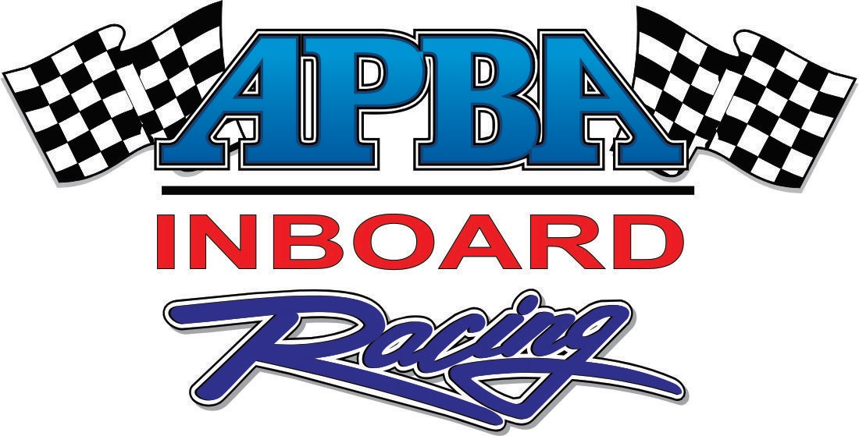

2018 HOST SITE PROPOSAL
The following is a sample of a proposal to solicit a race site to host an APBA racing event. Actual numbers and content of the proposal will depend on your club’s needs, actual costs and what you will agree to do for the race site. This Word document, which you can modify as your sample proposal is available to current APBA Clubs and promoters.

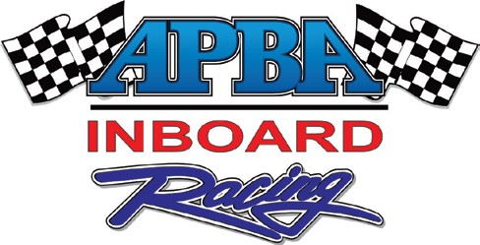

APBA HYDROFEST SAMPLE PROPOSAL

INTRODUCTION
Americans love hot summer days, extreme sports, music, racing and competition! How do you reach these consumers? Start with the secret ingredient: Water. How do you get their attention? With one of the world's most exciting motorsports: Inboard Hydroplane Racing! How do you make this work for you? Host an American Power Boat Association Inboard Racing event.
From the hottest cities and waterways in the United States, to some of the largest festivals, thousands of racing enthusiasts will be on hand to catch the excitement of the 2018 APBA Inboard Racing season. In addition to on-site spectators, millions of others will read about your event in boating magazines, local newspapers and online—or hear about it on radio or TV—and want to participate.
Inboard Hydroplane Racing is one of the most exciting sports on the water. This action-packed event will feature the United States and Canada’s top Inboard racers doing battle against one another while negotiating buoys and pounding waves. Each racer will be vying for cash, prizes and awards, en route to the prestigious APBA Inboard Hydrofest titles and awards.

EVENT DETAILS
When you hear the huge roar of automotive engines and catch a glimpse of giant roostertails, you know that Inboard Hydroplanes are on the water. As the APBA’s largest racing category, Inboard Racing includes both runabouts and hydroplanes that are fast, fun and LOUD. Classes range from wild Jersey Speed Skiffs (70 MPH)) to supercharged 1,500 horsepower Grand Prix Hydroplanes (170 MPH). Inboard Racing combines the casual summertime appeal of beach events with the high-speed thrills of competitive motorsports. On shore, the atmosphere is electric. Powerful, sleek raceboats, dramatic staging, a professional sound system, banners, flags, and pit tents set the stage for a truly spectacular event.
The Inboard Hydrofest features many United States and Canadian top racers and teams in the highly explosive and exciting sport of Inboard Racing. These racers utilize the most advanced equipment and technology to push their boats to top speeds. Inboard Racing is a fierce battle of skill, technology and innovation on and off the water.

“ON-SITE” PRESENTATION
The Inboard Hydrofest incorporates several unique and exciting staging features into its aquatic arena. The custom-built stage, scoring stands, shoreline banners, on-water inflatables, and more, provide excellent signage locations to enhance a sponsor’s image. Advance promotion and advertising, professional on-site appearance, great racing and crowds of spectators create an event experience that keeps a community buzzing for weeks to follow.
During competition, the public address announcers guide spectators through the waves and around the buoys, giving insight into the personalities and technology of Inboard Racing. Between race heats, the focus changes to the racers, sponsors and local partners. Spectators are encouraged to visit the food and vendor booths and meet the racers in the pits. The stage manager will ensure delivery of public address announcements and keep the crowd entertained with the hottest music and on-site giveaways.

ACCOUNTABILITY
THE INBOARD HYDROFEST TEAM
XYZ CLUB/XYZ PROMOTER
XYZ Club will serve as the organizer of the Inboard Hydrofest. With ???? years of experience running efficient and successful racing events, as well as a clear understanding of the importance of safety, reputation, image, and professional appearance, XYZ Club has all the knowledge, skill, and contacts necessary to direct the project from start to finish.
XYZ Club will be responsible for managing the race organization and officiating staff, as well as securing the race site permits. The Club will work closely with local site representatives and sponsors, and assist in the marketing of the event. XYZ Club will organize the promotion and publicity to the participants through the APBA and the Internet. The Club will organize and manage the race officials and safety team, and ensure that the event is run strictly per the APBA rulebook. The XYZ Club will assist the host site with the production of promotional materials, including advertisements, posters and event website.
???????????, who will serve as the Race Director for the event, heads the XYZ Club and will be your point of contact. ???????? has served as ??????????? of the ???????????????????????????, as is the Region ??? Chairman for the American Power Boat Association. ????????? has ??? years experience organizing Inboard racing events, and a vast knowledge of the sport of Inboard Racing, as well as all the contacts needed to maximize racer participation at the event.
AMERICAN POWER BOAT ASSOCIATION
The American Power Boat Association (APBA) will serve as the sanctioning body for the event, provide the event insurance package, and ensure event continuity in the form of structured classes and rules. Founded in 1903, APBA is the oldest governing body in motorsports, celebrating a phenomenal history of organized boat racing competition. The APBA is the only recognized authority for boat racing in the United States, representing the worldwide sanctioning body, the Union International Motonautique (U.I.M.). That means only APBA events can qualify as true World or Continental Championship events, and speed record runs, in the USA. For more information on the APBA, please visit www.apba.org .

OFFICIATING TEAM
In total, approximately ??? key officials will conduct the event. These trained and experienced officials are responsible for assuring that each event runs smoothly and fairly, according to the letter of the APBA rulebook, as well as assisting with pre-race setup, registration, promotions, and other related tasks. We would like to stress the team’s willingness to meet all the host site’s requirements and provisions as outlined in permits, applications and city/park guidelines.

HOST SITE BENEFITS
The following publicity, exposure and advertising benefits are available to the host site in association with the 2018 Inboard Hydrofest. In our search for support for these events, we position the hosting sites within the exposure avenues created by the Inboard Racing Commission.
GOALS
- To generate valuable exposure for your city, the event sponsors, and Inboard Racing, through a multi-level marketing format.
- To create a fun, exciting and unique experience for spectators and event participants.
- To attract people to an exciting Inboard Hydroplane racing event and to your city, to spend a fun- filled weekend enjoying Inboard Racing and all that your city has to offer.

ECONOMIC IMPACT
Each APBA Inboard Racing event has a huge impact on the local economy. Participants, their families and support crew spend money on fuel, meals, lodging, recreation, hardware, etc., offering a direct benefit to revenue for the city and local merchants. In addition, spectators traveling to the event bring tourist dollars to local vendors.
POSTERS
The XYZ Club will produce and distribute 300 custom-designed event posters. Your city/event name and/or logo, will be prominently featured on all posters, flyers and other materials produced. The Inboard Hydrofest will provide space on the event poster for up to ten local sponsor logos. Local sponsors’ names will also be mentioned in all press releases and other print media promotions related to the event. Posters will be sent to the host site to be distributed throughout the targeted market via local merchants, boating dealerships and businesses. The host site and sponsors will also be mentioned on the APBA website.
INSURANCE
The host site, city and park, its employees and agents, will be held harmless for any and all claims, etc., as well as named as an additional insured on a $5,000,000 Combined Single Limit spectator liability insurance policy.
It is understood that a copy of the insurance policy is available, upon request, and that also, upon request, the host site can name up to five additional insured on said policy.

HOST SITE REQUIREMENTS
The following are the basic site requirements to host an Inboard Racing event.
  - ????? feet of shoreline or large launch area with easy access to the water;
  - Water with flat to choppy conditions;
  - On-site parking on parking lot or grass;
  - Overnight camping on or near site;
  - Adequate restrooms (permanent or port-o-pots) on site;
  - Hotels within 10 miles of site;
  - ATV/UTV/Golfcart use allowed in pit area;
  - Beach or land area closed to swimming from Friday to Sunday.

CLUB SERVICES PROVIDED FOR EVENT
- The Club will provide a two-day, on-the-water racing event, professionally run and designed to entertain an audience for five to six hours each day
- Provide pre-race promotions, press releases and photos for local and national media
- Supply all necessary equipment for race: computer, printer, buoys, public address system, flags, stopwatches, tents; tables, chairs; air compressor, pit passes, rope, supplies, etc.
- Offer $10,000 minimum in tow/prize money and oversee the distribution of the purse to event participants
- Provide a minimum of 8 qualified officials to run each event, from the pit area to the race course, from Thursday afternoon on-site setup through the end of Sunday's racing
- Provide safety patrol boats for officials’ use
- Provide the scaffolding and stage equipment
- Prepare all the necessary insurance and official paperwork
- Convey all rules and regulations for event and administer those rules
- Enforce adherence to safety and insurance requirements
- Provide consultation on writing sponsor proposals and soliciting local sponsors
- COST TO HOST SITE FOR EVENT
Fee to be paid to the Inboard Hydrofest for a Two-Day Event $20,000 Opportunities To Reduce Fee
- Host site may provide two cranes capable of launching Hydroplanes (reduce fee $4,000);
- Provide Ambulance Service (will reduce fee by $1,200);
- Provide hotel rooms for officials at approved hotel (need 1 room Thursday, 10 rooms Friday and 10 rooms Saturday – reduce fee by $1,500)
- Provide officials’ lunches for Saturday and Sunday for 15 people (reduce fee by $300)
- Provide approximately 50 cinder blocks for anchoring buoys (reduce fee by $100)

SPONSORSHIP/PROMOTIONS
The event host will be entitled to all promotional, sponsorship, and merchandising dollars it raises pertaining to the Inboard Racing event, as well as all spectator and ancillary event gate fees, if applicable. The Inboard Hydrofest is entitled to all series promotional, sponsorship, and merchandising dollars it raises, as well as the racer entry fees.
The Inboard Hydrofest agrees to honor all event sponsorship commitments regarding signage, booth space, etc., that the host site makes pertaining to the race, while the host site agrees to honor all commitments regarding booth space, signage, etc., made by Inboard Hydrofest.
The rights to the sale of soft goods merchandise pertaining specifically to the Inboard Hydrofest are retained by the XYZ Club. The Club reserves the right to have an APBA soft goods area at the event.

END RESULT
An Inboard Racing event offers an enthusiast city or host site the opportunity to bring an exciting and entertaining event to the community. Inboard Hydroplane events generate a tremendous amount of publicity, exposure for the host location/event and bring in substantial revenue to the local community.
The appeal and excitement of Inboard Racing and the Inboard Hydrofest will send a message to other lifestyle enthusiasts that something is happening in your area. Prior to the event, posters, a full-scale public relations campaign and radio promotions will keep the area buzzing about the event. On race weekend, race teams from across the US and Canada will descend on the city, fill hotels, and spend money in the local community. The added publicity will build traffic that will in turn generate more revenue for the city and the entire area.
Our mutual goal should be to establish a relationship between the event and the city that is a win- win for all those involved. The APBA XYZ Club would like to establish a long-term relationship with the host site.
Thank you for considering hosting a 2018 APBA Inboard Racing event. If you have any questions or need additional information, please call ???????????? at (XXX) XXX-XXXX.

