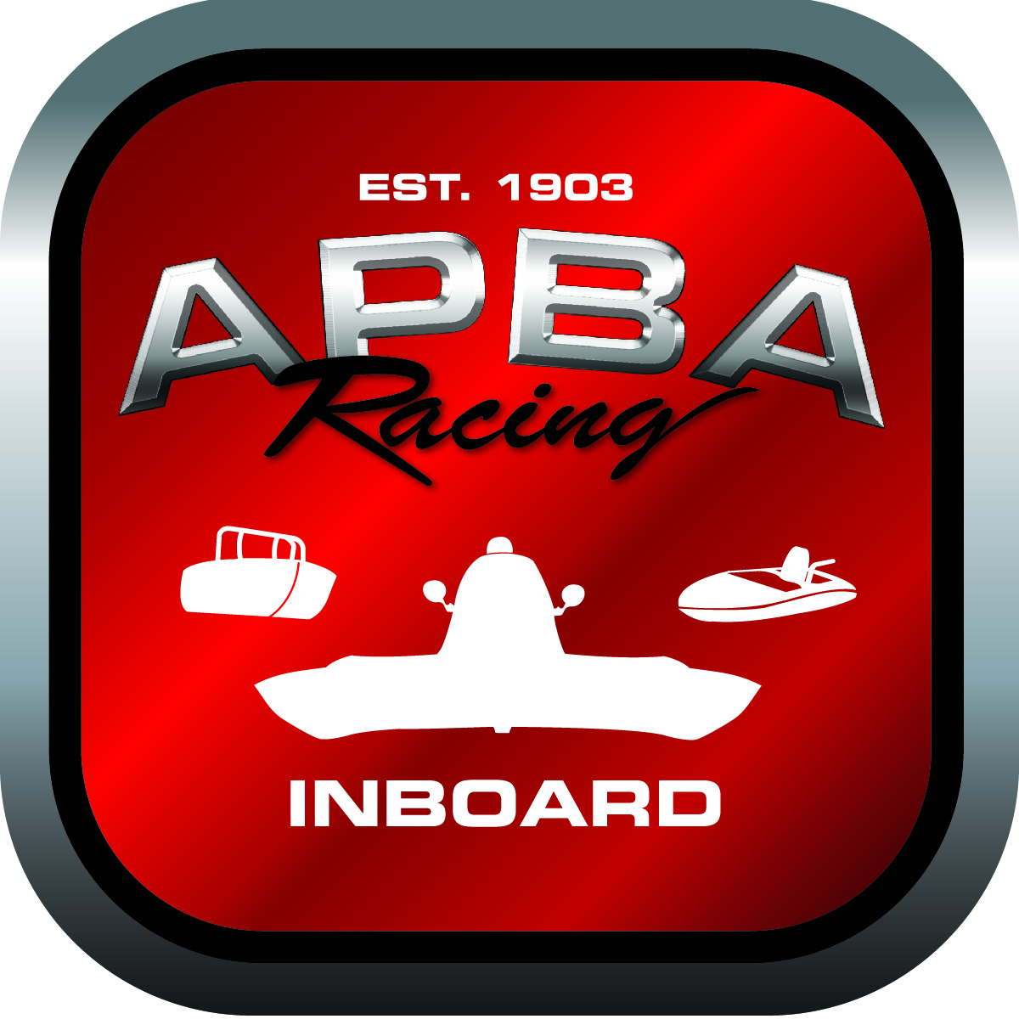
Office use only:
Control Number: 2014-005
Assigned Group:
Initial Screening :
Ballot: Pass: ______/ Fail: _____
Effective for Race Year: _________

2014 Rule Change Proposal

Author: Bill Thompson
APBA # 70216
E-mail: boatinspector@comcast.net
Telephone: 360-455-0107
Date: October 15, 2013

Note: Proposals must be submitted to the Inboard Office by October 31 ,2013 to be considered.
Save and E-mail completed form to: inboardracing@apba.org
US mail to APBA Inboard Office 17640 E. Nine Mile Road, Eastpointe, MI 48021

Check all that apply:
General Safety Rule
General Racing Rule x
Stock Class Technical Rule *
Modified Class Technical Rule *

Affected Class(es): All

Specific Rule Information: [Note: All fields must be completed for consideration.]

Inboard rule: 40.18.12
Page: 30

Author”s VERY BRIEF Summary of Proposed Action:

To add another racing fuel to the list of approved fuels

Affected Rule:
APBA approved racing fuels listed below.
Power Mist VP
T-102 C-11
T-105 C-12
T-111 C-14
T-112 C-16
Sunoco Trick
Sunoco Standard 110 Trick 114
Sunoco Supreme 112 Trick Turbo 119
Sunoco HCR 114 Renegade
Citgo Pro 110
Citgo 110 Turbo Blue
Turbo Blue 110

Proposed rule:
APBA approved racing fuels listed below.
Power Mist VP
T-102 C-11
T-105 C-12
T-111 C-14
T-112 C-16
Sunoco Trick
Sunoco Standard 110 Trick 114
Sunoco Supreme 112 Trick Turbo 119
Sunoco HCR 114
Sunoco Maximal Renegade
Citgo Pro 110
Citgo 110 Turbo Blue
Turbo Blue 110

Reason for change:
To enable an 116 octane fuel to be used. This fuel was dq'd at Nationals because it was not on the approved list.

