Table of Contents: 2013 RULES ARE SHADED / Effective 4-23-13 / Effective 5-1-13
Inspection Area Requirements 4
The Race committee should: 4
Levels of Inspection 4
General Modifications and Restrictions 4
Inspection Tools 5
Lynco Gage Instructions 5
Height Restrictions 6
Stock Outboard Category Fuel Rules 8
Fuel Testing Guidelines 8
Ceric Nitrate Reagent Testing Instructions 12
A CLASS GENERAL RULES 16
Johnson / Evinrude Specifications 16
Mercury Specifications 18
A Class Changes History 19
B CLASS GENERAL RULES 21
Hot Rod Specifications 21
B Class Changes History 22
25 CLASS GENERAL RULES 23
25SSR Parity Rules 23
MERCURY / MARINER 25XS SPECIFICATIONS (25 CLASS) 24
20 CU IN Hot Rod Engine Specifications (25SSR & 25SSH Classes) 26
25 Class Changes History 27
C CLASS GENERAL RULES 29
C Class Changes History 29
20 CLASS GENERAL RULES 30
Yamato-80 Engine Specifications (20 Class) 30
20 Class Changes History 32
302SS CLASS GENERAL RULES 33
D CLASS GENERAL RULES 34
Mercury / Mariner 44XS Specifications 34
Mercury 55H Specifications 38
MOTOR SPECIFICATIONS Mercury 402XS (D CLASS) 40
Tohatsu RAM50 MOTOR SPECIFICATIONS (D CLASS) 40
Mercury “Super Thunderbolt” 41
D Class Changes History 43
“45SS” CLASS 45
MOTOR SPECIFICATIONS FOR EVINRUDE/JOHNSON 15 (A CLASS) 46
MOTOR SPECIFICATIONS FOR MERCURY 15 (A CLASS) 50
SIDEWINDER SPECIFICATIONS 52
MOTOR SPECIFICATIONS FOR SIDEWINDER 15S (A CLASS) 53
MOTOR SPECIFICATIONS FOR SIDEWINDER 15H (B CLASS) 55
MOTOR SPECIFICATIONS FOR SIDEWINDER 20S (20SSH, B & 25 CLASSES) 57
MOTOR SPECIFICATIONS FOR HOT ROD 15 (B CLASS) 60
MOTOR SPECIFICATIONS FOR HOT ROD 20 ( 25 CLASSES) 62
MOTOR SPECIFICATIONS FOR MERCURY 25XS 65
Yamato-102C & 302F Specifications 68
MOTOR SPECIFICATIONS FOR YAMATO 102 (25SSR & C CLASS) 69
MOTOR SPECIFICATIONS FOR YAMATO 302 (25SSR, CSR, CSH, 302SSH) 72
MOTOR SPECIFICATIONS FOR YAMATO 302 SSH 74
MOTOR SPECIFICATIONS FOR YAMATO 80 (20 CLASS) 77
MOTOR SPECIFICATIONS FOR MERCURY 44XS (D CLASS) 81
MOTOR SPECIFICATIONS FOR MERCURY 55H (D CLASS) 84
MOTOR SPECIFICATIONS FOR RAM50 (D CLASS) 87
MOTOR SPECIFICATIONS FOR SUPER THUNDERBOLT (D CLASS) 90
MOTOR SPECIFICATIONS FOR MERCURY 402XS (D CLASS) 92
Conversion Table
Fraction | Decimal | Millimeters |  | Fraction | Decimal | Millimeters
1/64 | 0.015625 | 0.3969 |  | 33/64 | 0.515625 | 13.0969
1/32 | 0.03125 | 0.7938 |  | 17/32 | 0.53125 | 13.4938
3/64 | 0.046875 | 1.1906 |  | 35/64 | 0.546875 | 13.8906
1/16 | 0.0625 | 1.5875 |  | 9/16 | 0.5625 | 14.2875
5/64 | 0.078125 | 1.9844 |  | 37/64 | 0.578125 | 14.6844
3/32 | 0.09375 | 2.3813 |  | 19/32 | 0.59375 | 15.0813
7/64 | 0.109375 | 2.7781 |  | 39/64 | 0.609375 | 15.4781
1/8 | 0.125 | 3.1750 |  | 5/8 | 0.625 | 15.8750
9/64 | 0.140625 | 3.5719 |  | 41/64 | 0.640625 | 16.2719
5/32 | 0.15625 | 3.9688 |  | 21/32 | 0.65625 | 16.6688
11/64 | 0.171875 | 4.3656 |  | 43/64 | 0.671875 | 17.0656
3/16 | 0.1875 | 4.7625 |  | 11/16 | 0.6875 | 17.4625
13/64 | 0.203125 | 5.1594 |  | 45/64 | 0.703125 | 17.8594
7/32 | 0.21875 | 5.5563 |  | 23/32 | 0.71875 | 18.2563
15/64 | 0.234375 | 5.9531 |  | 47/64 | 0.734375 | 18.6531
1/4 | 0.25 | 6.3500 |  | 3/4 | 0.75 | 19.0500
17/64 | 0.265625 | 6.7469 |  | 49/64 | 0.765625 | 19.4469
9/32 | 0.28125 | 7.1438 |  | 25/32 | 0.78125 | 19.8438
19/64 | 0.296875 | 7.5406 |  | 51/64 | 0.796875 | 20.2406
5/16 | 0.3125 | 7.9375 |  | 13/16 | 0.8125 | 20.6375
21/64 | 0.328125 | 8.3344 |  | 53/64 | 0.828125 | 21.0344
11/32 | 0.34375 | 8.7313 |  | 27/32 | 0.84375 | 21.4313
23/64 | 0.359375 | 9.1281 |  | 55/64 | 0.859375 | 21.8281
3/8 | 0.375 | 9.5250 |  | 7/8 | 0.875 | 22.2250
25/64 | 0.390625 | 9.9219 |  | 57/64 | 0.890625 | 22.6219
13/32 | 0.40625 | 10.3188 |  | 29/32 | 0.90625 | 23.0188
27/64 | 0.421875 | 10.7156 |  | 59/64 | 0.921875 | 23.4156
7/16 | 0.4375 | 11.1125 |  | 15/16 | 0.9375 | 23.8125
29/64 | 0.453125 | 11.5094 |  | 61/64 | 0.953125 | 24.2094
15/32 | 0.46875 | 11.9063 |  | 31/32 | 0.96875 | 24.6063
31/64 | 0.484375 | 12.3031 |  | 63/64 | 0.984375 | 25.0031
1/2 | 0.5 | 12.7000 |  | 1 | 1 | 25.4000
Length  1 in = 25.4 mm  1 in = 2.54 cm  1 ft = 0.3048 m |  |  | Liquid  1 gal = 3.785 L  1 qt = 0.946 L  1 gal = 231 in³
Volume  1 in³ = 16.387 cm³  1 ft³ = 1728 in³ |  |  | Weight  1 oz = 23.35 g  1 lb = 4536 g  1 lb = 16 oz

Inspection Area Requirements
Inspection of a motor is not a public exhibit. Pit crews are welcome for help in lifting rigs on and off the scales, if required, but only the driver and the mechanic of the motor being inspected are allowed in the motor teardown area. The Inspector is in full charge of the entire inspection area. A person representing the Race Committee is recommended to maintain order and keep outside people from interfering with the Inspector in his work.

The Race committee should:
- Provide an enclosed area by using either snow fence or roping off the area.
  - Provide at least two tables:
    - One for the Inspectors’ tools
    - One for engine disassembly
  - Provide motor stands
- Place the scales in such a position so they are easily accessible to both the drivers and the Inspector.
- Radio, telephone, or other good communications should be provided between the judge’s stand and the inspection area. In case of a disqualification the other contestant’s positions have to be recomputed by the scorers on the basis that the disqualified boat did not participate in the race. Such recompilation does not always advance all contestants but at times also changes their relative position therefore this information is required by the Inspector.
- Provide cardboard boxes for motors that have been torn down along with small plastic bags for the small parts.
- Provide a Pit Manager to be in charge of tagging the engines as the rig is weighed. Wired shipping tags are recommended. The tag should contain class, final position, boat number and weight.

Levels of Inspection
- Level 1 - Inspection at all races (recommended)
Check height, weight, fuel with Digitron meter, and tuck where applicable.
- Level 2 – at Divisional, Winter National, Marathon National Championships, at minimum.
Class 1 plus fuel specific gravity or water solubility, cc’s of engine, carburetor dimensions, gear case dimensions, gear ratios, water inlet (where applicable), stroke, bore, with thru spark plug hole checker.
- Level 3 – at Summer National Championships and record runs be mandatory
Class 1 and 2 plus tear down and internal inspection to verify internal dimensions comply with the current inspection manual.
A class 1 inspection will be conducted prior to sealing a motor.

General Modifications and Restrictions
- The driver shall be responsible for the condition of the motor and boat as raced. For instance, errors on the part of the manufacturer, boat builder, mechanic, or previous owner will not excuse non-compliance with the rules.
- Allowable modifications herein are for either safety reasons or repair purposes. An Inspector may compare questionable parts to new ones. Use of these rules for an unfair advantage will be grounds for disqualification.
- Internal machined surfaces may be re-machined so long as minimum and maximum dimensions are met. Cast or forged surfaces must remain as cast with no alterations, bead blasting, sand blasting, media blasting, or blasting by any other material, or polishing. NOTE: It is not permissible to re-machine internal machined surfaces that do not have specific dimensions. (See specific class rules for other restrictions or exceptions).
- There shall be no substitution of components such as lower units, carburetors, etc. unless replacement components are specifically designated as stock for a particular model by the SORC.
- Any make of spark plugs or propellers may be used provided other parts are not altered to accommodate them.
- Broken or damaged parts may be repaired by welding or the use of plastic compounds, provided that all internal dimensions, contours, and surfaces remain the same as the original cast or machined surface. The Inspector will pass repairs which meet the word and spirit of this rule, but will disqualify engines having repairs which are obviously intended to provide an unfair advantage.
- Broken skegs and cavitation plates may be used provided that the edge of the break or breaks have not been filed or smoothed or otherwise altered, and provided that reasonable time was not available for repair or replacement. One or two weeks will be considered a reasonable amount of time. At championship events, the Inspector may rule out the use of broken skegs or cavitation plates.
- It is permissible to repair stripped threads by tapping oversize or using helicoils or threaded inserts.
- It is permissible to break the edge of the port windows, but it is not legal to chamfer them. A tool is being designed to measure the port timing to ensure the break is not excessive. (Note: some of the current motors we race have chamfered ports and it is legal in those class motors to have a chamfered port. Ex. Hot Rod engines).

Inspection Tools
The following is intended only as a guide in the acquisition of tools. The experienced Inspector has frequently substituted other equally satisfactory tools.
- 0”-1” Micrometer, 1”-2” Micrometer, 2”-3” Micrometer.
- 6” or 8” Dial or Digital Calipers.
- Large Outside Calipers.
- Set of Telescoping Gauges (Lufkin 79-L or equivalent).
- Depth Vernier (Dial & Digital type are also available).
- 16’ Flexible Steel Tape Rule (Carlson 416 or equivalent).
- 50 cc Burette
- 6” Steel Scale.
- 5/32”, 11/64”, 1/4”, 0.209” (#4), 0.228 (#1) Drills or Drill Blanks.
- Penlight.
- APBA Rule Book and Stock Outboard Inspection Manual.
- Two parallel blocks about 8” long with several holes to serve as measuring surfaces for some measurements.
- “S” shape spark plug hole bore gauge.
- Engine and Gear case templates and instruction sheets (for OMC “A”, 45SS and Mercury 25SX, 44XS).
- Fuel meter and related equipment.
- Lynco port checking gages for class A OMC

Lynco Gage Instructions
The Lynco plug gages are designed to be used exactly 90 degrees to the port window opening. This positioning of the gage is crucial to the accurate use of the tool. Although it is possible to use without an additional guide, it is recommended that some type of a guide be used to assist in keeping the gage perpendicular to the window being measured. A small v-block can be used for this purpose. The cut end of the gage is used to inspect each port opening. A set of gages consists of three sizes. (.650, .640, and .635). See Specification chart for proper maximum dimension of each port. As each port is measured, the gage should be rotated and tried at various positions. The proper gage should not pass through the port opening while in a perpendicular position. The SO chief inspector along with the Class A tech chairman may approve the manufacture of Lynco gages by a source other than Lynco (to date, none have been approved).
Minimum Overall Racing Weights (in pounds)
Class | Hydro | Runabout
A | 345  330 with Mercury 15 | 350  335 with Mercury 15
B | 365 | 360
20SS | 400 | N/A
25SS | 400 | 102,302 With 9/16 Restrictor = 430 102,302 With ½ Restrictor = 405 Y80, Merc 25, Hot Rod, Sidewinder 20 = 395
302SS | 420 | N/A
C | 440 | 475
D | 480 | 515
45SS | 700 | N/A

Age Requirements
Class | Minimum Age
A | 14
B | 15
20SSH | 15
25SS | 16
302SSH | 14
C | 16
D | 18
45SS | 18

Height Restrictions
Class | Hydro | Runabout
A | 1-3/8”  1-3/4” with Sidewinder 15S | 1-3/8”
B | ½”  1” with Sidewinder 20S | 1-3/8”
20SS | ½” with Yamato  1” with Sidewinder 20S | N/A
25SS | ½” | Merc = 1-3/8” Hot Rod, Sidewinder 20S = 1”  102, 302 Yamato = ¾”
302SS | 1-3/8” | N/A
C | ¾” | ¾
D | Merc = 0” Tohatsu = ½” | ¾”
For safety reasons, all Hydroplanes competing in the Stock Outboard Category have limitations on where the engine may be mounted on the boat transom relative to the bottom of the boat.
For ASH only – Two measurements are required: The aft end at the center of the prop shaft and the forward end at the split line of the gear case. The maximum allowable height difference between these two measurements is 1/2'”. The exclusion of air traps shall only be allowed so long as the air traps are not greater than 5/8 inch in depth at the aft end of the boat and 1-5/8 inches in depth at the point 18 inches forward and, in addition, are not any wider (i.e.: thickness which is measured transversely) than 7/8 inch each.

For 302SSH only - The engine may not be tucked more than ½”. Since there is no gear foot center line as in the OMC “A” engine, a common kick out checking tool will be used that can be attached to the prop shaft. Two measurements are required to determine the amount of tuck.
The two measuring points will be:
- The trailing edge of the boat bottom (planing surface) to the top of the tool
- The boat bottom (planing surface) to the top of the tool measured 11 ½” forward from the trailing edge. By subtracting those two measurements, the maximum allowable difference between these two measurements is ½”.
- An inspector is also permitted to use a digital angle gauge if desired. The maximum amount of tuck allowed will be 2.5 degrees. The decision to do so must be announced at driver’s meeting.
- In situations where there is a tunnel built into the bottom of the boat, the measurement will be made by bridging the tunnel with a straight edge to show the lowest wetted surface of the bottom.
- Also, the leading edge of the gearfoot (nose cone) may not be closer than 5” to the trailing edge of the bottom of the boat.

For both ASH and 302SSH - The planing surface is defined as the lowest wetted surface of the hull at the aft end of the boat forward excluding air traps. The previous definition of “air trap” above shall not be construed to include any wetted surface, which obviously does not serve the purpose of trapping air. Consequently, the procedures and/or tools used by the Inspector to measure these restrictions shall be deemed the procedures and/or tools for the day.

The following diagrams are intended as a guide for the measurement of the restrictions described above.

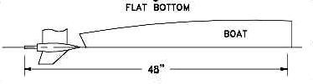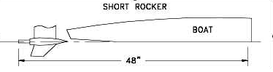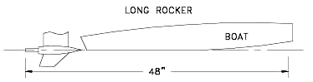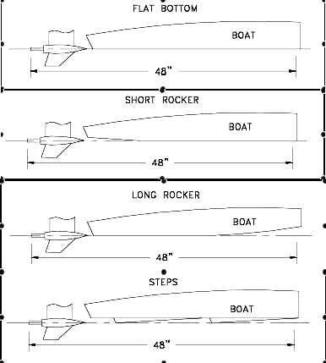
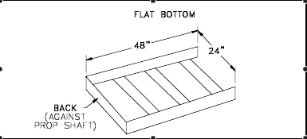

Stock Outboard Category Fuel Rules
- The Stock Outboard Category allows the use of pump gasoline, aviation gasoline and automotive racing gasoline. They may be used separately or mixed together. Pump Gasoline is defined as any product, which is offered to the general public for use in passenger automobiles.
- The addition of any substance other than oil, which is produced for use in consumer 2-cycle marine or off-road recreational products, is strictly prohibited.
- The race committee may take samples of any competitor’s fuel to be sent for analysis.
- The race committee may, when notice is given, have available at the race site, a gasoline product for purchase at a reasonable price and require competitor’s to purchase and use that gasoline.
- In addition, the APBA Board of Directors is in process of establishing a list of banned harmful substances that might be used additives in fuel. The SORC has agreed that this list, when available, will be part of the Stock Outboard Category Fuel Rules and any substance contained on the banned list would be treated in the same manner as Dioxane.
- All fuel tanks must have a minimum sized opening of 1” and be able to accept the Digatron fuel meter probe.

Fuel Testing Guidelines
It is recommended that evaluation of fuels be conducted using the following tests, in preference as listed. Additional tests may be used if deemed necessary.
- Digatron DT-15 or the Digatron DT 47 FT Fuel meter Tester
- Specific gravity Test
- Water Solubility Test
- Ceric Nitrate Reagent Test
- Germaine Fuel Test
Instructions for each of the above four tests are given below.

Digatron DT-15/47FT Fuel Meter Instructions
The purpose of this test is to measure certain electrical properties of the fuel sample and determine if they are within the permissible limits. The test procedures described herein are in accordance with the instructions supplied by the Digatron DT15 fuel meter manufacturer. Before performing your fuel testing, ensure that the fuel meter is in good working order:
- Sensor Condition -Visually check the sensor and its connecting wire to assure that it has not been damaged.
- Battery Condition -When the meter is on, the words “LO BAT” will appear in the upper left corner of the display if the battery needs to be replaced. Do not use the meter if the “LO BAT” is displayed, as its readings will not be accurate.
- The recommended fuel test procedure is as indicated below:
  - Turn the meter on and allow it to warm up at least 15 minutes before doing any testing. This will allow the internal components to stabilize at their normal operating temperature.
  - Attach the sensor’s connecting wire to the meter. Hold the sensor’s connecting wire and lower the sensor into the calibration liquid—Cyclohexane (C6H12)—such that the sensor is completely submerged. Take care to assure that the sensor is not in contact with the container. Gently wiggle the sensor wire to displace any air bubbles that may be trapped between the sensor plates. Using the knob on the front of the meter, adjust until “-75” is shown on the display.
  - Remove the sensor from the calibration liquid, and blow any excess liquid from between the plates. Lower the sensor into the fuel sample, in the fashion described in item “b” above.
  - Observe the reading on the meter’s display. If the reading is zero or a negative number, the fuel is legal. If the reading is greater than zero (a positive number), the fuel is not legal.
- The electrical characteristics of gasoline change somewhat with temperature. As such, it is important that the temperature of the calibration liquid and the fuel sample be within about 15 degrees F of each other. When a fuel sample is found to be illegal, per the above procedure, it is recommended that the following additional steps be performed:
  - Clean the sensor with some spray-on brake cleaner and allow it to air-dry at least 30 seconds.
  - Re-check the calibration setting (-75) of the meter in Cyclohexane and adjust if necessary.
  - Allow the fuel sample to stabilize to the same temperature as the Cyclohexane and then repeat the test as described in item 3 above.
During the course of the day, it is recommended that the calibration setting in Cyclohexane be occasionally checked. It is interesting to note that the calibration reading of “-75” in Cyclohexane has a corresponding reading when the sensor is in air, although this corresponding air reading varies somewhat with each particular meter. As such, the specific corresponding air reading for the particular meter being used can be a useful reference during the time between occasional Cyclohexane calibration checks.

Specific Gravity Testing Instructions
The purpose of this test is to measure the relative density of a fuel sample and determine if it is within the permissible limits. Two pieces of special equipment are required to perform this test:
- Specific gravity hydrometer(s) which cover the range of 0.750 -0.800 (at 60OF).
- A clear glass container, which is at least as tall as the hydrometer. A “graduated cylinder” works well for this purpose. The recommended fuel testing procedure is as indicated below:
  - Assure that the glass container and hydrometer are clean.
  - Place the glass container on an essentially level surface and fill with the fuel that is to be tested. The depth of the fuel should be equal to or greater than the length of the hydrometer.
  - Carefully insert the hydrometer into the fuel sample with the weighted end facing down. Take care to minimize the contact between the hydrometer and the container.
  - When the hydrometer has reached a stable free float in the fuel sample, read the specific gravity from the scale within the hydrometer. This is done by visually sighting along the upper surface of the fuel and reading where the scale crosses the fuel’s surface. Record this reading.
  - Measure the temperature (°F) of the fuel.
The specific gravity characteristics of fuel (gasoline and oil) change somewhat with temperature. As such, the maximum permissible specific gravity reading will change as the fuel temperature changes. Below is a listing of the maximum permissible specific gravity readings and their corresponding fuel temperature:
The Minimum Specific Gravity reading for fuel is .700.
Fuel Temperature (°F) | Maximum Permissible Specific Gravity Reading
40º  50º  60º  70º  80º  90º  100º  110º | 0.785  0.780  0.775  0.771  0.776  0.761  0.757  0.752

Water Solubility Testing Instructions
The purpose of this test is to determine if water-soluble additives are present in a fuel sample. The only piece of special equipment necessary to perform this test is a graduated container. It is recommended that a good quality clear glass graduated cylinder be utilized, with a capacity of 100 ml and subdivisions of 0.1 ml (or less). The recommended fuel testing procedure is as indicated below:
- Assure that the graduated cylinder is clean.
- Place the graduated cylinder on an essentially level surface.
- Pour approximately 60 ml of the fuel sample into the graduated cylinder.
- Carefully measure and record the amount of fuel in the graduated cylinder using the scale on the cylinder.
- Slowly pour approximately 35 ml of water into the graduated cylinder.
- The liquid in the cylinder will separate into two layers. The water will settle to the bottom of the cylinder, carrying water-soluble additives with it. Often froth will form in the lower layer. As such, allow some time for the froth to clear.
- Carefully measure and record the total amount of liquid in the graduated cylinder using the scale on the cylinder.
- Subtract the amount of fuel in the cylinder (step 4) from the total liquid (step 7) to determine the exact amount of water that was added. Record this result.
- Carefully measure and record the amount of liquid in the lower layer of the graduated cylinder using the scale on the cylinder.
- If the amount of liquid in the lower layer (step 9) is greater than the amount of water added (step 8), the fuel contains water-soluble additives and is not legal.

Ceric Nitrate Reagent Testing Instructions
The purpose of this test is to determine if alcohol is present in a fuel sample.
- Following is a list of special equipment necessary to perform this test:
    - 50 ml graduated cylinder with subdivisions of 1.0 ml (or less).
    - 100 ml glass beaker.
    - 18 mm X 150 mm clear glass test tube.
    - 2 ounce glass dropper bottle with dropper assembly.
- Following is a list of the chemicals necessary to perform this test:
    - Ceric Ammonium Nitrate (NH4)2Ce (NO3)6.
    - Nitric Acid (HNO3) (70%).
- The Reagent Solution should be made prior to the race (within a couple of days) and is done as follows:
  - Pour 41 ml of distilled water into the glass beaker.
  - Carefully add 9.0 ml of Nitric Acid to the water in the glass beaker.
  - Add 20 grams of Ceric Ammonium Nitrate to the solution in the glass beaker.
  - Dissolve the Ceric Ammonium Nitrate by gently stirring. Slight heating of the solution will speed the process; however, DO NOT BOIL!
  - Pour the Reagent Solution into the dropper bottle and secure the cap. The Reagent Solution should have a yellow color.
- Recommended fuel test procedure:
  - Pour approximately 10 ml of the fuel sample into the test tube.
  - Carefully add six (6) drops of the Reagent Solution to the fuel sample in the test tube.
  - Seal the open end of the tube and invert several times.
  - The Reagent Solution should accumulate at the bottom of the test tube. Observe the color of the accumulated Reagent Solution. If it is the same color (yellow) as the original solution in the dropper bottle, the fuel sample contains no alcohol. If the accumulated Reagent Solution in the test tube has changed its original color (yellow) to orange or red, the fuel sample contained alcohol and is not legal.

Germaine Fuel Test
Because of the serious health risks of the agent Dioxane, a very serious penalty has been adopted by the SORC if it is found at a race. Dioxane is a very powerful carcinogen! The MSDS information is posted on APBA’s website. Anyone found to have Dioxane in his or her fuel will be suspended for a period of one year from the date of disqualification! Specifically, the rule is:
“Using the prescribed Germaine Fuel Test as outlined following this rule. If a participant is disqualified for failing the Germaine fuel test, he/she will be allowed to compete in subsequent races only if their fuel is pre-qualified with inspection prior to each race. If the official lab results confirm the initial Germaine test results, the one-year suspension is retroactive to the time of the initial disqualification. Any races that the participant competed in since that initial disqualification will be re-scored to reflect the suspension. This would mandate an automatic appeal for the driver, unless the driver specifically requests that the sample not be submitted to the lab”.
- Equipment required:
- Disposable test tubes
- Test tube rack suitable to hold test tubes above
- Disposable eyedroppers or pipettes
- Protective latex or rubber gloves
- Bottle of Germaine reagent
- The Germaine Reagent is available from John Copeland at Fox Valley Kart Shop, 520 N 9th St., Lafayette, IN 47904. Phone number 765-7420935 - Fax 765-429-8395
Email: foxvalle@pop.nlci.com
- Optional:
- Bottle of 1.4 dioxane
- A bottle of known legal fuel
Test tubes and pipettes can be purchased from most supply houses. I used Fisher Scientific as they do take major credit cards. Here are the part numbers I ordered:
- Test Tubes – p/n 14958D – 13 x 100 ml
- Test Tube Rack – p/n 14809A – supports 72 tubes 10-13 ml
- Pipettes – p/n 137117 – 7.7 ml
Nytrl Gloves can be purchased locally. Safety glasses should be worn.
NOTE: Try to keep your chemicals shaded while using, stored in dark container. Reagent is light sensitive and will turn color.

Germaine Reagent Fuel Test Procedure
- Using a new, clean pipette or eyedropper, draw a fuel sample from competitor’s tank or fuel line and fill test tube approximately 2/3 full. Always use a new pipette and a new test tube for each competitor.
- Wearing protective latex or rubber gloves carefully squeeze one drop of Germaine Reagent directly into the center of the fuel sample in the test tube. Do not allow reagent to run down the side of the test tube, as it makes reading the test more difficult.
NOTE: Most users will find the test easier to read by holding the tube up at eye level when the reagent is added to make viewing any reaction more convenient.
- When the Germaine reagent drop first hits the fuel sample, any oil dissolved and/or suspended in the gasoline will come out of solution and fall immediately to the bottom of the test tube. This is not a positive reaction. Different oils may react differently, but a single, fast falling drop is typical.
- The formation of a white or light brown precipitate (like little snowflakes) at the point where the Germaine Reagent hits the fuel sample is a positive indication of the presence of 1.4 dioxane. The precipitate will drift, depending on size and density, to the bottom of the test tube. Within a few minutes it will darken from contact with oil drop in the bottom of the tube.
- It is always advisable to repeat a positive test to insure that no error has been made.
- It is a good practice to carry a sample of known legal fuel and a sample of 1.4 dioxane to use as a verifying test. Simply make up 3 test tubes, one containing the known legal fuel, one containing known legal fuel to which you then add some 1.4 dioxane, and one containing the competitor’s fuel. Then repeat the test, observing any reaction in the known legal sample, then the known legal sample containing 1.4 dioxane, and finally the competitor’s sample. Having observed the reaction of the sample known to contain 1.4 dioxane, it will be easier to confirm the reaction in the competitor’s sample.

Recommended Procedure for Measuring Combustion Chamber Volume
- The engine should be elevated in such a manner so that the face of the cylinder head is horizontal in position.
- The piston in the cylinder to be measured should be set at top dead center (TDC).
- A titrating burette (preferably 50 ml capacity) graduated in 0.1 cc increments should be used.
- A mixture of 50% mineral spirits and 50% TCW II or III outboard motor oil should be used as the measuring fluid. This mixture should be prepared in a separate container not the burette.
- The burette should be filled with the measuring fluid to well above the 0.0 cc marks. Note: The liquid in the burette should be inspected to insure that there are no bubbles present especially at the location of the meniscus. Air bubbles will cause an erroneous reading. Gently lapping the side of the burette will disperse the bubbles.
- The burette should be drained through the use of the stop-cock so as to read exactly 0.0.
Note: The burette should be read at the bottom of the meniscus (the concave line at the top of the column of fluid). A reading taken from other than the bottom of the meniscus will be inaccurate.
- The burette should now be drained into the cylinder containing the piston placed at TDC (step 2) until the fluid reaches the bottom of the spark plug threads. At this point close the stop-cock and carefully rock the engine slightly from side to side and top to bottom to evacuate any air from within the cylinder.
Note: Drain the burette slowly so as not to introduce air bubbles into the combustion chamber.
- Continue to drain the burette until the fluid level reaches the very top of the spark plug threads.
Note: In the case of engines with angled spark plugs the centerline axis of the spark plug should be vertical (i.e. the OMC A engine).
- The combustion chamber volume may now be read from the burette. Remember, the reading should again be taken at the bottom of the meniscus. Your reading should be recorded to within five-hundredths (0.05) of a cc. To accomplish this you must estimate if the meniscus is half way between two tenth (0.1) cc graduation lines.
- Compare the reading obtained from the burette to the cc specification of the engine being measured. If the burette reading is equal to or greater than the minimum cc requirement, then the engine is legal. In the event the burette reading is less than the minimum cc requirement the engine is not legal.
Note: Should the first cylinder measured be found to be right at or less than the minimum cc specification, the above process should be repeated on the remaining cylinders. Should it become necessary to repeat this process on a cylinder that has just been measured, under no circumstances should solvents be used to flush the measuring fluid from the cylinder. If the engine has a removable cylinder head it is not to be removed to allow cleaning of the combustion chamber. The only acceptable method of cleaning the measuring fluid from the cylinder is to run the engine for several minutes. This will restore the combustion chamber to its original state (as raced).
It is recommended that you try to have another Inspector assist you during this procedure. He will be able to verify the accuracy of the measurements.

A CLASS GENERAL RULES
- Permitted Motors
  - Johnson Model # JKT See Chart pg. 46 Drawing pg. 48
  - Evinrude Model # EKT See Chart pg. 46 Drawing pg. 48
  - Mercury 15 Model # See Chart pg. 50
  - Sidewinder Model # 15S See Specs. pg. 52 Chart pg. 53 Drawing pg. 59

Johnson / Evinrude Specifications
The engine should be raced as received from the manufacturer, without modification. Following is a list of restrictions, descriptions, and modifications, which apply to this engine.
- It is permissible to leave the gear case unpainted (bare Aluminum). Unpainted gear cases may be polished.
- The engine shall be operated with the production upper and lower motor covers installed as originally supplied by the manufacturer. All knobs, grommets and plugs shall remain in place or covered with tape.
- The mounting of a fuel tank to the engine or steering bar is prohibited.
- Adjustable high-speed carburetor jets are not permissible. Larger or smaller fixed jets are permissible.
- The addition or removal of material from any moving part is prohibited, including the flywheel.
- The addition or removal of material from internal engine components or surfaces is prohibited. However, the addition of material is permissible in the following circumstances: (1) the water slot hole at the bottom of the cylinder block and (2) the small hole at the top of the water passages around the exhaust ports.
- The exhaust passage in the gear case shall retain its original cast surface finish.
- The gear case may be profiled as long as minimum dimensions and templates are met.
- It will be permissible to use a thrust bracket of any manufacture, provided the engine is not altered.
- The steering bar brackets shall have their retainer bolts safety wired as supplied by the manufacturer.
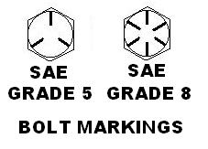
- Only genuine OMC service parts for this model (1986 or later) will be considered as legal replacement parts. This includes gear case bolts, connecting rod bolts, throttle plate screws, reed stop screws and cylinder head gasket. Other than listed above, any make or type of bolt, nut, screw, washer, or gasket may be used, provided it is equivalent to the original. Steering bar bracket bolts shall be grade 8 heat-treated and drilled for safety wire to match the OEM bolt. Steering bar bolts shall be grade 5 heat treated and fitted with elastic stop nuts and the steering bar swivel bolts are to be cross drilled and fitted with cotter pins to match the OEM configuration. All steering bar bracket and steering bar bolts shall have their heat treat markings clearly visible.
- Only a minimal amount (thin film) of sealer may be used on engine gaskets.
- The intake and exhaust ports are drilled (round) holes. Only the center transfer port and the center exhaust port for each cylinder break through fully into the cylinder bore. All other ports do not fully break through into the cylinder bore.
- The gear case split line screw cavities shall be left as supplied by the manufacturer (i.e. -unfilled).
- The only legal cylinder block is OMC part number 396780. The part number is cast on the top of the block on the exhaust side. Service number 396010 includes block 396780.
- Any OEM piston manufactured for this model engine is permissible for use in the OMC A engine. These include part numbers 332364 (standard), 568523 (0.010” oversize), and 393852 (0.030” oversize). The part number is cast on the under-side of the piston. Service number 397487 includes 332364. Any OEM piston ring manufactured for this year and model engine is permissible for use in the OMC A engine. This includes the standard (P.N. 386279) or the 0.030” oversize (P.N. 386288) piston rings. The 0.030” oversize ring may be used on the 0.010” oversize piston in addition to the 0.030” oversize piston and may be cut down to fit the cylinder bore for use on the 0.010” oversize piston.
- It is permissible to hone the wrist pin bores of the pistons to allow for a slip fit of the wrist pin.
- The factory performs a small de-burring operation on the top of the piston dome to remove flashing at the mold parting line.
- The only legal cylinder heads are OMC part numbers 332162 and 336160. The part number is cast on the back of the head on the lower port side.
- The only legal flywheels are OMC part numbers 583077 or 583913. The part number is cast on the underside of the flywheel.
- OMC Carburetor assembly part number 397653 is stamped into a tag that is fastened to the carburetor. 388275 is stamped into the top of the die-cast carburetor body assembly. Earlier sand-cast carburetors may also be used as long as they meet all specifications.
- It is permissible to remove transom cleats, located on the transom surface of the stern bracket.
- The engine must meet the requirements of OMC inspection templates as listed below:
  - OMC part number 568050, for the gear case.
  - OMC part number 568051, for the shape of the combustion chamber only. (Do not use the template to measure the top of the piston or the shape of the piston dome.)
  - OMC part number 568052, for the height of the piston and ports.
- In order to compensate for engines used in the APBA Universal J Class, it is permissible to use two standard gaskets, OMC part number 318932, between the carburetor and the intake manifold.
- The only legal transfer port covers are part #328820 #333733, and #336637.
- It is permissible to machine a portion of the cast surface on the cylinder head adjacent to the head gasket surface
- OMC p/n 323497 inner exhaust plate is legal.
- It is permissible to use plastic reeds—Boyesen #122 and #122R. The shim may be removed provided the reed stop height is maintained.
- The screw fastening the carburetor butterfly to the throttle shaft must be furnished by the manufacturer. With that exception, any make or type of nut, bolt, screw, washer or stud may be used anywhere in the engine.
- The solid motor mounts manufactured by J. W. Myers are legal.
- It is permissible to use an electric starter, as provided by the motor manufacturer and limited to a 12 volt DC system. The associated electric start flywheel is also allowed
- It is permissible to secure the water pump impeller to the prop shaft by any means.
- Port diameters will be measured with the Lynco plug gauges (520-782-0607). Instructions for use may be found on page 3. Port openings may have plastic compound added for repair. The entire hole may not be filled and re-drilled.
- It is permissible to weld broken carburetors. (Suggested source of repair -Mike Schmidt, Durham, CT. (860) 349-9310). Weld penetration into the throat may be smooth; however, under no circumstances may the ID be honed. Caution: Original throttle plate screws must be used.
- Steering Bars, brackets, and throttle linkages of any manufacture are permissible.
- Re-sleeving of cylinder block for repair purposes is legal.
- After-market racing components are legal as long as the parts are substantially similar to OEM parts.
- Pre 1986 Belly Pan and steering bracket are legal.
- Aftermarket or modified motor mounts are legal.
- It is permissible to solder or epoxy the hole closed in the OEM service carb butterfly.
- The use of any bearing or seal is permissible.
- It is permissible to hone the connecting rod and center main as long as current specs are maintained.
- Any boden cable clamp may be used to accommodate the use of an electric starter.
- WSM .030” over pistons and rings are legal. Part no. 100-101-06K

Mercury Specifications
- The Carburetor venturi diameter is 1.000 +/- .010” The removal of the OEM fuel connector is permitted.
- It is permissible to use the Mercury “High energy ignition kit” p.n. 339-7370A40
- Any fuel fitting may be used on the Mercury 15 A class.

A Class Changes History
  - Aft end of the prop shaft or aft end of gear housing motion that the ASH height measurement will be measured at the which ever is higher.
  - Motion to accept a detuned Hot Rod as a prototype for 2005 and a probationary engine for 2006 and a legal A motor for the 2007 year. The SORC will be updated with data yearly on the progress.
  - OMC A Engines –
    - Motion to approve the pre 1986 belly pans and steering bracket. Part #s and specs to follow.
- Mercury A Engines –
    - Motion to allow after market or modified motor mounts.
    - Motion to allow the hole in the service butterfly to be soldered closed or closed with epoxy.
    - Motion to allow the use of any bearing or seal.
    - Motion to allow the honing of the connecting rod as long as it meets the current specs.
    - Motion to allow the honing of the center main bearing as long as it meets current specs.
    - Motion to allow any Bowden cable clamp to accommodate the use of electric start.
2006
  - Motion made for the ash height will be measured at the aft end of the prop shaft (1 3/8 below bottom) and also at the forward end of the gear case split line. The difference of these measurements shall not exceed ½ inch (of tuck under).
- Motion made to extend the approval of the Hot Rod a engine for 1 more year.
2007
  - Motion made to approve this ignition kit from Mercury.
  - Motion made to approve the use of oversized pistons for the Mercury/mariner.
  - Motion to place the A class 15cc sidewinder motor on probationary status for the 2007 season.
2008
  - Motion made to make the sidewinder a engine probationary for 2008 and 2009.
2009
  - Motion made to remove the Mercury as an eligible motor in the a class.
  - Motion made to accept aftermarket 16-glm pistons as a replacement part for the OMC.
  - Motion to remove probationary time period for the sidewinder a, thus leaving it without a probationary end date.
Motion made to accept “ash” air trap rule 20 section 4 – air traps shall be limited to a maximum depth of 5/8” at the aft end of the boat and 1 5/8” depth 18” forward, and at no point shall the air trap depth exceed the line created by the maximum depth dimensions provided. The maximum width of air traps is 7/8” each.
- Motion to extend date of deletion for Mercury motor in a class from November 1, 2009 to November 1, 2010.
2010
  - The Mercury 15 is reinstated in the A classes beyond October 31, 2010
  - The Mercury water discharge hose can be any length as long as the restrictor in the hose end is left in.
  - It is allowable to countersink and use flat head screws in the reed block for ease of changing the restrictor plate on the Mercury.
  - On the Mercury any fuel line may be used from the gas fitting to the carb.
  - On the Mercury any piston ring may be used as long as the piston is not altered.
  - The Sidewinder 15S motor is off probation on August 15, 2010

2011
  - The parity committee changed the minimum cc’s of the Sidewinder 15S to 18.5
  - The parity committee changed the carburetor venturi is 15mm (0.590 +/- 0.010 on the 15S Sidewinder
  - It is permissible to use an adjustable high speed jet on the 15S Sidewinder
  - Any 1/4-20 bolt may be used to attach the gear case on the OMC engine after 11/1/11.

2012
  - The OMC power head may be fitted with double ended studs and attached to the drive housing and through the steering bar brackets and secured with washers and lock nuts.
  - The Sidewinder cc’s are changed from 18.5 cc’s to 15.0 cc’s minimum - 16.5 cc’s maximum by the A parity committee.
  - The Dellorto PHBG 21mm carburetor, adaptor, and new spray shield have been approved for the Sidewinder 15S by the A parity committee.
  - The fuel fitting may be removed on the Mercury 15 in A classes.

2013
- OMC engine pistons and rings – WSM .030” over Approved. Part no. 100-101-06K
- 8 lb flywheels in the OMC A are no longer a legal part.
- New carb mounting adapter and new intake manifold approved for the 15S.
- The A class parity committee lowered the 15S engine in ASH to 1-3/4” and lowered the weight 15 lbs for entries using the Mercury 15 engine in both classes. (effective 4-23-13)

B CLASS GENERAL RULES
- Permitted Motors
  - Hot Rod Model #15 See Chart pg. 60
  - Sidewinder Model # 15H See Specs pg. 52 Chart pg. 55 Drawing pg. 59
  - Sidewinder Model # 20S See Specs pg. 52 Chart pg. 57 Drawing pg. 59

Hot Rod Specifications
- Polishing and filing of the Hot Rod engines, in general, is permissible.
- Connecting rods with four oil slots approximately 0.500” wide and 0.062” deep are permissible. Rods may be polished as long as minimum weights are met. It is not permissible to remove any metal from any flywheel configuration. Some flywheels are balanced at the factory.
- Rod caps are nicked at factory for clearance.
- It is permissible to grind the corners of the head to provide clearance for the top and bottom corners of the piston deflector. Only American Hot Rod heads with integral cast head catcher are legal.
- Transfers in block are cast not machined (1984 and up). A small de-burring operation is performed at the parting line.
- The Lectron 30MMHV (High Velocity) is also a legal carburetor. The front half is labeled 32 and the back half is labeled 30. The throat of this carb is fitted with a sleeve. The throat bore behind the restrictor may be partially machined at the rear.
- Any make of piston ring, seal, and bearing or magneto parts may be used provided other parts are not altered to accommodate them.
- Any type brackets for throttle spark, steering controls and tachometer will be permitted.
- Flexible fuel lines may be installed on any motor. Any standard hose fittings may be used, but there shall be no alteration of the threads in the carburetor or fuel pump.
- Throttle disks of any manufacture may be used, but must be of sufficient diameter to match the carburetor throats in which they are used. Any needle valve may be used in any carburetor provided that no change is made in the threaded section or the pointed end of the needle valve in order to use it. Crossbars may be added to the exterior end of needle valves to facilitate adjustment.
- The screw fastening the carburetor butterfly to the throttle shaft must be furnished by the manufacturer. With that exception, any make or type of nut, bolt, screw, washer, or stud may be used anywhere in the engine. Gaskets of any make of manufacture, including homemade, are permitted providing they are equivalent to the original in shape and thickness and, in case of cylinder base gaskets, maintain the cylinder port dimensions within the limits of the engine specifications.
- Oversize pistons furnished by the manufacturer of the motor may be used in the mode for which they are furnished. The bore of the engine may be enlarged by the amount that the oversize piston differs from the standard piston. An additional total 0.005 inch enlargement of the bore will be allowed due to wear or re-machining errors, or measuring tolerances. Under no circumstances will the bore be enlarged more than 0.040 inches over the original dimension. It is not legal to coat or plate cylinder walls with chromium or any other material.
- Main bearing bores in crankcases may be bored and fitted with bushings to provide a good fit on standard crankcase main bearings. Alternatively, the crankcase may be re-bored to accept any bearings having oversize outside diameters but which are otherwise standard. Similarly, on engines having flywheel magnetos, the magneto neck of the crankcase may be fitted with a sleeve to provide a tight fit in the magneto stator bore. Conversely, the stator bore may be fitted with a bushing for the same purpose. Magneto stator plates may be clamped or otherwise fixed in position on the crankcase by any means.
- It shall be permissible to use studs of larger than standard diameter for the purpose of joining the lower unit to the exhaust housing. Also, modification of the exhaust housing to accommodate the larger studs is permissible.
- The removal of material from aluminum flywheels by drilling or any other method, for any reason, is specifically prohibited. Weight such as solder, lead or copper may be added to the flywheel for balancing.
- It is permissible to re-sleeve any block provided engine specifications are maintained.
- It is permissible to install a lubrication line between the top and bottom bearing.
- To repair stripped spark plug holes, helicoils, oversize holes, or bushings are permissible.
- Knurling of pistons is not permitted.
- Separate fuel tanks may be installed in the hull or on the outside of the transom or on the motor or steering bar so long as mounted in a safe manner. There shall be no restrictions on design or manufacture of such tanks other than for safety. Auxiliary fuel lines and connections may be added as needed. A filter or pressure regulator may be added to any fuel line or fuel tank. Electric fuel pumps may not be used.
- No drilling or modifications of any type, except repair, may be done on the water jackets to change the cooling pattern.
- A shim may be added when using the new style head gasket in order to meet minimum cc’s.
- The PBL ignition system is an approved system. The single unit ignition coil and new 6HP Flywheel #3584222 is approved.

B Class Changes History
2005
  - Hot Rod Engines –
  - Motion to approve single unit ignition coil and 6 hp flywheel part #3584222
2006 - No changes
2007
  - Motion to approve the use of this flywheel.
  - Motion made to make the sidewinder 15cc engine a probationary motor for the 2007 and a legal motor for 2008.
2008
  - Motion made to set a b stock hydro height restriction at 0.50”.
2009
  - Motion made to add tech manual for 15 cid Sidewinder.
  - Motion made to approve only a horizontal split line gear case (little) Hot Rod skeg & use the Hot Rod down housing with the new Sidewinder power heads. These must meet skeg dimensions and specifications for the Sidewinder.
2010
  - No changes were made in 2010.
2011
  - Reduce the cc’s by 1 in the 15H Sidewinder motor to 11.5.
  - Change the maximum bore size in the 15 cu. in. Hot Rod to +0.040”.Effective 11/1/11
2012
  - The short stroke crankshaft is permissible to use in the 15ci Hot Rod engine.
  - The Dellorto VHST 28mm carburetor, spray shield bracket and velocity tubes are approved for the 15H Sidewinder by the B parity committee .
2013
- New intake manifold approved for the 15H and 20S.
- 20S Sidewinder approved.
- The B class parity committee approved the 7/8” restrictor for the Sidewinder 20S engine using the 30mm Dellorto carburetor only on 3-25-13. Also, the 20S engine height in BSH was lowered to 1” below.

25 CLASS GENERAL RULES
- Permitted Motors
- Yamato Model # 102C Runabout only See Specs. pg. 68 Chart pg. 69 Drawing pg. 75
- Yamato Model # 302F Runabout only See Specs. pg. 68 Chart pg. 72 Drawing pg. 75
- Sidewinder Model # 20S Runabout and Hydro See Specs pg. 52 Chart pg. 57 Drawing pg. 59
- Hot Rod Model # 20 Runabout and Hydro See Chart pg. 62 Drawing pg. 64
- Mercury Model # 25XS Runabout and Hydro See Specs. pg. 24 Chart pg. 65 Drawing pg. 67

25SSR Parity Rules
This is a special set of rules that apply to the 25SS Runabout Class only. These rules are current as of 3/1/06, but are likely to change in the future. Every attempt will be made to update this page in the inspection manual and keep it current.
- The mission concept for the 25SSR Class:
  - The Mercury and Hot Rod Engines should continue to be competitive in this class.
  - The 25SSR class should NOT become only a second class for CSR drivers to race.
  - This class should be dedicated to drivers who fit the traditional "B Class" size—drivers’ weight between 175 – 210 lbs.
  - If the Hot Rod 20 cu. in. Engine is produced again; this should be the "engine of choice" for this class while still allowing the Mercury and restricted-Yamato 102 & 302 to be competitive and able to win.
- Rule Changes: Effective 3/1/06
  - The Yamato 102s and 302s may run a 9/16" restrictor (the current one) at 430 lbs minimum weight.
  - The Yamato 102s and 302s have the alternative of running a 1/2" restrictor at 405 lbs (the current weight).
  - The Weight for the Mercury’s, Yamato 80s and Hot Rods is reduced from 405 lbs to 395 lbs.
  - The Hot Rod engines shall run at a 1.0" height restriction.
  - The Mercury’s continue to run with NO restrictor.

MERCURY / MARINER 25XS SPECIFICATIONS (25 CLASS)
Note: It is the intention of the manufacturer and the SORC that the 25SX engine to be raced as received from the manufacturer without modification.
- No modifications of any kind including grinding, polishing, machining shot peening, bead blasting, etc. will be allowed on any engine or drive components unless otherwise noted in this section. No material may be added or removed from any engine or drive components unless otherwise noted in this section.
- The paint may be removed from the external cast surfaces of the cylinder block.
- Only cylinder blocks, pistons and piston rings manufactured by Mercury Marine are allowed.
- The only permissible block is 1986 and newer with a 7 bolt rear water jacket.
Piston:
  - P/N 767-879878T5
  - P/N 767-821968A3
  - 767-855283T2
  - 767855283T3
Piston Rings:
  - 39-827491A12
The part numbers of the cylinder blocks with chrome bores and related components are:
Pistons:
- P/N 767-9104A10
- P/N 767-9104A11
- P/N 767-9104A17
- P/N 767-9104A18
- P/N 767-9104A19
- P/N 767-9104T19
- The minimum allowable volume of the combustion chamber, at T.D.C., to the top of the spark plug hole for engines with chrome bores is 21.7 CM. The minimum allowable volume of the combustion chamber, at T.D.C., to the top of the spark plug hole for engines with Mercosil aluminum bores is 21.2 CM.
- Phillips head fasteners may be replaced with hex head screws. Larger diameter starter mounting screws and/or studs, washers and nuts with rubber isolation washers are permissible. Throttle butterfly screws, connecting rod fasteners and nuts must be factory original. Gear case mounting studs must be factory original but may be altered to allow increased clearance.
- Any make of seals, bearings, fuel line, throttle bracket, or thrust bracket, may be used provided other parts are not altered to accommodate them. It is permissible to use an aftermarket water pump impeller that replicates the OEM impeller.
- It is not permissible to machine off the mating surfaces of the split crankcase.
- The main bearing bores in the crankcase may not be bored to accept oversize bearings or fitted with bushings.
- Material may be added to the recoil housing. Internal flywheel to housing clearance must not be changed.
- Honing of the cylinder bores and connecting rod journal bores is permitted.
- The 25XD carburetor is legal for the 25XS engine if it is fitted with a full butterfly. The model numbers for carburetors having the same venturi and throat diameters as the 25XS carburetor (Walbro WX-2263) are:
- WMC-1
- WMC-3
- WMC-11
- WMC-13
- It is permissible to add a second pair of cross drilled holes, at 90°, to the original fuel inlet holes in the high speed jet holder. They must be the same diameter (0.096 inches) as the original holes. It is NOT permissible to add an adjustable needle valve to any of the legal carburetors.
- Approved reed cage assemblies are P/N 42471-2 (casting no. 41380-C1) and P/N 14112.
- The following reeds are approved for the 25XS engine:
  - Steel reed (Mercury P/N 34-99319 & P/N 34-816806)
  - Plastic reed (Mercury P/N 34-814764A1, 34848066)
  - Reed cage P/N 14112: use plastic reed 34-848066 or the steel reeds supplied with P/N 14112.
- It is permissible to use replacement reeds manufactured by Boyesen.
- There are two (2) legal flywheels for the 25XS engine.
  - P/N 258-8274A6 (9 lb. 7 oz. min. weight)
  - P/N 258-8274A11 (7 lb. 8 oz. min. weight)
- There are two legal drive shaft housings for the 25XS engine:
  - The “long” housing manufactured before 1986
  - The “short” housing manufactured after 1986.
- The only legal gear case for the 25XS engine is the larger skeg gear case (P/N 16041116A15). The gear case may be unpainted or must be completely painted original factory colors (tail cone need not be painted). This gear case must meet the specifications on the attached page and on the Mercury template (#91-17456). Note: This inspection template must be checked for dimensional accuracy before each use.
- The clamp bracket screw handles may be repaired or replaced with an alternative handle as long as no modifications are required on the bracket of the drive shaft housing.
- The steering arms that come standard on the “short” 25XS drive shaft housing may be replaced with new arms if they have at least the same minimum cross section dimensions (1.0 inch horizontal X 0.25 inch vertical. Material may be either steel or aluminum.
- The lower tower housing swivel pin bushing may be replaced with any type of bushing provided no modifications are made to the tower housing, pin or clamp bracket assembly.
- It is permissible to remove the plastic baffle in the top of the upper engine cowling on all models.
- It is permissible to use replacement ignition parts manufactured by CDI Components
- It is permissible to use an electric starter, as provided by the motor manufacturer and is limited to a 12 volt DC system.
- The restrictor for the Yamato 302F engine, for use in the 25SSR class, has a slot width dimension = 0.563” MAX. (There is NO height dimension).
- The clamp bracket screw handles may be repaired with an alternative handle as long as no modifications are required on the bracket of the DSH. Mercury’s kit #1497-8794A5 is a legal replacement.
- The lower tower hsg. swivel pin bushing may be replaced with any type of bushing provided no modifications are made to the tower hsg., pin, or clamp bracket assy.
- Any throttle linkage is allowed as long as the operation is similar to OEM linkage.
- Drive Shaft Housings (DSH) manufactured by IAI Performance are legal replacement parts for the Mercury/Mariner 25 XS engines.
- OEM Type Restrictors made by “Wings and Things” are legal replacement parts.
- It is legal to use the machined flywheel made by “Wings and Things”. (This is the only machined flywheel that is legal!)
- The adapter and tuner plate assembly assembled by “Wings and Things” is a legal replacement part.

20 CU IN Hot Rod Engine Specifications (25SSR & 25SSH Classes)
- Polishing and filing of the Hot Rod engines, in general, is permissible.
- Connecting rods with four oil slots approximately 0.500” wide and 0.062” deep are permissible. Rods may be polished as long as minimum weights are met.
- It is not permissible to remove any metal from any flywheel configuration. Some flywheels are balanced at the factory.
- Rod caps are nicked at factory for clearance.
- It is permissible to grind the corners of the head to provide clearance for the top and bottom corners of the piston deflector.
- Transfers in block are cast not machined (1984 and up). A small de-burring operation is performed at the parting line.
- Any make of piston ring, seal, and bearing or magneto parts may be used provided other parts are not altered to accommodate them.
- Any type brackets for throttle spark, steering controls and tachometer will be permitted.
- Flexible fuel lines may be installed on any motor. Any standard hose fittings may be used, but there shall be no alteration of the threads in the carburetor or fuel pump.
- Throttle disks of any manufacture may be used, but must be of sufficient diameter to match the carburetor throats in which they are used. Any needle valve may be used in any carburetor provided that no change is made in the threaded section or the pointed end of the needle valve in order to use it. Crossbars may be added to the exterior end of needle valves to facilitate adjustment.
- The screw fastening the carburetor butterfly to the throttle shaft must be furnished by the manufacturer. With that exception, any make or type of nut, bolt, screw, washer, or stud may be used anywhere in the engine. Gaskets of any make of manufacture, including homemade, are permitted providing they are equivalent to the original in shape and thickness and, in case of cylinder base gaskets, maintain the cylinder port dimensions within the limits of the engine specifications.
- Oversize pistons furnished by the manufacturer of the motor may be used in the mode for which they are furnished. The bore of the engine may be enlarged by the amount that the oversize piston differs from the standard piston. An additional total 0.005 inch enlargement of the bore will be allowed due to wear or re-machining errors, or measuring tolerances. Under no circumstances will the bore be enlarged more than 0.030 inches over the original dimension. It is not legal to coat or plate cylinder walls with chromium or any other material.
- Main bearing bores in crankcases may be bored and fitted with bushings to provide a good fit on standard crankcase main bearings. Alternatively, the crankcase may be re-bored to accept any bearings with oversize outside diameters but which are otherwise standard. Similarly, on engines having flywheel magnetos, the magneto neck of the crankcase may be fitted with a sleeve to provide a tight fit in the magneto stator bore. Conversely, the stator bore may be fitted with a bushing for the same purpose. Magneto stator plates may be clamped or otherwise fixed in position on the crankcase by any means.
- It shall be permissible to use studs of larger than standard diameter to join the lower unit to the exhaust housing. Also, modification of the exhaust housing to accommodate the larger studs is permissible.
- Removing material from aluminum flywheels by drilling or any other method, for any reason, is specifically prohibited. Weight such as solder, lead or copper may be added to the flywheel for balancing.
- It is permissible to re-sleeve any block provided engine specifications are maintained.
- To repair stripped spark plug holes, helicoils, oversize holes, or bushings are permissible.
- Knurling of pistons is not permitted.
- Separate fuel tanks may be installed in the hull, on the outside of the transom or on the motor or steering bar so long as mounted in a safe manner. There shall be no restrictions on design or manufacture of such tanks other than for safety. Auxiliary fuel lines and connections may be added as needed. A filter or pressure regulator may be added to any fuel line or fuel tank. Electric fuel pumps may not be used.
- No drilling or modifications of any type, except repair, may be done on the water jackets to change the cooling pattern.
- A shim may be added when using the new style head gasket in order to meet minimum cc’s.

25 Class Changes History
2005
  - Motion to remove restrictor from 25SSR.
2006
  - OEM Restrictors: Remove Rule 13 from Tech manual and replace with:
“All 25XS engines shall be run with a carburetor restrictor securely in place behind the carburetor which shall conform to the diagram herein. OEM and non-OEM restrictors are legal as long as they conform to the specifications and dimensions of the OEM restrictors.”
  - Motion made to approve the OEM restrictors made by wings and things as a legal replacement part.
  - Flywheels: “The service flywheel may be machined down to the dimensions and size of the racing flywheel, balanced and bust tested.”
- Motion made to approve the machined flywheels made by wings and things. They will need a part identification # for the tech manual so inspectors know this is the approved flywheel.
  - Motion made to approve adaptor and tuner plate from wings and things. With a maximum id dimension to be provided by Mercury technical committee.
  - Motion made to run the 102/302 with a ½ inch restrictor and have a parity committee set up with the power to make changes during the racing season.
  - Motion made to allow the Hot Rod 20 cubic inch to run at 1 inch height restriction.
  - Allow the use of any replacement block to be run in the 25SS Mercury. Replace Paragraph 4 of Technical Rules with: “Any Cylinder Block and crank case manufactured by Mercury Marine 1986 or later with thermostat housing is a legal 25XS replacement part. OEM Pistons and Rings for these blocks are also legal.”
  - Motion made to approve all blocks manufactured by Mercury since 1986 with thermostat housing for the 25 cubic inch engine.
2007
  - Motion to remove the restrictor plate in 25SSH.
2008
  - Motion to raise the minimum age to 16 years in 25SSR.
  - Motion to make the 20 cid sidewinder engine in the 25SSR a probationary engine for 2008 at 395lbs.
  - Motion to remove the 2008 restriction for the 20 cid sidewinder engine in the 25SSR class. This would make the engine a probationary one indefinitely.
  - Motion to make the "a" hull dimension 46” and the "b" dimension 10’ for 25SSR for entries using sidewinder engines beginning in 2009.
2009
  - Motion to remove probationary time period for the sidewinder 25, thus leaving it without a probationary end date.
  - Motion made to remove the restricted Yamato restricted motors as of November 1, 2010.
  - Motion made stating that the Yamato 80 will no longer be legal in 25ssr. Amended motion to state that this will be effective November 1, 2010.
  - Motion to accept 25XS an aftermarket impellor as long as it is a replica of the current impellor.
  - Motion to make the only permissible block 1986 & newer a 7 bolt rear water jacket.
  - Motioned to change 6.540 + - .030 “k” dimension in inspection manual.
  - Motion to make 25XS rules previously passed at this meeting to make go into effect 2009.
  - Motors from the 25SSR class. Amended to remove
2010
  - The height for 25SSH is ½” below the bottom of the boat measured at the aft end of the prop shaft centerline.
  - The Sidewinder 20S is a legal motor for the 2010 season in both 25SSR and 25SSH classes.
  - The Yamato 102 and 302 were reinstated in the 25SSR class past the November 1, 2010 date.
  - The BRP flywheel #584222 was approved on the 20 cu. in. Hot Rod.

2012
  - The 20S Sidewinder may utilize the Dellorto VHSH 30mm carburetor, new spray shield bracket, and velocity tubes. All approved by the 25 parity committee.

2013
- New intake manifold approved for the 20S.

C CLASS GENERAL RULES
- Permitted Motors
- Yamato Model # 102C See Specs. pg. 68 Chart pg. 69 Drawing pg. 75
- Yamato Model # 302F See Specs. pg. 68 Chart pg. 72 Drawing pg. 75

C Class Changes History
2005
- Yamato 102C and 302F motor:
- It is permissible to use any fuel fittings provided threads in the tank and carburetor are not changed. A fuel filter may be added to the fuel line.
- >Delete this rule as any tank can be used (rule 4) and there are no threads in the carburetor.
- It is permissible to enlarge the fuel tank or build a complete new tank. If the tank is removed, the tank-mounting bracket may be also removed.
- >Add from rule 3: A fuel filter may be added to the fuel line.
- Any type thrust bracket is allowed.
- >Move rule 18 to rule 7. It is permissible to drill two holes at the forward end of the cavitation plate to facilitate the mounting of a thrust bracket block.
- It is permissible to mill the cylinder head within the H and I dimension. No changes may be made to the combustion chamber. It is not legal to remove any of the squish band from the head in spite of the H and I dimension. This means that there must be a visible ledge surrounding the squish band.
- Re-word to read: It is permissible to mill the cylinder head within the H and I dimensions. No changes may be made to the combustion chamber. (Rule 20)It is legal to re-machine the squish band for repair purposes only. The angle is 15 degrees +/- 2 degrees, 2.612 =/- 0.015.
- Move to rule 7.
- Move to rule 13.
2006 - No changes
2007
- Motion made to allow the remounting of any coil on a 102.
- Motion to set up an advisory committee to monitor the CSH class in 2007 and come up with a solution to make this class more equally matched and report these findings to the SORC.
- Motion to approve the ¾ height restriction for all CSH class using both 102 and 302
- Motion made to allow any aftermarket roping plate on the 102 Yamato roping add the thickness, diameter, and dimensions for the aftermarket roping plate.
2008
- Motion to remove the h & i dimensions on the Yamato 102 & 302 engines.
2009 - No changes
2010- No changes
2011- No Changes
2012
- It is permissible to use gear ratio 14:15 straight cut or helical cut gears in the Yamato 102.

2013- No changes

20 CLASS GENERAL RULES
- Permitted Motors
- Yamato Model # 80 See Chart pg. 77 Drawing pg. 79
- Yamato Model # 102C See Specs. pg. 68 Chart pg. 69 Drawing pg. 75
- Yamato Model # 302F See Specs. pg. 68 Chart pg. 72 Drawing pg. 75
- Sidewinder Model # 20S See Specs pg. 52 Chart pg. 57 Drawing pg. 59

Yamato-80 Engine Specifications (20 Class)
- No use of parts other than Yamato 80 parts are allowed, except as approved herein.
- Any make of spray shield may be used. It is permissible to use any make of gaskets (other than head gaskets), bearings, seals, ignition components, piston rings, or prop shaft, provided no engine modifications are made to accommodate them.
- Any make of prop shaft may be used. The minimum diameter shall be 9/16”. Only one shear pin hole is permissible. This allows the fabrication of a new 9/16” prop shaft without the forward shear pin hole. The fabricated shaft will be similar to the original but is not required to use metric threads.
- It is permissible to enlarge the fuel tank or build a complete new tank. If the tank is removed, the tank mounting brackets may also be removed.
- A fuel pump may be used for racing, but the carburetor shall not be modified in any way.
- It is permissible to remove the timing knob. The magneto stator plate may be fixed in position on the crankcase by any means.
- Any type of thrust bracket adjustment is allowed. It is permissible to drill 2 holes at the front of the cavitation plate to facilitate the mounting of a thrust bracket block.
- Any fuel line or fittings are permissible provided the threads in the fuel tank and on the carburetor are not changed. A fuel filter may be used.
- No polishing or removal of metal on any internal passages of the carburetor, intake manifold, crankcase, exhaust bypass, or tuned exhaust system is allowed. Bead blasting, sand blasting, or blasting by any other media of any internal engine components is not permissible.
- A metal head gasket is mandatory (0.5 mm or 1 mm size only).
- No modifications are permitted to reed port openings or reeds.
- It is legal to bore the cylinders one size larger bore size than the standard bore.
- It is permissible to re-sleeve any block provided engine specifications are maintained.
- No expanding or knurling of pistons is permitted.
- The Yamato carburetor butterfly must remain intact. No thinning or tapering is allowed.
- Except for the butterfly screw, any type, size, or make of nut, bolt, screw, or washer may be used.
- No balancing of reciprocating or rotating parts is allowed.
- There shall be no substitution of components such as lower units, carburetors, etc. unless replacement components are specifically designated as stock for a particular model by the SORC.
- No drilling or modifications of any type, except repair, may be done on the water jackets to change the cooling pattern.
- It is permissible to grind, file, or polish the lower unit as long as all dimensions and templates are met. The “bulge” may be ground flush with the sides of the skeg.
- Drilling of water drain holes in the ignition casting (coil plate and crankcase end cap) is permissible, and these holes may be tapped and plugged.
- One or two water outlet tube(s) on Y-80 are permissible.
- To measure the Q dimension, lightly depress the reed against the reed block. Next, measure between the top of the reed and the bottom edge of the reed stop.
NOTE: Do not remove the shim from under the reed.
- In order to compensate for the removal of the “bulge” from gear cases, Inspectors should add an extra 0.275 inches to the template to properly measure a gear case without the “bulge”.
- The restrictor for the Yamato 102C & 302F engines, for use in the 20SSH class, is shown below. The slot width dimension = 0.438” MAX. Any non-OEM restrictor plate is legal as long as it conforms to OEM parts.
- It is permissible to use non-OEM crank pins and exhaust stacks. (The inspector may compare to new).
- The water inlet holes may be repaired with weld or plastic compounds. Water inlet hole diameter 0.270 – 0.297. Contours and shape must be as originally manufactured.
- It is legal to re-machine squish band area to match Mod rule angle 15° ± 2°, 2.350 ± 0.015. No changes may be made to the combustion chamber. There must be a visible ledge surrounding the squish band.
- Any aftermarket 14:16 straight cut gears may be used on the Y-80.
- Any ignition coil may be used on the Y-80 and the mounting may be altered to accommodate the coil.

20 Class Changes History
2005
- Yamato Engines –
- Motion to approve any aftermarket 14 16 gears for replacement on the Yamato 80.
- Motion to eliminate the exhaust relief hole in the y-80 tuning pipe elbow. It is permissible to have a hole or fill that hole. Delete rule 34 completely.
- Yamato 80 motor
- The 16mm Yamato prop shaft may be welded and a new shear pinhole drilled. In any case only one shear pin is allowed.
- >Delete this rule as it is covered by rule 4.
- Any type thrust bracket is allowed.
- >Add: It is permissible to drill two holes at the front of the cavitation plate to facilitate the mounting of a thrust bracket block. (Same as rule 18 in the 102/302 specs.)
- It is not permissible to fill holes in the exhaust pipe holder to fit the exhaust pipe.
- >Delete this rule as it is covered by rule 34.
- Mufflers, expansion chambers, or other exhaust system components must remain as furnished by the manufacturer.
- >Delete this rule as it is covered by rule 34.
- It is permissible to mill the cylinder head within the H and I dimensions. No changes may be made to the combustion chamber. It is not legal to remove any of the squish band from the head in spite of the H or I dimensions. This means that there must be a visible ledge surrounding the squish bans.
- >Delete this rule as there are no H and I dimensions.
- It is legal to re-machine the squish band to match the Modified rule angle 15 degrees +/-2 degrees, 2.350 +/- 0.015.
- >Add from rule 23: No changes may be made to the combustion chamber. There must be a visible ledge surrounding the squish band.
- Require the drilling of relief hole on old style exhaust elbow. The hole is required. Minimum diameter of the hole to be .187” (3/16). There is no maximum dimension, as a larger hole will only diminish performance. For reference, the hole is located approximately .500” (1/2) to the rear and .440” (7/16) above the current slot. The Y-102 drawing in the 2001 Inspection Manual may be referenced for visual approximate location for this hole.
- >Re-word to read: There must be an exhaust relief hole in the exhaust elbow and pipe assembly. The old style elbow may be drilled to simulate the new style elbow. Minimum diameter for the hole is .187” (3/16). There is no maximum dimension, as the larger hole will only will only diminish performance. For reference the hole is located .500” (1/2) to the rear and .440” (7/16) above the current clamping slot, or the hole may be drilled in the pipe at the top of the clamping slot.
2006
- Motion made to allow any ignition coil and the mounting to be altered to accommodate the coil on a Y-80.
2007 - No changes
2008
- Motion to approve the 20CID sidewinder engine as a probationary motor in the 20SSH class for 2008.
- Motion to remove the 2008 restriction for the 20CID sidewinder engine in the 20SSH class. This would make the engine a probationary one indefinitely.
2009
- Motion to remove probationary time period for the sidewinder 20, thus leaving it without a probationary end date.
- Motion to accept Wiseco pistons, part number 0186m06046.
- Motion made for the Yamato 102 to no longer be legal for competition in 20SSH.
2010
- The restricted Yamato 102 was reinstated in the 20SSH class.
- The Sidewinder 20S was approved for the 20SSH class November 1, 2010 with parity committee to be appointed.
2011
- A parity committee was appointed to oversee the Sidewinder 20. They set the prop shaft height at 1 3/8” below the bottom of the boat.
2012
- The parity committee raised the prop shaft height to 1” below and also approved the Dellorto carburetor.

2013
- New intake manifold approved for the 20S.

302SS CLASS GENERAL RULES
Intent: To have what could be our first ever “stock” outboard class in APBA racing. This class shall lower barriers to entry, have very low startup costs and provide a place for new members to hone their racing skills before making a transition into the faster classes. It will also offer a class to current drivers that no longer wish to race at higher speeds.
Governing of class rules: Each year the Stock Outboard Chairman may appoint up to four members to join the Chair on the 302 Super Stock Parity Committee. This committee will act as a regulatory board to keep the original intent of the class moving forward and address issues as they arise during the racing season. (See the Stock Safety and Racing rules for more information on engine height, tuck and other class specifications)
Permitted Motor: Yamato Model # 302F. See 302 Specs. pg. 70, 71; 302SS Chart pg. 72 Drawing pg. 72, 73.
The Model 302 Yamato engine must be purchased from Ric Montoya of RPM Marine, his designee or his predecessor. Before shipping or buyer pickup, the following will be ensured:
- The following wire and lead seals with his trademark are in place: Intake to crankcase and crankcase to block.
- All EPA paperwork has been completed.
- A kill switch plug has been installed.
- New piston rings have been installed.
- The cylinders have been honed.
- The exhaust housing has been flattened.
- The gear foot meets all 302SSH measurements with the stock 16mm prop shaft.
- A 302SSH two blade Brinkman propeller is provided.
The engine may not be bored oversize. Only standard OEM pistons and standard OEM rings are permitted.
No fuel pumps are permitted. Extended OEM gas tanks are permitted. The spray shield may have one hole on the starboard side for access to the carburetor. This hole may not be larger than 1.38”.
Speed: It is the intent of this class to have a maximum speed of 60 mph. If the class exceeds this speed, restrictions will be set to reduce the speed as needed by the 302 Parity Committee or by the SORC.
Propellers: All entries will race the APBA 302 Super Stock propellers provided with the engines. An engine owner only owns the rights to “a” propeller and not a specific propeller. At driver’s meeting the day of the race all propellers from the entries in the class will be turned in to the race inspector (or a person designated by the inspector). The race inspector (or designee) will place one propeller each in a bag or box to conceal it. A driver will then pull a number from a hat that corresponds with the number on the box or bag. This will also occur in inspection after each heat of racing has been completed. Any participant who alters or marks on the propeller(s) in order to later identify them will be required to return the propeller to the authorized propeller service center for repair or replacement with all costs incurred by the participant.
Repair Centers: The following men have accepted the responsibility of being an authorized repair center for the class:
East - Jerry Davids Sr., Midwest - Tom Johnston, Northwest - Ric Montoya and Southwest - Roger Carr
There will be only four authorized centers and the centers may be appointed each year by the Stock Outboard Chairman. They will provide all internal mechanical repairs and refresh for the sealed portions of the engine. It is not permissible for an engine to be certified by the same repair center more two consecutive times. Ric Montoya or Tom Johnston may also inspect a previously raced stock 302 engine and detune the engine (if necessary) to make it legal for this class. Those costs will be determined by the repair center for labor and parts used. Once their work is completed, they will seal the engine and therefore approve it for racing.
If any of the four repair center member’s wish to participate in this class, another repair center must be used for certification of the member’s engine.

D CLASS GENERAL RULES
- Permitted Motors
  - Mercury/Mariner 44XS See Specs pg. 34 Chart pg. 81 Drawing pg. 83
  - Mercury 55H See Specs pg. 38 Chart pg. 84 Drawing pg. 86
  - Mercury 402XS See Specs pg. 40 Chart pg. 92 Drawing pg. 94
  - Mercury Thunderbolt See Specs pg. 41 Chart pg. 90
  - Tohatsu RAM50 See Chart pg. 87 Drawing pg. 89
- D Parity Committee Rules
- Use of fiber reeds (Boyesen two stage version) is legal in the Tohatsu Engine.
- Weights for the following classes regardless of engine:
  - DSH – 480#
  - DSR –515#

Mercury / Mariner 44XS Specifications
NOTE: It is the intention of the manufacturer and the SORC that the 44XS engine to be raced as received from the manufacturer, without modifications.
- No modifications of any kind, including grinding, polishing, machining, shot peening, bead blasting, etc. will be allowed on any engine or drive components unless otherwise noted in this section. No material may be added or removed from any engine or drive components unless otherwise noted in this section.
- The engine must retain its original factory color. The engine must display manufacturer’s decals. The cylinder block must retain the original factory finish.
- It is permissible to add two louvers to the top of the cowl with the opening facing aft. The front cowling cover must remain in position as manufactured.
- Phillips head fasteners may be replaced with hex head screws. Throttle butterfly screws, connecting rod fasteners and gear case mounting studs and nuts must be factory original.
- Any make of seals, bearings, fuel line or thrust brackets may be used provided other parts are not altered to accommodate them. It is permissible to use a pressure regulator in the fuel system.
- It is not permissible to machine off the mating surfaces of the split crankcase. These surfaces must retain their original finish.
- The main bearing bores in the crankcase may not be bored to accept oversize bearings or fitted with bushings. The outlet water dump tube restrictor must be in place.
- Legal flywheels for the 44XS engine are P/N 249-6080A27 and flywheels from Mercury / Mariner service motors. It is permissible to assemble 44XS components and SST 120 components as long as all 44XS specs are met. It is permissible to balance the 44XS flywheel. The addition or removal of material from any flywheel by drilling or any other method for any other reason is prohibited. It is not permissible to cut down service flywheels.
- Honing of the cylinder bores and connecting rod journal bores is permitted.
- It is permissible to re-sleeve the cylinder block provided that 44XS specifications are maintained.
- Only pistons and piston rings manufactured by Mercury/Mariner specifically for this engine are allowed.
Legal parts for three-ring pistons are:
  - Pistons:
  - P/N 743-5172A6 (standard)
  - P/N 743-3366A2 (0.015 oversize)
  - P/N 743-7716A2 (.030 oversize)
- Rings:
  - P/N 39-27841A12 (standard)
  - P/N 39-28616A12 (0.015 oversize)
  - P/N 39-89822A12 (0.030 oversize)
Legal parts for two ring pistons are:
- Pistons:
  - P/N 780-9229A7 (standard)
  - P/N 780-9229A10 (0.015 oversize)
  - P/N 780-9229A11 (.030 oversize)
- Rings:
  - P/N 39-18653A12 (standard)
  - P/N 3918653A1 (0.015 oversize)
  - P/N 39-18653A2 (0.030) oversize
It is permissible to “collapse” the bottom ring on the older, three-ring pistons if these are used.
- Mercury / Mariner stock fiber reeds are allowed (P/N 34-16684). It is also permissible to use reeds manufactured by Boyesen (part number 16684).
- Only one engine cooling water outlet may be used. It may be at either the top of the block or the rear of the block. The stock threaded holes must be used. No holes or fittings may be enlarged. No other modifications of any kind may be made to the water cooling system.
- There is one legal drive shaft housing for the 44XS engine. It is the “short” housing manufactured in 1986 and later. The part number is 3501-9544A12.
- It is permissible to use service cylinder block/case assemblies provided that, with the exception of the fuel pump mounting bosses that are cast into the front of the case, they are of the same configuration as Mercury/Mariner 44XS cylinder block/case assemblies and provided that they meet all 44XS specifications. Service cylinder block/case assemblies need not have the fuel pump bosses on the front of the case, but must use the 44XS fuel pump. The 44XS fuel pump may mount on the cast bosses on the front of the case or may be mounted on another part of the engine. If the fuel pump is not mounted on the case bosses on the case, the case may be drilled and tapped to provide an impulse line for the fuel pump. The service block must accept the 44XS upper end cap without modification to the end cap, block, or case. The intent of this rule is to allow only service cylinder block/case assemblies that were produced during the same era as 44XS cylinder block/case assemblies sold by Mercury Performance Products.
NOTE: Currently produced service blocks do not meet 44XS specifications. The appropriate range of blocks begins in 1976 and ends in 1992.) Other legal cylinder blocks are those sold by Mercury Performance Products.
Their serial numbers are:
- OB135471 through OB135570
- OB290165 through OB290184
- OC276360 through OC276379
- OB135486 through OB135545
- OC175690 through OC175699
- OD937373 through OD937379 (LONG BLOCKS)
- 89C200 through 89C209
- 90H400 through 90H409
It is permissible to use the late model 44XS cylinder block/case assemblies that do not have reed block locating bolts. It is permissible to fill the oil gear cavity and the oil pump drive shaft cavity in the crankcase of late model block/case assemblies.
- The only legal Mercury/Mariner gear case for the 44XS engine is the large skeg gear case (P/N 1603-1148A1). The gear case may be unpainted or must be completely painted original factory color (tail cone need not be painted). The Mercury/Mariner gear case must meet the specifications shown on the attached page and on the Mercury Inspection Template (P/N 91-17708). NOTE: This template must be checked for dimensional accuracy before each use.
It is permissible to use gears manufactured by Phil McDaniel as legal replacement parts for Mercury/Mariner gears. The only legal gear ratio is 14:14. The BASS model 100T gear case is legal; however no modifications are permitted to any 44XS components to facilitate its installation. Two-piece drive shaft’s are permitted with either the Mercury/Mariner or the Bass gear case.
- The one piece tail cone manufactured by Lee Tietze is a legal replacement for the Mercury two piece design.
- Propeller shafts made by Steckbauer Speedmaster Service are legal replacements for the OEM propeller shaft.
- The clamp bracket screw handles may be repaired or replaced with an alternate handle provided no modifications are required on the bracket or drive shaft housing. Mercury’s transom bracket kit (P/N 1497-8794A5) is a legal replacement part.
- The standard steering arms may be replaced provided the replacement arms have at least the same minimum cross section dimensions (0.38” vertical X 1.00” horizontal). The material may be either steel or aluminum. The co-pilot may be modified to increase the tension as long as no modifications are made to the tower housing assembly.
- The lower tower housing swivel pin bushing may be replaced with any type of bushing, provided no modifications are made to the tower housing, pin or clamp bracket assembly.
- The upper tower housing swivel pin tab washer may be replaced with any type of washer, provided no modifications are made to the tower housing, pin or clamp bracket assembly.
- The crankcase and cylinder block is furnished by the manufacturer as a matched set. However, it is permissible to mismatch these components. The crankcase to cylinder block dowel pins may be removed.
- Any Mercury or RAPAIR ignition part which is a direct replacement part for O.E.M. 44XS ignition components may be used on Mercury/Mariner 44XS engines.
- It is permissible to use an electric starter, as provided by the motor manufacturer; the starter is limited to a 12 volt DC system.
- It is permissible to lap reed block surfaces.
- The balance tube must remain in place. The balance tube, balance tube elbows, and the holes in the block where the elbows mount must not be plugged.
- There are two legal exhaust baffle plates.
The Mercury part numbers are:
- 90421
- 90421-1
- There are two legal transfer port covers.
The Mercury part numbers are:
- 87553A1
- 18827A1
- Internal machined surfaces may be re-machined so long as minimum and maximum dimensions are met. Cast or forged surfaces must remain as cast with no alterations, bead blasting, media blasting or polishing.
NOTE: It is not permissible to re-machine surfaces that do not have specific dimensions.
- It is permissible to clean reed stops with abrasives or media blasting as long as all original dimensions and contours are maintained. The purpose of this rule is to allow rust removal.
- It is permissible to replace the 44XS throttle linkage with any throttle linkage similar to the 44XS throttle linkage.
- It is permissible to use any Mercury connecting rod that meets current 44XS specifications and is compatible with 44XS pistons and crankshaft. Only connecting rods that can be used without modification to the rod, piston, or crankshaft are allowed.
- It is permissible to use any Walboro WMA series carburetor that meets current 44XS specifications. Service carburetors must use full butterflies.
NOTE: This also requires a change in the table that provides Mercury/Mariner 44XS carburetor specifications. The relevant line should state: “Top/bottom: Any Walboro No. WMA series carburetor. (In the event that the ears are broken off a Walboror WMA series carburetor, the carburetor may be repaired by welding)”.
- It is permissible to use butterflies from Walboro WMA series service carburetors as replacement butterflies for 44XS full butterflies. When butterflies from service carburetors are used, the idle holes in the butterflies must be soldered shut. These butterflies may be lapped, but must retain a minimum thickness of .025”.
- Drive shaft housing manufactured by IAI Performance are legal replacement parts for the Mercury/Mariner 44XS engines.
- It is legal to modify current (new) 44 carbs to meet technical specs of the old carbs.
- Any starter housing manufactured by Mercury Marine that bolts to the cylinder block/case assembly with no modification to the starter housing or cylinder block/case assembly may be used.
- Any straight cut 14:14 gears for a Mercury 44XS may be used.
- The Bass Tohatsu M50D2 racing engine is a legal Class D Stock Outboard Engine.
- On November 1, 2006, The Mercury “Super Thunderbolt” became a legal Class D engine approved for competition in the Stock Outboard Division. Rules and Specifications are included in the 2006 inspection manual at the end of the Class D section.
- Aftermarket pistons manufactured by “Vertex” and “Sierra” in OEM sizes are legal replacement parts for the 44XS Mercury.
- It is permissible to chamfer/break the edge of the ports.

Mercury 55H Specifications
- Any 4 cylinder magneto used on a Mercury motor is legal.
- Aluminum reed block 527-16191A1 is a legal replacement for bronze reed blocks. Any reed block is permissible which meets the specifications.
- Any curved or straight port covers are permissible. Some have chamfered edges.
- Pistons:
  - 726-1611A2 (std.)
  - 726-1612A2
    - (0.015 oversize)
  - 726-5052A2
    - (0.030 oversize)
- The turning and balancing of pleasure engine flywheels to two lbs. weight minimum with the timing belt pulley on is permissible. It is not permissible to turn and balance the 55-H flywheel.
- It is permissible to cut the flange off the top main bearing cap so a timing belt can be replaced without taking off the flywheel.
- It shall be permissible to repair the magneto adapter housing.
- It shall be permissible to use the old prop shaft which utilizes the C prop nut.
- Any KA series carburetor can be used as long as the venturi stays at one inch and the throat diameter at one and one-eighth inches. Any needle and seat is legal. Thread change is not permissible.
The allowable Carter carburetors are:
- N2150-S
- N2537-S
- All stock 4 cylinder Mercury blocks are allowed to be used for racing excluding padded blocks (larger pads than MARK 55). The front case may be milled out to 55-H specs so the Carter or Tillotson carburetors can be used. It is not permissible to port the cylinder block. It is permissible to mismatch cylinder block and case.
- It is permissible to use the KG9H and MK40H tower housings.
- It is illegal to use two fuel pumps.
- It is illegal to run the short skeg gear case from the KG9H or MK40H unless the skeg is welded on to match the 55H skeg as closely as possible.
- On small port fishing blocks only, add the following port width dimensions: the 5/8” round hole ports to be 0.625 +/-0.020 width only; on the 9/16” oval hole ports to be 0.563 +/-0.020 on width only. Evidence of the ridge between the two milled holes must be present.
- It is legal to machine the carburetor opening of small reed blocks to match the 55H specs.
- Replacement gear cases are manufactured with the leading edge of the skeg sharpened.
- No polishing or balancing is permitted.
- The 35SS tower housing is a legal replacement part for these engines.
- The MK-40 small carburetor hole face is legal.
- It is permissible to use an electric starter, as provided by the motor manufacturer and is limited to a 12 volt DC system.
- Any make of piston ring, seal, and bearing or magneto parts may be used provided other parts are not altered to accommodate them.
- Any type brackets for throttle spark, steering controls and tachometer will be permitted.
- Any standard hose fittings may be used, but there shall be no alteration of the threads in the carburetor or fuel pump.
- Solid swivel bushings of any make or manufacture may be used on the swivel pins of all motors.
- Throttle disks of any manufacture may be used, but must be of sufficient diameter to match the carburetor throats in which they are used and must be of .025” minimum thickness. Any needle valve may be used in any carburetor provided that no change is made in the threaded section or the pointed end of the needle valve in order to use it. Crossbars may be added to the exterior end of needle valves to facilitate adjustment.
- The screw fastening the carburetor butterfly to the throttle shaft must be furnished by the manufacturer. With that exception, any make or type of nut, bolt, screw, washer, or stud may be used anywhere in the engine. Gaskets of any make of manufacture, including homemade, are permitted providing they are equivalent to the original in shape and thickness.
- Oversize pistons furnished by the manufacturer of the motor may be used in the model for which they are furnished. The bore of the engine may be enlarged by the amount that the oversize piston differs from the standard piston. An additional total 0.005 inch enlargement of the bore will be allowed due to wear or re-machining errors, or measuring tolerances. Under no circumstances will the bore be enlarged more than 0.035 inches over the original dimension. It is not legal to coat or plate cylinder walls with chromium or any other material.
- It shall be permissible to use studs of larger than standard diameter for the purpose of joining the lower unit to the exhaust housing. Also, modification of the exhaust housing to accommodate the larger studs is permissible.
- Exhaust relief holes may not be added or enlarged. Exhaust plates must be in place and properly secured as designed.
- It is not permissible to grind the reed block or to re-pin it to line it up with the crankcase.
- It is permissible to re-sleeve any block provided engine specifications are maintained.
- To repair stripped spark plug holes, helicoils, oversize holes, or bushings are permissible.
- Tail cones may be made for replacement of gear cases which require re-bore and rethreading providing outside dimensions meet those of originals. There is no minimum number of threads for tail cones. Lock screws are allowed.
- Knurling of pistons is not permitted.
- Separate fuel tanks may be installed in the hull or on the outside of the transom or on the motor or steering bar so long as mounted in a safe manner. There shall be no restrictions on design or manufacture of such tanks other than for safety. Auxiliary fuel lines and connections may be added as needed. A filter or pressure regulator may be added to any fuel line or fuel tank. Electric fuel pumps may not be used.
- No drilling or modifications of any type, except repair, may be done on the water jackets to change the cooling pattern.
- It is permissible to add an additional needle bearing or to use a roller-type bearing in the Mercury tail cone.
- Tolerance on reed block port opening dimensions is +/-0.010.
- Omit all – “minus” dimension tolerances on the “Crankcase Carb Opening Machining Detail” drawing.

MOTOR SPECIFICATIONS Mercury 402XS (D CLASS)
The Mercury 402XS was used in the 35SSR, 35SSH, DSR, and DSH classes.
- The motor shall remain original factory colors.
- The motor shall run with all cowlings installed.
- It is permissible to modify the throttle linkage.
- It is permissible to remove the air jet from the carburetor.
- 35SS approved power heads may be mounted on the approved Class D drive shaft housings (55H). The rear stud holes will have to be relocated to accept the 402 power head. Exhaust housing, clamp bracket assembly, and lower unit must comply with #1 (original factory colors).
- The 1980 3 port 35 block is a legal replacement part.
- 1977-1979 Merc 402 power heads are legal replacement parts.
- Adjustable jet OK.

Tohatsu RAM50 MOTOR SPECIFICATIONS (D CLASS)
The Tohatsu RAM50 consists of a factory stock power head of type found on Tohatsu M50D or Nissan NS50D series two stroke carbureted motors produced by Tohatsu or the Nissan Company under license to Tohatsu since approximately 1997. The power head is mounted on a Bass Machines tower with an internally provided water pump. The gear foot is a Bass Machines unit designed to drive the water pump and is provided with a 1:1 gear ratio.
- The engine is exempt under 40CFR 91.704 from emissions standards and related requirements. A placard stating this is affixed to the bottom cowling. The placard MUST remain in place. The top cowling MUST retain the original appearance. As a minimum, the top cowling must display the decals as found on Tohatsu M50D series engine top cowls.
- Transom attachment methods are optional. Any clamping arrangement may be used from a 40cu in or larger motor.
- Any throttle linkage and choke system is permissible.
- Any fuel filter or fuel line may be used as long as it fits into the pump fitting securely.
- The use of any cowling restraints may be used.
- Tohatsu head gaskets MUST be used.
- As long as all dimensions are met, honing of cylinders and rods are permissible.
- It is permissible to re-sleeve the cylinder block provided that Tohatsu specifications are maintained.
- The bottom engine cowling may have two 5/8 in. holes drilled at the rear to facilitate head bolt removal.
- Installation of cowling plugs in the bottom cowl is optional.
- Any bolt may be used to secure the fuel pump.
- The use of any steering system is permissible.
- Boyesen reeds T32 and T32R are legal. Reed stops are REQUIRED.
- Shaping the profile of the gear foot is acceptable as long as all specifications are maintained.
- The addition of grease fittings to lubricate the pivot pin is permissible.
- Crank shafts may have the pins welded or fused to prevent the shaft from growing in length or twisting.
- The ground system for ignition coils may be modified. Ground wires may be attached to the bolts on the exhaust cover.
- The spark plug caps may be replaced.
- The starter rewind housing may have a window cut into it to facilitate the checking of engine timing.
- The link connecting the throttle cam to the timing plate may be modified to set timing.
- Carburetor jets may be changed or resized.
- It is permissible to lap the surface of the reed block which attaches to the intake manifold to achieve flatness.
- It is permissible to use an electric starter as provided by the manufacturer. Removal of the manual rewind starter and pulley is optional when an electric starter is installed, as long as the handle opening is sealed closed on manual start top cowls.
- The cylinder head may be surfaced to remove unevenness. The amount removed shall NOT remove the squish-band on the center cylinder. No material may be added and the cylinder chamber MUST NOT be reshaped.
- Timing MUST NOT exceed 28 degrees before TDC.
- No tuner pipe is permissible for use.
- The only legal gear ratio permitted is 17:17.

Mercury “Super Thunderbolt”
- Blocks must be pre-1968 44 cu. in. service blocks that have “Super Thunderbolt” cast in them. 1968 and newer type blocks with offset spark plug holes are not be allowed.
- Parts from the “Super Thunderbolt” motors allowed herein may be interchanged. Earlier model small flywheel taper crankshafts are not allowed.
- The Fairbanks Morse or Mercury 4-cylinder, belt drive magneto ignitions, are the only legal ignition systems.
- It is permissible to cut the flange off the top main bearing cap so a timing belt can be replaced without taking off the flywheel.
- Any KA series carburetor may be used as long as the venturi stays at one inch and the throat diameter stays at one and one-eighth inches. Any inlet needle and seat, high speed adjusting needle and seat or fixed jets are legal. Thread change is not permissible.
- Full carburetor butterflies are required. They may be of any manufacture, but must be of sufficient diameter to match the carburetor throats in which they are used.
- The screw fastening the carburetor butterfly to the throttle shaft must be as furnished by the manufacturer. With that exception, any make or type of nut, bolt, screw, washer, or stud may be used anywhere in the engine. Gaskets of any make of manufacture, including homemade gaskets, are permitted providing they are equivalent to the original in shape and thickness.
- Replacement flexible fuel lines may be installed on any motor. Any standard hose fittings may be used, but there shall be no alteration of the threads in the carburetor or fuel pump.
- The original type of fuel pump and mounting location must be used. It is permissible to use either the top inlet or side inlet type fuel pump. It illegal to use two fuel pumps.
- A steering bar mounted fuel tank is permitted as long as mounted in a safe manner. A filter or pressure regulator may be added to any fuel line or fuel tank. Electric fuel pumps may not be used.
- The front case on motors with small carburetor openings may be milled out to 55-H specs and the studs reset so the KA carburetor can be used.
- It is permissible to mismatch cylinder block and case.
- Any OEM aluminum or brass/bronze reed block that meets specifications is permissible. It is not permissible to enlarge the reed openings of the brass/bronze or small aluminum reed cages. (See Specification Sheet for reed block opening dimensions and tolerances.) Boyesen reeds, part #16684 are allowed. Only the long type reed stops are permissible on the large (1.300” reed opening) 44XS type aluminum reed cage. Any OEM reed stop is permissible on other reed cage types.
- It is legal to machine the carburetor opening of small reed blocks to match the55H specification. It is not permissible to grind the reed block or to re-pin it to line it up with the crankcase.
- Any make of piston ring, seal, and bearing or magneto parts may be used provided other parts are not altered to accommodate them.
- Any type brackets for throttle, spark advance, steering controls and tachometer will be permitted.
- Rewind starter and full OEM cowlings are required. This includes lower cowl “pan”, rewind starter top cowl of either 1959 and newer “square top” or 1958 “round top” type, and any front plate appropriate to the top cowl type and wraparound. Holes may be made to accommodate controls or priming only. The water tube snout may be removed from the lower OEM cowl for fitting the cowl to the Bass drive shaft housing.
- Any style Mercury (OEM) 44 standard or oversize pistons may be used. Three ring or two ring pistons are allowed. However, only three ring pistons may be used with small wrist pin connecting rods. The bore of the engine may be enlarged by the amount that the oversize piston differs from the standard piston. An additional total 0.005 inch enlargement of the bore will be allowed due to wear or re-machining errors, or measuring tolerances. +0.030” will be the largest oversize piston allowed. Knurling of pistons is not permitted. It is not legal to coat or plate pistons or cylinder walls with chromium or any other material.
- It is permissible to re-sleeve any block provided engine manufacturer’s specifications are maintained.
- No drilling or modifications of any type, except repair, may be done on the water jackets to change the cooling pattern.
- Motors with 1⁄4” exhaust plate bolts may be refitted with 5/16” bolts. Exhaust plates with 1⁄4” mounting holes maybe enlarged to accommodate 5/16” bolts. Later model exhaust plates with a “splitter” between cylinder pairs 1&2 and 3&4, are not allowed.
- Later style “fractured” large wristpin rods, that meet specifications are allowed.
Lower unit option #1
- Mercury 55H or 35SS drive shaft housing with the 55H or 44XS gear case assembly, 14:14 gear ratio.
- Solid swivel bushings of any make or manufacture may be used.
- Multiple piece drive shafts of any manufacture may be used.
- No exhaust tuners are allowed.
- Exhaust relief holes may not be added or enlarged. Exhaust plates must be in place and properly secured as designed.
- It is be permissible to use studs of larger than standard diameter for the purpose of joining the lower unit to the drive shaft housing. Also, drilling of the drive shaft housing to accommodate the larger studs is permissible.
- Tail cones may be made for replacement, which require re-bore and rethreading of gear cases providing outside dimensions meet those of originals. There is no minimum number of threads for tail cones. Lock screws are allowed.
Lower unit option #2
- Bass enclosed exhaust housing with the Bass model 100U gear case assembly and water pump kit, 17:17 gear ratio only.
- A 3⁄4” thick adaptor plate of any manufacture may be used for mounting and to route cooling water to inlet location on block.
- External water lines are not allowed.
- Mercury Mark 55H type cast aluminum saddle and forged clamps must be used.
- Multiple piece drive shafts of any manufacture may be used.
- Exhaust relief holes may not be added.
- No exhaust tuners are allowed.
SEE MERCURY / MARINER 44XS SPECIFICATIONS (D CLASS) and RAM50 Spec Sheet page for drawings.

D Class Changes History
2005
- Motion to approve new Bass/Tohatsu motor with an advisory committee to monitor the progress and parity.
- Motion to have Neil Bass send Mike Wienandt a new Bass/Tohatsu motor for dyno testing so the SO commission has data to review. Testing to be done within 6 months. Shipping costs to be incurred by SORC.
- Motion to accept the Super Thunderbolt D motor with the addition of the 44xs tower housing and gear case. Also all gear ratios will be 1 to 1.
- Motion to approve breaking the edge rather than chamfering the engine ports on 44xs engines.
- Proposal 1: Add a new specification to the table of the MERCURY/MARINER 44XS SPECIFICATIONS (D CLASS) of the 2004 Stock Outboard Inspection Manual. The new specification states: Port Chamfer Tolerance: .030.
- Rationale: Engine builders have been chamfering the ports in Mercury “D” motors for several decades. These engines have consistently passed inspection. However, the SO inspection manual has never explicitly stated that port chamfering is legal.
- Proposal 2: Add the following sentence to the list of specifications for the MERCURY/MARINER 44XS SPECIFICATIONS (D CLASS) of the 2004 Stock Outboard Inspection Manual.
- Motion to approve any starter housing manufactured by Mercury marine that bolts to the cylinder block/case assembly with no modification to the starter housing or cylinder block/case assembly may be used.
- Rationale: Mercury Marine has continued to refine the starter housing. The currently produced starter housing is a better (stronger) housing than the original 44XS starter housing.
- Proposal 3: Add the following sentence to the list of specifications for the MERCURY/MARINER 44XS SPECIFICATIONS (D CLASS) of the 2004 Stock Outboard Inspection Manual. Gears produced by Dennis Hansen are legal replacement parts for Mercury gears. Only gears manufactured in the 14:14 ratio may be used.
- Motion to approve any straight cut 14:14 gears for a Merc 44XS be used.
  - Amend this rule to remove the wording reading Mercury gears.
- Rationale: Mr. Hansen has acquired the tooling to produce Mercury gears. He is using Mercury’s original supplier to produce the gears.
2006
    - Motion made to approve aftermarket pistons for the 44XS from Sierra and Vertex with part #s to be provided for inspection purposes.
2007
    - Clean up to the 44XS rules: Add the work “tell-tale” to the first sentence of number 14 on page 26 of our current inspection manual. The sentence should state, “Only one engine cooling water tell-tale outlet may be used.” Reason: The first sentence in number 14 is currently incorrect. There is actually a main water outlet into the drive shaft housing and the tell-tale water changed to an alternative outlet in the cylinder head cover.
    - Without objection this rule will be corrected in the tech manual.
    - D Parity Committee Passed Rules:
    - The use of fiber reeds (Boyesen)
    - New weight for either motor configuration.
      - DSH – 480
      - DSR – 515
    - Keep the 1 inch below bottom measurements for DSH. Only the measurements to be at the aft end of the propeller shaft.
2008
- Motion to approve the D class Superthunderbolt proposed changes submitted by Alan Akerstrom. The changes are as follows:
  - Page numbers are from the 2007 SO Rules.
  - Pg 69 rule #1 Blocks. Change to: Blocks must be 44 cu.in. service blocks that have “Super Thunderbolt” cast in them.
  - Pg 69 rule #4 Flywheels. Change to: Any flywheel allowable for the 55H motor shall be allowed on the Super Thunderbolt.
  - Pg 70 rule #18 Cowlings. Add the use of the 44xs cowls with a Super Thunderbolt to the existing OEM cowls listed as allowable.
  - Pg 70 rule #19 Pistons. Change to: Aftermarket pistons manufactured by Sierra, Vertex, and Wiseco +.020” part # 1049PS / +.040” 1049P2 as well as Mercury pistons shall be allowed on the Super Thunderbolt.
  - Pg 70 rule # 22 Exhaust splitters. Change to: Exhaust splitters are allowed on a Super Thunderbolt if originally equipped with one.
  - Pg 70 Lower Unit Option #1 rule #1 Allow the 44xs drive shaft housing on a Super Thunderbolt with either the 55H gear case or the 44xs gear case with 14:14 gears. Also allowed are the 55H, 402x or 35ss drive shaft housing with either the 55H or 44xs gear case assembly with 14:14 gear ratio. This includes the IAI drive shaft housing.
  - Pg 70 Lower Unit Option #1 rule #4 Exhaust tuners. Change to: Exhaust tuners are allowed on a Super Thunderbolt if originally equipped with one.
  - Pg 70 Lower Unit Option #2 rule #7 Exhaust tuners. Change to: Exhaust tuners are allowed on a Super Thunderbolt if originally equipped with one.
- Motion to approve the 55H gear case on the Mercury 44XS in the D stock classes.
- Motion to implement the super thunderbolt changes Immediately.
- Motion to implement the use of the 55H gear case on a 44XS in the D classes immediately.
2009
- Proposal 3-DSR height to be ¾ in for any rule. Discussion. Note will be added to tech manual to match the rule book
2010
- The Bass/Tohatsu inspection tech were accepted.
- Rub or lifting rails are allowed on the DSR boats. They will be attached to the outside of the boar and not exceed 1 ½ inches in depth and width.
2011
- It is legal to seal the holes in the butterflies.

Rub or lifting rails are allowed on the DSR boats. They will be attached to the outside of the boar and not exceed 1 ½ inches in depth and width.

2012
- It is permissible to use foam inside the cowling for floatation.
- It is permissible to use standard and oversize Wiseco pistons and matching rings part numbers 3156ps2/2677kd, 3156p2/2697kd, 3156p3/2707kd.
- It is permissible to use the new gear foot with larger bearings PN 100T.
- The Tohatsu M50 engine previously manufactured by Bass Machines of Bremerton, Washington is now manufactured by Richmond Aero Marine of Richmond, Maine. The engine is now called a RAM50.
2013
- RAM50 top cowlings must retain their original appearance.
- RAM50 cowling front plugs are optional.
- RAM50 removal of manual rewind starter and pulley is optional when an electric starter is installed, as long as the handle opening is sealed closed on the manual start cowl.
- RAM50 cylinder heat shaving is approved.

“45SS” CLASS
OMC 45SS ENGINE SPECIFICATIONS (45SS CLASS)
FOR OMC 45SS ENGINE SPECIFICATIONS, SEE THE
MOST CURRENT OPC CATEGORY INSPECTION
MANUAL.

MOTOR SPECIFICATIONS FOR EVINRUDE/JOHNSON 15 (A CLASS)
Engine Model |  | Evinrude |  |  | EKT
 |  | Johnson |  |  | JKT
POWERHEAD SPECIFICATIONS | Group | Ref. # | Item | Dimension |  | Units |  | Definition
POWERHEAD SPECIFICATIONS | General Specs |  | Number of Cylinders | 2
POWERHEAD SPECIFICATIONS | General Specs |  | Engine Displacement | 13.2 |  | In³ |  | The Volume of all cylinders excluding the combustions chamber
POWERHEAD SPECIFICATIONS | General Specs |  | Minimum CC | 13.5 |  | Cm³ |  | Volume of each Cylinder at T.D.C. filled to top of spark plug hole
POWERHEAD SPECIFICATIONS | General Specs | J | Stroke | 1.760 ±0.008 |  | In |  | Distance the crank moves in 180° of rotation. Or the distance the piston moves
POWERHEAD SPECIFICATIONS | General Specs |  | Flywheel Weight | 5 lbs 4 oz
POWERHEAD SPECIFICATIONS | Cylinder Bore Diameter | G | Standard | 2.188 |  | In |  | This is a Reference only Dimension
POWERHEAD SPECIFICATIONS | Cylinder Bore Diameter | G | 0.010 OS (Ten Over) | 2.198 |  | In |  | This is a Reference only Dimension
POWERHEAD SPECIFICATIONS | Cylinder Bore Diameter | G | 0.030 OS (Thirty Over) | 2.218 |  | In |  | This is a Reference only Dimension
POWERHEAD SPECIFICATIONS | Cylinder Bore Diameter | G | Max Size | 2.225 |  | In |  | Maximum bore size including piston clearance
POWERHEAD SPECIFICATIONS | Rods | L | Rod Length | 3.000 ±0.006 |  | In |  | Length of the rod from center of crank pin hole to center of wrist pin hole
POWERHEAD SPECIFICATIONS | Piston | E | Rod Piston Length | 3.918 ±0.010 |  | In |  | Length of piston and rod from crank pin center to the top edge of the top ring
POWERHEAD SPECIFICATIONS | Piston | F | Piston Height (minus Crown) | 1.868 ±0.010 |  | In |  | Piston Height measured to the top edge of the top ring
POWERHEAD SPECIFICATIONS | Piston | G | Crown Height | 0.642 ±0.014 |  | In |  | Measured from the top edge of the top ring to the top of the piston
POWERHEAD SPECIFICATIONS | Piston Rings |  | Number per Piston | 2
POWERHEAD SPECIFICATIONS | Piston Rings | Upper | Design | Pressure Back |  |  |  | Also known as a keystone ring
POWERHEAD SPECIFICATIONS | Piston Rings | Lower | Design | Rectangular
POWERHEAD SPECIFICATIONS | Piston Rings | Upper | Thickness | 0.068 ±0.002 |  | In
POWERHEAD SPECIFICATIONS | Piston Rings | Lower | Thickness | 0.062 ±0.002 |  | In
POWERHEAD SPECIFICATIONS | Piston Rings | Upper | Free Diameter | 2.235 ±0.025 |  | In |  | Ring Diameter on bench before being compressed.
POWERHEAD SPECIFICATIONS | Piston Rings | Lower | Free Diameter | 2.235  +0.030 / -0.070 |  | In
POWERHEAD SPECIFICATIONS | Ports |  | Number of Exhaust | 3
POWERHEAD SPECIFICATIONS | Ports |  | Number of Transfer | 3
POWERHEAD SPECIFICATIONS | Ports | A | Height of Transfer | 3.480 max |  | In |  | Measured from center of crank to head edge of the port
POWERHEAD SPECIFICATIONS | Ports | A3 | Height of Transfer | 3.490 max |  | In |  | Measured from center of crank to head edge of the port
POWERHEAD SPECIFICATIONS | Ports | C | Height of Exhaust | 3.680 max |  | In |  | Measured from center of crank to head edge of the port
POWERHEAD SPECIFICATIONS | Ports | A1 | Transfer Diameter | 0.625  ±0.010 ∅ |  | In |  | Checked in both directions using Lynco gages
POWERHEAD SPECIFICATIONS | Ports | C1 | Exhaust Diameter | 0.625  ±0.015 ∅ |  | In |  | Checked in both directions using Lynco gages
POWERHEAD SPECIFICATIONS | Ports | A2 | Transfer Diameter | 0.625  ±0.025 ∅ |  | In |  | Checked in both directions using Lynco gages
POWERHEAD SPECIFICATIONS | Ports | C2 | Exhaust Diameter | 0.625  ±0.025 ∅ |  | In |  | Checked in both directions using Lynco gages
POWERHEAD SPECIFICATIONS | Block | K | Cylinder Height | 4.880 ±0.015 |  | In |  | Measured from crank center to head surface.
POWERHEAD SPECIFICATIONS | Block | K1 | Cylinder Width | 4.520 ±0.025 |  | In |  | Measured from exhaust machined surface to the intake machined surface
POWERHEAD SPECIFICATIONS | Block | K2 | Crankcase Height | 1.830 ±0.020 |  | In |  | Total height of crank case
POWERHEAD SPECIFICATIONS | Block | X | Cylinder Base | 1.056 min |  | In |  | Measured from bottom of block to bottom of bottom cylinder
POWERHEAD SPECIFICATIONS | Intake |  | Intake Manifold Height | 1.040 ±0.025 |  | In
POWERHEAD SPECIFICATIONS | Reeds and Reed Plate |  | Reed Material | Stainless Steel or Composite
POWERHEAD SPECIFICATIONS | Reeds and Reed Plate |  | Reed Thickness | 0.011 ±0.0005 |  | In
POWERHEAD SPECIFICATIONS | Reeds and Reed Plate |  | Shim Thickness | 0.012 ±0.001 |  | In
POWERHEAD SPECIFICATIONS | Reeds and Reed Plate | H | Reed Stop Heights | 0.256 ±0.020 |  | In
POWERHEAD SPECIFICATIONS | Reeds and Reed Plate | H1 | Reed Stop Radius | 5.000 ±0.500 |  | In
POWERHEAD SPECIFICATIONS | Reeds and Reed Plate | Y | Checking Distance | 1.260 ±0.030 |  | In
POWERHEAD SPECIFICATIONS | Reeds and Reed Plate | N | Port Location | 1.430 ±0.015 |  | In
POWERHEAD SPECIFICATIONS | Reeds and Reed Plate | N1 | Port Length | 1.010 ±0.030 |  | In
POWERHEAD SPECIFICATIONS | Reeds and Reed Plate | N2 | Port Width | 0.675 ±0.025 |  | In
Carb | Carburetor |  | Venturi Diameter | 0.875 ±0.005 |  | In
Carb | Carburetor |  | Bore Diameter | 1.000 ±0.005 |  | In
Tower | Exhaust Pipe | U | Meg Length | 10.633 ±0.050 |  | In
Tower | Exhaust Pipe | U1 |  | 10.510 ±0.050 |  | In
Tower | Exhaust Pipe | T | Meg. Relief Hole | 0.280 ±0.020 ∅ |  | In
Tower | Exhaust Pipe | P | Water Relief Hole | 0.040 ±0.010 ∅ |  | In
Tower | Tower | D | Large Exhaust Outlet | 0.880 ±0.020 ∅ |  | In
Tower | Tower | D1 | Small Exhaust Outlet | 0.500 ±0.020 ∅ |  | In
Tower | Tower |  | Housing Relief Holes | 0.310 ±0.020 ∅ |  | In
Gear Case |  |  | Impeller Blades | 5
Gear Case |  |  | Gear Ratio | 14:19
Gear Case |  | Q |  | 11.550 ±0.200 |  | In
Gear Case |  | Q1 |  | 9.100 ±0.200 |  | In
Gear Case |  | R |  | 2.050 Min |  | In
Gear Case |  | S |  | 0.980 Min |  | In
Gear Case |  | W |  | 4.765 ±0.020 |  | In
Gear Case |  | W1 |  | 4.340 ±0.100 |  | In
Gear Case |  | V |  | 18.000 ±0.060 |  | In
Bearings |  | 1 |  | Roller
Bearings |  | 2 |  | Roller
Bearings |  | 3 |  | Ball
Bearings |  | 4 |  | Roller w/Retainer
Bearings |  | 5 |  | Roller
Bearings |  | 6 |  | Roller
Bearings |  | 7 |  | Roller/Roller Thrust
Bearings |  | 8 |  | Roller/Roller Thrust
Bearings |  | 9 |  | Roller/Roller

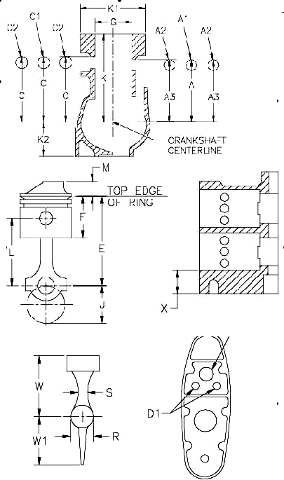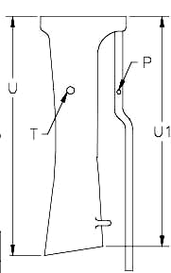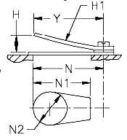

MOTOR SPECIFICATIONS FOR MERCURY 15 (A CLASS)
Engine Model |  | Mercury 15
POWERHEAD SPECIFICATIONS | Group | Ref. # | Item | Dimension | Units | Definition
POWERHEAD SPECIFICATIONS | General Specs |  | Number of Cylinders | 2
POWERHEAD SPECIFICATIONS | General Specs |  | Engine Displacement | 15.9 | In³ | The Volume of all cylinders excluding the combustions chamber
POWERHEAD SPECIFICATIONS | General Specs |  | Minimum CC | 16 | Cm³ | Volume of each Cylinder at T.D.C. filled to top of spark plug hole
POWERHEAD SPECIFICATIONS | General Specs | J | Stroke | 1.800 ±0.010 | In | Distance the crank moves in 180° of rotation. Or the distance the piston moves
POWERHEAD SPECIFICATIONS | General Specs |  | Flywheel Weight | 7 lbs 14.4 oz
POWERHEAD SPECIFICATIONS | Cylinder Bore Diameter | G | Standard | 2.376 | In | This is a Reference only Dimension
POWERHEAD SPECIFICATIONS | Cylinder Bore Diameter | G | Max Size | 2.410 | In | Maximum bore size including piston clearance
POWERHEAD SPECIFICATIONS | Rods | L | Rod Length | 3.100 ±0.005 | In | Length of the rod from center of crank pin hole to center of wrist pin hole
POWERHEAD SPECIFICATIONS | Piston | E | Rod Piston Length | 4.180 ±0.015 | In | Length of piston and rod from crank pin center to the top edge of the piston
POWERHEAD SPECIFICATIONS | Piston | F | Piston Height (minus Crown) | 2.653 ±0.030 | In
POWERHEAD SPECIFICATIONS | Piston | V | Crown Height | 0.563 ±0.005 | In
POWERHEAD SPECIFICATIONS | Piston Rings |  | Number per Piston | 2
POWERHEAD SPECIFICATIONS | Piston Rings | Upper | Design
POWERHEAD SPECIFICATIONS | Piston Rings | Lower | Design | Rectangular
POWERHEAD SPECIFICATIONS | Piston Rings | Upper | Thickness |  | In
POWERHEAD SPECIFICATIONS | Piston Rings | Lower | Thickness |  | In
POWERHEAD SPECIFICATIONS | Ports |  | Number of Exhaust | 3
POWERHEAD SPECIFICATIONS | Ports | A1 | Length of Transfer | 0.630 ±0.010 | In
POWERHEAD SPECIFICATIONS | Ports | A | Height of Transfer | 3.640 ±0.015 | In
POWERHEAD SPECIFICATIONS | Ports | C | Height of Exhaust | 3.781 ±0.015 | In
POWERHEAD SPECIFICATIONS | Ports |  | Width of Transfer | 0.950 ±0.020 | In
POWERHEAD SPECIFICATIONS | Ports | C1 | Length of Exhaust | 0.630 ±0.010 | In
POWERHEAD SPECIFICATIONS | Ports | C2 | Width of Exhaust | 2x0.950, 1x0.900 ±0.020 | In
POWERHEAD SPECIFICATIONS | Block | H | COMB. CH. Corner HT. | 5.713 ±0.010 | In
POWERHEAD SPECIFICATIONS |  | P | Reed Stop Heights | 0.325 max | In
POWERHEAD SPECIFICATIONS |  | P1 | Reed Stop Length | 1.230 ±0.020 | In
POWERHEAD SPECIFICATIONS |  |  | # of Ports | 3 | In
POWERHEAD SPECIFICATIONS |  | M | Port Length | 0.906 ±0.015 | In
POWERHEAD SPECIFICATIONS |  | N | Port Width | 0.510 ±0.015 | In
 | Carburetor |  | Venturi Diameter | 1.000 ±0.010 | In
 |  |  | Bore Diameter | 1.130 ±0.010 | In
Tower | Exhaust |  | Meg Length | 11.375 |  | This is a REF dimension
Tower |  |  | Meg Length | 10.500
Tower |  |  | Diameter at large end | 1.540
Tower |  |  | Diameter at small end | 1.380
Tower |  | D | ESH. Adapt. & Pipe | 13.280 ±0.125
Tower |  | V | DS HSC | 16.000 ±0.250
Tower |  |  | Adapter Plate | 0.500 ±0.010
Gear Case | Gear Case |  | Impeller Blades | 5
Gear Case |  |  | Gear Ratio | 14:19
Gear Case |  | Q |  | 11.550 ±0.200
Gear Case |  | Q1 |  | 9.100 ±0.200
Gear Case |  | R |  | 2.050 Min
Gear Case |  | S |  | 0.980 Min
Gear Case |  | W |  | 4.765 ±0.020
Gear Case |  | W1 |  | 4.340 ±0.100
Gear Case |  | V |  | 16.000 ±0.250

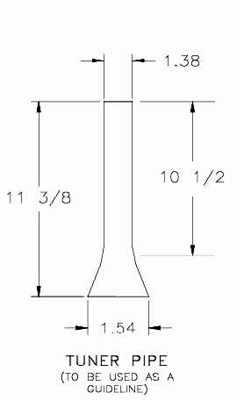

Sidewinder Specifications
It is the intention of the Manufacturer that the engine be raced as received with the following exceptions.
- Addition or removal of material on any internal engine surface is prohibited with the following exceptions:
A. The manufacturer de-burrs machined edges with a hand scraper or file.
B. It is permissible to clearance the corners of the cylinder head for the top and bottom edges of the piston deflector.
- It is permissible to profile and polish the gear case as long as minimum dimensions and templates are met.
- Timing, carburetor jets and metering rods may be adjusted or changed. No other modifications to the carburetor are permissible.
- Steering bars of any make or manufacture are permissible as long as racing association standards are met. The manufacturer does not recommend the mounting of a fuel tank to the steering bar or engine.
- The use of oversize pistons and boring of cylinders to accept oversized pistons is legal, as long as the cylinder bore does not exceed the maximum allowed cylinder diameter. Oversize pistons are available in +.010 and +.020” diameter. Oversized pistons must be used as supplied. Finish honing of the cylinder bores is permitted.
- It is permissible to machine the cylinder head to achieve minimum cc’s.
- Crankcase- Internal crankcase transfer area is CNC machined and matches block transfer area, all other internal surfaces of the crankcase are sand cast and must retain the original finish.
- Crankshaft/Rods/Bearings-
  - Crankshaft: is a full circle multi-piece press together design. There are two lightening holes .825” diameter in each crankshaft disc.
  - Crankshaft Bearings: Top main is a heavy duty cased needle bearing. Center main is a split sleeve with 36 loose needles. Bottom main is a ball bearing.
  - Rods: Are forged one piece with the outside diameter of the large end machined for clean up.
  - Rod Bearings:
    - Big End- Caged needle bearings in a silver plated race.
    - Small End- 22 loose needles retained by two spacers, one on each side of the rod with the small diameter facing the needle bearings. Wrist Pin: Ground and Hardened retained by 2 circlips in the piston.
  - Piston: Aluminum casting with 2 rings. Skirt is scalloped on the intake side. Wrist pin is a slip fit in wrist pin bore; grooves are machined in the bore for the retaining clips with a machined relief for clip removal.
- Cylinder Block-
  - Exhaust: The exhaust port openings in the block are machined. There is a 45 degree bevel machined in the exhaust outlet area between the water jacket rib and the power head mounting whole boss. The remaining exhaust area is sand cast and must be run as cast.
  - Intake: The intake port opening in the blocks is machined. The transfer opening is machined as well as the outer perimeter of the transfer area. The floor of the transfer area is sand cast with a 3/16 radius blending the floor into the perimeter. There is a rectangular window machined through the cylinder sleeve and transfer wall. This window connects the transfer passage to the cylinder below the piston. The window is closed by the piston skirt prior to opening the intake ports. The aluminum around three sides of the window is chamfered.
  - Water Passages: Water passages in the block are drilled. The water inlet is a 5/16” hole. A 5/16” diameter hole intersects the inlet and supplies water to the water jacket on the exhaust side of the block. A 3/8” diameter hole intersects the water inlet and supplies water to the cylinder water jacket.
- Cylinder Sleeves-
  - Ports: Ports are machined with a small chamfer on the top and bottom (head side/case side) edges of the ports. Exhaust ports are beveled at a 25 degree angle on the head side. Port timing is measured at the interface of the port edge and cylinder wall. The exhaust port openings of the 15S engine utilizes a squared port opening with radius corners on the edge closest to the head while having a radius edge furthest from the head. The 15H and 20S utilize a squared port opening with radius corners.
  - The intake port opening of the 15S engine utilizes radius port openings while the 15H utilizes a squared port opening with radius corners
- Cylinder Head and Gasket-
  - Cylinder Head Combustion Chamber: The cylinder head combustion chamber is cast, it is permissible to clearance the corners of the chamber to prevent contact between the piston deflector and the head.
  - Cylinder Head Gasket: The cylinder head gasket is a machined aluminum plate(s). There is one small hole in the bottom of the plate which is .062” +.015 -.015” dia. There are three .187” +.015 -.015” holes in the top of the plate. A light coating of RTV silicon is applied to both sides of the plate(s). The Hot Rod head gasket is legal to use on the Sidewinder 20S.
  - It is permissible to use the 20 cu. in. Hot Rod head gasket on the 20S Sidewinder engine as a replacement for the aluminum, plate provided the minimum cc’s specification is met.
- Intake-
  - Intake Housing: The area of the intake housing that extends into the transfer area of the block is fully machined. The internal passage of the housing is cast with the block side of the opening machined to size.
  - Intake Manifold: The internal surface of the manifold is cast with de-burring operations performed on the edges of the machined surfaces.
  - Reed Cage and Reeds: Reed cages are cast with the reed surfaces and the mounting surface machined. Reeds are of the 2 stage designs.
- Carburetor- The Lectron high velocity carburetor is the legal carburetor for the 15H model Sidewinder. The throat of this carburetor is fitted with a sleeve. The carburetor on the 15S Sidewinder is fitted with a 15mm (0.590 +/- 0.010) venturi sleeve. It is permissible to use an adjustable high speed power jet on the 15S Sidewinder.
- Exhaust Housing- Internal surfaces are as cast. There are 4 drilled 1/2” diameter exhaust relief holes in the exhaust housing. These holes are optional. They may be left un-drilled, filled, plugged or covered by any external option.
- Ignition System-
  - Flywheel: The flywheel is cast steel. The number 3584222 is cast on the underside of the flywheel. The minimum flywheel diameter is 5.990”.
  - Power pack: The power pack is identified by a sleeve on the input wires labeled Racing Outboards, LLC Part#60-01-0001. The ignition cut off wiring harness is integral and terminates with a 2 wire flat plug.
  - Armature Plate: The armature plate mounts 2 coils—a sensor coil and a charge coil. The armature plate is retained by a steel plate or by 2 machined aluminum clamps.
  - Ignition Coil: The ignition coil is mounted with 2 bolts and contains 2 individual coils in one housing.

MOTOR SPECIFICATIONS FOR SIDEWINDER 15S (A CLASS)
Engine Model |  |  |  |  | 15S
POWERHEAD SPECIFICATIONS | Group | Ref. # | Item | Dimension |  | Units |  | Definition
POWERHEAD SPECIFICATIONS | General Specs |  | Number of Cylinders | 2
POWERHEAD SPECIFICATIONS | General Specs |  | Engine Displacement | 14.94 |  | In³ |  | The Volume of all cylinders excluding the combustions chamber
POWERHEAD SPECIFICATIONS | General Specs |  | Minimum CC | 15 to 16.5 |  | Cm³ |  | Volume of each Cylinder at T.D.C. filled to top of spark plug hole
POWERHEAD SPECIFICATIONS | General Specs | J | Stroke | 2.031 ±0.005 |  | In |  | Distance the crank moves in 180° of rotation. Or the distance the piston moves
POWERHEAD SPECIFICATIONS | General Specs |  | Flywheel Weight | 4 lbs min
POWERHEAD SPECIFICATIONS | General Specs |  | Flywheel Diameter | 5.990 min
POWERHEAD SPECIFICATIONS | Cylinder Bore Diameter | G | Standard | 2.166 |  | In |  | This is a Reference only Dimension
POWERHEAD SPECIFICATIONS | Cylinder Bore Diameter | G | Max Size | 2.196 |  | In |  | Maximum bore size including piston clearance
POWERHEAD SPECIFICATIONS | Rods | L | Rod Length | 3.562 ±0.004 |  | In |  | Length of the rod from center of crank pin hole to center of wrist pin hole
POWERHEAD SPECIFICATIONS |  | F | Piston Height (minus Crown) | 2.082 ±0.015 |  | In |  | Piston Height measured to the timing edge of the piston
POWERHEAD SPECIFICATIONS |  | M | Crown Height | 0.640 ±0.015 |  | In |  | Measured from the timing edge of the piston to the top of the piston
POWERHEAD SPECIFICATIONS | Piston Rings | N | Pin to Crown edge | 1.204 ±0.015 |  | In |  | Wrist pin center to timing edge
POWERHEAD SPECIFICATIONS | Piston Rings |  | Number per Piston  Design | 2
POWERHEAD SPECIFICATIONS | Piston Rings | Upper | Number per Piston  Design | Rectangular
POWERHEAD SPECIFICATIONS | Ports | Lower |  | Rectangular
POWERHEAD SPECIFICATIONS | Ports |  | Number of Exhaust | 3
POWERHEAD SPECIFICATIONS | Ports |  | Number of Transfer | 2
POWERHEAD SPECIFICATIONS | Ports | A | Height of Transfer | 2.244 ±0.010 |  | In |  | measured from block face
POWERHEAD SPECIFICATIONS | Ports | A1 | Height of Transfer | 0.596 ±0.005 |  | In |  | measured from sleeve flange
POWERHEAD SPECIFICATIONS | Ports | C | Height of Exhaust | 2.466 ±0.010 |  | In |  | measured from block face
POWERHEAD SPECIFICATIONS | Ports | C1 | Height of Exhaust | 0.378 ±0.005 |  | In |  | measured from block face
POWERHEAD SPECIFICATIONS | Ports | D | Exhaust Height | 0.562 ±0.005 |  | In
POWERHEAD SPECIFICATIONS | Ports | D1 | Exhaust | 0.610 max |  | In |  | Height top of Bevel
POWERHEAD SPECIFICATIONS | Ports | D2 | Exhaust Length | 0.562 ±0.005 |  | In |  | Width Center Port
POWERHEAD SPECIFICATIONS | Ports | D3 | Exhaust Length | 2.102 ±0.020 |  | In |  | Width-edge to edge outside ports
POWERHEAD SPECIFICATIONS | Ports | B | Width of Transfer | 0.437 ±0.005
POWERHEAD SPECIFICATIONS | Ports | B1 | Length of Transfer | 2.186 ±0.020 |  |  |  | Edge of edge of outside ports
POWERHEAD SPECIFICATIONS | Ports | B2 | Port Web Length | 0.094 ±0.005
POWERHEAD SPECIFICATIONS | Block | K | Cylinder Height | 3.919 ±0.010 |  | In
POWERHEAD SPECIFICATIONS | Block | K1 | Cylinder Width | 5.380 ±0.015 |  | In
POWERHEAD SPECIFICATIONS | Block | K2 | Crankcase Height | 1.843 ±0.005 |  | In
POWERHEAD SPECIFICATIONS | Block | T | Intake Manifold Height | 1.656 ±0.010 |  | In
POWERHEAD SPECIFICATIONS | Intake | U | Reed opening | 1.062 ±0.025 |  | In |  | Intake Manifold Reed Opening to inlet face
POWERHEAD SPECIFICATIONS |  |  | Reed Thickness Top | 0.016 |  | In
POWERHEAD SPECIFICATIONS | Carburetor |  | Reed Thickness Bottom | 0.032 |  | In
POWERHEAD SPECIFICATIONS | Carburetor |  | Venturi Diameter | 15mm 0.590 ±0.010 |  | Mm |  | It is permissible to an adjustable high speed power jet
Carb | Carburetor |  | Bore Diameter | 28.2mm 1.110 ±0.010 |  | Mm
Carb | Carburetor |  | Relief Holes | 4X0.500 dia ±0.032
Tower | Tower |  | Height | 14.562 ±0.062 |  |  |  | Height; power head flange to gear case flange
Tower | Tower |  | Impeller Blades | 5
Gear Case | Gear Case |  | Gear Ratio | 14:19 |  |  |  | Must meet Sidewinder template 90-01-0001
Gear Case |  | Q |  | 12.000 max
Gear Case |  | Q1
Gear Case |  | R |  | 2.050 min
Gear Case |  | S |  | 0.750 min
Gear Case |  | W |  | 4.750 ±0.020
Gear Case |  | W1 |  | 4.350 ±0.100
Gear Case |  | V
Gear Case |  | 1 |  | Caged Roller
 |  | 2 |  | 36 loose Roller
 |  | 3 |  | 205 Ball
 |  | 4 |  | Roller w/Retainer
 |  | 5 |  | 22 loose Roller
 |  | 6 |  | Roller
 |  | 7 |  | Roller/Roller Thrust
 |  | 8 |  | Roller/Roller Thrust
 |  | 9 |  | Roller x2/Roller Thrust

Motor Specifications for Sidewinder 15H (B CLASS)
Engine Model |  |  |  |  | 15H
POWERHEAD SPECIFICATIONS | Group | Ref. # | Item | Dimension |  | Units |  | Definition
POWERHEAD SPECIFICATIONS | General Specs |  | Number of Cylinders | 2
POWERHEAD SPECIFICATIONS | General Specs |  | Engine Displacement | 14.94 |  | In³ |  | The Volume of all cylinders excluding the combustions chamber
POWERHEAD SPECIFICATIONS | General Specs |  | Minimum CC | 11.5 |  | Cm³ |  | Volume of each Cylinder at T.D.C. filled to top of spark plug hole
POWERHEAD SPECIFICATIONS | General Specs | J | Stroke | 2.031 ±0.005 |  | In |  | Distance the crank moves in 180° of rotation. Or the distance the piston moves
POWERHEAD SPECIFICATIONS | General Specs |  | Flywheel Weight | 4 lbs min
POWERHEAD SPECIFICATIONS | General Specs |  | Flywheel Diameter | 5.990 min
POWERHEAD SPECIFICATIONS | Cylinder Bore Diameter | G | Standard | 2.166 |  | In |  | This is a Reference only Dimension
POWERHEAD SPECIFICATIONS | Cylinder Bore Diameter | G | Max Size | 2.196 |  | In |  | Maximum bore size including piston clearance
POWERHEAD SPECIFICATIONS | Rods | L | Rod Length | 3.562 ±0.004 |  | In |  | Length of the rod from center of crank pin hole to center of wrist pin hole
POWERHEAD SPECIFICATIONS |  | F | Piston Height (minus Crown) | 2.082 ±0.015 |  | In |  | Piston Height measured to the timing edge of the piston
POWERHEAD SPECIFICATIONS |  | M | Crown Height | 0.640 ±0.015 |  | In |  | Measured from the timing edge of the piston to the top of the piston
POWERHEAD SPECIFICATIONS | Piston Rings | N | Pin to Crown edge | 1.204 ±0.015 |  | In |  | Wrist pin center to timing edge
POWERHEAD SPECIFICATIONS | Piston Rings |  | Number per Piston  Design | 2
POWERHEAD SPECIFICATIONS | Piston Rings | Upper | Number per Piston  Design | Rectangular
POWERHEAD SPECIFICATIONS | Ports | Lower |  | Rectangular
POWERHEAD SPECIFICATIONS | Ports |  | Number of Exhaust | 3
POWERHEAD SPECIFICATIONS | Ports |  | Number of Transfer | 2
POWERHEAD SPECIFICATIONS | Ports | A | Height of Transfer | 2.244 ±0.010 |  | In |  | measured from block face
POWERHEAD SPECIFICATIONS | Ports | A1 | Height of Transfer | 0.596 ±0.005 |  | In |  | measured from sleeve flange
POWERHEAD SPECIFICATIONS | Ports | C | Height of Exhaust | 2.466 ±0.010 |  | In |  | measured from block face
POWERHEAD SPECIFICATIONS | Ports | C1 | Height of Exhaust | 0.378 ±0.005 |  | In |  | measured from block face
POWERHEAD SPECIFICATIONS | Ports | D | Exhaust Height | 0.594 ±0.005 |  | In
POWERHEAD SPECIFICATIONS | Ports | D1 | Exhaust | 0.670 max |  | In |  | Height top of Bevel
POWERHEAD SPECIFICATIONS | Ports | D2 | Exhaust Length | 0.696 ±0.005 |  | In |  | Width Center Port
POWERHEAD SPECIFICATIONS | Ports | D3 | Exhaust Length | 2.186 ±0.020 |  | In |  | Width-edge to edge outside ports
POWERHEAD SPECIFICATIONS | Ports | B | Width of Transfer | 0.436 ±0.005
POWERHEAD SPECIFICATIONS | Ports | B1 | Length of Transfer | 2.186 ±0.020 |  |  |  | Edge of edge of outside ports
POWERHEAD SPECIFICATIONS | Ports | B2 | Port Web Length | 0.094 ±0.005
POWERHEAD SPECIFICATIONS | Block | K | Cylinder Height | 3.919 ±0.010 |  | In
POWERHEAD SPECIFICATIONS | Block | K1 | Cylinder Width | 5.380 ±0.015 |  | In
POWERHEAD SPECIFICATIONS | Block | K2 | Crankcase Height | 1.843 ±0.005 |  | In
POWERHEAD SPECIFICATIONS | Block | T | Intake Manifold Height | 1.656 ±0.010 |  | In
POWERHEAD SPECIFICATIONS | Intake | U | Reed opening | 1.062 ±0.025 |  | In |  | Intake Manifold Reed Opening to inlet face
POWERHEAD SPECIFICATIONS |  |  | Reed Thickness Top | 0.016 |  | In
POWERHEAD SPECIFICATIONS | Carburetor |  | Reed Thickness Bottom | 0.032 |  | In
POWERHEAD SPECIFICATIONS | Carburetor |  | Venturi Diameter | 28mm 1.102 ±0.010 |  | Mm
Carb | Carburetor |  | Bore Diameter | 30mm 1.181 ±0.010 |  | Mm
Carb | Carburetor |  | Relief Holes | 4X0.500 dia ±0.032
Tower | Tower |  | Height | 14.562 ±0.062 |  |  |  | Height; power head flange to gear case flange
Tower | Tower |  | Impeller Blades | 5
Gear Case | Gear Case |  | Gear Ratio | 14:19 |  |  |  | Must meet Sidewinder template 90-01-0001
Gear Case |  | Q |  | 12.000 max
Gear Case |  | Q1
Gear Case |  | R |  | 2.050 min
Gear Case |  | S |  | 0.750 min
Gear Case |  | W |  | 4.750 ±0.020
Gear Case |  | W1 |  | 4.350 ±0.100
Gear Case |  | V
Gear Case |  | 1 |  | Caged Roller
 |  | 2 |  | 36 loose Roller
 |  | 3 |  | 205 Ball
 |  | 4 |  | Roller w/Retainer
 |  | 5 |  | 22 loose Roller
 |  | 6 |  | Roller
 |  | 7 |  | Roller/Roller Thrust
 |  | 8 |  | Roller/Roller Thrust
 |  | 9 |  | Roller x2/Roller Thrust

MOTOR SPECIFICATIONS FOR SIDEWINDER 20S (20SSH, B & 25 CLASSES)
Engine Model |  |  |  | 20S
POWERHEAD SPECIFICATIONS | Group | Ref. # | Item | Dimension | Units | Definition
POWERHEAD SPECIFICATIONS | General Specs |  | Number of Cylinders | 2
POWERHEAD SPECIFICATIONS | General Specs |  | Engine Displacement | 19.94 | In³ | The Volume of all cylinders excluding the combustions chamber
POWERHEAD SPECIFICATIONS | General Specs |  | Minimum CC | 18.0 | Cm³ | Volume of each Cylinder at T.D.C. filled to top of spark plug hole
POWERHEAD SPECIFICATIONS | General Specs | J | Stroke | 2.031 ±0.005 | In | Distance the crank moves in 180° of rotation. Or the distance the piston moves
POWERHEAD SPECIFICATIONS | General Specs |  | Flywheel Weight | 4 lbs min
POWERHEAD SPECIFICATIONS | General Specs |  | Flywheel Diameter | 5.990 min
POWERHEAD SPECIFICATIONS | Cylinder Bore Diameter | G | Standard | 2.500 | In | This is a Reference only Dimension
POWERHEAD SPECIFICATIONS | Cylinder Bore Diameter | G | Max Size | 2.530 | In | Maximum bore size including piston clearance
POWERHEAD SPECIFICATIONS | Rods | L | Rod Length | 3.562 ±0.004 | In | Length of the rod from center of crank pin hole to center of wrist pin hole
POWERHEAD SPECIFICATIONS |  | F | Piston Height (minus Crown) | 2.068 ±0.015 | In | Piston Height measured to the timing edge of the piston
POWERHEAD SPECIFICATIONS |  | M | Crown Height | 0.740 ±0.015 | In | Measured from the timing edge of the piston to the top of the piston
POWERHEAD SPECIFICATIONS | Piston Rings | N | Pin to Crown edge | 1.190 ±0.015 | In | Wrist pin center to timing edge
POWERHEAD SPECIFICATIONS | Piston Rings |  | Number per Piston  Design | 2
POWERHEAD SPECIFICATIONS | Piston Rings | Upper | Number per Piston  Design | Rectangular
POWERHEAD SPECIFICATIONS | Ports | Lower |  | Rectangular
POWERHEAD SPECIFICATIONS | Ports |  | Number of Exhaust | 3
POWERHEAD SPECIFICATIONS | Ports |  | Number of Transfer | 2
POWERHEAD SPECIFICATIONS | Ports | A | Height of Transfer | 2.246 ±0.010 | In | measured from block face
POWERHEAD SPECIFICATIONS | Ports | A1 | Height of Transfer | 0.596 ±0.005 | In | measured from sleeve flange
POWERHEAD SPECIFICATIONS | Ports | C | Height of Exhaust | 2.466 ±0.010 | In | measured from block face
POWERHEAD SPECIFICATIONS | Ports | C1 | Height of Exhaust | 0.378 ±0.005 | In | measured from block face
POWERHEAD SPECIFICATIONS | Ports | D | Exhaust Height | 0.597±0.005 | In
POWERHEAD SPECIFICATIONS | Ports | D1 | Exhaust | 0.675max | In | Height top of Bevel
POWERHEAD SPECIFICATIONS | Ports | D2 | Exhaust Length | 0.695 ±0.005 | In | Width Center Port
POWERHEAD SPECIFICATIONS | Ports | D3 | Exhaust Length | 2..455 ±0.020 | In | Width-edge to edge outside ports
POWERHEAD SPECIFICATIONS | Ports | B | Width of Transfer | 0.381 ±0.005
POWERHEAD SPECIFICATIONS | Ports | B1 | Length of Transfer | 2.596 ±0.010 |  | Edge of edge of outside ports
POWERHEAD SPECIFICATIONS | Ports | B2 | Port Web Length | 0.100 ±0.005
POWERHEAD SPECIFICATIONS | Block | K | Cylinder Height | 3.919 ±0.010 | In
POWERHEAD SPECIFICATIONS | Block | K1 | Cylinder Width | 5.380 ±0.015 | In
POWERHEAD SPECIFICATIONS | Block | K2 | Crankcase Height | 1.843 ±0.005 | In
POWERHEAD SPECIFICATIONS | Block | X | Cylinder Base | 1.062 ±0.025 | In
POWERHEAD SPECIFICATIONS | Intake | T | Intake Manifold Height | 1.656 ±0.010 | In
POWERHEAD SPECIFICATIONS |  | U | Reed opening | 1.062 ±0.025 | In | Intake Manifold Reed Opening to inlet face
POWERHEAD SPECIFICATIONS |  |  | Reed Thickness Top | 0.016 | In
POWERHEAD SPECIFICATIONS |  |  | Reed Thickness Bottom | 0.032 | In
Carb | Carburetor |  | Venturi Diameter | 32 | Mm
Carb | Carburetor |  | Bore Diameter | 34mm 1.338 ±0.015 | Mm
Tower | Tower |  | Relief Holes | 4X0.500 dia ±0.032
Tower | Tower |  | Height | 14.562 ±0.062 |  | Height; power head flange to gear case flange
Gear Case | Gear Case |  | Impeller Blades | 5
Gear Case |  |  | Gear Ratio | 14:19 |  | Must meet Sidewinder template 90-01-0001
Gear Case |  | Q |  | 12.000 max
Gear Case |  | Q1
Gear Case |  | R |  | 2.050 min
Gear Case |  | S |  | 0.750 min
Gear Case |  | W |  | 4.750 ±0.020
Gear Case |  | W1 |  | 4.350 ±0.100
Gear Case |  | V
 |  | 1 |  | Caged Roller
 |  | 2 |  | 36 loose Roller
 |  | 3 |  | 205 Ball
 |  | 4 |  | Roller w/Retainer
 |  | 5 |  | 22 loose Roller
 |  | 6 |  | Roller
 |  | 7 |  | Roller/Roller Thrust
 |  | 8 |  | Roller/Roller Thrust
 |  | 9 |  | Roller x2/Roller Thrust
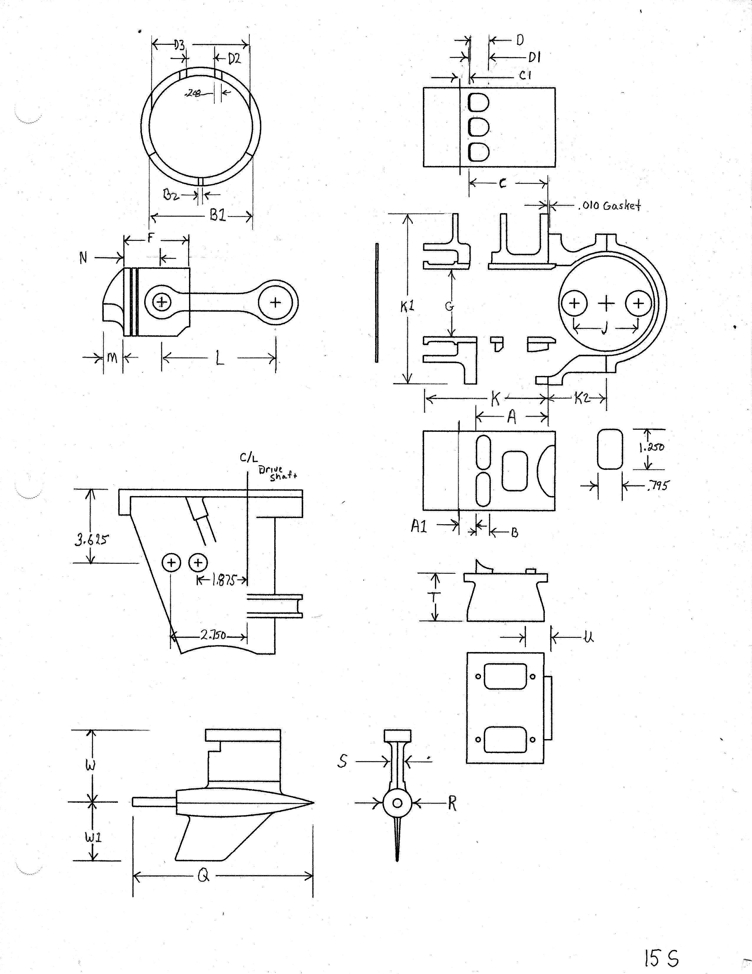

MOTOR SPECIFICATIONS FOR HOT ROD 15 (B CLASS)
Engine Model |  | Hot Rod 15
POWERHEAD SPECIFICATIONS | Group | Ref. # | Item | Dimension |  | Units |  | Definition
POWERHEAD SPECIFICATIONS | General Specs |  | Number of Cylinders | 2
POWERHEAD SPECIFICATIONS | General Specs |  | Engine Displacement | 14.94 |  | In³ |  | The Volume of all cylinders excluding the combustions chamber
POWERHEAD SPECIFICATIONS | General Specs |  | Minimum CC | 13 |  | Cm³ |  | Volume of each Cylinder at T.D.C. filled to top of spark plug hole
POWERHEAD SPECIFICATIONS | General Specs | J | Stroke | 2.031 ±0.006 |  | In |  | Distance the crank moves in 180° of rotation. Or the distance the piston moves
POWERHEAD SPECIFICATIONS | General Specs |  | Flywheel Weight | OMC 4 lbs  Motoplatt Heavy 3 lb 8 oz  Motoplatt Light  7 oz
POWERHEAD SPECIFICATIONS | General Specs |  | Flywheel Diameter | 5.990 min |  |  |  | This is for the Sidewinder Flywheel only
POWERHEAD SPECIFICATIONS | Cylinder Bore Diameter | G | Standard | 2.166 |  | In |  | This is a Reference only Dimension
POWERHEAD SPECIFICATIONS | Cylinder Bore Diameter | G | Max Size | 2.206 |  | In |  | Maximum bore size including piston clearance
POWERHEAD SPECIFICATIONS | Rods | L | Length | 3.562 ±0.004 |  | In |  | Length of the rod from center of crank pin hole to center of wrist pin hole
POWERHEAD SPECIFICATIONS |  |  | Weight | 4 oz |  |  |  | Including bearing and cap screws
POWERHEAD SPECIFICATIONS | Piston | E | Position at Bottom of Stroke | 1.890 ±0.015 |  | In |  | Including 0.031 in gasket
POWERHEAD SPECIFICATIONS | Piston | F | Piston Height (minus Crown) | 2.062 ±0.015 |  | In |  | Piston Height measured to the timing edge of the piston
POWERHEAD SPECIFICATIONS | Piston |  | Weight | 4 oz |  | In |  | Including rings, pin and bearings
POWERHEAD SPECIFICATIONS | Piston Rings |  | Number per Piston | 2
POWERHEAD SPECIFICATIONS | Piston Rings | Upper | Design | Rectangular
POWERHEAD SPECIFICATIONS | Piston Rings | Lower | Design | Rectangular
POWERHEAD SPECIFICATIONS | Piston Rings | Upper | Thickness |  |  | In
POWERHEAD SPECIFICATIONS | Piston Rings | Lower | Thickness |  |  | In
POWERHEAD SPECIFICATIONS | Ports |  | Number of Exhaust | 3 |  |  |  | Per cylinder
POWERHEAD SPECIFICATIONS | Ports |  | Number of Transfer | 2
POWERHEAD SPECIFICATIONS | Ports | A | Height of Transfer | 2.280 ±0.020 |  | In |  | Including 0.031 in gasket
POWERHEAD SPECIFICATIONS | Ports | C | Height of Exhaust | 2.498  +0.020/-0.030 |  | In |  | Including 0.031 in gasket
POWERHEAD SPECIFICATIONS | Ports | K | Crankcase Height | 1.843 ±0.005 |  | In
POWERHEAD SPECIFICATIONS | Rotary Value | N | Opens | 1.875 – 1.938 |  | In |  | Distance from TDC when value opens
POWERHEAD SPECIFICATIONS | Rotary Value | P | Close | 0.625 – 0.750 |  | In |  | Distance from TDC when value closes
Carb | Carburetor |  | Venturi Diameter | HL239A 0.875  Lectron 1.100 |  | In
Carb | Carburetor |  | Bore Diameter | HL239A 1.020 ±0.030  Lectron 1.180 ±0.015* |  | In |  | Measured at crankcase side
 |  |  | Plate | 0.500 ±0.031
 |  |  | Tower Exhaust Outlet Holes | 0.500Ø ±0.031
Gear Case | Gear Case |  | Impeller Blades | 5
Gear Case |  |  | Gear Ratio | 14:19 or 14:15
Gear Case |  | Q |  | 12.000 max
Gear Case |  | R |  | 2.062 Min
Gear Case |  | S |  | 0.750 Min
Gear Case |  | V |  | 19.312 ±0.062
 |  | 1 |  | Ball
 |  | 2 |  | Ball
 |  | 3 |  | Needle
 |  | 4 |  | Ball
 |  | 5 |  | Roller
 |  | 6 |  | Roller
 |  | 7 |  | Roller
 |  | 8 |  | Roller
 |  | 9 |  | Ball
 |  | 10 |  | Roller
 |  | 11 | Old | Ball
 |  | 11 | New | Roller
 |  | 12 | Old | Ball
 |  | 12 | New | Roller

MOTOR SPECIFICATIONS FOR HOT ROD 20 ( 25 CLASSES)
Engine Model |  | Hot Rod 20
POWERHEAD SPECIFICATIONS | Group | Ref. # | Item | Dimension |  | Units |  | Definition
POWERHEAD SPECIFICATIONS | General Specs |  | Number of Cylinders | 2
POWERHEAD SPECIFICATIONS | General Specs |  | Engine Displacement | 19.94 |  | In³ |  | The Volume of all cylinders excluding the combustions chamber
POWERHEAD SPECIFICATIONS | General Specs |  | Minimum CC | Old 17  New 18 |  | Cm³ |  | Volume of each Cylinder at T.D.C. filled to top of spark plug hole. New style head has head catchers
POWERHEAD SPECIFICATIONS | General Specs | J | Stroke | 2.031 ±0.006 |  | In |  | Distance the crank moves in 180° of rotation. Or the distance the piston moves
POWERHEAD SPECIFICATIONS | General Specs |  | Flywheel Weight | OMC 4 lbs  Motoplatt Heavy 3 lb 8 oz  Motoplatt Light  7 oz
POWERHEAD SPECIFICATIONS | General Specs |  | Flywheel Diameter | 5.990 min |  |  |  | This is for the Sidewinder Flywheel only
POWERHEAD SPECIFICATIONS | Cylinder Bore Diameter | G | Standard | 2.500 ±0.030 |  | In |  | This is a Reference only Dimension
POWERHEAD SPECIFICATIONS | Cylinder Bore Diameter | G | Max Size | 2.530 |  | In |  | Maximum bore size including piston clearance
POWERHEAD SPECIFICATIONS | Rods | L | Length | 3.562 ±0.004 |  | In |  | Length of the rod from center of crank pin hole to center of wrist pin hole
POWERHEAD SPECIFICATIONS |  |  | Weight | 4 oz |  |  |  | Including bearing and cap screws
POWERHEAD SPECIFICATIONS | Piston | E | Position at Bottom of Stroke | 1.890 ±0.015 |  | In |  | Including 0.031 in gasket
POWERHEAD SPECIFICATIONS | Piston | F | Piston Height (minus Crown) | 2.062 ±0.015 |  | In |  | Piston Height measured to the timing edge of the piston
POWERHEAD SPECIFICATIONS | Piston |  | Weight | 4 oz |  | In |  | Including rings, pin and bearings
POWERHEAD SPECIFICATIONS | Piston Rings |  | Number per Piston | 2
POWERHEAD SPECIFICATIONS | Piston Rings | Upper | Design | Rectangular
POWERHEAD SPECIFICATIONS | Piston Rings | Lower | Design | Rectangular
POWERHEAD SPECIFICATIONS | Piston Rings | Upper | Thickness |  |  | In
POWERHEAD SPECIFICATIONS | Piston Rings | Lower | Thickness |  |  | In
POWERHEAD SPECIFICATIONS | Ports |  | Number of Exhaust |  |  |  |  | Per cylinder
POWERHEAD SPECIFICATIONS | Ports |  | Number of Transfer
POWERHEAD SPECIFICATIONS | Ports | A | Height of Transfer | 2.280 ±0.020 |  | In |  | Including 0.031 in gasket
POWERHEAD SPECIFICATIONS | Ports | C | Height of Exhaust | 2.498  +0.020/-0.030 |  | In |  | Including 0.031 in gasket
POWERHEAD SPECIFICATIONS | Ports | K | Crankcase Height | 1.843 ±0.005 |  | In
POWERHEAD SPECIFICATIONS | Rotary Value | N | Opens | 1.875 – 1.938 |  | In |  | Distance from TDC when value opens
POWERHEAD SPECIFICATIONS | Rotary Value | P | Close | 0.625 – 0.750 |  | In |  | Distance from TDC when value closes
Carb | Carburetor |  | Venturi Diameter | HL168 1.281 ±0.015 |  | In
Carb | Carburetor |  | Bore Diameter | HL16 B 1.375 ±0.015  Lectron 1.338 ±0.015 |  | In |  | Measured at crankcase side
 |  |  | Plate | 0.500 ±0.031
 |  |  | Tower Exhaust Outlet Holes | 0.500Ø ±0.031
Gear Case | Gear Case |  | Impeller Blades | 5
Gear Case |  |  | Gear Ratio | 14:19 or 14:15
Gear Case |  | Q |  | 12.000 max
Gear Case |  | R |  | 2.062 Min
Gear Case |  | S |  | 0.750 Min
Gear Case |  | V |  | 19.312 ±0.062
 |  | 1 |  | Ball
 |  | 2 |  | Ball
 |  | 3 |  | Needle
 |  | 4 |  | Ball
 |  | 5 |  | Roller
 |  | 6 |  | Roller
 |  | 7 |  | Roller
 |  | 8 |  | Roller
 |  | 9 |  | Ball
 |  | 10 |  | Roller
 |  | 11 | Old | Ball
 |  | 11 | New | Roller
 |  | 12 | Old | Ball
 |  | 12 | New | Roller

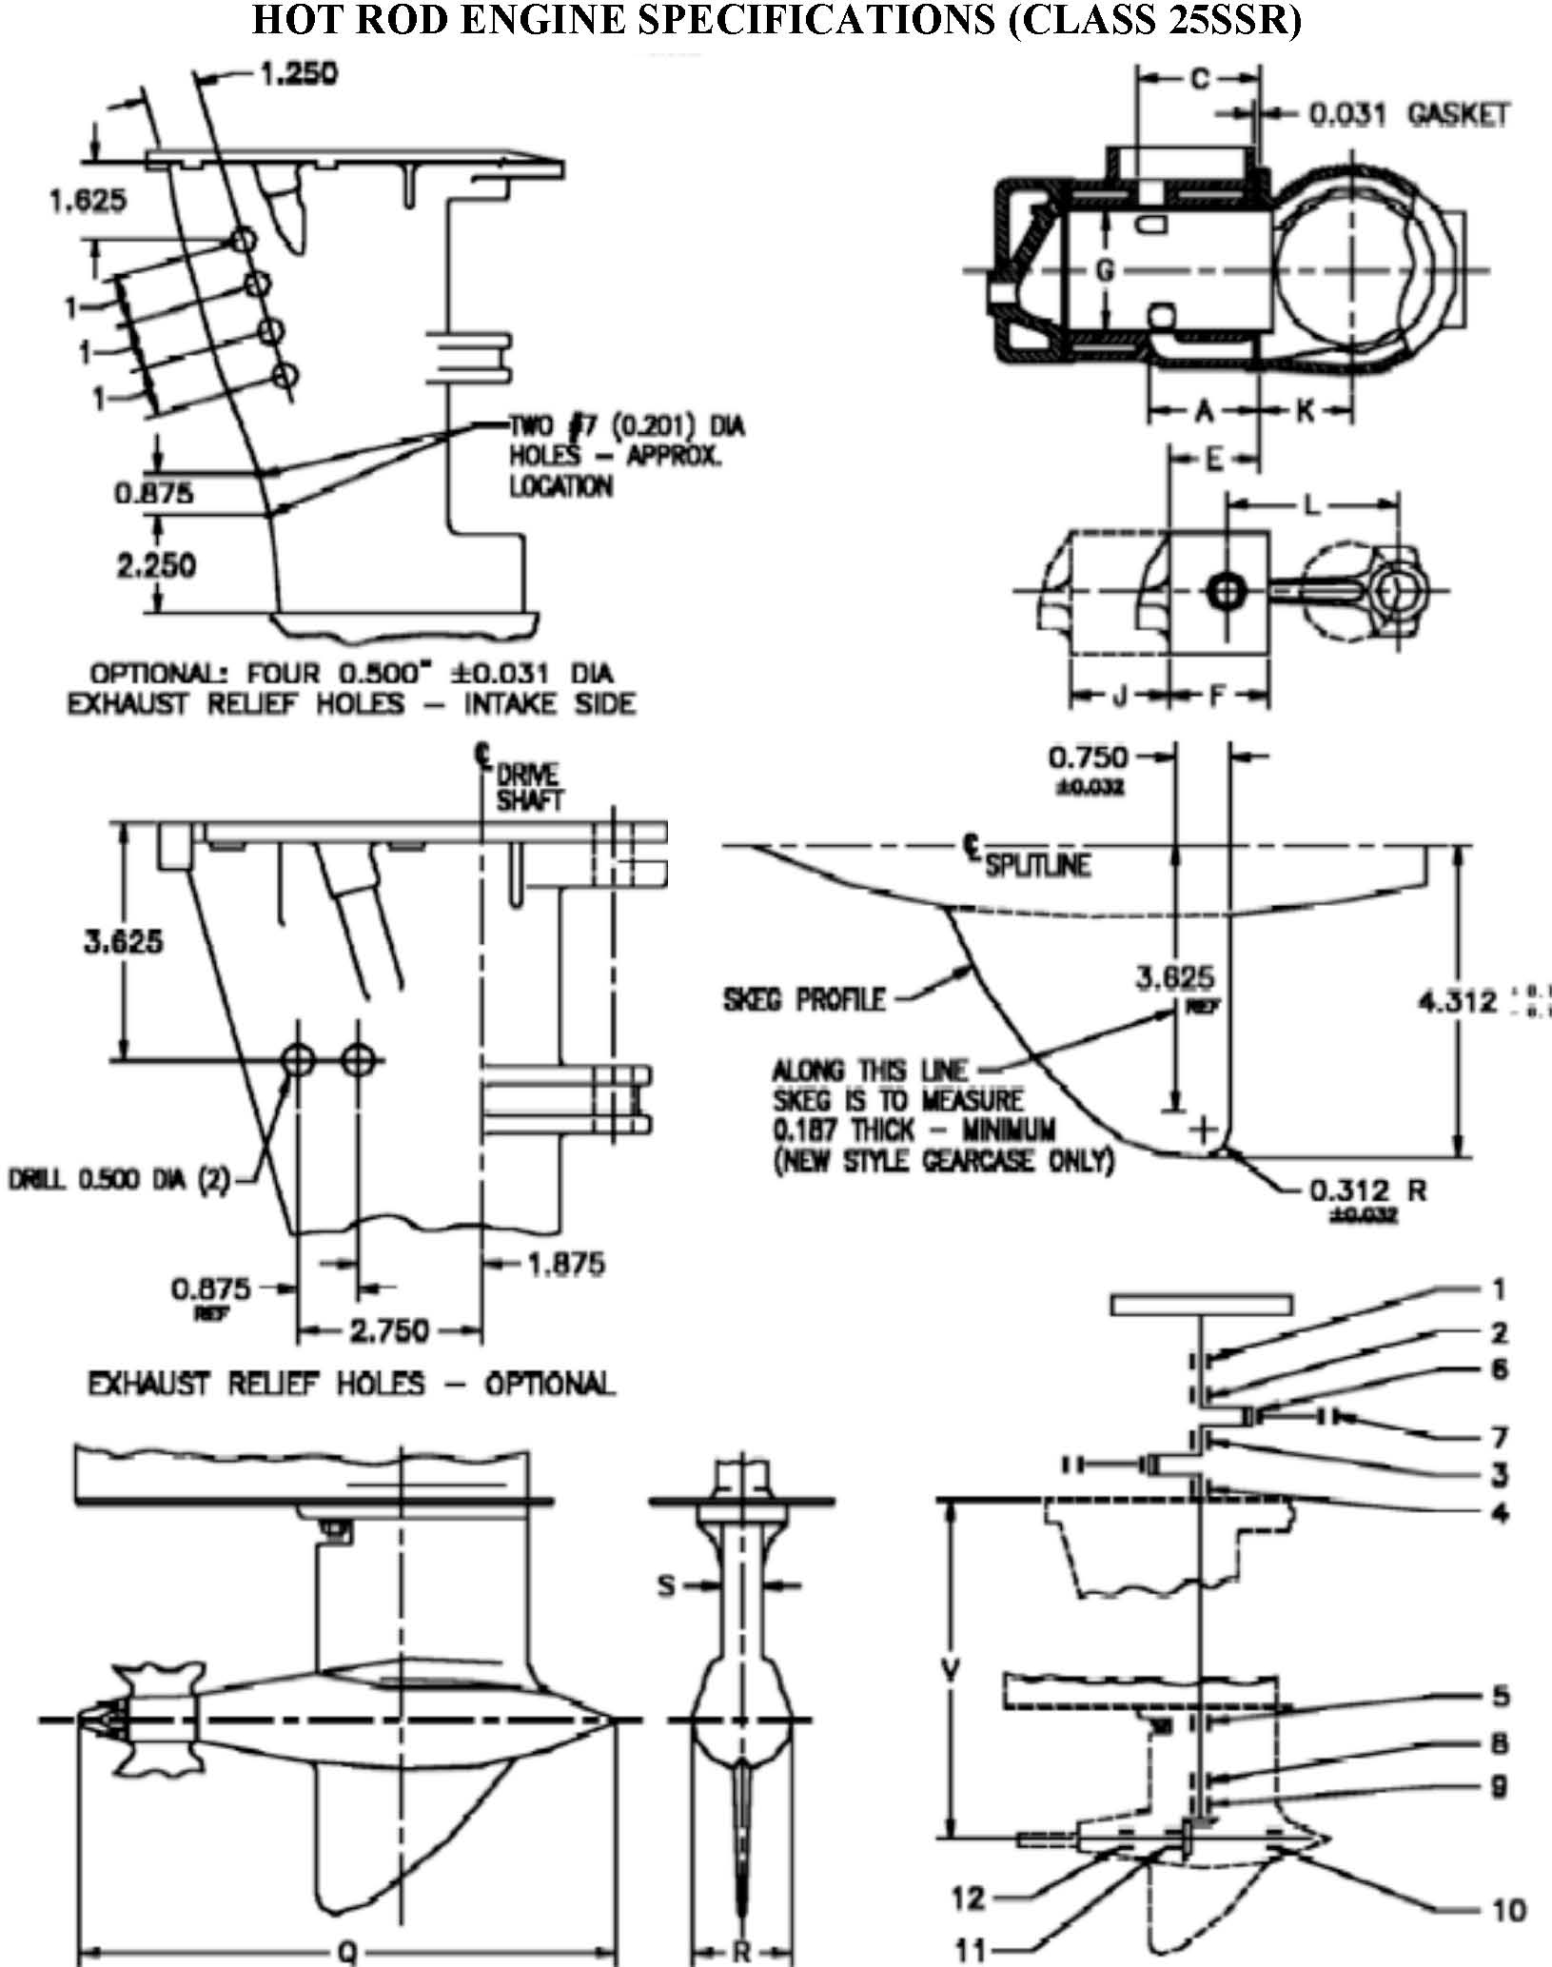

MOTOR SPECIFICATIONS FOR MERCURY 25XS
Engine Model |  | Mercury |  |  | 25XS
 |  | Mariner |  |  | 25XS
POWERHEAD SPECIFICATIONS | Group | Ref. # | Item | Dimension |  | Units |  | Definition
POWERHEAD SPECIFICATIONS | General Specs |  | Number of Cylinders | 2
POWERHEAD SPECIFICATIONS | General Specs |  | Engine Displacement | 24.4 |  | In³ |  | The Volume of all cylinders excluding the combustions chamber
POWERHEAD SPECIFICATIONS | General Specs |  | Minimum CC | 21.7 Chrome bore 21.2 Mercosil |  | Cm³ |  | Volume of each Cylinder at T.D.C. filled to top of spark plug hole
POWERHEAD SPECIFICATIONS | General Specs | J | Stroke | 2.362 ±0.005 |  | In |  | Distance the crank moves in 180° of rotation. Or the distance the piston moves
POWERHEAD SPECIFICATIONS | General Specs |  | Flywheel Weight | 7lbs. 8oz small  9lbs 7oz large
POWERHEAD SPECIFICATIONS | General Specs |  | Flywheel Diameter
POWERHEAD SPECIFICATIONS | Cylinder Bore Diameter | G | Standard | 2.563 ±0.005 |  | In |  | This is a Reference only Dimension
POWERHEAD SPECIFICATIONS | Cylinder Bore Diameter | G | Max Size | 2.566 |  | In |  | Maximum bore size including piston clearance
POWERHEAD SPECIFICATIONS | Rods | L | Rod Length | 4.062 ±0.005 |  | In |  | Length of the rod from center of crank pin hole to center of wrist pin hole
POWERHEAD SPECIFICATIONS | Piston | E | Rod Piston Length | 5.277 ±0.020 |  | In |  | Length of piston and rod from crank pin center to the top of the piston
POWERHEAD SPECIFICATIONS | Piston | F | Piston Height | 2.525 ±0.030 |  | In |  | Piston Height measured to the top edge of the piston
POWERHEAD SPECIFICATIONS | Piston Rings |  | Number per Piston | 2
POWERHEAD SPECIFICATIONS | Piston Rings | Upper | Design | Half Keystone |  |  |  | Also known as a keystone ring
POWERHEAD SPECIFICATIONS | Piston Rings | Lower | Design | Rectangular
POWERHEAD SPECIFICATIONS | Piston Rings | Upper | Thickness | 0.060 ±0.002 |  | In
POWERHEAD SPECIFICATIONS | Piston Rings | Lower | Thickness | 0.060 ±0.002 |  | In
POWERHEAD SPECIFICATIONS | Ports |  | Number of Exhaust | 1
POWERHEAD SPECIFICATIONS | Ports |  | Number of Transfer | 3
POWERHEAD SPECIFICATIONS | Ports | A | Height of Transfer | 4.493 ±0.030 |  | In
POWERHEAD SPECIFICATIONS | Ports | A3 | Height of Transfer | 1.079 ±0.030 |  | In
POWERHEAD SPECIFICATIONS | Ports | C | Height of Exhaust | 4.863 ±0.030 |  | In
POWERHEAD SPECIFICATIONS | Ports | A1 | Transfer Diameter | 0.395 ±0.030 |  | In
POWERHEAD SPECIFICATIONS | Ports | C1 | Exhaust Diameter | 0.750 ±0.030 |  | In
POWERHEAD SPECIFICATIONS | Ports | A2 | Transfer Diameter | 0.450 ±0.030 |  | In
POWERHEAD SPECIFICATIONS | Ports | C2 | Exhaust Diameter | 1.448 ±0.030 |  | In
POWERHEAD SPECIFICATIONS |  | A4 |  | 0.957 ±0.030
POWERHEAD SPECIFICATIONS |  | A5 |  | 1.114 ±0.030
POWERHEAD SPECIFICATIONS | Block | K | Cylinder Height | 6.540 ±0.030 |  | In
POWERHEAD SPECIFICATIONS | Reeds and Reed Plate |  | Reed Material | Steel or Fiber |  | In
POWERHEAD SPECIFICATIONS | Reeds and Reed Plate |  | Reed Thickness | Steel 0.008 ±0.0008  Fiber 0.020 ±0.002 |  | In
POWERHEAD SPECIFICATIONS | Reeds and Reed Plate | P | Reed Stop Heights | 0.260 ±0.030 0.285±0.020 |  | In |  | P/N 42471-2  P/N 14112
POWERHEAD SPECIFICATIONS | Reeds and Reed Plate | Y | Reed Stop Radius | 0.285 ±0.020 |  | In
POWERHEAD SPECIFICATIONS | Reeds and Reed Plate | M | Port Length | 0.700 ±0.030 |  | In
POWERHEAD SPECIFICATIONS | Reeds and Reed Plate | N2 | Port Width | 0.550 ±0.020 |  | In
Carb | Carburetor |  | Venturi Diameter | 1.120 ±0.015 |  | In
Carb | Carburetor |  | Bore Diameter | 1.250 ±0.015 |  | In
Tower | Exhaust | D | Meg Length | 7.120 ±0.150 |  |  |  | From top of adaptor to bottom of pipe
Tower | Exhaust | V |  | 14.625 ±0.060 |  |  |  | Measured with exhaust adaptor long
Tower | Exhaust | V |  | 9.750 ±0.060 |  |  |  | Short
Tower |  | D | Tower Exhaust Outlet Holes | 2.000x2.000 +0.250
Gear Case | Gear Case |  | Impeller Blades
Gear Case |  |  | Gear Ratio | 16:21 or 15:15
Gear Case |  | Q |  | 11.250 max
Gear Case |  | R |  | 2.090 min
Gear Case |  | S |  | 0.980 min
Gear Case |  | W |  | 1.870 min

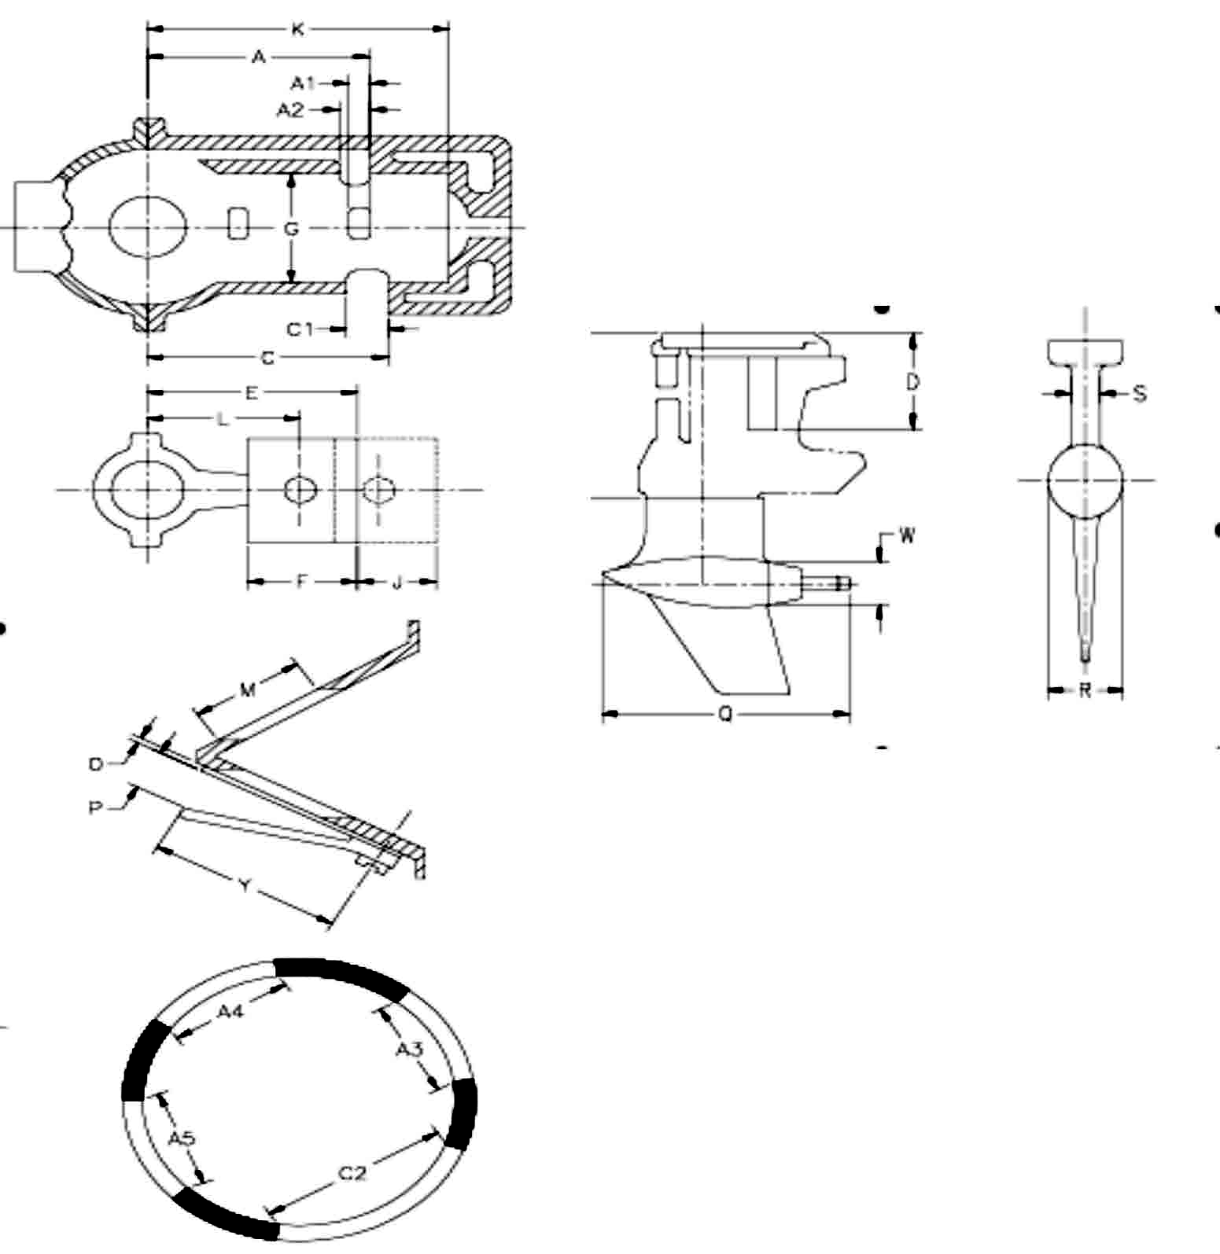

Yamato-102C & 302F Specifications
The intent of these rules is for the Yamato 102C & 302F engines to be raced as received from the manufacturer without modification except as specifically listed below. If a specific dimension is not listed in these rules, the Inspector may compare the dimensions of a new part to assist in making a decision regarding part legality.
Permissible Modifications
- It is permissible to use any make of bearings, seals, ignition components, piston rings, steering bar, or prop shaft provided no engine modifications are made to accommodate them.
- It is permissible to drill water drain holes in the ignition castings (coil plates and crankcase top end cap), and these holes may be tapped and plugged.
- It is permissible to enlarge the fuel tank or build a complete new tank. If the tank is removed, the tank mounting brackets may also be removed. A fuel filter may be added to the fuel line.
- A fuel pump may be used for racing, but the carburetor shall not be modified in any way.
- It is permissible to grind, file, or polish the lower unit as long as all dimensions and templates are met. The “bulge” may be ground flush with the sides of the skeg on both the 102 and 302.
- Any type of thrust bracket adjustment is allowed. It is permissible to drill 2 holes at the front of the cavitation plate to facilitate the mounting of a thrust bracket block.
- The tilt lock lever and spacer on the tilt bracket bolt may be removed.
- The magneto stator plate may be locked in position by any means and the stator plate timing knob may be removed.
- The spray shield may be modified for use with throttle cable to allow easier access for engine priming and it may be painted.
- The prop shaft may be turned down to 9/16 inch minimum diameter or a new propeller shaft may be made (9/16 inch minimum diameter). In either case, only one shear pinhole is permissible. The prop nut thread size is optional.
- It is legal to bore the Yamato 102C and 302F cylinders one size larger than standard bore. It is permissible to re-sleeve any block provided engine specifications are maintained.
- It is permissible to mill the cylinder head. No changes may be made to the combustion chamber. It is legal to re-machining of squish band for repair purposes only angle 15° ± 2°, 2.612 ± 0.015 for Y-102 and Y-302 engines. There must be a visible ledge surrounding the squish band.
- It is permissible to substitute the Yamato 302 gear case assembly for use on the 102 engine. The 102 gear case assembly may not be used on the 302 engine.
- The 102 exhaust megaphone may have any type of welding, gusset, strap, etc. used on the outside only, to repair or reinforce as long as all other dimensions are met. It will be left to the discretion of the inspector to decide if any changes to the inside of the megaphone were due to welding “melt through” or were done to intentionally change the interior configuration.
- It is permissible to use non-OEM crank pins and exhaust stacks. (The inspector may compare to new).
- The water inlet supply holes may be repaired with weld or plastic compounds. Water supply inlet hole diameter 0.270 – 0.297. Contours and shape must be as originally manufactured.
- It is permissible to reposition the ring groove stop pin to allow the use of the Model 302 piston in the 102.
- It is permissible to use the Yamato Model 202 magneto on the Model 102.
- It is permissible to remount any coil on the 102.
- Aftermarket roping plate is legal on the 102 as long as it meets OEM dimensions.
Non-Permissible Modifications
- No drilling or modifications of any type may be made to the cooling system. Extended length, flexible water outlet “dump” hoses are permissible, however.
- Addition or removal of metal on any cast or forged internal engine components, surfaces or passages including the intake system, carburetor, or exhaust system is prohibited. Honing of cylinder bores and connecting rods is permitted.
- Bead blasting, sand blasting, or blasting by any other media of internal engine components is not permissible.
- Addition or removal of material from any moving parts including the flywheel, crankshaft, and pistons is prohibited.
- The two water outlet drain holes in the bottom of the cylinder block must not be restricted.
General
- The volume of the combustion chamber will be measured with all the spark plugs and bushings removed without removing the cylinder head from the engine.
- Only Yamato parts will be considered as legal replacement parts (except as specifically noted in these rules). This includes (but is not limited to) all engine components, gaskets. etc.
- To measure the reed stop heights (Q): lightly depress the reed and the bottom edge of the end of the reed stop.
- For identification of the legal model 102, the outside dimension of the exhaust cover is 3-3/16 inches wide.
- The 302F gear case assembly can be identified by the snap ring and metal plate on the rear outside of the prop shaft cone. Some gear cases were supplied by the manufacturer without oil fill plugs. It is not permissible to add oil fill plugs to these units. Also, it is not permissible to eliminate the oil fill plugs from gear cases that were furnished by the manufacturer with oil fill plugs.
- In compensation for measuring the gear case skeg without the factory “bulge”, an additional 0.250 inches should be added to existing gear case templates in order to properly measure a gear case without the “bulge”.
- The latest replacement Carburetor has been approved for use on the 102 and 302.

MOTOR SPECIFICATIONS FOR YAMATO 102 (25SSR & C CLASS)
Engine Model |  | Yamato |  |  | 102C
POWERHEAD SPECIFICATIONS | Group | Ref. # | Item | Dimension |  | Units |  | Definition
POWERHEAD SPECIFICATIONS | General Specs |  | Number of Cylinders | 2
POWERHEAD SPECIFICATIONS | General Specs |  | Engine Displacement | 24 |  |  |  | The Volume of all cylinders excluding the combustions chamber
POWERHEAD SPECIFICATIONS | General Specs |  | Minimum CC | 14mm 25.5  18mm 26 |  |  |  | Volume of each Cylinder at T.D.C. filled to top of spark plug hole
POWERHEAD SPECIFICATIONS | General Specs | M | Stroke | 2.286 ±0.010 |  |  |  | Distance the crank moves in 180° of rotation. Or the distance the piston moves
POWERHEAD SPECIFICATIONS | General Specs |  | Flywheel Weight | 1500 min |  | g
POWERHEAD SPECIFICATIONS | General Specs |  | Crank Weight | 5200 min |  | g
POWERHEAD SPECIFICATIONS | General Specs |  | Roping plate | 415 min |  | g
POWERHEAD SPECIFICATIONS | General Specs |  | Ignition | Magneto
POWERHEAD SPECIFICATIONS | Cylinder Bore Diameter |  | Max Size | 2.625 |  | In |  | Maximum bore size including piston clearance
POWERHEAD SPECIFICATIONS | Rods | K | Rod Length | 4.204 – 4.221 |  | In |  | Length of the rod from center of crank pin hole to center of wrist pin hole
POWERHEAD SPECIFICATIONS | Rods |  | Weight | 184 min |  | g |  | With both bearings
POWERHEAD SPECIFICATIONS | Piston |  | Piston Weight | 260 min |  | g |  | With rings, wrist pin, and clips
POWERHEAD SPECIFICATIONS | Piston | L | Piston Height (minus Crown) | 2.322 – 2.402 |  | In |  | Piston Height measured to the top edge of the top ring
POWERHEAD SPECIFICATIONS | Piston | N | Wrist Pin to top | 1.291 ±0.010 |  | In |  | Measured from the top edge of the top ring to the center of the wrist pin
POWERHEAD SPECIFICATIONS | Piston Rings |  | No. per Piston | 2
POWERHEAD SPECIFICATIONS | Piston Rings | Upper | Design | Rectangular
POWERHEAD SPECIFICATIONS | Piston Rings | Lower | Design | Rectangular
POWERHEAD SPECIFICATIONS | Piston Rings | Upper | Thickness |  |  | In
POWERHEAD SPECIFICATIONS | Piston Rings | Lower | Thickness |  |  | In
POWERHEAD SPECIFICATIONS | Ports |  | Number of Exhaust | 2 per cylinder
POWERHEAD SPECIFICATIONS | Ports |  | Number of Transfer | 2 per cylinder and 1 boost
POWERHEAD SPECIFICATIONS | Ports | D | Height of Transfer | 1.890 – 1.915 |  | In
POWERHEAD SPECIFICATIONS | Ports | D1 | Height of Transfer | 1.855 – 1.900 |  | In
POWERHEAD SPECIFICATIONS | Ports | E | Height of Exhaust | 1.430 – 1.455 |  | In
POWERHEAD SPECIFICATIONS | Ports | D2 | Transfer Diameter | n/a |  | In
POWERHEAD SPECIFICATIONS | Ports | D3 | Exhaust Diameter | n/a |  | In
POWERHEAD SPECIFICATIONS | Ports | E1 | Transfer Diameter | n/a |  | In
POWERHEAD SPECIFICATIONS | Block | C | Cylinder Height | 4.104 ±0.010 |  | In
POWERHEAD SPECIFICATIONS | Block | F | Gasket | 0.012±0.004 |  | In
POWERHEAD SPECIFICATIONS | Block | A | Crankcase Height | 2.550 ±0.010 |  | In
POWERHEAD SPECIFICATIONS | Block | B |  | 2.545 ±0.010 |  | In
POWERHEAD SPECIFICATIONS |  | G | Head Gasket | 0.020 ±0.004
POWERHEAD SPECIFICATIONS | Intake |  | Block water hole near head | 0.140 ±0.005 |  | In
POWERHEAD SPECIFICATIONS | Reeds and Reed Plate |  | Block water hole near exhaust man. | 0.120 ±0.005 |  | In
POWERHEAD SPECIFICATIONS | Reeds and Reed Plate |  | # of Holes | 8 |  | In
POWERHEAD SPECIFICATIONS | Reeds and Reed Plate |  | Hole Size | 0.793 x 1.041 |  | In
POWERHEAD SPECIFICATIONS | Reeds and Reed Plate |  | Reed Thickness | 0.012 ±0.002
POWERHEAD SPECIFICATIONS | Reeds and Reed Plate | Q | Reed Stop Heights | 0.289 max |  | In
POWERHEAD SPECIFICATIONS | Reeds and Reed Plate | Q1 | Reed Stop Radius | 1.342 – 1.421 |  | In
Carb | Carburetor  Mikuni BV-36 |  | Venturi Diameter | 1.102 ±0.012 |  | In
Carb | Carburetor  Mikuni BV-36 |  | Bore Diameter | 1.407 ±0.012 |  | In
Tower | Exhaust | P | Meg Length | 11.625 ±0.050
Tower | Exhaust | P3 |  | 2.180 max
Tower | Exhaust | P4 | Meg. Relief Hole | 1.060 max
Tower | Exhaust | P2 | Tower Exhaust Outlet Holes | 2.400 ±0.040
Tower | Exhaust | P1 | Housing Relief Holes | 0.203 Ø max
Tower |  |  | Water Inlet Hole | 0.297 max
Gear case |  |  | Gear Ratio | 14:15 |  |  |  | Helical cut
Gear case | Tower Housing | O |  | 18.464 – 18.622
Gear case |  | S |  | 1.195 min
Gear case |  | T |  | 8.465 ±0.050
Gear case |  | U |  | 4.724 ±0.050
Gear case |  | V |  | 10.800 max
Gear case |  | W |  | 2.205 min
Gear case |  | X |  | 2.980 ±0.030
Gear case |  | Y |  | 50°
Gear case |  | Z1 |  | 0.190 min
Gear case |  | Z2 |  | 0.190 min
Gear case |  | Z3 |  | 0.150 min
Gear case |  | Z4 |  | 0.150 min
Gear case |  | Z5 |  | 1.949 min
Gear case |  | CL |  | 1.772 max
Gear case |  | CD |  | 2.100 min

MOTOR SPECIFICATIONS FOR YAMATO 302 (25SSR, CSR, CSH & 302SSH)
Engine Model |  | Yamato |  |  | 302F
POWERHEAD SPECIFICATIONS | Group | Ref. # | Item | Dimension |  | Units |  | Definition
POWERHEAD SPECIFICATIONS | General Specs |  | Number of Cylinders | 2
POWERHEAD SPECIFICATIONS | General Specs |  | Engine Displacement | 24 |  |  |  | The Volume of all cylinders excluding the combustions chamber
POWERHEAD SPECIFICATIONS | General Specs |  | Minimum CC | 14mm 25.5  18mm 26 |  |  |  | Volume of each Cylinder at T.D.C. filled to top of spark plug hole
POWERHEAD SPECIFICATIONS | General Specs | M | Stroke | 2.276 – 2.291 |  |  |  | Distance the crank moves in 180° of rotation. Or the distance the piston moves
POWERHEAD SPECIFICATIONS | General Specs |  | Flywheel Weight | 1500 min |  | g
POWERHEAD SPECIFICATIONS | General Specs |  | Crank Weight | 5300 min |  | g
POWERHEAD SPECIFICATIONS | General Specs |  | Roping plate | 360 min |  | g
POWERHEAD SPECIFICATIONS | General Specs |  | Ignition | Transistor Magneto
POWERHEAD SPECIFICATIONS | Cylinder Bore Diameter |  | Max Size | 2.625 |  | In |  | Maximum bore size including piston clearance
POWERHEAD SPECIFICATIONS | Rods | K | Rod Length | 4.204-4.221 |  | In |  | Length of the rod from center of crank pin hole to center of wrist pin hole
POWERHEAD SPECIFICATIONS | Rods |  | Weight | 191 min |  | g |  | With both bearings
POWERHEAD SPECIFICATIONS | Piston |  | Piston Weight | 260 min |  | g |  | With rings, wrist pin, and clips
POWERHEAD SPECIFICATIONS | Piston | L | Piston Height (minus Crown) | 2.346 – 2.378 |  | In |  | Piston Height measured to the top edge of the top ring
POWERHEAD SPECIFICATIONS | Piston | N | Wrist Pin to top | 1.291 – 1.307 |  | In |  | Measured from the top edge of the top ring to the center of the wrist pin
POWERHEAD SPECIFICATIONS | Piston Rings |  | Number per Piston | 2
POWERHEAD SPECIFICATIONS | Piston Rings | Upper | Design | Rectangular |  |  |  | Also known as a keystone ring
POWERHEAD SPECIFICATIONS | Piston Rings | Lower | Design | Rectangular
POWERHEAD SPECIFICATIONS | Piston Rings | Upper | Thickness |  |  | In
POWERHEAD SPECIFICATIONS | Piston Rings | Lower | Thickness |  |  | In
POWERHEAD SPECIFICATIONS | Ports |  | Number of Exhaust
POWERHEAD SPECIFICATIONS | Ports |  | Number of Transfer
POWERHEAD SPECIFICATIONS | Ports | D | Height of Transfer | 1.890 – 1.913 |  | In
POWERHEAD SPECIFICATIONS | Ports | D1 | Height of Boost Port | 1.772 – 1.827 |  | In
POWERHEAD SPECIFICATIONS | Ports | E | Height of Exhaust | 1.380 – 1.402 |  | In
POWERHEAD SPECIFICATIONS | Ports | D2 | Transfer Width | 1.255 – 1.295 |  | In
POWERHEAD SPECIFICATIONS | Ports | D3 | Boost Port Width | 0.978 – 1.018 |  | In
POWERHEAD SPECIFICATIONS | Ports | E1 | Exhaust Width | 1.791 – 1.831 |  | In
POWERHEAD SPECIFICATIONS | Block | C | Cylinder Height | 4.102 – 4.114 |  | In
POWERHEAD SPECIFICATIONS | Block | F | Gasket | 0.012 ±0.004 |  | In
POWERHEAD SPECIFICATIONS | Block | A | Crankcase Height | 2.827 – 2.843 |  | In
POWERHEAD SPECIFICATIONS | Block | B |  | 2.539 – 2.551 |  | In
POWERHEAD SPECIFICATIONS |  | G | Head Gasket | 0.020 ±0.004
POWERHEAD SPECIFICATIONS | Intake |  | Block water hole near head | n/a |  | In
POWERHEAD SPECIFICATIONS | Reeds and Reed Plate |  | Block water hole  near exhaust man. | 0.118 ±0.002 |  | In
POWERHEAD SPECIFICATIONS | Reeds and Reed Plate |  | # of Holes | 12 |  | In
POWERHEAD SPECIFICATIONS | Reeds and Reed Plate |  | Hole Size | 0.512 x 1.142 |  | In
POWERHEAD SPECIFICATIONS | Reeds and Reed Plate |  | Reed Thickness | 0.012 ±0.002
POWERHEAD SPECIFICATIONS | Reeds and Reed Plate | Q | Reed Stop Heights | 0.289 max |  | In
POWERHEAD SPECIFICATIONS | Reeds and Reed Plate | Q1 | Reed Stop Radius | 1.272 – 1.350 |  | In
Carb | Carburetor  Mikuni BV-36 |  | Venturi Diameter | 1.102 ±0.012 |  | In
Carb | Carburetor  Mikuni BV-36 |  | Bore Diameter | 1.407 ±0.012 |  | In
Tower | Exhaust | P | Meg Length | 10.157 – 10.315
Tower | Exhaust | P3 |  | 1.732 – 1.811
Tower | Exhaust | P4 | Meg. Relief Hole | 1.535 – 1.614
Tower | Exhaust | P2 | Tower Exhaust Outlet Holes | 2.469 ±0.040
Tower | Exhaust | P1 | Housing Relief Holes | 0.185 – 0.209
Tower | Tower Housing |  | Water Inlet Hole | 0.297 max
Gear case |  |  | Gear Ratio | 14:15 |  |  |  | Helical cut
Gear case |  | O |  | 17.283 – 17.402
Gear case |  | S |  | 1.195 min
Gear case |  | T |  | 8.465 ±0.050
Gear case |  | U |  | 4.754 ±0.050
Gear case |  | V |  | 10.800 max
Gear case |  | W |  | 2.205 min
Gear case |  | X |  | 2.980 ±0.030
Gear case |  | Y |  | 50°
Gear case |  | Z1 |  | 0.190 min
Gear case |  | Z2 |  | 0.190 min
Gear case |  | Z3 |  | 0.150 min
Gear case |  | Z4 |  | 0.150 min
Gear case |  | Z5 |  | 1.949 min
Gear case |  | CL |  | 1.712 max
Gear case |  | CD |  | 2.115 min

MOTOR SPECIFICATIONS FOR YAMATO 302 SSH
Engine Model |  | Yamato |  |  | 302F
 | General Specs. | Ref. # | Item | Dimension |  | Units |  | Definition
 | General Specs. |  | All current Yamato Model 302 specifications apply except the following
POWER | Cylinder Head |  | 14mm head only thickness | 1.440 min. |  | in |  | Formerly I dimension
Gear case |  |  | Gear Ratio | 14:15 |  |  |  | Helical cut
Gear case |  | W |  | 2.245 min.
Gear case |  | Z1 |  | 0.200 min.
Gear case |  | Z2 |  | 0.195 min.
Gear case |  | Z3 |  | 0.155 min.
Gear case |  | Z4 |  | 0.160 min.
Gear case | Bulge Thickness |  |  | 0.225 min.
Gear case | Skeg Radius leading and trailing edge |  |  | 7/64 min.
Gear case | Nose Cone Radius |  |  | 7/16 min.
Gear case | Top of gear foot leading radius (above nose cone) |  |  | 7/64 min.
Gear case | Top of gear foot trailing radius (above cone nut) |  |  | 17/64 min.

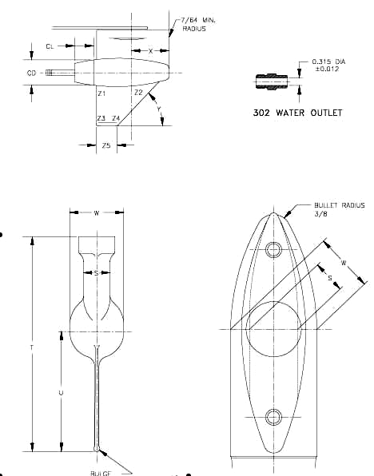

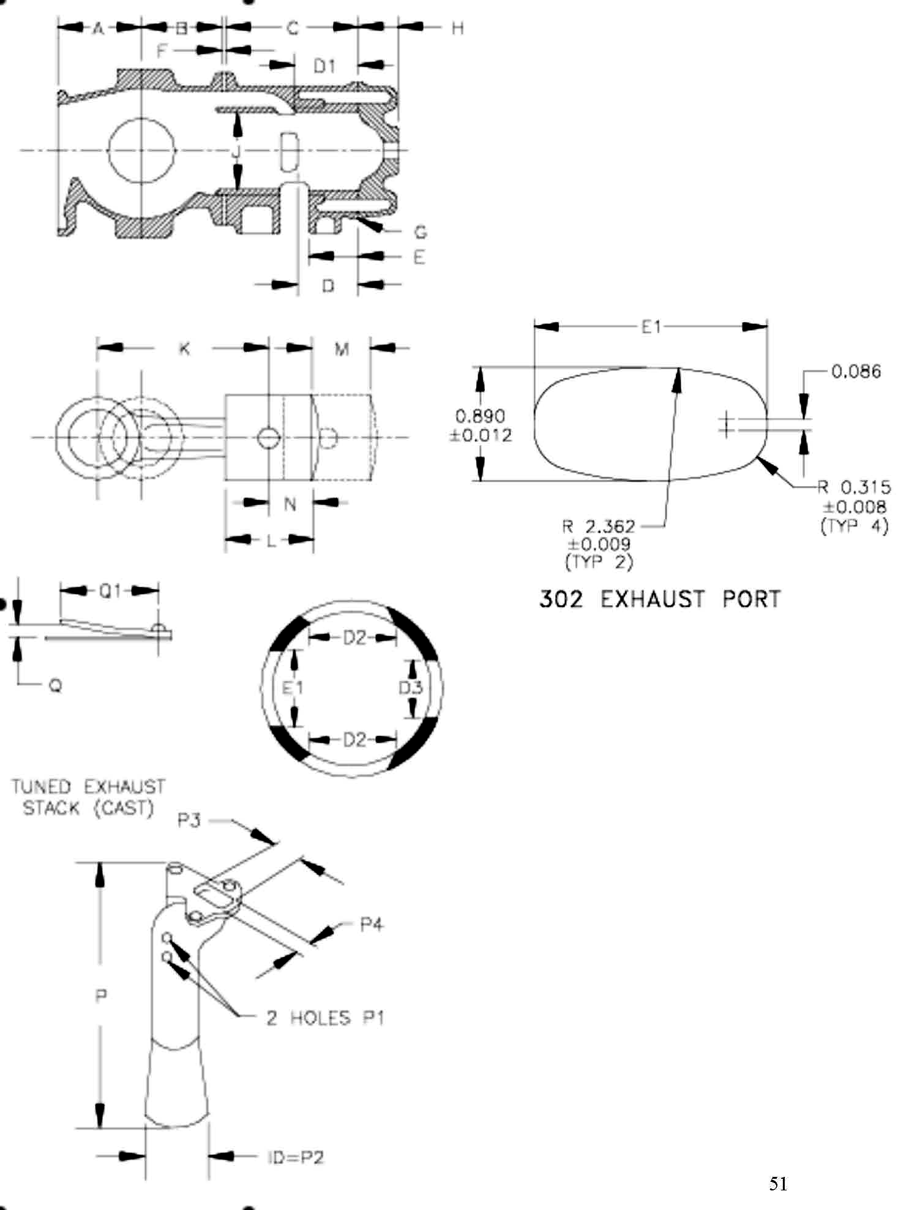

MOTOR SPECIFICATIONS FOR YAMATO 80 (20 CLASS)
Engine Model |  | Yamato |  |  | Y80
POWERHEAD SPECIFICATIONS | Group | Ref. # | Item | Dimension |  | Units |  | Definition
POWERHEAD SPECIFICATIONS | General Specs |  | Number of Cylinders | 2
POWERHEAD SPECIFICATIONS | General Specs |  | Engine Displacement | 20 |  |  |  | The Volume of all cylinders excluding the combustions chamber
POWERHEAD SPECIFICATIONS | General Specs |  | Minimum CC | 14mm 18  18mm 18.5 |  |  |  | Volume of each Cylinder at T.D.C. filled to top of spark plug hole
POWERHEAD SPECIFICATIONS | General Specs | M | Stroke | 2.279 – 2.288 |  |  |  | Distance the crank moves in 180° of rotation. Or the distance the piston moves
POWERHEAD SPECIFICATIONS |  |  | Flywheel Weight | 2.86 min |  | Lbs.
POWERHEAD SPECIFICATIONS |  |  | Standard bore .015 over | 2.360  2.375
POWERHEAD SPECIFICATIONS | Cylinder Bore Diameter | J | Max Size | 2.387 |  | In |  | Maximum bore size including piston clearance
POWERHEAD SPECIFICATIONS | Rods | K | Rod Length | 4.204 – 4.221 |  | In |  | Length of the rod from center of crank pin hole to center of wrist pin hole
POWERHEAD SPECIFICATIONS | Rods |  | Weight | min |  | g
POWERHEAD SPECIFICATIONS | Piston |  | Piston Weight | min |  | g
POWERHEAD SPECIFICATIONS | Piston | KN | Rod Piston Length | 5.496 – 5.527
POWERHEAD SPECIFICATIONS | Piston | L | Piston Height (minus Crown) | 2.322 – 2.402 |  | In |  | Piston Height measured to the top edge of the top ring
POWERHEAD SPECIFICATIONS | Piston Rings |  | Number per Piston | 2
POWERHEAD SPECIFICATIONS | Piston Rings | Upper | Design | Rectangular
POWERHEAD SPECIFICATIONS | Piston Rings | Lower | Design | Rectangular
POWERHEAD SPECIFICATIONS | Piston Rings | Upper | Thickness |  |  | In
POWERHEAD SPECIFICATIONS | Piston Rings | Lower | Thickness |  |  | In
POWERHEAD SPECIFICATIONS | Ports |  | Number of Exhaust
POWERHEAD SPECIFICATIONS | Ports |  | Number of Transfer
POWERHEAD SPECIFICATIONS | Ports | D | Height of Transfer | 1.800 – 1.830 |  | In
POWERHEAD SPECIFICATIONS | Ports | D1 | Height of Transfer | 1.840 – 1.875 |  | In
POWERHEAD SPECIFICATIONS | Ports | E | Height of Exhaust | 1.420 – 1.460 |  | In
POWERHEAD SPECIFICATIONS | Block | C | Cylinder Height | 3.885 – 3.906 |  | In
POWERHEAD SPECIFICATIONS | Block | F | Gasket | 0.010 – 0.020 |  | In
POWERHEAD SPECIFICATIONS | Block | A | Crankcase Height | 5.980 – 6.024 |  | In
POWERHEAD SPECIFICATIONS | Block | B |  | 2.752 – 2.760 |  | In
POWERHEAD SPECIFICATIONS |  | G | Head Gasket | 0.016 – 0.040
POWERHEAD SPECIFICATIONS | Reed Block |  | # of Holes | 8 |  | In
POWERHEAD SPECIFICATIONS | Reed Block |  | Hole Size | 0.512 x 1.142 |  | In
POWERHEAD SPECIFICATIONS | Reed Block | R1 | Reed Thickness | 0.012 ±0.002
POWERHEAD SPECIFICATIONS | Reed Block | SR | Shim Thickness | 0.006 – 0.009
POWERHEAD SPECIFICATIONS | Reed Block | Q | Reed Stop Heights | 0.281 max |  | In |  | See item 32
POWERHEAD SPECIFICATIONS | Reed Block | Q1 | Reed Stop Radius | 1.350 – 1.420 |  | In
Carb | Carburetor  Mikuni BV-36 |  | Venturi Diameter | 0.984 ±0.015 |  | In
Carb | Carburetor  Mikuni BV-36 |  | Butterfly Thickness | 0.058 ±0.005 |  | In
Tower | Exhaust | P | Meg Length | 10.625 ±0.062
Tower | Exhaust | P4 | Meg. Small Diameter | 1.614 ±0.050
Tower | Exhaust | P5 | Meg Large Diameter | 2.598 ±0.050
Tower | Exhaust | P2 |  | 4.724 ±0.050
Tower | Exhaust |  | Housing Relief Holes | 0.788 – 0.850
Tower |  |  | Water Inlet Hole
Gear case |  |  | Gear Ratio | 14:16 |  |  |  | Straight cut
Gear case | Tower Length | O |  | 18.464 – 18.622
Gear case |  | S |  | 1.195 min
Gear case |  | T |  | 8.465 ±0.100
Gear case |  | U |  | 4.724 ±0.100
Gear case |  | V |  | 11.340 max
Gear case |  | W |  | 2.300 min
Gear case |  | X |  | 2.874 - 3.031
Gear case |  | Y |  | 3.267 – 3.425
Gear case |  | Z1 |  | 0.185 min
Gear case |  | Z2 |  | 0.185 min
Gear case |  | Z3 |  | 0.130 min
Gear case |  | Z4 |  | 0.130 min
Gear case |  | Z5 |  | 1.969 ±0.050
Gear case |  | CL |  | 1.772 max
Gear case |  | CD |  | 2.150 min
 |  | 1 | Oil Seal | 25 x 40
 |  | 2 | Needle | 30 x 30
 |  | 3 | Needle | 28 x 35
 |  | 4 | Ball | 25 x 55
 |  | 5 | Oil Seal | 25 x 38
 |  | 6 | Needle | 28 x 35
 |  | 7 | Needle | 15 x 20
 |  | 8 | Oil Seal | 16 x 30
 |  | 9 | Ball | 15 x 35
 |  | 10 | Needle | 17 x 24
 |  | 11 | Ball | 15 x 35
 |  | 12 | Needle | 17 x 30
 |  | 13 | Oil Seal | 16 x 30

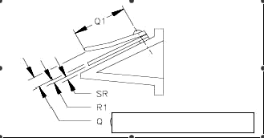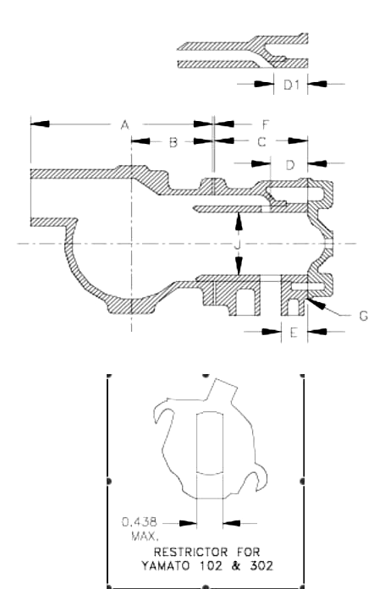

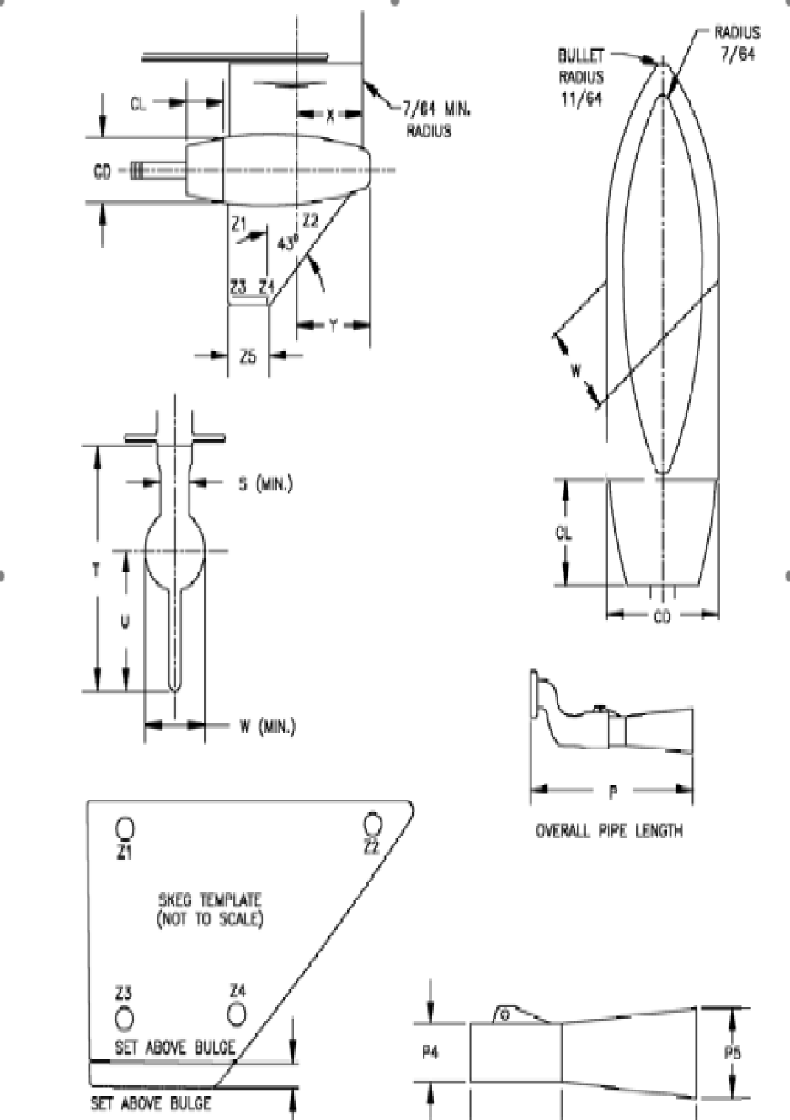

MOTOR SPECIFICATIONS FOR MERCURY 44XS (D CLASS)
Engine Model |  | Mercury |  |  | 44XS
 |  | Mariner |  |  | 44XS
POWERHEAD SPECIFICATIONS | Group | Ref. # | Item | Dimension |  | Units |  | Definition
POWERHEAD SPECIFICATIONS | General Specs |  | Number of Cylinders | 4
POWERHEAD SPECIFICATIONS | General Specs |  | Engine Displacement | 43.9 |  | In³ |  | The Volume of all cylinders excluding the combustions chamber
POWERHEAD SPECIFICATIONS | General Specs |  | Minimum CC | 23 |  | Cm³ |  | Volume of each Cylinder at T.D.C. filled to top of spark plug hole
POWERHEAD SPECIFICATIONS | General Specs | J | Stroke | 2.125 ±0.010 |  | In |  | Distance the crank moves in 180° of rotation. Or the distance the piston moves
POWERHEAD SPECIFICATIONS | General Specs |  | Flywheel Weight | 6 lbs 4 oz
POWERHEAD SPECIFICATIONS | General Specs |  | Flywheel Diameter
POWERHEAD SPECIFICATIONS | Cylinder Bore Diameter | G | Standard | 2.563 ±0.005 |  | In |  | This is a Reference only Dimension
POWERHEAD SPECIFICATIONS | Cylinder Bore Diameter | G | 0.010 OS (Ten Over) |  |  | In |  | This is a Reference only Dimension
POWERHEAD SPECIFICATIONS | Cylinder Bore Diameter | G | 0.030 OS (Thirty Over) |  |  | In |  | This is a Reference only Dimension
POWERHEAD SPECIFICATIONS | Cylinder Bore Diameter | G | Max Size | 2.598 |  | In |  | Maximum bore size including piston clearance
POWERHEAD SPECIFICATIONS | Rods | L | Rod Length | 3.625 ±0.005 |  | In |  | Length of the rod from center of crank pin hole to center of wrist pin hole
POWERHEAD SPECIFICATIONS |  |  | Weight | 6.7 oz min |  |  |  | With bearings and washers
POWERHEAD SPECIFICATIONS | Piston | E | Rod Piston Length | 4.595 ±0.015 |  | In |  | Length of piston and rod from crank pin center to the top edge of the top ring
POWERHEAD SPECIFICATIONS | Piston |  | Weight | 10.2 oz max
POWERHEAD SPECIFICATIONS | Piston | F | Piston Height | 2.756 ±0.031 |  | In |  | Piston Height measured to the top of the crown
POWERHEAD SPECIFICATIONS | Piston | E1 | Crown Height | 0.562 ±0.005 |  | In |  | Measured from the top edge of the top ring to the top of the piston
POWERHEAD SPECIFICATIONS | Piston Rings |  | Number per Piston
POWERHEAD SPECIFICATIONS | Piston Rings | Upper | Design
POWERHEAD SPECIFICATIONS | Piston Rings | Lower | Design
POWERHEAD SPECIFICATIONS | Piston Rings | Upper | Thickness |  |  | In
POWERHEAD SPECIFICATIONS | Piston Rings | Lower | Thickness |  |  | In
POWERHEAD SPECIFICATIONS | Ports |  | Number of Exhaust | 3
POWERHEAD SPECIFICATIONS | Ports |  | Number of Transfer | 3
POWERHEAD SPECIFICATIONS | Ports | A | Height of Transfer upper | 4.007 ±0.015 |  | In
POWERHEAD SPECIFICATIONS | Ports | C | Height of  Exhaust upper | 4.221 ±0.015 |  | In
POWERHEAD SPECIFICATIONS | Ports | A1 | Height of Transfer Lower | 3.382 +0.015/- 0.025 |  | In
POWERHEAD SPECIFICATIONS | Ports | C1 | Height of Exhaust Lower | 3.596 +0.015/-0.025 |  | In
POWERHEAD SPECIFICATIONS | Ports | A2 | Transfer Diameter | 0.625 ±0.010 |  | In
POWERHEAD SPECIFICATIONS | Ports | C2 | Exhaust Diameter | 0.625 ±0.010 |  | In
POWERHEAD SPECIFICATIONS | Block | H | Combustion Chamber corner hgt. | 6.468 ±0.010 |  | In
POWERHEAD SPECIFICATIONS | Front Inlet Cover |  | Mounting Space Length | 1.350 max |  | In
POWERHEAD SPECIFICATIONS | Reeds and Reed Plate |  | Reed Material |  |  | In
POWERHEAD SPECIFICATIONS | Reeds and Reed Plate | O | Reed Thickness | 0.020 ±0.002 |  | In
POWERHEAD SPECIFICATIONS | Reeds and Reed Plate | P | Reed Stop Heights | 0.156 ±0.031 |  | In
POWERHEAD SPECIFICATIONS | Reeds and Reed Plate | P1 | Checking Distance | 1.690 ±0.020 |  | In
POWERHEAD SPECIFICATIONS | Reeds and Reed Plate |  |  |  |  | In
POWERHEAD SPECIFICATIONS | Reeds and Reed Plate | M | Port Length | 1.300 ±0.015 |  | In
POWERHEAD SPECIFICATIONS | Reeds and Reed Plate | N | Port Width | 0.620 ±0.015 |  | In
Carb | Carburetor  Top Walboro WMA6-1  Bottom Walboro WMA6-3 |  | Venturi Diameter | Main 1.000 ±0.010  Boost 0.250 ±0.005 |  | In
Carb | Carburetor  Top Walboro WMA6-1  Bottom Walboro WMA6-3 |  | Bore Diameter | 1.125 ±0.005 |  | In
Tower | Exhaust | D | Meg Length | 6.000 ±0.250
Tower | Exhaust | D1 |  | 7.280 ±0.250
Tower |  | V |  | 10.030 ±0.060
Gear Case | Gear Case |  |  | Merc |  |  |  | Bass
Gear Case |  |  | Gear Ratio | 14:14 |  |  |  | 17:17
Gear Case |  | Q |  | 12.500 max |  |  |  | 15.750 ±0.250
Gear Case |  | Y |  | n/a |  |  |  | 4.000 min
Gear Case |  | R |  | 2.300 min |  |  |  | 1.950 min
Gear Case |  | S |  | 1.120 min |  |  |  | 1.850 min
Gear Case |  | W |  | 2.095 min |  |  |  | n/a
Gear Case |  | X |  | n/a |  |  |  | 3.250 min
Gear Case |  | X1 |  | n/a |  |  |  | 5.000 min
 |  | Z |  | n/a |  |  |  | 4.000 min
 |  | 1 |  | 6206TNC3
 |  | 2 |  | ROLLER 28&28
 |  | 3 |  | 6206TNC3
 |  | 4 |  | 25 needles
 |  | 5 |  | 27 needles
 |  | 6 |  | Ball ND R-12
 |  | 7 |  | Roller GB-1112
 |  | 8 |  | Roller GB-1112
 |  | 9 |  | Ball 6005
 |  | 10 |  | Roller B-118

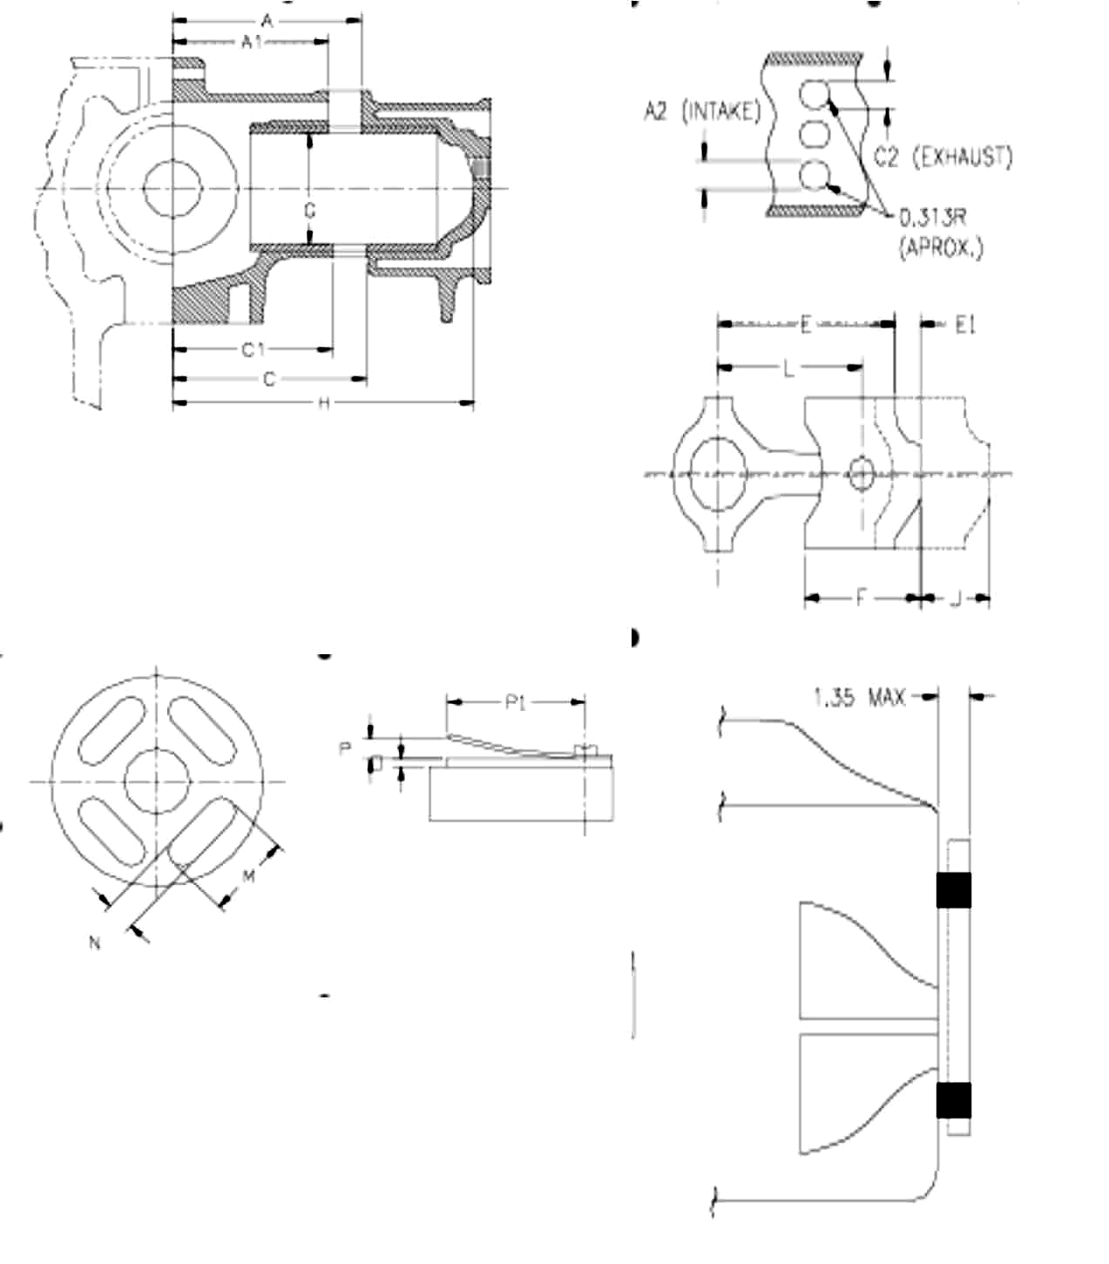

MOTOR SPECIFICATIONS FOR MERCURY 55H (D CLASS)
Engine Model |  | Mercury |  |  | 55H
 |  | Mercury |  |  | 55
POWERHEAD SPECIFICATIONS | Group | Ref. # | Item | Dimension |  | Units |  | Definition
POWERHEAD SPECIFICATIONS | General Specs |  | Number of Cylinders | 4
POWERHEAD SPECIFICATIONS | General Specs |  | Engine Displacement | 39.6 |  | In³ |  | The Volume of all cylinders excluding the combustions chamber
POWERHEAD SPECIFICATIONS | General Specs |  | Minimum CC | 20.5 |  | Cm³ |  | Volume of each Cylinder at T.D.C. filled to top of spark plug hole
POWERHEAD SPECIFICATIONS | General Specs | J | Stroke | 2.125 ±0.004 |  | In |  | Distance the crank moves in 180° of rotation. Or the distance the piston moves
POWERHEAD SPECIFICATIONS | General Specs |  | Flywheel Weight | 1 lbs 12 oz
POWERHEAD SPECIFICATIONS | General Specs |  | Flywheel Diameter
POWERHEAD SPECIFICATIONS | Cylinder Bore Diameter | G | Standard | 2.441 ±0.002 |  | In |  | This is a Reference only Dimension
POWERHEAD SPECIFICATIONS | Cylinder Bore Diameter | G | Max Size | 2.458 |  | In |  | Maximum bore size including piston clearance
POWERHEAD SPECIFICATIONS | Rods | L | Rod Length | 3.719 ±0.006 |  | In |  | Length of the rod from center of crank pin hole to center of wrist pin hole
POWERHEAD SPECIFICATIONS |  |  | Weight | 6.75 oz min |  |  |  | With both bearings and washers
POWERHEAD SPECIFICATIONS | Piston | E | Rod Piston Length | 4.412 ±0.018 |  | In |  | Length of piston and rod from crank pin center to the top edge of the top ring
POWERHEAD SPECIFICATIONS | Piston |  | Weight | 7.5 oz min |  |  |  | With rings, wrist pin, and clips
POWERHEAD SPECIFICATIONS | Piston | F | Piston Height (minus Crown) | 2.187 ±0.031 |  | In |  | Piston Height measured to the top edge of the top ring
POWERHEAD SPECIFICATIONS | Piston | E1 | Piston Position at BDC | 3.534 ±0.015 |  | In
POWERHEAD SPECIFICATIONS | Piston Rings |  | Number per Piston
POWERHEAD SPECIFICATIONS | Piston Rings | Upper | Design
POWERHEAD SPECIFICATIONS | Piston Rings | Lower | Design
POWERHEAD SPECIFICATIONS | Piston Rings | Upper | Thickness |  |  | In
POWERHEAD SPECIFICATIONS | Piston Rings | Lower | Thickness |  |  | In
POWERHEAD SPECIFICATIONS | Ports |  | Number of Exhaust
POWERHEAD SPECIFICATIONS | Ports |  | Number of Transfer Upper
POWERHEAD SPECIFICATIONS | Ports | A | Height of Transfer | 55H- 4.076 ±0.010  55- 4.007 ±0.010 |  | In
POWERHEAD SPECIFICATIONS | Ports | C | Height of Exhaust Upper | 55H- 4.281 ±0.010  55- 4.221 ±0.010 |  | In
POWERHEAD SPECIFICATIONS | Ports | A1 | Transfer Lower Height | 3.329 ±0.010 |  | In
POWERHEAD SPECIFICATIONS | Ports | C1 | Exhaust Lower height | 3.543 ±0.010 |  | In
POWERHEAD SPECIFICATIONS | Block | H | Cylinder Height | 6.307 +0.005/  -0.010 |  | In
POWERHEAD SPECIFICATIONS |  | O | Reed Thickness | 0.012 |  | In
POWERHEAD SPECIFICATIONS |  | P | Reed Stop Heights | 0.156 ±0.031 |  | In
POWERHEAD SPECIFICATIONS |  | M | Port Length | 1.000 or 1.219 ±0.033 |  | In
POWERHEAD SPECIFICATIONS |  | N | Port Width | 0.625 ±0.033 |  | In
Carb | Carburetor  Tillotson |  | Venturi Diameter | KA 1.000 ±0.015  Carter 0.937 |  | In
Carb | Carburetor  Tillotson |  | Bore Diameter | KA 1.125 ±0.015  Carter 1.312 |  | In
Tower | Exhaust | D | Housing | Cast Snout
Tower | Drive Shaft Housing | V |  | 55H- 17.062 ±0.062  55- 12.062 ±0.062
Gear Case | Gear Case |  |  | Merc
Gear Case |  |  | Gear Ratio | 14:14
Gear Case |  | Q |  | 12.500 max
Gear Case |  | R |  | 2.375 ±0.031
Gear Case |  | S |  | 1.093 ±0.031
Gear Case |  | W |  | 4.400 min
Gear Case |  | X |  | 3.062 min
 |  | Y |  | 3.312 min
 |  | Z |  | 5.250 min
 |  | 1 |  | 206K
 |  | 2 |  | ROLLER

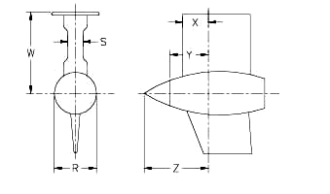

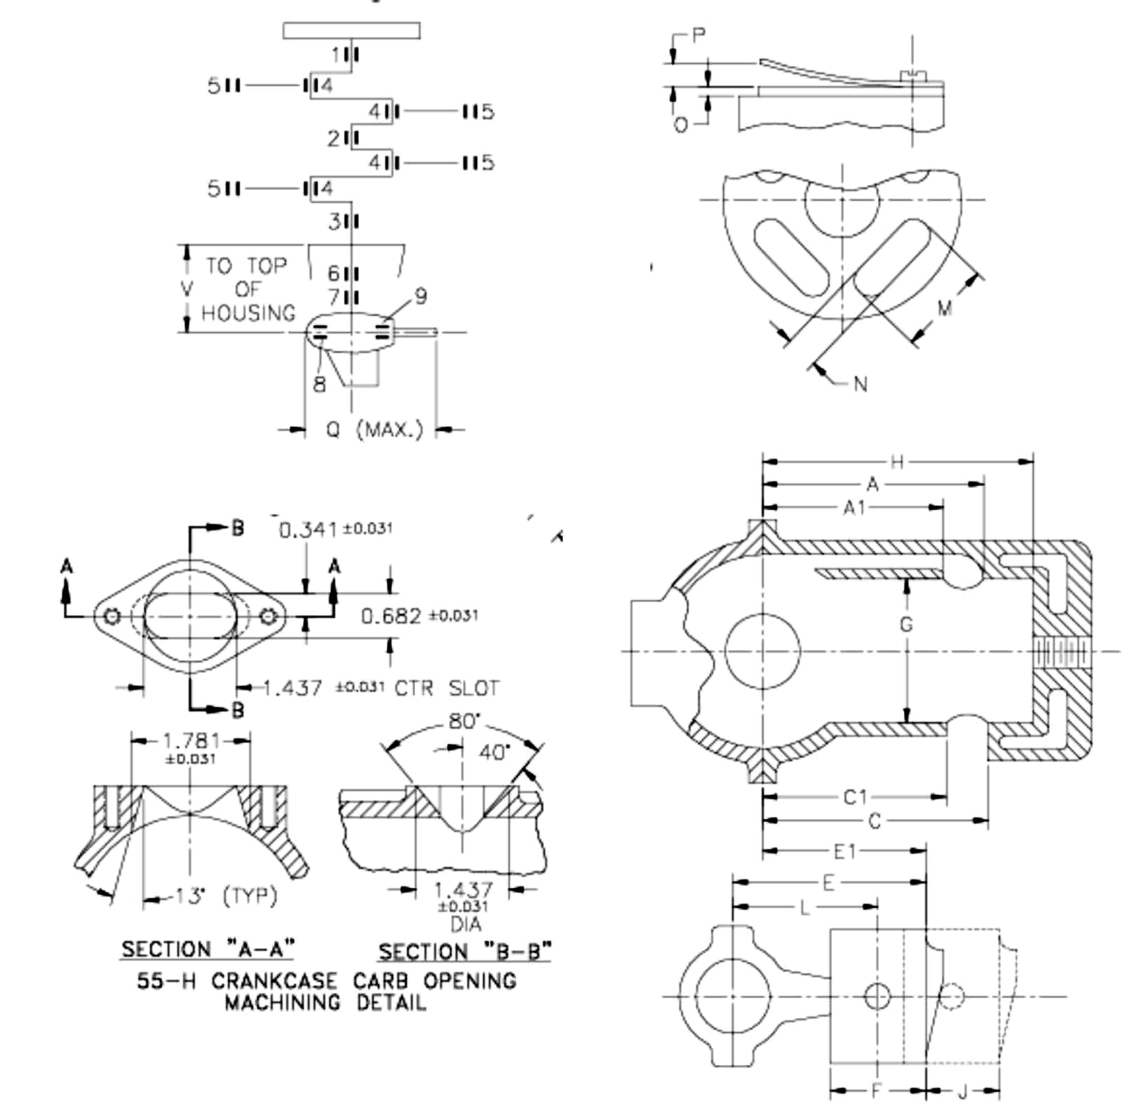

MOTOR SPECIFICATIONS FOR RAM50 (D CLASS)
Engine Model |  | RAM50 |  |  | M50
POWERHEAD SPECIFICATIONS | Group | Ref. # | Item | Dimension |  | Units |  | Definition
POWERHEAD SPECIFICATIONS | General Specs |  | Number of Cylinders | 3
POWERHEAD SPECIFICATIONS | General Specs |  | Engine Displacement | 42.6 |  | In³ |  | The Volume of all cylinders excluding the combustions chamber
POWERHEAD SPECIFICATIONS | General Specs |  | Minimum CC | 25 |  | Cm³ |  | Volume of each Cylinder at T.D.C. filled to top of spark plug hole
POWERHEAD SPECIFICATIONS | General Specs | J | Stroke | 2.520 ± 0.002 |  | In |  | Distance the crank moves in 180° of rotation. Or the distance the piston moves
POWERHEAD SPECIFICATIONS | General Specs |  | Flywheel Weight | 8.818 lbs. Minimum
POWERHEAD SPECIFICATIONS | General Specs |  | Flywheel Diameter
POWERHEAD SPECIFICATIONS | Cylinder Bore Diameter | G | Standard | 2.677 |  | In |  | This is a Reference only Dimension
POWERHEAD SPECIFICATIONS | Cylinder Bore Diameter | G | Max Size | 2.707 |  | In |  | Maximum bore size including piston clearance
POWERHEAD SPECIFICATIONS | Rods | L | Rod Length | 4.587 ±0.007 |  | In |  | Length of the rod from center of crank pin hole to center of wrist pin hole
POWERHEAD SPECIFICATIONS | Piston | F | Piston Height (minus Crown) | 2.638 ±0.018 |  | In |  | Piston Height measured to the top edge of the top ring
POWERHEAD SPECIFICATIONS | Piston | M | Wrist Pin To Top Ring | 1.260 ±0.008 |  | In |  | Measured from the top edge of the top ring to the center of the wrist pin
POWERHEAD SPECIFICATIONS | Piston Rings |  | Number per Piston | 2
POWERHEAD SPECIFICATIONS | Piston Rings | Upper | Design
POWERHEAD SPECIFICATIONS | Piston Rings | Lower | Design
POWERHEAD SPECIFICATIONS | Piston Rings | Upper | Thickness | 0.079 |  | In
POWERHEAD SPECIFICATIONS | Piston Rings | Lower | Thickness | 0.0776 ± 0.0015 |  | In
POWERHEAD SPECIFICATIONS | Ports |  | Number of Exhaust
POWERHEAD SPECIFICATIONS | Ports |  | Number of Transfer
POWERHEAD SPECIFICATIONS | Ports | A | Height of Transfer | 5.000 ±0.039 |  | In
POWERHEAD SPECIFICATIONS | Ports | C | Height of Exhaust | 5.492 ±0.039 |  | In
POWERHEAD SPECIFICATIONS | Ports | EX | EX Width | - ±0.059 |  | In
POWERHEAD SPECIFICATIONS | Ports | HE | Finger Height | 0.413 ±0.059
POWERHEAD SPECIFICATIONS | Ports | T | Finger Width | 0.118 ±0.020
POWERHEAD SPECIFICATIONS | Ports |  | Transfer Width | T1- 0.610 ±0.059  T2- 0.827 ±0.059  TB- 0.787 ±0.059 |  | In
POWERHEAD SPECIFICATIONS | Block | K | Cylinder Height | 7.087 ±0.008 |  | In
POWERHEAD SPECIFICATIONS | Head |  | Head Gasket | 0.047 ±0.008 |  | In |  | Measured compressed
POWERHEAD SPECIFICATIONS | Reeds and Reed Plate |  | Reed Material | Plastic or Steel |  | In
POWERHEAD SPECIFICATIONS | Reeds and Reed Plate |  | Reed Thickness | 0.008 ±0.001 |  | In
POWERHEAD SPECIFICATIONS | Reeds and Reed Plate | Y | Reed Length | 1.390 ±0.020
POWERHEAD SPECIFICATIONS | Reeds and Reed Plate | T | Reed Stop Heights | 0.396 ±0.028 |  | In
POWERHEAD SPECIFICATIONS | Reeds and Reed Plate |  | Port Length | 1.181 ±0.020 |  | In
POWERHEAD SPECIFICATIONS | Reeds and Reed Plate |  | Port Width | 0.591 ±0.020 |  | In
Carb | Carburetor |  | Venturi Diameter | 1.024 ±0.020 |  | In
Carb | Carburetor |  | Throttle Housing | 1.260 ±0.028 |  | In
Gear Case | Gear Case |  |  | Bass
Gear Case |  |  | Gear Ratio | 17:17
Gear Case |  | Q |  | 11.700 min
Gear Case |  | Y |  | 3.750 min
Gear Case |  | R |  | 1.950 min
Gear Case |  | S |  | 1.950 min
Gear Case |  | X |  | 3.000 min
Gear Case |  | T |  | 5.000 min
 |  |  | Prop Shaft Diameter | 11/16
 |  |  | Shear Pin Diameter | 0.250

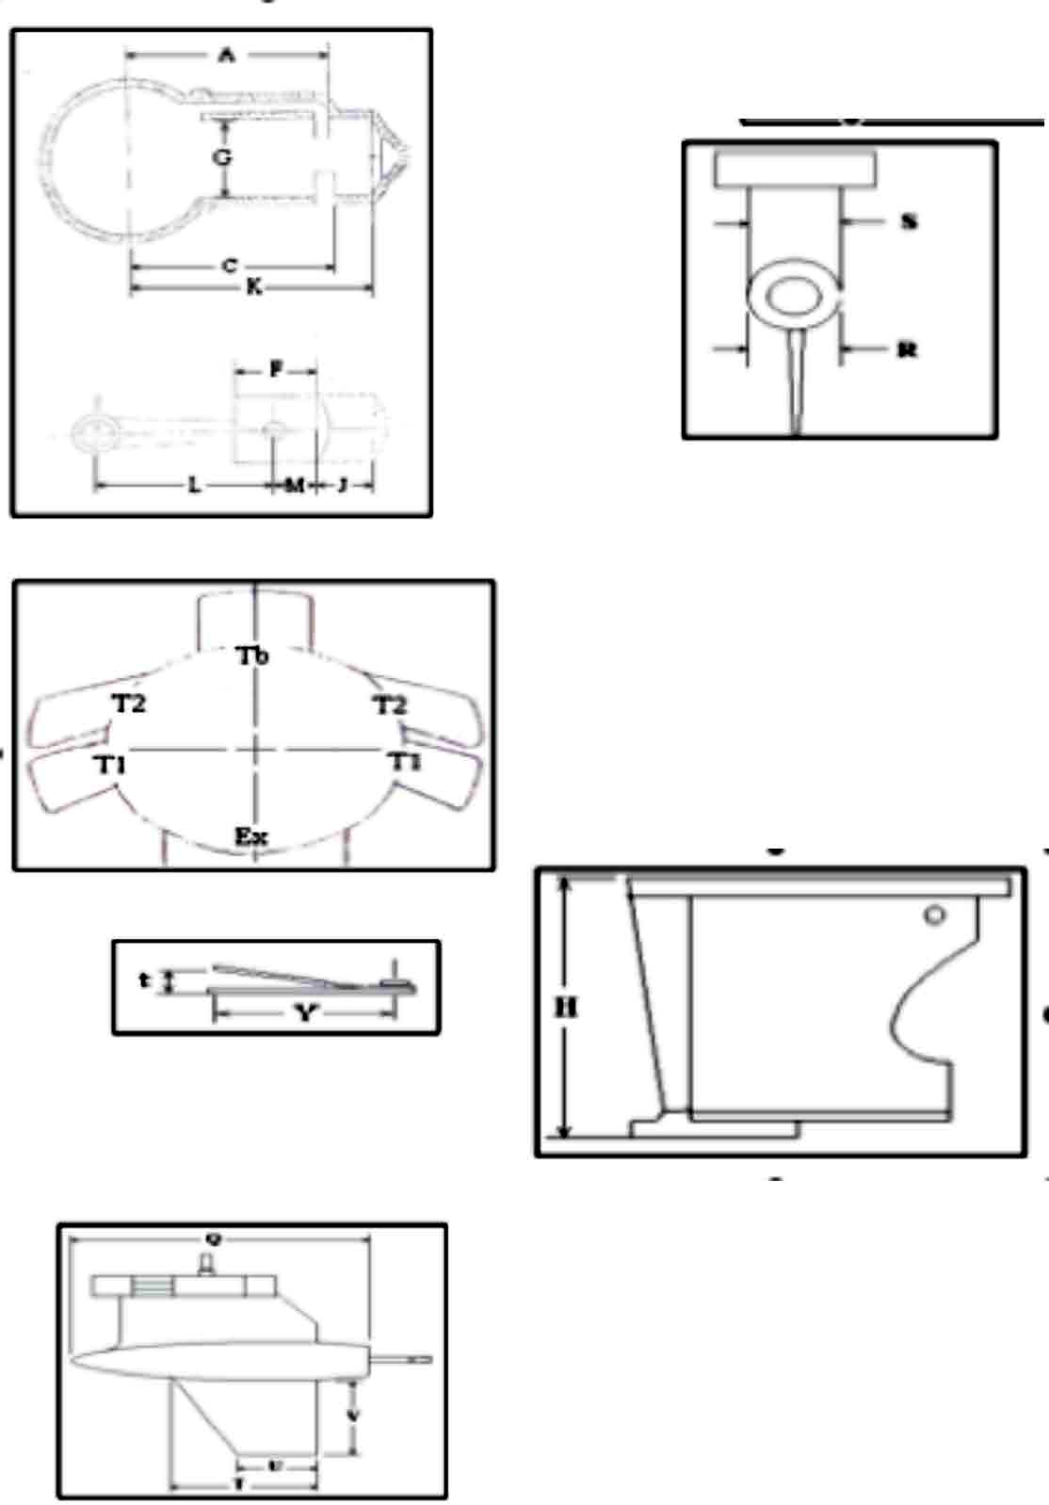

MOTOR SPECIFICATIONS FOR SUPER THUNDERBOLT (D CLASS)
Engine Model
POWERHEAD SPECIFICATIONS | Group | Ref. # | Item | Dimension |  | Units |  | Definition
POWERHEAD SPECIFICATIONS | General Specs |  | Number of Cylinders | 4
POWERHEAD SPECIFICATIONS | General Specs |  | Engine Displacement | 43.9 |  | In³ |  | The Volume of all cylinders excluding the combustions chamber
POWERHEAD SPECIFICATIONS | General Specs |  | Minimum CC | 22 |  | Cm³ |  | Volume of each Cylinder at T.D.C. filled to top of spark plug hole
POWERHEAD SPECIFICATIONS | General Specs | J | Stroke | 2.125 ±0.004 |  | In |  | Distance the crank moves in 180° of rotation. Or the distance the piston moves
POWERHEAD SPECIFICATIONS | General Specs |  | Flywheel Weight | 5 lbs |  |  |  | With Timing Belt Pulley
POWERHEAD SPECIFICATIONS | General Specs |  | Flywheel Diameter
POWERHEAD SPECIFICATIONS | Cylinder Bore Diameter | G | Standard | 2.565 ±0.003 |  | In |  | This is a Reference only Dimension
POWERHEAD SPECIFICATIONS | Cylinder Bore Diameter | G | Max Size | 2.602 |  | In |  | Maximum bore size including piston clearance
POWERHEAD SPECIFICATIONS | Piston | E | 3 Ring Piston Weight | 8.7 oz |  | In |  | With rings, wrist pin, and clips
POWERHEAD SPECIFICATIONS | Piston |  | 2 Ring Piston Weight | 10.2 |  |  |  | With rings, wrist pin, and clips
POWERHEAD SPECIFICATIONS | Piston | F | Piston Height (minus Crown) | 2.187 ±0.031 |  | In |  | Piston Height measured to the top edge of the top ring
POWERHEAD SPECIFICATIONS | Piston | E1 | Deck Height | 3.534 ±0.015 |  | In
POWERHEAD SPECIFICATIONS | Piston Rings |  | Number per Piston
POWERHEAD SPECIFICATIONS | Piston Rings | Upper | Design
POWERHEAD SPECIFICATIONS | Piston Rings | Lower | Design
POWERHEAD SPECIFICATIONS | Piston Rings | Upper | Thickness |  |  | In
POWERHEAD SPECIFICATIONS | Piston Rings | Lower | Thickness |  |  | In
POWERHEAD SPECIFICATIONS | Ports |  | Number of Exhaust
POWERHEAD SPECIFICATIONS | Ports |  | Number of Transfer
POWERHEAD SPECIFICATIONS | Ports | A | Height of Transfer | 4.007 ±0.010 |  | In |  | 3 round ports per cylinder
POWERHEAD SPECIFICATIONS | Ports | C | Height of Exhaust | 4.221 ±0.010 |  | In |  | 3 round ports per cylinder
POWERHEAD SPECIFICATIONS | Ports | A1 | Transfer Height | 3.382 ±0.010 |  | In |  | 3 round ports per cylinder
POWERHEAD SPECIFICATIONS | Ports | C1 | Exhaust Height | 3.596 ±0.010 |  | In |  | 3 round ports per cylinder
POWERHEAD SPECIFICATIONS | Block | H | Combustion Chamber Corner Height | 6.307 +0.005/  -0.010 |  | In
POWERHEAD SPECIFICATIONS | Reed Block | O | Reed Thickness | Metal 0.012 ±0.001  Plastic 0.012 ±0.002 |  | In
POWERHEAD SPECIFICATIONS | Reed Block | P, P1 | Reed Stop Heights | 0.156 ±0.031, Long: 1.690 ±0.020  Short: 1.438 ±0.010 |  | In
POWERHEAD SPECIFICATIONS | Reed Block | M | Port Length | 1.300 ±0.015 Big Aluminum 1.000 or 1.219 ±0.033  Bass or Small Aluminum |  | In
Carb | Carburetor  Tillotson |  | Venturi Diameter | 1.000 ±0.015 |  | In
Carb | Carburetor  Tillotson |  | Bore Diameter | 1.123 ±0.015 |  | In
Tower | Exhaust | D | Housing | Cast Snout  Bass 7/8” max
Tower |  | V | Housing Height | 55H/33SS 17.062 ±0.062  Bass 8.500 ±0.062
 |  | A | Bass Adapter | 0.750 ±0.032
Gear Case | Gear Case |  | Model | 55H |  | 44XS |  |  | Bass
Gear Case |  |  | Gear Ratio | 14:14 |  | 14:14 |  |  | 17:17
Gear Case |  | Q |  | 12.500 max |  | 12.500 max |  |  | 11.700 min
Gear Case |  | R |  | 2.375 ±0.031 |  | 2.300 min |  |  | 1.950 min
Gear Case |  | S |  | 1.093 ±0.031 |  | 1.120 min |  |  | 1.950 min
Gear Case |  | T |  |  |  |  |  |  | 5.000 min
Gear Case |  | U |  |  |  |  |  |  | 3.000 min
Gear Case |  | V |  |  |  |  |  |  | 3.750 min
Gear Case |  | W |  | 4.400 min |  | 2.095 min
Gear Case |  | X |  | 3.062 min
 |  | Y |  | 3.312 min
 |  | Z |  | 5.250 min
 |  | 1 |  | 206K
 |  | 2 |  | ROLLERS
 |  | 3 |  | 206K
 |  | 4 |  | 25 rollers
 |  | 5 |  | 22 rollers
 |  |  |  | 55H |  | 44XS |  |  | Bass
 |  | 6 |  | 5-8K |  | BALL 12-R |  |  | Roller
 |  | 7 |  | Roller GB-1112 |  |  |  |  | Ball
 |  | 8 |  | Roller GB-1112 |  |  |  |  | n/a
 |  | 9 |  | 9105K |  | 6005 |  |  | Ball & Roller

MOTOR SPECIFICATIONS FOR MERCURY 402XS (D CLASS)
Engine Model |  | Mercury |  |  | 402XS
POWERHEAD SPECIFICATIONS | Group | Ref. # | Item | Dimension |  | Units |  | Definition
POWERHEAD SPECIFICATIONS | General Specs |  | Number of Cylinders | 2
POWERHEAD SPECIFICATIONS | General Specs |  | Engine Displacement | 33.3 |  | In³ |  | The Volume of all cylinders excluding the combustions chamber
POWERHEAD SPECIFICATIONS | General Specs |  | Minimum CC | 28.0 |  | Cm³ |  | Volume of each Cylinder at T.D.C. filled to top of spark plug hole
POWERHEAD SPECIFICATIONS | General Specs | J | Stroke | 2.562 ±0.006 |  | In |  | Distance the crank moves in 180° of rotation. Or the distance the piston moves
POWERHEAD SPECIFICATIONS | General Specs |  | Flywheel Weight | 10.0 Steel Min. 7lbs14oz Alum |  | lbs
POWERHEAD SPECIFICATIONS | General Specs | K |  |  |  |  |  | Not Known
POWERHEAD SPECIFICATIONS | Cylinder Bore Diameter | G | Standard | 2.875 ±0.003 |  | In |  | This is a Reference only Dimension
POWERHEAD SPECIFICATIONS | Cylinder Bore Diameter | G | Max Size |  |  | In |  | Maximum bore size including piston clearance
POWERHEAD SPECIFICATIONS | Rods | L | Rod Length | 4.062 ±0.006 |  | In |  | Length of the rod from center of crank pin hole to center of wrist pin hole
POWERHEAD SPECIFICATIONS |  |  | Weight | 10.9 Min |  | Oz |  | With both bearings and washers
POWERHEAD SPECIFICATIONS | Piston | E | Rod Piston Length | 4.279 ±0.025 |  | In |  | Length of piston and rod from crank pin center to the top edge of the top ring
POWERHEAD SPECIFICATIONS | Piston |  | Weight | 13.0 Min |  | Oz |  | With rings, wrist pin, and clips
POWERHEAD SPECIFICATIONS | Piston | F | Piston Height (minus Crown) | 2.630 ±0.032 |  | In |  | Piston Height measured to the top edge of the top ring
POWERHEAD SPECIFICATIONS | Piston Rings |  | No. per Piston
POWERHEAD SPECIFICATIONS | Piston Rings | Upper | Design
POWERHEAD SPECIFICATIONS | Piston Rings | Lower | Design
POWERHEAD SPECIFICATIONS | Piston Rings | Upper | Thickness |  |  | In
POWERHEAD SPECIFICATIONS | Piston Rings | Lower | Thickness |  |  | In
POWERHEAD SPECIFICATIONS | Ports |  | Number of Exhaust
POWERHEAD SPECIFICATIONS | Ports |  | Number of Transfer Upper
POWERHEAD SPECIFICATIONS | Ports | A | Height of Transfer | 4.828 ± 0.025 |  | In
POWERHEAD SPECIFICATIONS | Ports | C | Height of Exhaust Upper | 5.066 ± 0.025 |  | In
POWERHEAD SPECIFICATIONS | Ports | A1 | Transfer Lower Height | 4.278 ± 0.025 |  | In
POWERHEAD SPECIFICATIONS | Ports | C1 | Exhaust Lower height | 4.363 ± 0.025 |  | In |  | C1 Dimensions on 1981 and newer 3 port blocks is 4.328 ± 0.025
POWERHEAD SPECIFICATIONS | Block | H | Cylinder Height |  |  | In
POWERHEAD SPECIFICATIONS | Reed Block | O | Reed Thickness |  |  | In
POWERHEAD SPECIFICATIONS | Reed Block | P | Reed Stop Heights | 0.156 ±0.031 |  | In
POWERHEAD SPECIFICATIONS | Reed Block | N | Port Diameter | 20 Ports .56 Dia. |  | In |  | N refers to the number and size of  reed port openings in reed block
Carb | Carburetor  Walbro WMK-21 |  | Venturi Diameter | 1.250 |  | In
Carb | Carburetor  Walbro WMK-21 |  | Bore Diameter | 1.375 |  | In
Tower | Exhaust | D | Housing | Cast Snout
Tower | Drive Shaft Housing | V |  | 17.062 ± .062
Gear Case | Gear Case |  |  | Merc |  |  |  | Skeg dimensions same as 55H
Gear Case |  |  | Gear Ratio | 14:14
Gear Case |  | Q |  | 12.500 max
Gear Case |  | R |  | 2.375 ±0.031
Gear Case |  | S |  | 1.093 ±0.031
Gear Case |  | W |  | 4.500 min
Gear Case |  | X |  | 3.062 min
 |  | Y |  | 3.312 min
 |  | Z |  | 5.250 min
 |  | 1 |  | 206K
 |  | 2 |  | ROLLER

